Course Outline for Church Youth Education
Pastor Chui, ckchui1@gmail.com

Course Title: Church Youth Education (MN425 - 525). This course prepares the students to be future youth pastors for churches.
Course Content: All course content is judged by Martin Luther’s “Sola Scriptura.” This course will prepare students to be future youth pastors. A church with more than 10 youth would require a youth pastor. The youth would be divided into two groups: Junior Youth Fellowship and Senior Youth Fellowship. The approximate dividing line could be about 12 years of age. The younger ones would be in the junior group, while the rest would be in the senior group. God made us in spirit, soul, and body. As we age, there are special needs in each area. Students will be required to do their own study and research.
Course Objectives: At the end of the course, students will have confidence of being youth pastors as outlined in the course content. Emphasis will be placed on the application to daily lives.
Criteria to Pass: The student must turn in all assignments and must turn in one summary and reflections paper. There will be a final exam. Assignments will be given every week and due in the following week. A 2-page summary report will be due in the following week. You will need the parent’s permission to contact at least one youth (Age 6 to 18) for at least 10 minutes once a week. You will write a one-page report about the contact. You need to understand the spiritual, intellectual, and physical needs of the youth. You will work to meet the need of the youth. Please only give the first name of the youth. No photo is needed. It is due before the end of the quarter, and it is worth 400 points.
Pre-Requisite: The student must have a desire to study the Bible and a desire to study lecture notes in depth. Lecture notes can be downloaded from chui_page9 at the http://christcentergospel.org.
Textbook(s): The English and Chinese Bibles in various versions. Other reference books are available in the library. The Internet is also very useful for research. Use Google to find what you need.
Week 1: The importance of games during junior years. Learn from Moses. (7 pages of notes.)
Week 2: The importance of hymns during junior years. Introduce “Pray’s Children Stories.” 2-page summary report is due. (37 pages of notes.)
Week 3: The importance of social studies during junior years. Learn from David. 2-page summary report is due. (33 pages of notes.)
Week 4: The importance of science studies during junior years. Learn from Master Books. 2-page summary report is due. (34 pages of notes.)
Week 5: The importance of sports during junior years. Learn from Christian Sports International. Cartoons. 2-page summary report is due. (59 pages of notes.)
Week 6: The importance of computer knowledge during senior years. Learn from homeschools. 2-page summary report is due. (24 pages of notes.)
Week 7: The importance of understanding current culture during senior years. 2-page summary report is due. (31 pages of notes.)
Week 8: The importance of Christian friendship during senior years. Summary report is due. (43 pages of notes.)
Week 9: The importance of understanding counter-culture during senior years. 2-page summary report is due. (60 pages of notes.)
Week 10: The importance of understand Genesis as the foundation of Christianity. 2-page summary report is due. (27 pages of notes.)
There is a final examination which is worth 400. In addition, turn in all 2-page summary reports and one term paper will constitute part of the grade of this course. Each 2-page summary report will worth 200 points. All assignment reports must be written in Chinese or English. The term summary reflection paper will provide what you have learned in the course. It will be at least 4 pages in length. It is worth 400 points. There will one 10-page interview results and comments, and this will be worth 400 points. The complete scores will be 3000 points.

教会青少年教育课程大纲
崔牧师ckchui1@gmail.com

课程名称：教会青少年教育（MN425-525）。该课程使学员成为未来的青年牧师。
课程内容：所有课程内容均由马丁·路德（Martin Luther）的“ Sola Scriptura”评判。该课程将使学生成为未来的青年牧师。一个拥有10多名青年的教会将需要一名青年牧师。青年将分为两类：初级青年和高级青年。大致的分界线可能约为12岁。较年轻的将在初级组中，其余的将在高级组中。上帝使我们活在灵, 魂, 和体上。随着年龄的增长，每个领域都有特殊的需求。学员要做自己的学习和研究。
课程目标：在课程结束时，学员将有信心成为课程内容中概述的青年牧师。重点将放在日常生活中的应用程序上。
通过标准：学员必须上交所有作业，并且必须上交一份总结和反思论文。将会有期末考试。作业每周分配一次，并在下周到期。下周将有一份2页的摘要报告。您需要获得家长的许可，每周至少与1名6至18岁的年轻人联系至少10分钟。您将编写一份有关该联系人的报告。您需要了解年轻人的灵魂，智力和身体需求。您将努力满足年轻人的需求。请只给出年轻人的名字。不需要照片。它应在本季度末之前到期，价值400点。
先决条件：学生必须有学习圣经的愿望和深入学习讲义的愿望。演讲笔记可以从http://christcentergospel.org的chui_page9下载。
教科书：各种英文和中文圣经。图书馆提供其他参考书。互联网对于研究也非常有用。使用Google查找所需内容。
第1周：初中游戏的重要性。向摩西学习。( 7页笔记。)
第2周：初中圣歌的重要性。介绍Pray的《儿童圣经故事》。 2页摘要报告到期。( 37页笔记。)
第3周：初中社会科学的重要性。向大卫的童年学习。 2页摘要报告到期。(33页笔记。)
第4周：初中科学的重要性。向Master Books书籍学习。 2页摘要报告到期。( 34页笔记。)
第5周：初中运动的重要性。向基督教体育国际学习。卡通。 2页摘要报告到期。( 59页笔记。)
第6周：高中计算机知识的重要性。向家庭学校学习。 2页摘要报告到期。( 24页笔记。)
第7周：高中了解当代文化的重要性。 2页摘要报告到期。( 31页笔记。)
第8周：高中了解基督徒友谊的重要性。2页摘要报告到期。( 43页笔记。)
第9周：高中了解反文化的重要性。 2页摘要报告到期。( 60页笔记。)
第10周：高中了解创世记是基督教基础的重要性。 2页摘要报告到期。( 27页笔记。)
最终考试的总价值为400。此外，交上所有2页的总结报告，其中一份学期论文将构成本课程成绩的一部分。每份2页的摘要报告将获得200分。所有作业报告必须以中文或英文撰写。提供总结您在本课程中学到的知识。长度至少为4页。它值得400分。交上一份10页的采访结果和评论，这将价值400分。满分为3000分。

Week 1: The importance of games during junior years. Learn from Moses.
Games may be important during junior years. Games are fun. They are stimulating. They are friendship building. There are various of games that youngsters can be involved.
第一周：初中游戏的重要性。 向摩西学习。
在初中，游戏可能很重要。 游戏可以很有趣。 游戏可以很刺激。 游戏可以建立友谊。 青少年可以参与各种游戏。

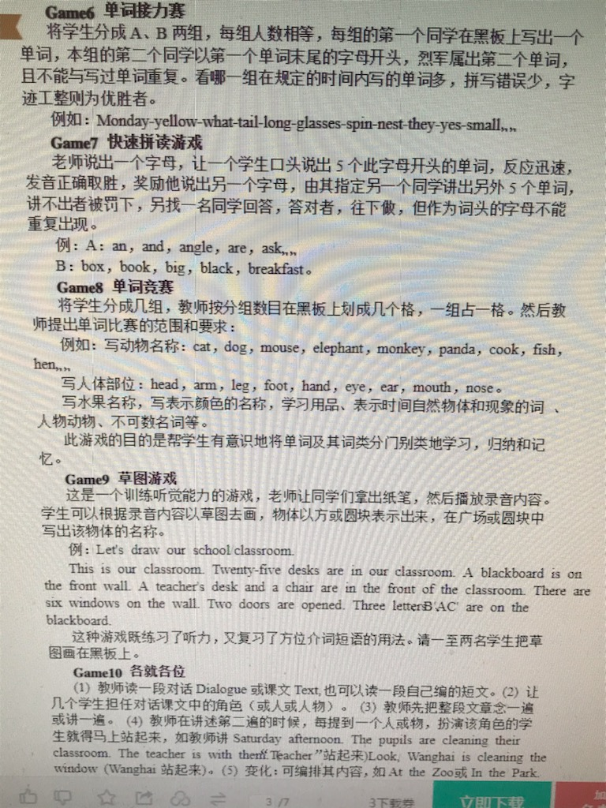
Kids today need heroes – and not just people who are good at throwing a football or who have a terrific singing voice or who were born into a famous family.
They need heroes they can identify with and learn from – they need heroes like Moses.
Unfortunately, many churches focus on teaching kids STORIES and the “morals of those stories” instead of letting them get to know the real PEOPLE involved.
For example: Most churches teach kids about Moses in snippets - kids might learn about the Ten Commandments one year and then hear about him parting the Red Sea the next. So kids remember a guy who was involved in some pretty amazing things but they really don’t get to know what he was like as a man.
今天的孩子们需要英雄-不仅是擅长踢足球，歌声出色或出生于著名家庭的人。
他们需要可以与之认同并向他们学习的英雄-他们需要像Moses这样的英雄。
不幸的是，许多教会专注于教导孩子们的故事和“那些故事的道德”，而不是让他们了解所涉及的真正的人。
例如：大多数教堂都以片段的形式教给孩子有关摩西的知识-孩子们可能会在一年中了解十诫，然后在第二年听到他分开红海的消息。 因此，孩子们记得一个人参与了一些令人惊讶的事情，但他们真的不知道摩西作为一个男人的样子。
Moses becomes just another passing character that they know is in the Bible, but that they don’t really come to KNOW.
And there is so much about Moses that is worth knowing and learning from. He committed a grievous sin yet he became extremely close to God. He survived a trip down the Nile as a baby. He appeared at the Transfiguration with Jesus. Consider these verses from the Bible:
摩西只是他们在圣经中知道的另一个过时人物，但他们并不是真的来了解。
摩西有很多值得我们学习和借鉴的地方。 他犯下了严重的罪，但变得与上帝极为亲近。 他小时候从尼罗河中幸存下来。 他出现在与耶稣的变形中。 考虑一下圣经中的这些经文：
“Now the man Moses was very meek, more than all people who were on the face of the earth.” – Numbers 12:3
“But this is not true of my servant Moses; he is faithful in all my house. With him I speak face to face, clearly and not in riddles; he sees the form of the Lord.” – Numbers 12:7-8
“By faith Moses, when he was grown up, refused to be called the son of Pharaoh’s daughter, choosing rather to be mistreated with the people of God than to enjoy the fleeting pleasures of sin.” – Hebrews 11:24-25
Don’t those verses paint a picture of a complex, interesting man that kids would benefit from knowing better – someone who can inspire them to step out of their comfort zone and accomplish more?
“现在，摩西这个人非常温柔，比地球上所有的人都更加温柔。” –民数记12：3
“但这对我的仆人摩西而言并非如此； 他对我全家都很忠实。 我和他在一起，面对面地讲，很清楚，而不是一个谜。 他看到了主的形式。” –民数记12：7-8
“由于信仰，摩西长大后就拒绝称他为法老的女儿，而是宁愿与上帝的子民相处，而不愿享受短暂的罪恶享受。” –希伯来书11：24-25
这些经文难道不是描绘了一个复杂有趣的男人的图画吗？孩子们会从更好的了解中受益-有人可以激励他们走出自己的舒适区并取得更大的成就？

In All the Facts About Moses we lay out the truth about this amazing man.
Instead of learning about Moses as just a character in popular Bible lessons, kids will discover Moses as a PERSON.
They will learn about his fascinating life story, his personality, his mistakes, his triumphs.
在《关于摩西的所有事实》中，我们阐明了关于这个了不起的人的真相。
孩子们会发现摩西是一个人，而不是在流行的圣经课程中将摩西当作一个角色来学习。
他们将了解他迷人的生活故事，他的个性，他的错误，他的胜利。
- How Moses Survived a Journey Down the Nile as a Baby
- How Moses Committed the Sin of Murder But Was Forgiven by God
- How Moses Worked as Sheep Herder in Midian
- How Moses saw the Burning Bush
- How Moses Asked Pharaoh to “Let My People Go!”
- How Moses was Involved in The Plagues That Struck Egypt
- How Moses was Able to Part the Red Sea
- How Moses Made Water Flow from a Rock
- How Moses was Given the Ten Commandments
- How Moses Reacted When He Saw His People Worshipping a Golden Idol
- How Moses saw the Holy Land Before His Death
- How Moses Appeared at the Transfiguration
- •摩西如何在婴儿时期幸存下来的尼罗河之旅
- •摩西如何犯下谋杀罪，但被上帝宽恕
- •摩西如何在米甸作牧羊人
- •摩西如何看待燃烧的布什
- •摩西如何要求法老王“让我的人民去！”
- •摩西如何参与袭击埃及的瘟疫
- •摩西如何能够分开红海
- •摩西如何使水从岩石中流出
- •摩西如何被赋予十诫
- •摩西看见百姓敬拜黄金偶像时有何反应
- •摩西死前如何看待圣地
- •摩西在变身时的样子

Week 2: The importance of hymns during junior years. Introduce Pray’s Kids Bible Stories. https://www.pray.com/series/kids-bible-stories/
2-page summary report is due.
Singing must be a vital part of any Christian fellowship. There is a myriad of hymns available in YouTube and other websites. We will use some of them during the class.
第2周：初中圣歌的重要性。 介绍Pray的《儿童圣经故事》。 2页摘要报告到期。
唱歌必须是任何基督徒团契的重要组成部分。 YouTube和其他网站上有无数赞美诗。 我们将在课堂上使用其中的一些。
Kids Stories
Kids' Bible Stories are filled with the most popular and family-friendly teachings of the Bible. Children can learn Biblical history through a fun, faithful, and adventurous audio experience. Kids’ Bible Stories feature lively acting and entertaining music to tell Bible-based tales - perfect for educating young Bible readers.
儿童故事
《儿童圣经故事》充满了最受欢迎和家庭友善的圣经教义。 孩子们可以通过有趣，忠实和冒险的音频体验来学习圣经的历史。 儿童圣经故事以生动活泼的表演音乐和有趣的音乐来讲述基于圣经的故事，非常适合教育年轻的圣经读者。

The Creation
4 MIN

Adam and Eve
3 MIN

The Tree that Gives the Knowledge
5 MIN

Cain and Abel
4 MIN

Noah and the Ark
6 MIN

After the Flood
4 MIN

Abram and Sarai
4 MIN

Abram and Lot Separate
7 MIN

Abraham and Sarah's New Life
3 MIN

A Plan for Ishmael
5 MIN

The Passover Events
6 MIN

The Word Will Be Fulfilled
4 MIN

True Prophecy
4 MIN

Jesus on Trial
5 MIN

Jesus' Death and Burial
5 MIN

The Resurrection
3 MIN

God Testing Abraham
3 MIN

Esau's Birthright
4 MIN

Jacob and Esau
7 MIN

Preview
5 MIN

Jacob Meets Rachel
4 MIN

Jacob's Family
7 MIN

Fleeing Laban
5 MIN

You Are Israel
5 MIN

Returning to Egypt
5 MIN

The Story of Joseph
5 MIN

The Story of Joseph, Part II
3 MIN

Joseph Reunited with his Family
5 MIN

Baby from the Nile
4 MIN

A Conversation with Fire
7 MIN

Zipporah and Aaron
3 MIN

The Ten Commandments
4 MIN

Pharaoh says No!
7 MIN

The Lord Gives Water and Victories
3 MIN

A God we can See?
5 MIN

Journey Towards the Promise Land
3 MIN

God Provides Quail
4 MIN

Defying Moses
4 MIN

The Borders of Canaan
5 MIN

Water Flows from the Rock
4 MIN

God Makes a Donkey Speak
5 MIN

Balaam's Prophecy
7 MIN

The Life of a True Servant
6 MIN

Rahab and the Spies
5 MIN

Crossing the Jordan
6 MIN

God Gives his People Jericho
5 MIN

Achan Sins
6 MIN

Joshua and the Treaty
6 MIN

Joshua's Farewell
6 MIN

The Book of Job
6 MIN

Gideon: The Trivial Judge
5 MIN

Gideon's Army and God's Glory
5 MIN

King of Trees
8 MIN

Jephthah Keeps His Promise
6 MIN

Samson's Downfall
5 MIN

Micah, The Levite, and the Tribe of Dan
5 MIN

Naomi meets Faithful Ruth
6 MIN

Ruth and Boaz Unite
4 MIN

The Rise of Samuel
7 MIN

The Philistines Defeat Israel
4 MIN

God's Ark Returns to Israel
5 MIN

Israel's Return to God
6 MIN

The First King of Israel: Saul
6 MIN

Saul's Victory over the Ammonites
5 MIN

Saul and Samuel
4 MIN

Jonathans Victory
4 MIN

Saul Disobeys God
5 MIN

David is Chosen
4 MIN

Friendship, Jealousy, and Marriage
4 MIN

David and Goliath
5 MIN

David is Protected
4 MIN

The Bond of Friendship
5 MIN

Running from Saul
4 MIN

David's Kindness Towards Saul
4 MIN

Abigail and David
4 MIN

David on the Run
5 MIN

David in Ziklag
4 MIN

Guidance from the Medium
4 MIN

The End of Saul and Jonathan
5 MIN

The Best of Friends Fight
4 MIN

King of Israel
4 MIN

Bringing the Ark Home
6 MIN

A Kingdom that Lasts
4 MIN

Victory after Victory
3 MIN

David & Bathsheba
3 MIN

David Repents
3 MIN

Sibling Drama
4 MIN

Absalom Returns
2 MIN

Absalom comes for the Throne
3 MIN

The Death of Absalom
3 MIN

David Returns to Jerusalem
3 MIN

The Death of Sheba
3 MIN

David Righting Wrongs
4 MIN

Taking a Count of the People
5 MIN

Adonijah or Solomon: Who will become king?
5 MIN

Solomon Avenging the Righteous
6 MIN

Solomon's God Given Wisdom
5 MIN

Solomon Builds the Temple of the Lord
5 MIN

Solomon's Fall from God
5 MIN

The Kingdom of Israel Splits
4 MIN

The Sin of King Jeroboam
4 MIN

The Man of God & the Old Prophet
3 MIN

The Legacy of Kings
4 MIN

Abijah and His Son Asa
5 MIN

Elijah and the Drought
4 MIN

Elijah on Mount Carmel
7 MIN

Elijah at Mount Horeb
6 MIN

Naboth's Vineyard
5 MIN

Jehoshaphat and Ahab
6 MIN

Jehoshaphat's Victory
6 MIN

Captain of 50
3 MIN

Elijah in the Whirlwind
6 MIN

Stew and Axe
4 MIN

Shunammite Woman
4 MIN

Naaman
3 MIN

Gehazi
3 MIN

Elisha vs. the Aram Soldiers
2 MIN

Famine in Samaria
3 MIN

Elisha and Hazael
3 MIN

Isaac and Rebekah
7 MIN

God Gives Water and Manna
5 MIN

David and His Mighty Men
5 MIN

Three Kings vs. the Moabites
5 MIN

Death of Elisha
3 MIN

Jonah and the Vine
5 MIN

The Thistle and the Cedar
5 MIN

An Evil King Who Repented
5 MIN

A Book is Found
4 MIN

Josiah's Reforms
5 MIN

Broken Pot
5 MIN

Burning the Book
5 MIN

Esther Saves Her People
4 MIN

The Hand on the Wall
5 MIN

A Great Kings Downfall
3 MIN

King Nebuchadnezzar's Fiery Furnace
4 MIN

King Nebuchadnezzar Turns into a Wild Animal
5 MIN

Daniel and the Lion's Den
4 MIN

The Second Temple of Jerusalem
5 MIN

Esther the Jewish Queen of Persia
5 MIN

Nehemiah's Wall
4 MIN

The Birth of John the Baptist
4 MIN

The Three Wise Men
4 MIN

The Birth of Jesus
4 MIN

Young Jesus
3 MIN

From the Water to the Wilderness
5 MIN

The First Miracle
4 MIN

The New Birth
4 MIN

Woman at the Well
5 MIN

Jesus and His Ministry
4 MIN

Fishing for People
5 MIN

Sermon on the Mount
8 MIN

Forgiving Sins
3 MIN

The Twelve
4 MIN

The Ending of a Witch's Story
6 MIN

Athaliah
6 MIN

Joash
4 MIN

The Prophet Jonah
4 MIN

Israel's Sins and Punishment
3 MIN

King Hezekiah: A King That Honored God
4 MIN

Fifteen Years
4 MIN

Good and Bad Fruit
4 MIN

Jerusalem Under Attack
3 MIN

God Protects Jeremiah
3 MIN

Ezekiel's Vision: Israel's Revival
5 MIN

The King's New Courtiers
3 MIN

Daniel and the King's Dream
4 MIN

Jehu Becomes King
5 MIN

Ahaz: A Bad King
3 MIN

God Helps Out King Hezekiah
3 MIN

Judah's Chaos
5 MIN

A Roman Official
3 MIN

Forgiven and Grateful
3 MIN

Four Soils
3 MIN

Stories by Jesus
3 MIN

Jesus Calms the Storm
4 MIN

Healing on the Sabbath
4 MIN

John the Baptist
3 MIN

Jesus Walks on Water
3 MIN

Not by Bread Alone
4 MIN

You Without Sin Cast the First Stone
4 MIN

Blind at Birth
4 MIN

A Beautiful Transformation
5 MIN

The Temple Tax
3 MIN

Warning from the Rich Man
3 MIN

Continue to Forgive
3 MIN

A Good Neighbor
3 MIN

Lost and Found
4 MIN

Lepers, Judge, and Pride
4 MIN

Raising Lazarus
5 MIN

He Came To Serve Everyone
5 MIN

An Obedient Life
3 MIN

Speak Truth Despite Others’ Beliefs
4 MIN

Encounter on the Road to Emmaus
4 MIN

Jesus Appears to His Disciples
5 MIN

Jesus’ Last Days on Earth and the New Twelve
4 MIN

The Holy Spirit Comes Upon God’s People
4 MIN

Healing at the Gate Called Beautiful
5 MIN

Was it Worth the Price?
4 MIN

The Apostles Arrested
4 MIN

The Story of Stephen
3 MIN

Philip Shares Jesus
3 MIN

Saul’s Conversion
4 MIN

Healing of Dorcas
2 MIN

Cornelius and Peter
4 MIN

The Story of Antioch
3 MIN

Prison Break
5 MIN

Paul and Barnabas Go to Perga
5 MIN

Paul's Trip to Iconium
4 MIN

Accepting Gentile Believers
4 MIN

Dear Galatia
5 MIN

Singing Jailbirds
5 MIN

Paul, Silas, and Timothy Under Attack
5 MIN

Mob in Corinth
5 MIN

The Message of Jesus is Glorified
4 MIN

Paul’s First Letter to the Church in Corinth I
7 MIN

Paul’s First Letter to the Church in Corinth II
9 MIN

Paul’s Second Letter to the Church in Corinth I
7 MIN

Paul’s Second Letter to the Church in Corinth II
9 MIN

Paul’s Letter to the Church in Rome
6 MIN

Paul’s Letters to Rome
4 MIN

Paul’s Travels
4 MIN

Paul and the Enraged Crowd
5 MIN

Whitewashed Tombs
4 MIN

Paul on Trial
5 MIN

The Mighty Storm
5 MIN

Paul's Shipwreck
3 MIN

Philemon
4 MIN

John See’s The End
4 MIN

John’s Journey Through New Creation
5 MIN

The Creation

儿童圣经故事

你最喜爱的圣经故事. 完全免费.
其他语言


圣经故事
请确定计算机已安装 Adobe Reader
旧约 |  |  |  |  |  |  | 
1 上帝创造万物 | 故事 | 彩图 | 彩图 | PDA | 小手册 | 小手册 | 创世纪第一和第二章
2 人类悲伤的开始 | 故事 | 彩图 | 彩图 | PDA | 小手册 | 小手册 | 创世记第三至第六章
3 洪水泛滥 | 故事 | 彩图 | 彩图 | PDA | 小手册 | 小手册 | 创世纪第六至第十章
4 上帝对亚伯拉罕的诺言 | 故事 | 彩图 | 彩图 | PDA | 小手册 | 小手册 | 创世记第十一至第二十一章
5 上帝考验亚伯拉罕的爱 | 故事 | 彩图 | 彩图 | PDA | 小手册 | 小手册 | 创世记第二十二至第二十四章
6 骗子雅各 | 故事 | 彩图 | 彩图 | PDA | 小手册 | 小手册 | 创世记第二十五至第三十三章
7 宠儿变成奴仆 | 故事 | 彩图 | 彩图 | PDA | 小手册 | 小手册 | 创世记第三十七章，创世记第三十九章
8 神给奴仆约瑟尊荣 | 故事 | 彩图 | 彩图 | PDA | 小手册 | 小手册 | 创世记第三十九至第四十五章
9 来自河流的王子 | 故事 | 彩图 | 彩图 | PDA | 小手册 |  | 出埃及记第二章
10 王子成为牧羊人 | 故事 | 彩图 | 彩图 | PDA | 小手册 |  | 出埃及记第二章至第五章
11 告别了,法老! | 故事 | 彩图 | 彩图 | PDA | 小手册 | 小手册 | 出埃及记第四至十五章
12 四十年 | 故事 | 彩图 | 彩图 | PDA | 小手册 | 小手册 | 出埃及记第十五章 – 民数记第十四章
13 约书亚掌管者 | 故事 | 彩图 | 彩图 | PDA | 小手册 | 小手册 | 约书亚记第一章至第六章
14 参孙，神的大力士 | 故事 | 彩图 | 彩图 | PDA | 小手册 |  | 士师记第十三章至十六章
15 基甸的小军队 | 故事 | 彩图 | 彩图 | PDA | 小手册 | 小手册 | 士师记第六章至第九章
16 路得的爱情故事 | 故事 | 彩图 | 彩图 | PDA | 小手册 |  | 路 得 記
17 撒母耳，神的仆人 | 故事 | 彩图 | 彩图 | PDA | 小手册 |  | 撒母耳记上第一章至第七章
18 羞愧的国王 | 故事 | 彩图 | 彩图 | PDA | 小手册 |  | 撒母耳记上第八章至第十六章
19 牧羊的大卫 | 故事 | 彩图 | 彩图 | PDA | 小手册 | 小手册 | 撒母耳记上第十六章至第二十章
20 大卫王（第一集） | 故事 | 彩图 | 彩图 | PDA | 小手册 | 小手册 | 撒母耳记上第二十四至三十一章， 撒母耳记下第一至二章
21 大卫王（第二集） | 故事 | 彩图 | 彩图 | PDA | 小手册 | 小手册 | 撒母耳记下第一至十二章
22 明智的所罗门王 | 故事 | 彩图 | 彩图 | PDA | 小手册 |  | 列王纪上第一章至第十二章
23 好王、坏王 | 故事 | 彩图 | 彩图 | PDA | 小手册 | 小手册 | 历代志下第三十三章至三十六章
24 求神降火的以利亚 | 故事 | 彩图 | 彩图 | PDA | 小手册 |  | 列王纪上第十七章至第十九章； 列王纪下第二章
25 行神迹的以利沙 | 故事 | 彩图 | 彩图 | PDA | 小手册 | 小手册 | 列王纪下第二章至第十三章
26 约拿和大鱼 | 故事 | 彩图 | 彩图 | PDA | 小手册 | 小手册 | 约拿书
27 以赛亚看见未来 | 故事 | 彩图 | 彩图 | PDA | 小手册 | 小手册 | 以赛亚书第一章、第六章、第七章、 第九章、第五十三章
28 流泪的耶利米 | 故事 | 彩图 | 彩图 | PDA | 小手册 | 小手册 | 耶利米书
29 以西结：看见异象的人 | 故事 | 彩图 | 彩图 | PDA | 小手册 | 小手册 | 以 西 結 書
30 漂亮的以斯帖王后 | 故事 | 彩图 | 彩图 | PDA | 小手册 | 小手册 | 以 斯 帖 記
31 但以理被抓 | 故事 | 彩图 | 彩图 | PDA | 小手册 | 小手册 | 但以理书第一章和第二章
32 但以理和神秘的梦 | 故事 | 彩图 | 彩图 | PDA | 小手册 | 小手册 | 但以理书第二章
33 不肯屈服的人 | 故事 | 彩图 | 彩图 | PDA | 小手册 |  | 但以理书第三章
34 但以理和狮子坑 | 故事 | 彩图 | 彩图 | PDA | 小手册 | 小手册 | 但以理书第六章
35 尼希米的巨大城墙 | 故事 | 彩图 | 彩图 | PDA | 小手册 |  | 尼希米记

新约
36 耶稣的诞生 | 故事 | 彩图 | 彩图 | PDA | 小手册 | 小手册 | 马太福音第一和第二章，
37 神差遣约翰 | 故事 | 彩图 | 彩图 | PDA | 小手册 | 小手册 | 路加福音第一和第二章，马可福音第六章
38 耶稣受试探 | 故事 | 彩图 | 彩图 | PDA | 小手册 | 小手册 | 马太福音第四章，路加福音第四章
39 耶稣呼召十二门徒 | 故事 | 彩图 | 彩图 | PDA | 小手册 | 小手册 | 马太福音第四至第七章，马可福音第一章，路加福音第六章
40 耶稣的神迹 | 故事 | 彩图 | 彩图 | PDA | 小手册 |  | 马太福音第八至第九章、 马可福音第一至第二章、马可福音第四章、 路加福音第四章、路加福音第八章、 约翰福
41 圣殿领袖探访耶稣 | 故事 | 彩图 | 彩图 | PDA | 小手册 | 小手册 | 约翰福音第二章至第三章、 民数记第二十一章
42 伟大的教师耶稣 | 故事 | 彩图 | 彩图 | PDA | 小手册 | 小手册 | 马太福音第五章至第七章、路加福音第六章
43 农夫和种子 | 故事 | 彩图 | 彩图 | PDA | 小手册 |  | 马太福音第十三章
44 财主、穷人 | 故事 | 彩图 | 彩图 | PDA | 小手册 |  | 路加福音第十六章
45 浪子回头 | 故事 | 彩图 | 彩图 | PDA | 小手册 |  | 路加福音第十五章
46 好撒玛利亚人 | 故事 | 彩图 | 彩图 | PDA | 小手册 |  | 路加福音第十章
47 井边的妇人 | 故事 | 彩图 | 彩图 | PDA | 小手册 |  | 约翰福音第四章
48 耶稣平静风浪 | 故事 | 彩图 | 彩图 | PDA | 小手册 | 小手册 | 马太福音第八和第十四章；马可福音第四章； 路加福音第八章
49 重生的女孩 | 故事 | 彩图 | 彩图 | PDA | 小手册 |  | 马可福音第五章和路加福音第八章
50 耶稣医治瞎子 | 故事 | 彩图 | 彩图 | PDA | 小手册 | 小手册 | 马可福音第十章，路加福音第十八章， 约翰福音第九章
51 耶稣喂饱五千人 | 故事 | 彩图 | 彩图 | PDA | 小手册 | 小手册 | 约翰福音第六章
52 耶稣与拉撒路 | 故事 | 彩图 | 彩图 | PDA | 小手册 | 小手册 | 约翰福音第十一章
53 耶稣与撒该 | 故事 | 彩图 | 彩图 | PDA | 小手册 | 小手册 | 路加福音第十九章
54 第一个复活节 | 故事 | 彩图 | 彩图 | PDA | 小手册 | 小手册 | 马太福音第二十六至第二十八章、 路加福音第二十二章至第二十四章、 约翰福音第十三章至第二十一章
55 教会的诞生 | 故事 | 彩图 | 彩图 | PDA | 小手册 |  | 使徒行传第一章至第四章
56 教会遭受困难 | 故事 | 彩图 | 彩图 | PDA | 小手册 |  | 使徒行传第四章至第九章
57 彼得和祷告的能力 | 故事 | 彩图 | 彩图 | PDA | 小手册 |  | 徒行传第九至第十二章
58 传讲耶稣的扫罗 | 故事 | 彩图 | 彩图 | PDA | 小手册 | 小手册 | 使徒行传第八和第九章
59 保罗奇遇的经历 | 故事 | 彩图 | 彩图 | PDA | 小手册 | 小手册 | 使徒行传第十六，二十七和二十八章， 以及提摩太后书第四章
60 天堂，神美好的家 | 故事 | 彩图 | 彩图 | PDA | 小手册 | 小手册 | 约翰福音第十四章，哥林多后书第五章， 启示录第四，二十一章和第二十二章

Week 3: The importance of social studies during junior years. Learn from David’s boyhood. 2-page summary report is due.
Social studies are taught in all schools. The differences between public schools and Christian schools are that public schools are secular, and liberal, while Christian schools are Bible-based in the curricula. There are several Christian publishers that provides books and materials to Christian schools. These publishers include Master Books, the Greenleaf Publishers, Zondervan and others.
第3周：初中社会研究的重要性。 向大卫的童年学习。 2页摘要报告到期。
所有学校都教授社会研究。 公立学校和基督教学校之间的区别在于:公立学校是世俗的和自由的，而基督教学校的课程是基于圣经的。 有几家基督教出版社为基督教学校提供书籍和材料。 这些出版商包括Master Books，Greenleaf出版商，Zondervan等。

OBJECTIVE: To help the children understand that God had a special plan for King David’s family, and he has a special plan for our families too!
MAIN IDEA: David trusted God for protection and deliverance from enemies. David was “a man after God’s own heart,” and he held a pivotal role within the family line that God would one day use to provide salvation through Jesus Christ.
SCRIPTURE PASSAGES: 1 Samuel 15:20-26, 16:10-12, 31:1-6, 1 Chronicles 18:1-6, Psalm 21:1-7
Suggested MATERIAL(S): Magic Color Scratch Hearts (from Oriental Trading)
目的：为了帮助孩子们了解上帝为大卫王的家庭制定了一项特别计划，而他也为我们的家庭制定了一项特别计划！
主要思想：大卫相信上帝会保护和从敌人中间拯救出来。 大卫是“追求上帝自己心意的人”，他在家庭世系中扮演着举足轻重的角色，上帝有一天会利用他通过耶稣基督提供救恩。
经文注释：撒母耳记上15：20-26，16：10-12，31：1-6，历代志上18：1-6，诗篇21：1-7
推荐材料：Magic Color Scratch Hearts（来自东方贸易公司）
——————————————————————————————
Introduction (5 minutes)
OPENING PRAYER: “God, thank you for having a special plan for each of us! Help us learn from David by choosing obedience to your specific will for each of our lives. Amen.”
ICEBREAKER REVIEW: Say, “Last week we learned about a woman who became the great-grandmother of King David. Who remembers her name (Ruth)? What happened in her life (famine, became a widower, left her country to live with Naomi, met Boaz, married Boaz and had a son)?” Emphasize that God loves to use families even though we are imperfect. We should strive to obey him no matter what obstacles we face.
简介（5分钟）
开场祈祷：“上帝，感谢您为我们每个人制定一个特别的计划！ 选择服从您一生的特定意愿，帮助我们向大卫学习。 阿们。”
ICEBREAKER REVIEW：说，“上周，我们了解到一位女士成为大卫王的曾祖母。 谁记得她的名字（路得）？ 她一生发生了什么（饥荒，丧偶，离开她的国家与娜奥米生活，遇见了波阿斯，与波阿斯结婚并育有一子）？” 强调即使我们不完美，上帝也喜欢使用家庭。 无论我们面对什么障碍，我们都应努力服从他。

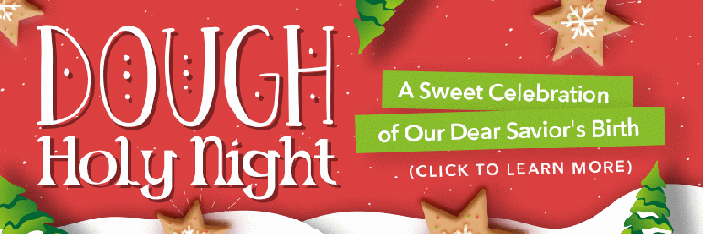

逆境塑造人的品格：大衛童年給我們的啟發
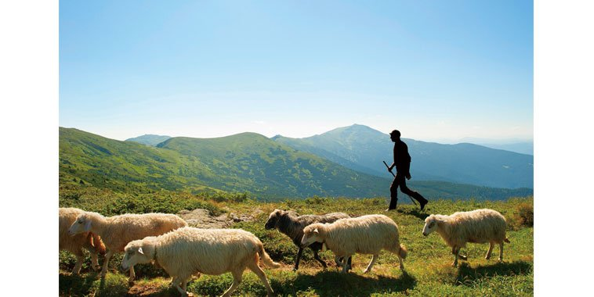

熱門新聞 靈修
記者/作者: 論壇報副刊 日期: 2018-08-20

FacebookLineTwitterWeChat
Email
◎陳坤田（浸信會大村教會傳道）
我們所了解聖經中的大衛王，小時候是一個牧童，至於他為何去牧羊，聖經並沒有清楚說明。有的人說大衛去牧羊，是因為他在兄弟的排行是最小的，但在一個猶太家中，排行最小的並不一定最不重要，因為創世記中的約瑟，在家中幾乎也是最小的，可是雅各卻最疼愛他。因此，最小而最不重要的說法，似乎並不那麼明確。
此外，我們都知道大衛有美好的屬靈生命，詩篇超過半數是大衛寫的。而大衛是如何認識上帝的？為何他有美好的靈性，能夠寫出這麼多詩篇讓後世的人吟誦？
從猶太人聯姻傳統說起
筆者做了一點研究，發現還有一種傳統的猶太說法。大衛的父親耶西是一位恪守道德標準的人，在當時也是有名的猶太公會（Sanhedrin）領袖。
他與妻子尼徹微（Nitzevet）結婚多年、並生了幾個孩子以後，發現若根據傳統，猶太女子不能嫁給外邦人（外邦女子則可以嫁給猶太男子），所以他是沒有資格娶尼徹微的；因為尼徹微是猶太人，而耶西因為祖母的緣故，有摩押人的血統。「撒門從喇合氏生波阿斯，波阿斯從路得氏生俄備得，俄備得生耶西，耶西生大衛王。」（馬太福音六章5-6節）
耶西身為公會領袖，他覺得他有道德義務來糾正這個情況，所以他與尼徹微分居。耶西有一個女傭，是迦南人，在血統上具有與耶西發展關係的資格。因此，耶西打算娶她，她也爽快答應了。但這位女傭心腸柔軟，同情尼徹微的遭遇，於是仿效利亞與拉結的故事，在預定與耶西同寢的夜晚，讓尼徹微與耶西同房。
很可能因為耶西喝醉了，就像雅各取拉結時喝醉一樣，這個計劃成功了，尼徹微也因而再度懷孕。但是為了避免使耶西難堪，尼徹微未將懷孕的事告訴耶西。
大衛遭親人疏遠
當耶西與其他家人發現尼徹微懷孕時，認為尼徹微通姦，打算用石頭將她打死。但是因為耶西愛尼徹微，讓她把孩子生下來，這孩子就是大衛。
我們不難想像，在成長的過程中，大衛在家中所受到的不平待遇：家人不許他同桌吃飯、讓他去牧羊、希望野狼或獅子把他撕裂……。他也成為鄰人揶揄的對象，在他的餐盤放膽汁，在他的杯中放醋；如果掉了羊隻，就說是大衛偷的。
詩篇六十九篇可以看出大衛的苦情：「無故恨我的人比我的頭髮還多；無理敵對我、想除滅我的人多麼強大。他們要我交出我沒有搶奪的東西。」、「我的親人跟我疏遠；我家裏的人把我當作陌生人。」
敬虔母親教導大衛認識神
筆者認為，尼徹微與耶西分居之後，很可能把注意力全放在大衛這個孩子的身上，也教導大衛摩西五經，這很可能是大衛從小就認識上帝的原因。
有段經文可以說明：「求你顧念我，憐憫我；求你賜力量給我，拯救我，因為我像我母親那樣侍奉你。」（詩篇八十六篇16節；現代中文修訂版）這節經文透漏了，大衛的母親尼徹微認識且追求上帝。
另外，從大衛的自述，我們也可以得知他對上帝的認識。在自願去和巨人歌利亞作戰之前，「大衛對掃羅說：『你僕人為父親放羊，有時來了獅子，有時來了熊，從群中啣一隻羊羔去。我就追趕牠，擊打牠，將羊羔從牠口中救出來。牠起來要害我，我就揪著牠的鬍子，將牠打死。你僕人曾打死獅子和熊，這未受割禮的非利士人向永生上帝的軍隊罵陣，也必像獅子和熊一般。』大衛又說：『耶和華救我脫離獅子和熊的爪，也必救我脫離這非利士人的手。』掃羅對大衛說：『你可以去吧！耶和華必與你同在。』」（撒母耳記上十七章34-37節）
神在逆境中塑造我們
大衛的童年給我們什麼啟發？首先我們可以知道，不論我們身處在怎樣的景況之中，上帝都可以塑造我們成為可用的器皿。創世記中的約瑟是如此，大衛也是如此。大衛童年時在曠野牧羊，看似卑微，但是神藉此調教他，讓他在曠野中有很多時間禱告，和神建立關係，而成為合神心意的人。此外，他在曠野中學會使用彈弓，成為一個神射手，這使得他能打敗歌利亞；也因為在曠野，大衛有時間玩奏樂器，得在掃羅的宮中服事掃羅，學習治理國家的事，為將來作王打下基礎。
第二，逆境會將人的潛能逼出來。大衛不被家人接納，在曠野牧羊，面對掠食動物的威脅，險象環生。但這逆境卻鍛煉出一個不畏危險，勇敢保護羊群的牧羊人，使大衛獲得詩篇廿三篇的靈感，不但如此，大衛後來成了以色列家的王。
第三，在棒球場上，投手有時會因為被安打而亂了投球的節奏。這時，投手的教練會走上投手丘，來安撫投手。我們的生命也是一樣，當狀況發生時，我們需要一位生命的教練來安撫我們，這生命的教練就是上帝。神是我們的安慰者、保惠師，投靠祂的人必得著幫助。
FacebookLineTwitterWeChat
文章來源：基督教論壇報 https://www.ct.org.tw/1328438#ixzz6dhUYpkWq

第二章 大衛為王合神意 第一節 神揀選受膏為王
- Last Updated: 02 August 2015
- Hits: 4265

第二章 大衛為王合神意

第一節 神揀選受膏為王
I. 神揀大衛(撒上16:1-13):
神厭棄掃羅, 隨即命撒母耳往伯利恆耶西家揀新王, 耶和華預定在他眾子內, 擇一作王, 撒母耳
奉命, 不敢明目張膽前往, 因恐遭掃羅殺害, 耶和華乃面授玄機, 要他牽牛犢去, 假向耶和華獻祭之名,
邀耶西吃祭肉, 再面示機宜. 撒母耳依計往伯利恆, 在眾長老恭迎下, 將牛犢向耶和華獻祭, 並邀耶西
及眾子自潔後吃祭肉, 入席前耶西命七子逐一從撒母耳面前經過, 都不是耶和華要揀選的, 最後耶西
才説還有一幼子在牧羊, 撒母耳命耶西速召該子前來, 否則不入席. 此子一來, 果然與眾不同, "面目光
紅, 雙目清秀, 容貌俊美," 耶和華甚悅, 當即命撒母耳在他七兄長面前以油膏他, 大衛雀屏中選, 成為
新王人選, "從這日起, 耶和華的靈就大大感動大衛."
從神揀選大衛到與神立约, 可以看出這與神的救贖及神對列祖應許, 都有密關係. 神曾應許亞伯拉罕,
要從他的後裔中興起君王, 接着在雅各對眾子的祝福中, 神预言君王要由猶大支派而出. 這預言的初步
應驗就在大衛身上; 但其完全應驗超過大衛時代, 直指將來的那位彌赛亞, 彌赛亞意即 "受膏者." 到那日,
天上地下一切權柄都屬那彌赛亞, 就是我們的救主耶穌基督. 雖然, 神第一次揀選的王是掃羅, 但他是
便雅憫人, 與預言不符, 結果還是由屬猶大支派的大衛取代, 方合神意.
II. 童年大衛:
在耶西八子中, 大衛最幼, 並非父之至愛, 小小年纪就讓他曠野牧羊. 撒母耳奉神命赴耶西家揀
新王時, 耶西只讓七子出現, 幼子大衛排除在外, 神慧眼識人, 逼出大衛, 終於中選受膏, 取代掃羅為王.
大衛曠野牧羊, 艱辛危險, 而他毫無怨言, 甘之若飴, 在荒涼冷寂的曠野中, 四顧無人, 惡獸出沒, 如此
險惡環境, 非但沒把他打倒, 反而讓他有機會接近大自然, 與神親近交往, 得到裝備造就, 真是 "萬事
相互效力, 叫愛神的人得益處."(羅8:28). 大衛自已曾說過他童年牧羊事, "有時來了獅子, 有時來了熊,
從群中啣一隻羊羔去. 我就追趕他, 擊打他, 將羊羔從他口中救出來, 他起來要害我, 我就揪著他的鬍子,
將他打死, 我曾打死獅子和熊."(撒上17:34-36). 可見神早在大衛幼年牧羊時, 在曠野中把他磨鍊成
以色列的大能勇士.
III. 掃羅恩怨:
神雖厭棄掃羅, 改揀大衛接替, 但掃羅一無所知, 只命撒母耳暗中私膏, 並未立即廢掃羅, 讓大衛
正式登基為王, 反而讓大衛追隨掃羅, 建立戰功, 培養聲望, 厚植根基, 直至掃羅戰死基利波山, 才順神
命, 登基為王.
(I) 大衛驅魔(撒上16:14-23):
耶和華厭棄掃羅, 靈隨即離開他, 於是惡魔從耶和華那裏來擾亂他, 掃羅不勝其苦, 臣下建
議找一琴手, 為他彈琴驅魔, 終於找到耶西一子, 善於彈琴, 且係大能勇士, 談吐得宜, 容貌俊美, 尤有
甚者, 耶和華與他同在, 此子就是大衛. 一經引荐王前, 掃羅大悅, 甚是喜愛, 立即任命為御前侍衛, 隨
侍左右, 惡魔來襲, 大衛立即彈琴驅魔, 惡魔驚遁, 掃羅舒暢爽快萬分, 大衛益得君心, 寵信有加.
(II) 誅歌利亞(撒上17:1-54):
歌利亞乃非利士巨人悍將, "身高六胕零一虎口, 頭戴銅盔, 身穿鎧甲, 甲重五千舍客勒, 腿
上有銅護膝, 兩肩之中背負銅戟, 槍桿粗如織布的機軸, 鐵槍頭重六百舍客勒." 真是威風凜凜, 氣勢凌
人, 可怕可畏.
大衛隨侍掃羅不久, 非利士大軍來犯, 掃羅率大軍親征, 兩軍分別於二個山頭紮營佈陣, 隔
谷對峙, 情勢緊張, 大戰一觸即發. 非軍士氣高昂, 首派巨人歌利亞在一盾兵前導下, 向以軍挑戰, 矛
頭直指掃羅, 要他速派一人與他對決, 若能勝他, 把他殺死, 非利士人當立即降服為僕, 供以色列人役
使; 反之, 若來將敗陣, 被他誅殺, 以色列人也要投降為僕, 服事非利士人. 掃羅及諸將見巨人如凶神
惡煞, 趾高氣揚, 破口罵陣, 莫不驚惶失措, 極其害怕, 不敢出陣迎戰. 非軍卻緊咬不放, 步步進逼, 一
連四十日, 早晚出來叫罵, 極盡侮辱能事.
那時, 大衛雖任掃羅御前侍衛, 仍在牧羊, 一日奉父命送麥餅給隨軍出征三位兄長, 及送奶
餅給千夫長, 大衛在長兄陣中, 見歌利亞囂張狂妄, 肆意謾罵, 不堪入耳, 而以軍龜縮怯戰, 不敢迎敵,
大衛認係奇恥大辱, 激動高喊: "這未受割禮的非利士人是誰呢? 竟敢向永生神的軍隊罵陣麼!" 其兄聞
言, 立加斥責, 命他速回家牧羊, 少發狂言. 但大衛雄言壯語傳入掃羅耳中, 認此子壯志可嘉, 立即召見
讚許, 因他年幼, 不宜上陣犧牲. 大衛王前請纓, 謂自幼為父牧羊, 耶和華與他同在, 赤手與獅熊博鬥,
救羊羔於獸口, 雙拳打死獅熊, 毫不費力; 這未受割禮的非利士人, 狂妄無禮, 竟敢向永生神的軍隊罵
陣, 耶和華必助我擊殺此狂徒如獅熊. 掃羅甚覺有理, 有耶和華同在, 何懼強敵不敗, 乃欣然下旨, 命
大衛出戰, 原擬將自己的盔甲賜他, 因穿著不慣婉謝, 只手中拿杖及甩石機弦, 並在溪中檢石五塊放袋
中, 就此上陣. 巨人見以軍竟派黃毛小子迎戰, 不住冷笑, 不把大衛放在眼裏, 指著自己的神咒詛他, 要
將他的肉餵空中飛烏, 田野走獸; 大衛立即反擊, 大聲告訴當前強敵, 你靠刀槍銅戟攻擊我, 我是靠萬
軍之耶和華的名, 今日我的神必將你交在我手中, 我必殺你, 斬你的頭, 並將你們的軍兵的屍首餵空中
飛鳥及地上野獸, 好讓天下的人都知道, 耶和華使人得勝, 不是用刀用槍, 因爭戰勝敗, 全在耶和華, 衪
必將你們交在我們手裏, 你死定了! 巨人聞言, 怒不可遏, 全力向大衛猛撲, 大衛不慌不忙, 從袋中掏出
一石, 用機弦甩出, 正中歌利亞的頭, 石子穿進額內, 巨人應聲仆地, 大衛從容拔刀, 把他殺死, 割下頭
顱, 這凶惡巨人, 竟敗在童子手下, 大出非軍意外, 頓時陣腳大亂, 倉惶逃命, 潰不成軍, 以軍趁勝追擊,
大獲全勝, 大衛一舉成名, 頓時成為以色列討神喜悅, 全民敬仰的大英雄, 也是日後一代英君大衛王.
(III) 功高震主(撒上17:55-18:9):
大衛誅歌利亞, 提頭奏凱回營, 元帥押尼珥引謁掃羅, 君心大悅, 立封大衛為戰士長, 臣僕
誠服, 百姓歡欣. 大衛誅殺巨人, 擊潰來敵, 捷報傳來, 舉國歡騰, 全國婦女湧入京城, 歡歡喜喜, 打鼓
擊磬, 歌唱跳舞, 迎接掃羅班師回朝, 一瞻大衛英姿丰采, 婦女舞蹈高唱:"掃羅殺死千千,大衛殺死萬萬."
掃羅聞歌, 怒不可遏, 大聲喝道: "將萬萬歸大衛, 千千歸我, 只剩下王位沒有給他了!" 從這日起, 大衛
功高震主, 掃羅恨惡痛絕, 對他逼害追殺, 無所不用其極. 悲哉掃羅! 毫無自知之明, 神早厭棄他, 已膏
新王大衛, 逼迫大衛, 無異與神為敵, 怎不落得悲慘下場!
(IV) 東床駙馬(撒上18:17-30, 19:8-17):
大衛初建奇功, 侍立王前, 頗得掃羅器重青睞, 要將長女米拉下嫁大衛, 並勉勵他 "只要你為
我奮勇, 為耶和華爭戰." 但心中暗忖, "我不好親手害他, 要藉非利士人的手害他." 大衛謙稱出身微寒,
不敢高攀, 豈料米拉原定嫁大衛之日, 掃羅竟將米拉改嫁米何拉人亞得列; 幸其次女米甲愛大衛, 掃羅
甚悦, 心想將米甲嫁大衛, 好作他的網羅, 藉非利士人的手害他. 乃對大衛說, "你今日可以第二次作我
的女婿." 惟掃羅要臣僕告大衛, 要娶米甲 "王不要甚麼聘禮, 只要一百非利士人的陽皮, 好在王的仇敵
身上報仇." 其實掃羅是要借刀殺人, 讓大衛死在非利士人手裏, 狠毒至極. 大衛不知有詐, 闻言甚喜,
立率部屬深入敵營, 殺了二百非利士人, 滿數將陽皮獻給掃羅, 為要作王駙馬, 掃羅祗好將米甲嫁大衛.
婚後, 掃羅見米甲深愛大衛, 且耶和華與大衛同在, 心中更是害怕, 益發要殺大衛.
大衛米甲婚後, 出乎掃羅意外, 恩愛甜美, 如膠似漆. 大衛常率軍與非利士人交戰, 每戰必
勝, 使非利士人聞風喪膽. 有次, 惡魔又降掃羅身上, 急召大衛驅魔, 掃羅持槍坐屋內, 當大衛彈琴為他
驅魔, 不料掃羅竟用槍向大衛猛刺, 大衛機敏躲過, 槍深深刺入牆中, 大驚外逃, 回家避難, 掃羅不放過,
派兵把駙馬府團團圍住, 待天明時再殺他. 米甲心急要夫速逃, 今晚不走, 明日必死, 急中生智, 將愛夫
從窗口縋下, 讓他逃命; 為免父王究責, 米甲把家中神像放床上, 頭枕山羊毛枕, 身蓋錦被; 翌晨, 掃羅
派兵入府捉拿大衛, 米甲佯稱大衛病了, 掃羅不信, 下令連床抬出殺他, 使者進入發現真相, 掃羅大怒,
嚴責米甲, 為何欺哄老父, 放走仇敵, 後患無窮, 米甲答得好, "我不放他, 他要殺我." 奈何! 掃羅不仁,
於大衛逃亡期間, 竟逼米甲改嫁迦琳人拉億之子帕提為妻(撒上25:44).
[註] 掃羅二女Merab和Michal,經文譯作米拉與米甲,庸俗無女人味,若改譯美拉和美佳,較雅艷像公主名.
(V) 惺惜至交(撒上19:1-20:42):
説來弔詭, 大衛功高震主, 與掃羅交惡, 但與其子約拿單, 則一見如故, 惺惺相惜成莫逆,
經文描述得好, "約拿單的心, 與大衛的心, 深相契合, 約拿單愛大衛, 如同愛自己的性命, 就與他結盟.
約拿單從身上脫下外袍, 給了大衛, 又將戰衣 刀弓 腰帶 都給了他." 二人相知相惜, 推心置腹, 共同經
歷事蹟如下:
1. 化仇解恨(撒上19:1-7):
有次, 掃羅對約拿單和眾臣僕宣示, 要殺大衛, 約拿單急忙要大衛明晨躲一僻靜田間, 他將
帶父王至該處, 為他説好話. 約拿單直稟父王, "王不可得罪王的僕人大衛, 因為他未曾得罪你, 他所行
的, 都與你大有益處. 他拼命殺那非利士人, 耶和華為以色列人大行拯救, 那時你看見, 甚是歡喜, 現在
為何無故要殺大衛, 流無辜人的血, 自己取罪呢?" 掃羅聽愛子勸諫, 至為感動, 誓不殺他, 約拿單喜告
大衛, 並領他進謁父王, 掃羅前嫌盡釋, 仍飭大衛侍立王前.
2. 生死結盟(撒上19:18-20:42):
大衛侍立王前, 非利士來犯, 大衛迎戰, 大獲全勝; 惡魔襲掃羅, 大衛為他彈琴驅魔, 儘管
如此, 仍不見宥於掃羅, 逼使大衛走避拉瑪, 投奔撒母耳, 掃羅聞訉追來, 再從拉瑪的拿約, 逃住約拿單
處, 向他投訴, 不知何故, 被其父苦苦追殺; 約拿單亦苦思再三, 父王何以對他獨瞞此事, 乃允大衛代為
說項解圍. 大衛又告約拿單, 明日初一, 要與王共席, 請讓他藏身田野直至第三日晚上, 王若問起, 就說
回伯利恆老家獻祭去了, 王若説好, 平安無事; 王若發怒, 就知他決意要害我. 大衛求約拿單, 二人既是
知交, 看在耶和華份上, 與其交你父殺我, 不如你把我殺了罷. 約拿單答曰, 斷無此事, 他若知父王決意
要害他, 定會早早要他走避. 大衛聞言至慰, 轉問若你父厲言回答, 誰來通知我?
於是約拿單與大衛相偕至田野, 約拿單在耶和華面前向大衛保證, 無論其父是喜是怒,
都會設法通知大衛, 保他平安, 二人肝膽相照, 乃在神前結盟, 永遠友好. 約拿單隨即對大衛說, 明日
初一, 與王共席, 你的座位空著, 人自以為你不在, 你要等三日, 趕緊到你以前藏身的田野, 在以色磬
石靜候, 我將以石為靶發射三箭, 並命童子檢箭, 若我說箭在石後, 你可回來, 保證平安無事; 若我說
箭在石前, 你就趕快逃跑, 這是神意.
大衛依約藏身田野, 到了初一, 王照常入席, 坐靠牆位上, 約拿單侍立, 押尼珥坐王身旁,
大衛之位空著, 這日掃羅沒説話, 以為大衛偶染不潔缺席; 初二日座位仍空, 掃羅按耐不住, 問約拿單
耶西之子為何昨日今日沒來吃飯? 約拿單回答說, 大衛懇求我讓他回伯利恆老家獻祭, 我允他還鄉,
故沒來吃飯. 掃羅聞言大怒, 痛責約拿單, "耶西的兒子若在世間活著, 你和你的國位必站立不住, 現在
你要打發人去, 將他捉拿交給我, 他是該死的." 約拿單反問, "他為甚麼該死, 他作了甚麼!" 掃羅怒極,
拿槍要刺他, 約拿單見狀, 趕忙閃躲, 知父王殺大衛之意已決, 難以改變.
次日清晨, 約拿單依约攜童子前往大衛藏身的田野, 箭射石前, 高聲叫童子往石前撿箭,
童子不知何意, 只有約拿單和大衛心知, 箭一撿回, 立即遣童子攜箭回城. 童子一走, 大衛從石後出來,
俯伏三拜, 二人親嘴, 擁抱哭泣, 大衛哭得更是傷心. 約拿單對大衛說, 我倆曾在耶和華面前起誓結盟,
"願耶和華在你我中間, 並你我後裔中間為證, 直到永遠." 約拿單祝福大衛, 要他平平安安走罷, 臨別
依依, 互道珍重, 後會有期.
(VI) 狠心追殺(撒上21:1-):
大衛誅巨人, 克強敵, 屢建奇功, 聲譽日隆, 全民愛載, 功高震主, 不見容於掃羅, 視為眼中釘,
用盡心機, 狠心追殺, 必除之而後快. 除上述無情追殺, 米甲 約拿單兄妹義薄雲天, 違父命放走大衛外,
其後追殺歷程, 分述如下:
1. 挪伯取刀(撒上21:1-9):
大衛泣別約拿單後, 投奔挪伯祭司亞希米勒. 挪伯位於耶路撒冷東北, 基比亞以南一小城,
示羅被毀後, 會幕所在地(撒上4:2-3; 耶7:12), 大衛來此似係想藉大祭司以弗得上的烏陵和土明胸牌
尋求耶和華引領前路避禍(撒上2:28; 出28:30). 亞希米勒戰兢恭迎,開頭就問,何以未帶隨從,獨自前來?
大衛不敢據實相告, 佯稱奉王命辦事, 保密不得張揚, 已派少年在他處候我, 大衛向祭司要五餅及食物.
祭司面有難色, 因無尋常餅, 只有聖餅, 少年未近婦人者, 方可食用. 大衛坦言, 眾人三日未近女色, 絕
對潔淨, 祭司乃更換新餅, 在耶和華靣前撒下陳設餅給他. 當日掃羅的鷹犬司牧長以東人多益也在那裏.
大衛對亞希米勒說, 此次奉命, 匆忙離京, 來不及攜械隨身, 有無刀槍可借？ 祭司説, 你以前在以拉谷
殺非利士人歌利亞那把刀, 現包在布中, 放在以弗得後邊, 你可拿去, 除此以外, 沒有別的. 大衛喜極,
這刀無可比, 取刀後立即離去, 免生枝節.
2. 王前裝瘋(撒上21:10-15):
離挪伯後, 大衛逃到非利士人五大城之一的迦特, 一進城就被捕帶迦特王亞吉前, 臣下
指認, "這不是以色列國王大衛麼? 那裏的婦女跳舞唱和, 不是指著他說, 掃羅殺死千千, 大衛殺死萬萬
麼?" 大衛見被識破, 心中恐懼, 就在眾人面前, 一改常態裝聾作啞; 在王手下, 舉動乖張瘋瘋癲癲. 故意
在城門上胡亂塗鴉, 並讓口水流滿鬍鬚, 狀至邋遢狼狽. 亞吉不悅, 斥臣下曰, 此人是瘋子, 為何帶來見
我? 難道我這裏瘋子還少嗎? 要他在我靣前瘋癲麼? 快把他趕走, 這瘋子豈可進我家! 於是大衛被無情
驅離迦特, 哀哉大衛, 竟淪落到裝瘋保命!
詩篇第34, 56 二篇正道出他的傷痛, 不妨一讀.
3. 洞中落難(撒上22:1-5):
大衛迦特裝瘋保命, 驚魂甫定, 拔腳逃往迦特東南一小城亞杜蘭, 藏身山洞, 其父耶西及
七兄全家, 為免掃羅逼害, 聞訉趕來相聚. 大衛雖落難, 惟其英名遠播, 凡失意的 欠債的 不滿現狀的都
紛紛前來投靠, 建立山寨, 擁他為王, 聲勢日壯, 追隨者達四百之眾.
為安置父兄, 大衛特往米斯巴謁摩押王, 求王收容他的父兄, 讓他安心, 靜候神的引領,
王慨允所請, 於是 "大衛住山寨多少日子, 他的父母也住摩押王那裏多少日子."
投奔大衛四百人中, 人才濟濟, 不少精英, 那時大衛正在等待繼承以色列王位. 首先先知
迦得加入陣營, 不久祭司亞比亞他, 在父亞希米勒遭掃羅爪牙多益殺害後, 也來投奔, 這些精英都是日
後大衛登基王朝骨幹, 他們多是掃羅逼走的流亡人土. 大衛摩押歸來, 先知迦得就勸他, 不要呆在山寨,
要往猶大地去, 大衛納諫, 立即往猶大支派境內哈列森林去.
大衛逃亡洞中, 曾作詩篇第 57, 142 二篇, 不妨一讀.
4. 怒斬祭司(撒上22:6-23):
掃羅追殺大衛來到基比亞的拉瑪, 一日, 持槍坐柳蔭下, 想起大衛背叛他, 糾眾與他為敵,
心中惱怒, 向隨侍便雅憫臣僕, 大發牢騷, 斥責他們, "便雅憫人哪! 你們結黨害我, 我兒約拿單與大衛
結盟, 無人向我稟奏; 挑撥臣子謀害我, 也無人揭發, 令我寢食難安. 你們這樣做, 難道大衛會讓你們升
官發財嗎?" 那時, 以東人多益正好在臣僕中, 於是將前在挪伯親眼看到大衛投奔祭司亞希米勒, 得餅
充飢, 並將殺非利士人歌利亞那把寶刀交給大衛一事, 稟奏掃羅. 掃羅大怒, 立即遣使前往挪伯, 急召
祭司亞希米勒全家來拉瑪朝見, 掃羅當面質問亞希米勒, "為何與大衛結黨害我? 給他食物寶刀, 又為
他求問神, 使他起來反我!" 亞希米勒忠心直諫, "王的臣僕中有誰比大衛忠心呢? 他是王的愛婿, 又是
王的侍衛, 在王的家中貴為駙馬. 我豈是今日才為他求問神呢? 斷然不是, 王不要將罪歸我和我父全
家, 大衛叛逃事, 我毫無所悉!" 掃羅對其直諫, 不為所動, 立即令多益誅殺祭司. 多益奉命, 大開殺戒,
共誅穿細麻布以弗得者八十五人, 並殺盡祭司城挪伯中的男女 孩童 嬰兒和牛羊牲畜, 慘絕人寰!
百密一疏, 祭司亞希米勒之子亞比亞他, 在多益大屠殺中, 竟能在血泊中安然逃出, 直奔
大衛, 立得大衛安置撫慰曰, "那日, 見多益在那裏, 知他必告掃羅, 你父全家喪命, 都因我而起, 你可在
我處安居, 不必懼怕, 因尋索你命就是尋索我命, 你在我處, 安全無虞."
以東人多益向掃羅告密一節, 大衛耿耿於心, 曾作詩篇第52篇抒懐, 不妨一讀.
5. 曠野追殺(撒上23:1-29):
一日, 大衛在猶大得報, 非利士攻打基伊拉, 搶掠禾場. 大衛信靠神, 凡事求問神, 這次
也不例外, 立即求問耶和華, 可否出兵馳救? 耶和華馬上回應, 可出兵攻打非利士, 拯救基伊拉. 此時,
部屬存疑, 謂在猶大尚且懼敵, 何況出兵基伊拉挑戰非利士呢? 大衛再求問, 耶和華指示他大膽出師,
必將非利士人交他手中. 大衛依示率軍赴基伊拉, 猛攻非利士大營, 果然順利攻破, 擊潰敵軍, 掠其牲
畜, 拯救了基伊拉百姓。
大衛捷報, 瞬即傳入掃羅耳中, 心中暗喜, 大衛進入基伊拉有門有閂城中, 當可甕中捉鱉,
神將他交我手中, 死定了! 於是掃羅立即率兵圍攻基伊拉. 大衛見掃羅兵臨城下, 立請亞比亞他拿
以弗得來求問耶和華, 掃羅會不會攻城? 基伊拉人會不會將他們出買? 耶和華明確告訴大衛, 掃羅
鐵定會攻城, 基伊拉人會出買他們. 大衛聞示色變, 感謝神恩, 立即率六百軍兵突圍, 速離基伊拉返回
大寨, 全身而退, 有驚無險..
此後, 大衛常出沒西弗曠野, 掃羅尾隨不放, 但神就是不把他交給掃羅. 大衛在西弗曠野
林中紥營, 約拿單特來堅固他的信心, "不要懼怕, 我父掃羅的手必不加害於你, 你必作以色列的王, 我
也作你的宰相, 這事我父掃羅知道了," 於是二人再一次在耶和華面前立約後, 約拿單始依依離去.
不久, 西弗人來基比亞見掃羅, 檢舉大衛正藏身西弗曠野南邊哈基拉山中, 請掃羅前住
擒拿, 他們必親自將大衛交給他. 掃羅謝過來人, 要他們特別注意, 大衛狡猾, 詭計多端, 回去查明確實
藏匿地方, 再同去未遲. 西弗人遵示先往西弗, 而大衛及其隨從那時却在瑪雲曠野南方的亞拉巴, 掃羅
據報, 乃趕往瑪雲曠野搜索大衛蹤跡. 掃羅與大衛於是在曠野大捉迷藏, 掃羅在山這邊追, 大衛和隨眾
在山那邊逃, 後大衛發現已被掃羅團團圍住, 萬分危急, 千鈞一髮之際, 掃羅突然得報, 非利士兵犯境
告急, 請王速回師迎敵解危. 掃羅無奈, 長嘆一聲, 祗好暫停追殺大衛, 轉去攻打非利士人. 危機解除,
大衛轉往隱基底大寨, 休養生息. 有關西弗人告密一事, 大衛曾作詩篇第54篇抒懐, 不妨一讀.
6. 不殺掃羅(撒上24:1-22):
掃羅回師擊潰非利士大軍, 奏捷之際, 得報大衛遁隱基底曠野, 立率精兵三千往野羊磬石
進剿, 適路邊羊圈旁有一山洞, 掃羅便急, 摸黑入內大解, 恰好大衛及隨從正匿洞中深處, 隨從提醒
大衛, 耶和華曾應許你, "我要將你的仇敵交在你手裏, 你可以任意待他" 現時機終於到了. 大衛乃偷偷
在暗中接近掃羅, 悄悄把他的外袍衣襟割下, 隨後大衛心中自責, 跟隨從説, "我的主乃耶和華的受膏
者, 我在耶和華面前萬不敢伸手害他, 因他是耶和華的受膏者." 大衛用這話阻止隨從, 不容他們傷害
追殺他的仇敵. 掃羅毫未察覺, 大搖大擺走出洞中, 大衛尾隨出來, 呼叫 "我主, 我王!" 掃羅回頭一看,
只見大衛俯伏下拜, 向他泣訴, "我主為何聽信讒言, 誣我要殺害你呢? 今日你親見在洞中耶和華把你
交我手中, 有人要我殺你, 我卻愛惜你, 不忍殺你, 因你是耶和華的受膏者. 我父啊! 你外袍的衣襟在我
手中, 我只割下你的衣襟, 沒殺你, 由此可見, 我沒惡意背叛你, 也沒得罪你, 而你不斷追殺我, 要我的
命, 願耶和華作你我中人, 明辨是非, 為我申冤. 俗語云, "惡事出於惡人." 我從未親手害過你. 以色列王
出來要找誰呢? 追誰呢? 不過追條死狗, 趕隻跳蚤罷了! 願耶和華主持公道, 斷定是非, 明察善惡, 還我
清白, 救我脫離你手." 掃羅聞言, 一陣心酸, 萬分感動說, "我兒大衛, 這是你說的話麼?" 接著放聲大哭
道, "你比我公義, 以善待我, 我卻以惡待你. 今日你明顯以善待我, 因耶和華將我交你手中, 你卻不殺
我. 一般人遇見仇敵, 豈肯輕易把他放走? 願耶和華因你今日對我所行, 以善報你. 我深知你必作王,
以色列的國必在你手中堅立. 現在我要你指著耶和華向我起誓, 不剪除我的後裔, 在我父家不滅沒我
的名." 言罷大衛立即向掃羅起誓, 二人前嫌盡釋, 一哭泯恩仇, 掃羅率兵回朝, 不再追殺大衛; 大衛也
率眾回大寨, 相安無事, 暫且不表.
7. 再放掃羅(撒上26:1-25):
過些日子, 西弗人來基比亞謁掃羅, 報稱大衛仍藏身曠野前哈基拉山中, 掃羅得報, 再動
殺戒, 即率精兵三千, 直奔西弗曠野, 搜捕大衛. 大衛風聞, 不敢置信, 立差探子出寨探聽, 掃羅果然領
軍來了! 大衛趁月黑風高, 摸入敵營, 發現掃羅睡主帥營中, 眾兵紥營四週守護. 回寨後,率部將亞比篩
黑夜潛入主帥營中, 見掃羅槍插床頭酣睡, 押尼耳與御前侍衛睡他周圍, 可謂守衛極其嚴密. 亞比篩語
大衛, "現神已將你的仇敵交你手中, 求你讓我動手, 一槍就可把他刺死." 大衛答曰, "不可, 誰能殺害
耶和華的受膏者而無罪的? 我指著永生的耶和華起誓, 他若是被耶和華擊打, 或者死期到了, 或是出戰
陣亡, 我在耶和華面前, 斷不敢伸手害耶和華受膏者. 你去把他床頭插槍取來, 我們就走." 言罷, 二人
輕易從掃羅床頭取了插槍和水壺後, 速即離去. 神不知鬼不覺, 因耶和華使他們沉睡不醒.
翌日, 大衛站立山頭, 向掃羅陣營喊話, "押尼耳啊, 快出來答話!" 押尼耳大聲怒答, "何
方狂徒, 竟敢向王叫陣!" 大衛譏曰, "你不是勇士麼? 國中誰能比得上你? 民中有人潛入你營, 要害死
王你的主, 你為何沒有保護王你的主呢? 太差了! 我指著永生的耶和華起誓, 你們都該死, 沒好好保護
你們的主, 就是耶和華的受膏者. 現在你看看, 你們王床頭的槍和水壺在那裏?"
掃羅聽出是大衛的聲音, 就説, "我兒大衛, 這是你的聲音麼?" 大衛説, "我的王啊! 是我
的聲音. 我做了甚麽事? 作了甚麽惡? 我主竟要再來追殺僕人呢? 求主聽我言, 若是耶和華激發你攻擊
我, 願耶和華收納祭物; 若是人激發你, 願他在耶和華面前受咒詛! 現求王不要使我的血流在離耶和華
遠的地方. 以色列王出來找一隻跳蚤, 如同人入山獵一個鷓鴣, 一樣可笑." 掃羅聞言愧疚萬分説, "我 有罪了, 我兒大衛, 因你今日看我的性命寶貴, 我必不再加害你, 我真是糊塗人, 大大錯了."
大衛聞言甚慰, 語王曰, "王的槍在此, 請派人過來取回, 今日耶和華將你交在我手裏, 我
卻不伸手害耶和華的受膏者, 耶和華必照各人的公義誠實報應他. 我今日重看你的性命, 願耶和華也 重看我的性命, 並拯救我脫離一切患難."
最後, 掃羅對大衛說, "我兒大衛, 願你得福, 你必作大事, 也必得勝." 掃羅與大衛再度捐
棄前嫌, 他解仇恨, 重歸舊好.
IV. 娶拿八妻(撒上25:1-44):
看標題有點難以置信, 大衛怎會娶人妻! 這段奇特姻缘, 又是一則有趣故事, 細說如下:
(I) 撒母耳逝(撒上25:1):
話説, 掃羅收手, 不再追殺大衛, 不久, 撒母耳逝世, 舉國哀痛,下葬拉瑪安息.
(II) 拿八恩怨(撒上25:2-13):
撒母耳安葬拉瑪後, 大衛起身往巴蘭曠野. 有個瑪雲人在迦密發達致富, 家有綿羊三千, 山羊
一千, 名叫拿八, 為人剛愎兇惡; 其妻亞比該則聰穎秀麗, 是個美人, 討人喜歡.
大衛到了巴蘭曠野, 聽説拿八在剪羊毛, 乃遣十僕上迦密見拿八, 以他的名向拿八問安, "願
你平安! 願你家平安! 願你一切所有的都平安!" 並說, "聽説有人為你剪羊毛, 你的牧人在迦密和我們
在一起時, 我們沒欺負他們, 且晝夜盡力保護他們, 這點他們定可證實, 願我僕在你眼前蒙恩, 因是在
好日子來見你的, 求你取點肉食賜給我僕和你兒大衛." 諸僕遵命前往, 依示面陳拿八, 拿八聞言,
毫不客氣, 對來僕說, "大衛是誰? 近來逃僕甚多, 我怎能把飲食和宰肉, 隨便送给來路不明的人呢?"
十僕碰了釘子, 滿肚怨氣, 當即轉身從原路回去, 照實稟告主子, 大衛聞言不悅, 立即指示屬下帶刀, 他
自己也帶刀, 率領四百人, 二百人留守, 直馳迦密找拿八算帳.
(III) 智解殺禍(撒上25:14-35):
拿八一僕見主人開罪大衛, 大勢不妙, 急忙稟告主母亞比該, 將大衛遣僕代表他向主人請安,
因二家一向和好, 乃向主人要點肉食, 主人毫不給情面, 惡言拒絕, 得罪大衛, 急請主母及早籌劃, 好好
化解, 不然我主和他全家, 定必大禍臨頭, 主人暴戾, 沒人敢向他進言, 特請主母速設法祛禍消災.
亞比該得報色變, 急忙備好二百餅 二袋酒 五隻宰好的羊 五細亞烘好穗麥 一百葡萄餅 二
百無花果餅, 馱在驢上, 要僕人前行, 他自己隨後, 這事暗中進行, 瞞著拿八, 不敢稟告.
亞比該騎驢, 正下山坡, 見大衛一行迎面而來, 趕忙下驢迎接, 大衛説過, "我在曠野為他看
守一切, 使他一樣不失, 實是徒然, 他對我以惡報善, 凡屬拿八男丁, 我若留一個到天明, 願神重重罰我."
亞比該俯伏大衛腳前説, "我主啊! 願這罪歸我, 求容婢女進言, 更求你聽婢女訴說, 不要理這壞人拿八
(愚頑), 他人如其名, 果然愚蠢頑固, 但你派來傳話僕人, 我未見到, 故我一無所知. 我主啊! 耶和華既然
阻止你報仇, 取流血的罪, 我現指著耶和華向你起誓, 願你的仇敵和謀害你的, 都像拿八一樣. 現請將
婢女送來禮物交給你的僕人, 求你饒恕我的罪過, 耶和華必為我主建立堅固的家, 因我主為耶和華爭
戰, 且在你有生之年查不出任何過犯. 雖有人追逼你, 要你的命, 耶和華却保護你的命, 像包裹的寶器;
你仇敵的性命, 耶和華必如機弦甩石拋去. 我主現若不親手報仇, 流無辜人的血, 到了耶和華照應許,
賜福與你, 立你作以色列王, 那時, 我主必不致心裏不安, 覺得良心有虧. 耶和華賜福我主時, 請毋忘我."
大衛對亞比該說, "耶和華以色列的神是應當稱頌的, 因為他們今日使你來迎接我. 你和你的
見識也當稱讚, 因為你今日攔阻我親手報仇, 流人的血. 我現在指著阻止我加害於你的耶和華永生神
起誓, 若非你速速來迎接我, 明日早晨, 凡屬拿八男丁, 定必一個不留." 大衛接受亞比該送來禮物後對
她說, "我接受妳的解釋, 看在妳的情面, 妳可以平平安安回家了."
(IV) 神懲拿八(撒上25:34-39a):
亞比該平安回到家中, 見拿八在家, 大擺王宴, 個人獨樂, 喝得酩酊大醉. 亞比該一言不發,
對見大衛事, 隻字不提. 翌晨, 拿八酒醒, 其妻將出迎大衛, 阻止殺機, 前後經過, 詳告夫君, 拿八聞言,
嚇得魂不附體, 身僵如石, 十天後, 耶和華擊打拿八, 立即死亡. 大衛得報拿八身亡, 就說, "應當稱頌
耶和華, 因他為我伸了拿八羞辱我的冤, 又阻止了我行惡, 也使拿八的惡歸到拿八頭上."
(V) 迎娶美人(撒上25:39b-44):
拿八暴斃, 亞比該新寡, 大衛見亞比該慧美賢淑, 不覺動了憐香惜玉之心, 乃遣僕赴迦密見
亞比該提親, 開門見山就說, "我主要我們來見妳, 是想要娶妳為妻," 亞比該立即俯伏在地説, "我情願
作婢女, 洗我主僕人的腳." 説罷隨即帶了五個使女, 騎上毛驢, 隨大衛使者去了. 亞比該愛慕大衛之情,
不言可喻, 美人愛英雄, 大衛多情, 順利抱得美人歸, 一時傳為佳話.
綜觀大衛婚姻, 初作駙馬, 娶掃羅次女米甲為妻, 後與王失和, 追殺期間, 掃羅怒逼米甲改嫁,
結束婚姻; 應是在山寨落草, 逃亡期間, 大衛娶耶列斯人亞希暖為妻; 故亞比該應是大衛有名份的第三位
紅粉知己.
[註] Ahinoam及Abigail經文分別譯作亞希暖及亞比該, 沒女人味, 那像大衛嬌妻芳名, 似應改譯雅熙暖 及雅碧姬, 較為雅艷.
米甲( Michal) 前已建識改譯美佳.
V. 投非利士(撒上27, 29, 30章):
(I) 外逃避禍(撒上27:1):
大衛為避掃羅追殺, 開始逃亡, 挪伯取刀後, 直奔非利士迦特, 不料被人認出, 情急智生, 乃
在王前裝瘋保命, 前已談及. 逃亡期間, 大衛不斷思量, "逃亡非上策, 總有一天死在掃羅手下, 不如逃
奔非利士世仇, 掃羅見我不在以色列境内, 對他沒有威脅, 才會死心, 不再追殺, 方能逃出他的魔掌."
(II) 投奔亞吉(撒上27:2-12, 29:1-30:31):
1. 合家投奔(撒上27:2-4):
大衛決意投非利士後, 立即採取行動, 帶了手下六百人, 連同亞希暖及亞比該二嬌妻, 並
手下各人眷屬, 浩浩蕩蕩, 投奔非利士迦特王亞吉, 蒙王接納安頓. 果然, 掃羅得悉大衛逃往迦特, 就不
再追殺大衛.
2. 賜洗革拉(撒上27:5-7, 28:1-2):
大衛投靠迦特王亞吉時, 非利士人正整軍經武, 欲與以色列人一決雌雄. 亞吉面諭大衛,
"你當心有準備, 你和你的手下, 都要隨我出戰." 大衛答曰, "我等絕對効忠, 請王放心." 亞吉聞言至慰,
立即封大衛為王前永遠護衛長.
大衛為擁有自己地盤, 與亞吉王保持距離, 免招忌惹禍, 婉言向王要求, "我若在你眼前蒙
恩, 求王在京外堿邑中賜我一地安身, 僕人豈敢與王同住京都呢?" 言之有理, 亞吉王當即把洗革拉賜給
大衛. 查洗革拉係猶大南方諸城之一(書15:31), 原屬西緬支派(書19:1-5), 後為非利士人所佔, 經王賜
地後, 洗革拉重屬猶大, 直至今日. 大衛在非利士居住達一年四個月之久.
3. 攻城掠物(撒上27:8-12):
大衛以洗革拉為基地, 率部侵奪基述 基色 亞瑪力三族從書珥直至埃及之地, 擊殺那
地的人, 不分男女, 一個不留; 並且掠奪牛羊駝驢, 衣物用品, 獻給亞吉, 王問, "今日侵奪了那些地方?"
大衛答曰, "侵奪了猶大 那拉篾及基尼三地南方, 無論男女, 格殺不留, 因怕當地留下活口, 説大衛在
非利士之日, 暴虐凶殘, 屠殺平民." 亞吉聞言暗喜, 大衛暴行, 使本族以色列人恨他, 他必永作我的僕
人了.
4. 不容大衛(撒上29:1-11):
不久, 非利士與以色列爭戰再起, 二軍分別在亞弗及耶斯列對陣. 非利士首領各率大軍
依次前進, 大衛率眾跟在亞吉後邊, 非利士首領見狀, 質問亞吉曰, "這些希伯來人在此幹嗎?" 亞吉答
道, "他豈不是以色列王掃羅的臣子大衛麼? 他投降我有些年日, 忠心順服, 沒出過差錯." 非利士首領
不以為然, 責問亞吉曰, "你應令這人速回你安置他之地, 不可讓他與我們一同出戰, 恐怕他在陣前反
成我們的死敵! 他用甚麼跟他的舊主復和呢? 還不是用我們的人頭麼? 從前以色列婦女邊舞邊唱的:
'掃羅殺死千千, 大衛殺死萬萬.' 所指的不就是這個大衛麼?"
亞吉王無奈, 祗好回頭對大衛說, "我指著永生的耶和華起誓, 你為人正直, 隨我軍中出
入, 表現良好. 自從你投奔我至今, 未犯任何過失, 只是眾首領不容你留我軍中, 現在你可領你的隨眾
平安回去, 免得眾首領傷害你." 大衛對王說, "我做了甚麼呢? 自從僕人投靠我主, 直至今日, 你曾查出
我犯過甚麼過錯, 使我不去攻擊主我王的仇敵呢?" 亞吉再安撫他說,"我知道你在我面前表現良好,像神
的使者一樣; 只是我們的首領一致要求 '這人不可同我們出戰.' 因此你和跟隨你的人, 也是本主的僕人,
明晨天一亮就回去吧!" 大衛無可奈何, 祗好遵命按時回洗革拉去, 非利士大軍隨即向耶斯列前進廝殺.
5. 擊亞瑪力(撒上30:1-31):
(1) 城破眷擄(撒上30:1-2):
大衛一行退出非利士大軍, 三日後方抵洗革拉, 祗見城中空無一人, 滿目瘡痍, 慘不
忍睹, 原來亞瑪力人見非利士大軍遠征, 大衛又率眾隨行, 乃趁虛侵奪南地, 攻破洗革拉, 縱火焚城,
擄走城中婦孺, 大小人口, 一個不殺, 隨軍帶走.
(2) 怨言四起(撒上30:3-6):
大衛和隨從見狀大驚, 尤其妻兒被擄, 生死末卜, 不禁悲從中來, 莫不放聲大哭, 哭得
死去活來. 大衛因二妻被擄, 焦急萬分; 眾人因妻兒落入敵手, 惶恐不安, 怨氣發向大衛, 怪他未善盡保護
之責, 還有人想用石頭打死他. 大衛却逆來順受, 信靠耶和華他的神, 益加鎮定堅固.
(3) 靠神營救(撒上30:7-20):
驚魂甫定, 大衛召見祭司亞比亞他, 要他把以弗得拿來, 求問耶和華, "我追趕敵軍,
還追得上嗎?" 耶和華回應説, "你可以追, 必追得上, 都救得回來."
大衛得神指示後, 立即率眾六百, 急行至比梭溪, 二百人體力不濟, 無法續行, 乃留守
比梭溪, 餘四百精壯, 在大衛帶領下, 往前追趕. 不久, 在田野發現一埃及少年, 飢渴倒地, 乃帶大衛前,
給他吃餅喝水, 再加給他一塊無花果餅, 二個葡萄餅, 讓他吃飽喝足, 恢復體力後, 一問之下, 才知他是
亞瑪力人的奴僕, 三日前患病被主人拋棄田野, 三天三夜沒吃沒喝, 幾乎死去. 他目睹亞瑪力軍兵侵奪
基利提和迦勒南方及猶大地, 他更親見洗革拉焚城擄眷慘劇. 大衛於是問他, 願不願意作響導帶他深
入敵營? 埃及少年為報救命之恩, 萬分情願, 但要大衛向他指著神發誓, 事後不殺他, 也不將他交還舊
主, 還他自由之身. 大衛欣然應允, 在那少年引領下, 很快就找到亞瑪力人營地, 因從非利士和猶大地,
掠得財寶甚多, 紥營後狂歡慶功, 吃喝歌舞, 杯盤狼藉, 醉倒滿地. 大衛見狀暗喜, 一聲令下, 四百壯士,
衝入敵營, 大開殺戒, 從黎明殺至翌日黃昏, 除四百騎駱駝少年外, 殺個精光, 沒個逃脫.
後清點戰場, 亞瑪力人擄去財寶, 全都奪回; 大衛救回二個愛妻, 凡亞瑪力人擄去的,
無論老少 兒女 財物, 悉數奪回, 沒有一個失落. 大衛奪來牛羊牲畜, 交人牧管, 趕在原有群畜前面, 聲
稱, "這是大衛的掠物." 大衛信靠神, 凡事求問神, 這次遵神指示, 殺敵奏凱, 營救眷屬也成功, 使他信心
彌堅, 感謝主.
(4) 戰利均分(撒上30:21-31):
大衛奏凱回師, 途經比梭溪, 原體弱未能隨軍出征留守二百人出迎, 大衛向他們問安,
隊中有心地狹小者高嚷, "這些人既未與我們同去殺敵, 所有擄獲戰利品, 他們無份, 祗能把被擄救出
家眷, 讓他們領回," 大衛不以為然, 懇切教訓眾人曰, "弟兄們! 萬萬不可, 耶和華賜給我們的, 不可不
分給他們, 因為祂保佑我軍, 把攻擊我們的敵軍交在我們手裏, 這事誰敢聽你們的? 應依神旨意, 上陣
的得多少, 留守的也得多少, 應當大家平分." 大衛將這原則定為以色列律例, 一體遵行, 直至今日.
此外, 大衛回到洗革拉, 還自戰利品中取些送给猶大長老, 並説, "這是從耶和華仇敵
那裏奪來的, 送给你們作禮物." 他也送禮物给住在伯待利 拉末 雅提珥 亞羅珥 息末 以實提莫 拉哈勒
耶拉篾 基尼 何珥瑪 歌拉珊 亞撻 希伯崙等地的同胞, 以及大衛和隨從經常所到之地的人. 可見這次
戰利豐碩, 金銀財物, 堆積如山, 取之不盡, 大衛毫不自私, 未暗入私囊, 反而大方拿出, 同胞共享, 實在
難能可貴, 深得民心, 神人喜悦.
.
VI. 掃羅末日(撒上28, 31章):
(I) 荒唐交鬼(撒上28:3-25):
1. 心神不寕(撒上28:3-6):
掃羅前出征亞瑪力, 違神命未滅絕亞瑪力人, 且私取不當得物. 神震怒厭棄, 命撒母耳
另覓新王如前述. 神厭棄掃羅, 靈離他身, 惡魔纏身, 苦不堪言, 致有大衛為他彈琴驅魔之舉. 撒母耳
逝後, 掃羅頓失良相, 國家大事, 無人輔佐獻策, 致心神不寕, 不知所措, 值非利士大軍壓境, 書念安營;
掃羅面對強敵, 急令三軍, 開赴基利波迎戰, 掃羅見非利士軍容壯大, 殺氣騰騰, 心中戰抖, 懼怕萬分.
他情急求問耶和華, 耶和華不理, 不藉夢或烏陵或先知指示他, 令他徬徨失措, 坐立不安, 竟違反 "國中
不容交鬼及巫術行為" 律法(申18:9-14; 賽8:19), 想出交鬼荒唐下策, 益干神怒, 末日不遠.
2. 女巫交鬼(撒上28:7-25):
掃羅在無人可求, 問神不應的困境中, 情急之下, 乃命臣僕為他找個交鬼婦人, 供他求問,
終於在隱多珥找到. 掃羅於是帶二人隨行, 微服黑夜前往.
掃羅一見那交鬼婦人就說, "求妳用交鬼法術, 將我要見的死人, 為我招上來." 這婦人
知係違法, 在陌生人前作法, 特別小心, 以防中計被出賣, 故直對掃羅說,"你明知掃羅從國中剪除交鬼及
行巫術的, 為何還要害我送命呢?" 掃羅立向婦人保證. "我指著永生的耶和華起誓, 你必不會為此受刑."
婦人才允為他作法, 問掃羅, "你要我為你招誰上來呢?" 答曰, "為我招撒母耳上來." 接著婦人作法, 口
中唸唸有詞, 突然渾身顫抖, 對掃羅厲聲大叫, "你是掃羅! 為甚麽欺哄我呢?" 掃羅安撫婦人, "不要怕,
妳看見甚麽?" 婦人說, "我看見有神從地裏上來." 掃羅說, ”他長得怎麽樣?" 婦人說, "上來的是個身穿
長袍的老人." 掃羅心想是撒母耳, 趕忙屈身伏地下拜, 撒母耳對掃羅說, "你為甚麽攪擾我, 招我上來
呢?" 掃羅答曰, "我甚窘急, 見非利士大軍壓境, 求問無門, 神離開我, 不再藉夢或先知指點我, 因此請
你上來指示我當怎樣行." 撒母耳說, "耶和華已離開你, 且與你為敵, 你何必問我呢? 耶和華照衪藉我
說的話, 已經從你手裏奪去國權, 賜給別人, 就是大衛, 因你沒聽耶和華命令, 祂惱怒亞瑪力人, 而你
沒遵命滅絕他們, 所以今日耶和華才這樣對你. 並且耶和華必將你和以色列人交在非利士人手裏. 明
日你和你眾子必與我在一起了, 耶和華必將以色列軍兵交在非利士人手裏." 掃羅聞言, 涼了半截, 猛
仆在地, 因撒母耳的話, 非常可怕, 直刺他心, 令他一晝一夜沒進食, 以致渾身乏力, 癱在地上.
後婦人來到掃羅面前, 見他極其驚恐, 反安慰他說, "婢女聽你指示, 不顧自己性命, 違法
交鬼, 害你嚇得失魂落魄, 始所未料, 現求你聽婢女的話, 讓婢女給你弄點食物, 好吃了恢復體力, 起身
行走" 掃羅初時拒絕, 後經侍從及婦人相勸再三, 才勉强從地上起來, 坐在床上. 於是婦人急忙宰了家
中一頭肥牛犢, 配上麵做的無酵餅, 擺在掃羅主僕面前, 讓他們飽餐一頓, 飯後當夜就動身離去.
3. 似真還假:
撒上28章掃羅交鬼經文, 解經家看法不一, 爭議頗多, 歸納約有下列三說:
(1) 神容許撒母耳的靈向婦人顯現, 警示掃羅.
(2) 婦人所見撒母耳, 乃污鬼或邪靈冒充, 婦人自已也受其欺騙及控制.
(3) 婦人事先洞悉掃羅意圖, 藉超自然心靈感應, 順著掃羅所求, 一場超人表演.
以上三說, 第一說似較合理, 雖有瑕疵, 仍可接受. 綜觀整部經聖, 神掌管一切, 主宰一切,
只有神容許的事, 才會發生. 掃羅交鬼, 似真還假, 神藉掃羅荒唐之舉, 向他警示, 迫在眉睫的基利波
大戰, 是他末日之戰, 必死無疑; 因而粉碎他王朝永存美夢; 以色列的慘敗宣告他統治的結束. 掃羅作
王, 終其一生, 無日不與非利士人爭戰, 最後死在慘烈的基利波戰役. 這一切發生在掃羅身上的事, 正
如撒母耳所言, 都肇因於掃羅對耶和華不忠, "你厭棄耶和華的命令, 耶和華也厭棄你作以色列的王."
(撒上15:26).
(II) 殉難沙場(撒上31:1-13):
1. 父子捐軀(撒上31:1-6):
掃羅交鬼歸來, 忐忑不安, 自知凶多吉少, 身為一國之君, 無可卸責, 祗好鼓起勇氣, 率領
三子, 親自迎戰非利士強敵. 二軍對壘, 不停廝殺, 以色列軍漸感不支, 敗象顯露, 不少士兵竟棄甲遁逃,
基利波山前, 伏屍遍野, 非利士精兵終於攻入以色列陣內, 緊追掃羅父子, 約拿單 亞比拿達和麥基舒亞
三子先後陣亡, 掃羅被敵軍弓箭手發現, 亂箭齊發, 中箭重傷, 自知必死, 乃令侍衛拔刀, 把他刺死, 以
免落入未受割禮之人的手, 凌辱致死, 侍衛不忍下手, 掃羅見情勢急迫, 別無選擇, 最後衹好自伏刀上,
壯烈犧牲; 侍衛見掃羅殞命, 也伏刀自盡, 其餘士兵跟著紛紛自刎成仁, 此役悲慘壯烈, 了結被神厭棄
以色列王掃羅的一生, 令人唏噓!
2. 曝屍示眾(撒上31:7-10):
那時, 世居平原那邊及约但河以西的以色列人, 見以軍全軍覆沒, 掃羅父子陣亡, 大勢不妙,
為避戰禍, 紛紛棄城外逃, 非利士大軍趁勝佔領, 擴大版圖. 非利士得勝, 士氣大振, 清理戰場, 於剝下
敵屍軍服時, 發現掃羅及三子陳屍基利波山前, 乃剝下他們的軍裝, 割下他們的首級, 隨著捷報傳遍
非利士四境, 最後將掃羅的軍裝, 陳放亞斯他錄廟中, 將他們的屍身, 釘在伯珊城牆上示眾, 慘不忍睹,
殘忍至極.
3. 安息雅比(撒上31:11-13):
基列雅比的以色列人, 得悉非利士人對掃羅父子, 雖死亦不放過, 對他們的遺體, 更極盡
侮辱之能事, 哀痛萬分, 憤慨之餘, 城中所有勇士, 趁夜趕往伯珊, 取下釘在城牆上掃羅父子屍身, 運回
雅比, 全城哀悼, 火化後骸骨葬雅比垂絲柳樹下, 接著禁食七日, 聊表哀思. 以色列第一個王掃羅一生,
就此畫下句點.

Week 4: The importance of science studies during junior years. Learn from Master Books. 2-page summary report is due.
Science studies are taught in both public schools and Christian schools. There are two kinds of science: operational science which deals with observable and repeatable phenomena, and historical science which speculates about the past. Historical science is based on many assumptions which are not repeatable, and observable. In fact, assumptions are debatable. Christian publishers will help to bridge the gap.
第4周：初中科学研究的重要性。 向Master Books书籍学习。 2页摘要报告到期。
公立学校和基督教学校都教授科学研究。 科学有两种：处理可观察和可重复现象的操作科学，以及推测过去的历史科学。 历史科学基于许多不可重复且不可观察的假设。 实际上，假设是有争议的。 基督教出版商将帮助弥合差距。

Master Books Series

  - The Adventure Series
  - America's & World's Story
  - The Answers Series
  - Big Book of ... Series
  - Building Block Series
  - By Design Series
  - Exploring the World Of...
  - Fight for Freedom
  - For You They Signed
  - Frode Jensen
  - God's Wondrous Machine
  - The Grand Experiment
  - How Do We Know the Bible is True?
  - Investigate the Possibilities
  - Jacob's Algebra
  - Jacob's Geometry
  - Language Lessons for a Living Education
  - Math Lessons for a Living Education
  - Meet the Skeptic
  - Noah Justice
  - Principles of Mathematics
  - Skills for Language Arts
  - Skills for Literary Analysis
  - Stobaugh History
  - Stobaugh Literature
  - Studies in World History
  - True North Series
  - Ussher's History
  - Wonders of Creation
  - Wonders of the Human Body
  - Worldviews in Conflict
  - Writing Strands
10,000 results found in http://AnswersInGenesis.org

Teaching Science to Children
https://answersingenesis.org/train-up-a-child/christian-parenting/teaching-science-to-children/
April 4, 2007 … My husband Richard and I developed the God’s Design science curriculum.

Find Hands-on Science Teaching on Answers.tv
https://answersingenesis.org/blogs/ken-ham/2020/06/14/find-hands-on-science-teaching-on-answerstv/
June 14, 2020 … Unlocking Science introduces concepts, and Unlocking Science Hands On!

UK State-Funded Schools Ban All Teaching of Creation Science
https://answersingenesis.org/public-school/uk-state-funded-schools-ban-all-teaching-creation-science/
June 24, 2014 … UK mandates teaching that natural biological processes explain origins of life on earth.

A Christian Creationist View of Teaching Science
https://answersingenesis.org/creation-science/a-christian-creationist-view-of-teaching-science/
Feb. 1, 1984 … Science teaching is made more than normally important, because science in the modern world has for many …

Priesthood of Science
https://answersingenesis.org/public-school/teaching-evolution/priesthood-of-science/
June 18, 2011 … The priesthood of science discourages people from thinking for themselves.

Science
https://answersingenesis.org/science/
What is science? Is it really just a set of facts or how we interpret data? … Science is knowledge, which can only be tested and verified in a consistent universe.

Florida Supports the Teaching of Evolution
https://answersingenesis.org/public-school/science-standards/florida-now-supports-teaching-evolution/
Feb. 23, 2008 … The Florida Board of Education passed standards for science education that, for the first time in the … state’s history, support the teaching of “evolution.”

Teaching Evolution
https://answersingenesis.org/public-school/teaching-evolution/
Evolutionary teaching holds the monopoly in education.

Tools for Teaching
https://answersingenesis.org/answers/tools-for-teaching/
Tools for Teaching is a multi-volume series that gives you, the instructor, personal training by one … Whether you’re teaching in a Sunday-school class, homeschool group, adult lecture, youth group study …

Natural Teaching Tool
https://answersingenesis.org/geology/sedimentation/natural-teaching-tool/
Jan. 1, 2015 … Volunteers have started a teaching ministry to take advantage of a nearby geologic wonderland.

Teaching Science to Children

Learning by doing
by Debbie Lawrence on April 4, 2007
Have you ever tasted a volcano? You can if you make a volcano model from ice cream and chocolate syrup. We have observed that “learning by doing” is one of the best ways to learn science. This is one reason my husband Richard and I developed the God’s Design science curriculum. We wanted our children to enjoy learning about God’s creation.
儿童科学教学
边干边学
由黛比劳伦斯在2007年4月4日
您曾经品尝过火山吗？ 如果您用冰淇淋和巧克力糖浆制作火山模型，则可以。 我们观察到，“边做边学”是学习科学的最好方法之一。 这就是我丈夫理查德（Richard）和我开发上帝设计科学课程的原因之一。 我们希望我们的孩子喜欢学习关于神的创造。
When our children were younger, we used a Christian school textbook to teach them science. But we felt that they would benefit from more hands-on activities to help them fully understand and enjoy what they were reading. We also wanted to teach our four children as a group.
As trained engineers, my husband and I applied our educational backgrounds and work experience and began writing science lessons. After much trial and error, we came up with a method that was easy to use and fun for both Mom and kids. We started with a short explanation of a concept, followed up with a fun activity, then wrapped up the lesson with review and application questions.
当我们的孩子小时候，我们使用了一本基督教学校教科书来教他们科学。 但是我们认为，他们将从更多的动手实践中受益，以帮助他们充分理解和享受他们所阅读的内容。 我们还想教四个孩子。
作为训练有素的工程师，我和丈夫运用了我们的教育背景和工作经验，并开始撰写科学课程。 经过反复试验，我们为妈妈和孩子们提供了一种易于使用且有趣的方法。 我们首先对概念进行了简短的解释，然后进行了有趣的活动，然后在课程中总结了复习和应用问题。

While we found many activity books with fun experiments, most were not connected to a curriculum. Our kids did the experiments but didn’t really understand what they were supposed to learn from them. By incorporating the activities into a short lesson each day, and organizing the lessons so that they built upon each other, we taught our children to enjoy growing plants, measuring friction, and making perfume. And most importantly, they learned the concepts behind each experiment.
尽管我们发现许多活动书都带有有趣的实验，但大多数活动书都与课程无关。 我们的孩子做了实验，但并没有真正理解他们应该从中学到什么。 通过每天将活动纳入简短的课程，并组织课程以使彼此形成基础，我们教会孩子们欣赏植物的生长，测量摩擦力和制作香水。 最重要的是，他们了解了每个实验的概念。
Because we also wanted our children to learn about science from a biblical perspective, we incorporated into the lessons what we learned about God’s creation from Answers in Genesis, the Institute for Creation Research, and other creation organizations. Creation versus evolution teaching was not an extra subject or something we visited just once; it became an integral part of our science curriculum because the idea of evolution and millions of years is pervasive in our culture today. We wanted our children to be able to easily identify evolutionary biases in the material they read. We also wanted them to critically examine scientific claims and to compare them with the teachings of the Bible. After our children completed a biblically based science curriculum each year, from elementary through high school, they were prepared for the challenges of public universities and the secular world. We’re excited about a new resource that was not available when our sons were in high school—AiG’s Answers Education Online. These classes can help cement a child’s understanding of science from a biblical worldview.
因为我们还希望我们的孩子从圣经的角度学习科学，所以我们将从创世记答案，创造研究所和其他创造组织学到的关于上帝创造的知识纳入课程。创造与进化教学不是一门额外的科目，也不是我们一次访问过的东西。它之所以成为我们科学课程不可或缺的一部分，是因为进化论和数百万年的观念在当今的文化中无处不在。我们希望我们的孩子能够轻松地识别他们所读材料中的进化偏见。我们还希望他们认真审查科学主张，并将其与圣经的教义相提并论。从小学到高中，我们的孩子每年完成一本以圣经为基础的科学课程后，就为迎接公立大学和世俗世界的挑战做好了准备。对于我们的儿子上高中时没有的新资源，我们感到很兴奋-AiG的Answers Education Online。这些课程可以帮助孩子从圣经的世界观中巩固对科学的理解。

A Benefit of Using TV
Most children are like ours—they really enjoy a good science video. But given the evolutionary bias of most library resources, we sought to include alternatives from a biblical perspective. Happily, we found many DVDs that keep a child’s attention. For instance, Moody Bible Institute offers several video series that reveal the wonders of creation from a biblical perspective, including Newton’s Workshop, Journey to the Edge of Creation, and the classic Wonders of God’s Creation. Answers in Genesis offers the award-winning Creation Adventure Team series. And AiG and other creation organizations also offer an extensive line of more lecture-oriented DVDs in many specialized areas of science.
使用电视的好处
大多数孩子都像我们的孩子一样-他们真的喜欢看好科学视频。 但是，鉴于大多数图书馆资源的发展偏向，我们试图从圣经的角度考虑替代方案。 幸运的是，我们发现了许多吸引孩子注意力的DVD。 例如，穆迪圣经学院（Moody Bible Institute）提供了多个视频系列，从圣经的角度揭示了创造奇迹，包括牛顿工作室（Newton's Workshop），《创造边缘之旅》和经典的《神创造奇迹》。 《创世纪的答案》提供了屡获殊荣的创造冒险团队系列。 AiG和其他创作组织还在许多专业领域提供了一系列更多的面向演讲的DVD。
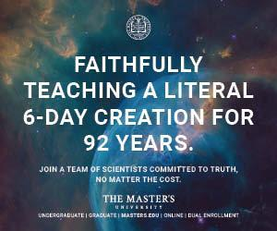

Family Field Trips
One of the most enjoyable parts of teaching your children is being able to go on field trips. We loved to leave the plains of eastern Colorado behind us and take our kids a few hours west to the Rocky Mountains, where they could identify plants and animals. We also enjoyed going to the Denver Zoo and the Museum of Nature and Science. However, their evolutionary bias was extreme and has only grown worse. The Denver Museum of Nature and History advertises its “Prehistoric Journey” exhibit this way:
Travel through time—starting 3.5 billion years ago. Your journey begins beneath ancient seas. Life diversifies as you move through the millennia, surrounded by fearsome fish and waving sea lilies. Soon you’re out of the water and the air is filled with huge dragonflies. Foot-long centipedes crawl around you. Then the dinosaurs appear!
家庭实地考察
教孩子们最有趣的部分之一就是能够进行实地考察。 我们喜欢将科罗拉多州东部的平原抛在身后，将我们的孩子带到西部几个小时的落基山脉，在那里他们可以识别动植物。 我们还喜欢去丹佛动物园和自然科学博物馆。 但是，它们的进化偏向是极端的，并且只会变得更糟。 丹佛自然历史博物馆以这种方式宣传其“史前之旅”展览：
穿越时空-从35亿年前开始。 您的旅程从古老的海底开始。 穿越千年后，生活变得多样化，周围有可怕的鱼类和挥舞着的海百合。 很快您就出水了，空气中充满了巨大的蜻蜓。 一英尺长的cent在你周围爬行。 然后恐龙出现了！
Their displays include a movie showing the fiery start of the earth, followed by its slow cooling and the gradual development of life in the primordial seas.
While raising our children, we didn’t avoid museums; instead, we learned to talk about the evolutionary worldview of each exhibit and bring the biblical perspective to what our children saw. New creation materials are making this even easier. For instance, you can now take the AiG Zoo Guide with you and easily discuss God’s design in the animals you see.
他们的展览包括一部电影，展示了地球的火热起点，然后是缓慢的降温以及原始海洋中生命的逐渐发展。
在抚养我们的孩子时，我们没有避开博物馆； 相反，我们学会了谈论每个展览的进化世界观，并将圣经的观点带入我们的孩子所看到的。 新的创作材料使这一过程变得更加容易。 例如，您现在可以随身携带《 AiG动物园指南》，并轻松地在您看到的动物中讨论神的设计。
Our children have reaped the benefits of a biblical science program by becoming well-grounded in the truth of the Bible. To no small degree, we credit God using the lessons and activities that are now the God’s Design science curricula to strengthen our kids’ faith in His Word.
As a result of the education they received, four more kids are now able to effectively defend their faith in a humanistic world and to share the logic and authority of God’s Word with others. These same benefits are available to any child. Besides that—take it from a mom who knows—science truly can be fun and exciting. Are you ready to get started?
See AiG–USA acquires God’s Design science curriculum for more information on God’s Design science curriculum and the Lawrences. Visit God’s Design Science Curriculum—Sample Lessons to view a sample lesson from the God’s Design science curriculum.
我们的孩子通过充分理解圣经的真理，已经从圣经科学计划中受益。 在很大程度上，我们使用现在是上帝设计科学课程的课程和活动来赞美上帝，以加强我们的孩子对上帝圣言的信心。
通过接受教育，现在又有四个孩子能够有效捍卫他们对人文世界的信仰，并与他人分享上帝圣言的逻辑和权威。 这些好处也适用于任何孩子。 除此之外，从一位了解母亲的母亲那里获得知识，科学确实可以充满乐趣和刺激。 你准备好开始了吗？
请参阅AiG –美国获得了神的设计科学课程，以获取有关神的设计科学课程和劳伦士的更多信息。 参观上帝的设计科学课程-示例课程，以观看上帝的设计科学课程中的示例课程。

Teaching the Truth from an Early Age

Whether your children attend school in a traditional classroom setting—such as a public or Christian school—or in a less formal homeschool setting, they need to understand the scientific aspects of our world from a biblical, creationist worldview. Without a creation-based Christian worldview, they soon begin to think that secular scientists have the “facts,” while churches have “stories.”
从小传授真理

无论您的孩子是在传统的课堂环境（例如，公立或基督教学校）上学，还是在非正式的家庭学校环境中上学，他们都需要从圣经的创世论世界角度理解我们世界的科学方面。 没有基于创造的基督教世界观，他们很快就开始认为世俗科学家具有“事实”，而教堂却具有“故事”。
Various research, including the recent AiG/Brent Beemer poll,1 reveals that tens of millions of young people in the USA will walk away from the church once they’re out of the home. Moms and dads of public school students must closely monitor and supplement what their children are being taught in class. Homeschooling parents should carefully choose primary curricula that present the biblical creation interpretation of the world while also explaining the basics of the evolutionary interpretation.
It is essential that you get the right information into your children’s minds early and often. See Educational Resources for a list of resources that can help you do this.
各种研究，包括最近的AiG / Brent Beemer民意测验1都表明，一旦离开家，美国成千上万的年轻人就会离开教堂。 公立学校学生的父母必须密切监视和补充孩子在课堂上所学的内容。 在家上学的父母应该仔细选择能够提供圣经世界解释的主要课程，同时还要解释进化解释的基础。
您必须尽早且经常将正确的信息带入孩子的脑海。 请参阅教育资源以获取可以帮助您完成此任务的资源列表。

A Christian Creationist View of Teaching Science
by R Rushdoony on February 1, 1984
Originally published in Creation 6, no 3 (February 1984): 30-31.
Science teaching is made more than normally important, because science in the modern world has for many replaced God as the source of authority.
Modern Science is a product of a Biblical view, with its belief in God and the world under God's law. Without that substructure, science will quickly disintegrate.
基督教创世论的教学科学观
由R Rushdoony发表于1984年2月1日
最初发表于Creation 6，第3期（1984年2月）：30-31。
科学教学变得比平时更加重要，因为现代世界中的科学已经取代了上帝成为权威的源头。
现代科学是圣经观点的产物，它在上帝的律法下信仰上帝和世界。 没有这种基础结构，科学将迅速瓦解。

False Authority
In one field after another, appeal is made to the authority of science; in religion, in the forms of modernism; in education, in progressivist theory; and so on. If we fail to teach science properly, we will only enhance its false authority and obscure its use.
For a Christian, the task of instruction is made simpler by the fact that the biblical, Hebrew word for instruction, Torah, means both law and instruction. For us, all things in every sphere are under an ultimate and fundamental law, God's law, and education is instruction in that law order. Modern science is a product of a Biblical world view, with its belief in God and the world under God's law. Without that substructure, science will quickly disintegrate.
虚假授权
在一个接一个的领域中，人们呼吁科学的权威。 在宗教中，以现代主义的形式； 在教育中，在进步主义理论中； 等等。 如果我们不能正确地教授科学，我们只会增强其虚假权威并掩盖其使用。
对于一个基督徒来说，圣经中的希伯来文圣经“律法”（Torah）既意味着法律又意味着教义，这使得教义的任务变得更加简单。 对我们来说，每个领域中的所有事物都遵循终极和基本定律，即上帝的律法，而教育就是该律法中的指示。 现代科学是圣经世界观的产物，它相信上帝，并相信上帝的律法下的世界。 没有这种基础结构，科学将迅速瓦解。

The History of Science
It should not surprise us that modern science was not only born out of Christianity, but especially out of a Puritan context in 17th century England. This Christian orientation persisted almost into the 20th century. Popular history to the contrary, science did not find its origins in the thought of men like Giordano Bruno, (Italian Philosopher born 1548). Bruno's humanism led him into occultism.¹ In a universe without God, either blind fate renders man meaningless, or a chaotic universe gives man the opportunitv to be an occult lord. Not dominion, but power becomes man's goal.
Among the early Puritan leaders in the sciences, a post-millennial perspective was prominent in their minds. Science was a means of exercising dominion. Significantly, even non-orthodox scientists shared a strong interest in eschatology (views of the end of time). Thus, Isaac Newton, while having Unitarian or Socinian ideas about Jesus Christ, still spent time in study and writing about revelation. Scientists were concerned, because science was seen as a means of fulfilling God's command to exercise dominion and to subdue the earth.
科学史
我们不应该感到惊讶，现代科学不仅源于基督教，而且尤其源于17世纪英格兰的清教徒时代。这种基督教倾向几乎一直持续到20世纪。相反，在通俗的历史上，科学并不是在乔丹奴·布鲁诺（Giordano Bruno）（意大利哲学家，1548年出生）这样的人的思想中找到起源的。布鲁诺的人本主义使他进入了神秘主义。1在没有上帝的宇宙中，盲目的命运会使人失去意义，或者混乱的宇宙使人有机会成为神秘的主人。不是统治，而是权力成为人的目标。
在清教徒早期的科学领导者中，他们认为后千年的观点是突出的。科学是行使统治权的一种手段。值得注意的是，即使是非正统的科学家也对末世论有着浓厚的兴趣（对时间终结的看法）。因此，艾萨克·牛顿（Isaac Newton）在对耶稣基督有一神论或索契尼主义的思想的同时，仍然花时间研究和写作启示。科学家对此感到担忧，因为科学被视为履行上帝命令行使统治权和征服地球的手段。

Humanist Science
The Christian and the non-Christian approach the universe differently and hence they define it differently. The humanist believes this world is all there is. Life is defined chemically and physiologically, within totally naturalistic confines. They reason that if the reality of our world is entirely natural, then definition is relatively easy. Given enough time, all things can be defined after sufficient research, dissection, experimentation, or study. From a Christian perspective, this is not true. Leviticus 17:11 makes clear that life is "in the blood" but it is even more clear that life is not from the blood, but from God. (Genesis 2:7). To understand life we must look beyond life to God. Definition has to be more than naturalistic: it goes beyond us and our world, and is thus in essence impossible. For us, therefore, science is not definitive but descriptive and theological. Science will become more productive if it abandons its goal to define naturalistically (which leads to theoretical science) and limits itself to description in terms of theological premises.
人文科学
基督教徒和非基督教徒以不同的方式对待宇宙，因此他们对宇宙的定义也不同。人文主义者相信这个世界就是一切。在完全自然主义的范围内，化学和生理是生命的定义。他们认为，如果我们世界的现实是完全自然的，那么定义就相对容易了。如果有足够的时间，可以在进行充分的研究，解剖，实验或研究后定义所有事物。从基督徒的角度来看，这是不正确的。利未记17:11清楚地表明生命是“在血中”，但更清楚的是生命不是来自血，而是来自上帝。 （创世记2：7）。要了解生活，我们必须超越生活而仰望上帝。定义不仅仅是自然主义：它超越了我们和我们的世界，因此从本质上讲是不可能的。因此，对我们而言，科学不是权威的，而是描述性的和神学的。如果科学放弃其自然定义的目标（这导致了理论科学），并且将自身局限于神学前提的描述，它将变得更有生产力。

Limits of Science
The theological foundation also means a realistic view of scientific goals. Because God is God. this means simply that "With God all things are possible" (Matthew 19:26). If the physical universe is the ultimate, then it follows logically that, "With nature, all things are possible!!" Because humanistic scientists operate on this premise, they are ever ready to experiment or to hypothesize in areas known to be impossible from scientific experience. Thus, science tells us that spontaneous generation is not possible, and yet it is necessary in evolutionary thought. Because infinite potentiality is ascribed, not to God but to nature, this impossibility is regarded as only impossible in the present; in infinite time, the infinite potentiality of nature will overcome all limitations.
科学极限
神学基础也意味着对科学目标的现实看法。 因为上帝是上帝。 这简单地意味着“有了上帝，一切皆有可能”（马太福音19:26）。 如果物理宇宙是终极的，那么从逻辑上可以得出这样的结论：“有了大自然，万物皆有可能！ 由于人文主义科学家是在此前提下开展工作的，因此他们随时准备在科学经验无法得知的领域进行实验或进行假设。 因此，科学告诉我们自发的生成是不可能的，但在进化思想中却是必需的。 因为无限的潜力不是归因于上帝，而是归因于自然，所以这种可能性在目前仅被视为不可能。 在无限时间内，自然的无限潜力将克服所有限制。

Nature is not God
Much current genetic research also operates in terms of infinite potentiality. Organ transplants are clear examples of this. The June 1977 attempt to transplant a baboon's heart into a human being failed. It was done in the clear knowledge that transplants face a rejection factor: they are like an alien and infection agent to the host body. The hope is, however, that man can overcome this barrier, and the hope rests on the faith that infinite potentiality belongs to nature rather than to God.
The lines God created between various forms of life and inorganic matter are seen as enemies by humanistic science, because this fixity defies the infinite potentiality of nature. But this is not all. Because eternity is an attribute of ultimacy, i.e. God, time is a problem to the humanist, and an enemy. Hence their hostility to clock time (i.e. to a young universe).²
自然不是上帝
当前许多遗传学研究还具有无限的潜力。 器官移植就是明显的例子。 1977年6月，试图将狒狒的心脏移植到人类身上的尝试失败了。 显然，移植是一个排斥因素：移植就像宿主的外星人和感染因子。 但是，希望是人类可以克服这一障碍，而希望建立在这样的信念上，即无限的潜力属于自然而不是上帝。
人文科学把上帝在各种生命形式和无机物质之间创造的界线视为敌人，因为这种固定性无视自然的无限潜力。 但这并不是全部。 因为永恒是终极属性，即上帝，所以时间是人道主义者的问题，也是敌人的问题。 因此他们对计时的敌意（即对年轻的宇宙）.2

Science Frauds
Because, for humanistic science, all potentiality belongs to nature, it is easy for humanistic scientists to read their beliefs into their research. The result is a massive trend to scientific fraud in experimentation. This is not new, as witness the drawings of the development of the human embryo by Haeckel in the last century. Science Digest (June 1977) has called attention to the high percentage of frauds in reported scientific experiments. The attitude of such researchers apparently is that, 'if it isn't true now, it soon will be'.
January 8, 1983.
Science News.
PATENT FRAUD.
Following a 10-month investigation, officials of the Mt. Sinai School of Medicine revealed last week that a chemical compound to treat hemophilia for which the school holds the patent was never actually synthesized. Based on the falsified claims made by a former employee in the patent application, the New York medical school had secured considerable research funding from private industry.
January 6, 1983,
New Scientist.
FAKE RESULTS.
Dr Joseph Cort, an American who fled Britain for Czechoslovakia 30 years ago under a cloud of anti-Communist feeling, last week owner up to fabricating important research results since his return to the United States in 1976.
科学欺诈
因为对于人文科学来说，所有潜力都属于自然，所以人文科学家很容易将自己的信念读入研究中。结果是在实验中出现科学欺诈的巨大趋势。这不是什么新鲜事，正如上世纪Haeckel所描绘的人类胚胎发育图所示。 《科学文摘》（Science Digest，1977年6月）呼吁人们注意已报道的科学实验中的高欺诈率。这类研究人员的态度显然是，“如果现在不正确，很快就会成为现实”。
1983年1月8日。
科学新闻。
专利欺诈。
在进行了10个月的调查之后，西奈医学院（Sinai School of Medicine）上周透露，该校获得专利的用于治疗血友病的化合物从未真正合成过。根据前雇员在专利申请中提出的虚假主张，纽约医学院获得了来自私营企业的大量研究资金。
1983年1月6日，
新科学家。
假结果。
约瑟夫·科特（Joseph Cort）博士是30年前在一片反共情绪下逃往英国的捷克斯洛伐克的美国人。上周，他自1976年返回美国以来就一直在捏造重要的研究成果。

Applying this to Teaching
One of the major problems in all teaching, and no less in the teaching of science, is the dominance of an academic orientation. For example, biology, chemistry, and physics are taught in isolation from one another, as though a different world existed for each. This means that an abstracted and academic view of science prevails, with theoretical science predominant. If we teach instead the history of scientific research, development, and invention, and the role of the various areas in that history and application, we gain a more accurate knowledge of the place of science (its theological premises) and therefore its meaning. From such an approach, we gain a more realistic view of the sciences and how man has tried to understand himself and the world through science, and to exercise dominion through that knowledge and by means of the instruments it has produced.
Because, for Humanistic Science, all potentiality belongs to nature, it is easy for Humanist Scientists to read their belief into their research. The result is a massive trend to scientific fraud in experimentation.
将此应用于教学
在所有教学中，尤其是在科学教学中，主要问题之一是学术取向的主导地位。例如，生物学，化学和物理是相互隔离地讲授的，好像每个人都有一个不同的世界。这意味着普遍存在抽象的学术观点，其中以理论科学为主导。如果我们代之以科学研究，发展和发明的历史，以及各个领域在历史和应用中的作用，我们将获得关于科学位置（其神学前提）及其含义的更准确的知识。通过这种方法，我们可以获得对科学的更现实的看法，以及人类如何尝试通过科学理解自己和世界，以及如何通过该知识及其所产生的手段来行使统治权。
因为对于人文科学而言，所有潜力都属于自然，所以人文主义科学家很容易将自己的信念读入研究中。结果是在实验中出现科学欺诈的巨大趋势。

References
- Francis A. Yates: "Giordano Bruno and the Hermetic Tradition" New York: Random House Vintage Books. (1964) 1969.
- R J. Rushdoony: "The Mythology of Science" p.76f, Nutley, New Jersey, The Craig Press. (1967) 1976.
Reprinted from The Philosophy of the Christian Curriculum 5 Copyright Ross House Books, P.O. Box 67, Vellecito, California, 95251, USA.

Science
Science means “knowledge” and refers to a process by which we learn about the natural world. There are two different kinds of science; observational and historical. Historical science deals with the past and is not directly testable or observable so it must be interpreted according to your worldview.

The Foundation of Science
The Bible is the foundation for science. Non-Christians must borrow biblical ideas—such as an orderly universe that obeys laws—in order to do science. If naturalism were true—if nature is “all there is”—then why should the universe have such order? Without the supernatural, there is no basis for logical, orderly laws of nature.
科学
科学是指“知识”，是指我们了解自然世界的过程。 有两种不同的科学。 观察性和历史性。 历史科学是关于过去的，不能直接检验或观察，因此必须根据您的世界观进行解释。
科学基础
圣经是科学的基础。 非基督徒必须借用圣经的思想（例如遵守法律的有序宇宙）才能进行科学研究。 如果自然主义是真的-如果自然是“一切都存在”-那么为什么宇宙应该具有这种秩序？ 没有超自然现象，就没有逻辑，有序的自然规律的基础。

What Is Science?
In its original form science simply meant “knowledge.” Now, the denial of supernatural events limits the depth of understanding that science can have and the types of questions science can ask. Although naturalistic science claims to be neutral and unbiased, it starts with this bias. Making a distinction between operational (observational) science and historical (origins) science helps us to understand the limitations of these naturalistic presuppositions in science.

Do Creationists Reject Science?
For those who haven’t already made up their minds before hearing us out—or reading what we’ve written many times on this website—are we truly against science? Not at all! Like other creationist groups Answers in Genesis affirms and supports the teaching and use of scientific methodology, and we believe this supports the biblical account of origins. So why all the disagreement?
什么是科学？
科学在其原始形式中仅表示“知识”。 现在，否定超自然事件限制了科学可以拥有的理解深度以及科学可以提出的问题类型。 尽管自然科学声称自己是中立且公正的，但它始于这种偏见。 在操作（观测）科学和历史（起源）科学之间进行区分有助于我们理解科学中这些自然主义预设的局限性。
神创论者拒绝科学吗？
对于那些在听到我们的声音或阅读我们在该网站上多次撰写的内容之前尚未下定决心的人，我们是否真的反对科学？ 一点也不！ 像其他创世论团体一样，《创世纪的答案》肯定并支持科学方法论的教学和使用，我们相信这支持圣经对起源的解释。 那么为什么所有的分歧呢？

Science Producing Life?
The chemical origin of life remains the “holy grail” of evolutionists seeking to explain how life randomly emerged. Lifeless randomly interacting chemicals would have to be able to create the informational blueprint for an organism and the code to transmit that information, as well as a system for deciphering and implementing that code. Despite often-sensationalized headlines to the contrary, nothing in biology has ever been observed to do this.

Science Topics


科学生产生命？
生命的化学起源仍然是进化论者寻求解释生命如何随机出现的“圣杯”。 没有生命的，随机相互作用的化学物质将必须能够创建生物体的信息蓝图和用于传输该信息的代码，以及用于解密和实施该代码的系统。 尽管经常引起轰动，但在生物学上却从未见过如此的报道。
科学主题

What Is Science?
Observational science is testable and repeatable, whereas historical (origins) science is extrapolation of current rates and processes back into the past.



Astronomy
Astronomy gives us glimpses of the incomprehensible size and complexity of the universe—proclaiming the infinite majesty and power of God.


什么是科学？
观察科学是可检验和可重复的，而历史（起源）科学是对当前速度和过程的推断。
天文学
天文学让我们瞥见了宇宙不可理解的规模和复杂性，宣告了上帝的无限威严和力量。
•

Biology
Biology, the study of living things, is a rich science filled with intricacy and complexity that demands the presence of an intelligent Creator God.



Chemistry
Chemistry, the study of the elements that make up matter, powerfully demonstrates the complexity of life and the inability of chemicals to produce life.


生物学
生物学是对生物的研究，是一门充满复杂性和复杂性的丰富科学，需要有聪明的造物主上帝的存在。
化学
化学是构成物质的元素的研究，有力地证明了生命的复杂性和化学物质无法产生生命。
•

Environmental Science
How should we view climate change, global warming, environmental conservation, and biblical stewardship? Where does the Ice Age fit into biblical history?

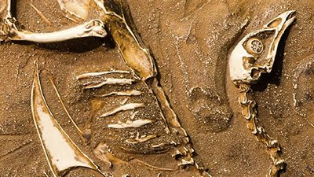

Fossils
Is the fossil record millions of years old, or is it powerful evidence for the global Flood of Genesis? And where are the transitional fossils and missing links?


环境科学
我们应该如何看待气候变化，全球变暖，环境保护和圣经管理？ 冰河时代在什么地方适合圣经历史？
化石
化石记录了几百万年的历史，还是全球性创世纪洪水的有力证据？ 过渡性化石和缺失的联系在哪里？
•

Genetics
DNA, the information stored within it, and the processes surrounding it are clear evidence of the need for an intelligent Creator God.

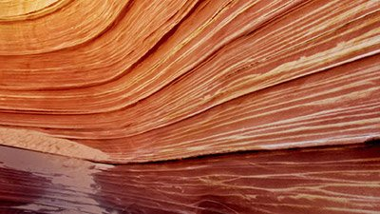

Geology
While many think rock formations and rock layers are evidence of an old earth, the Bible’s history and the rocks themselves teach a different story.


遗传学
DNA，DNA中存储的信息及其周围的过程清楚地证明了需要聪明的造物主上帝。

地质学
尽管许多人认为岩层和岩石层是古老地球的证据，但圣经的历史和岩石本身却在教导着不同的故事。
•

Human Body
The human body is an absolute marvel of design. The intricate combination of muscles, bones, organs and tissues is a symphony that cries out for a Creator.



Mathematics
The characteristics of math reflect characteristics of God, its Creator.
人体
人体绝对是设计的奇迹。 肌肉，骨骼，器官和组织的错综复杂的交响曲呼唤着创造者。
数学
数学的特征反映了神的创造者上帝的特征。



Physics
The laws of physics are fine-tuned for life—exactly what we would expect if the universe were intelligently designed.



Technology
Humanity has utilized God-given intelligence and an orderly universe to create some breathtaking and astonishing inventions and technologies.
物理
物理定律针对生命进行了微调-正是我们对宇宙进行智能设计所期望的。

技术
人类利用了上帝赐予的智慧和有序的宇宙来创造出一些惊人的，惊人的发明和技术。
Week 5: The importance of sports during junior years. Learn from Christian Sports International. Cartoons. 2-page summary report is due.
Sports are important for the development of the body and mind. Various sports should be encouraged. Schools usually do a good job on sports. Every young person must be engaged in at least one sport.
第5周：初中运动的重要性。 向基督教体育国际学习。卡通。 2页摘要报告到期。
体育对于身心发展至关重要。 应鼓励进行各种运动。 学校通常在体育方面做得很好。 每个年轻人都必须从事至少一项运动。

About Christian Sports International
Christian Sports International (CSI) is a 501(c) (3) nonprofit organization founded in 1990 and it’s headquartered in a suburban community north of Pittsburgh, Pennsylvania, with a division in the San Diego, CA area. CSI facilitates Sports Programs for kids, Campus Ministry for middle/high school students, BMX Racing Ministry and Men’s Ministry Events to challenge and empower the participants to live their lives for Jesus Christ. Since 1990, over 640,000 individuals received the Gospel message through CSI programs and thousands have accepted Jesus as their Savior as a result.
​
CSI endeavors to reach as many kids as possible in the suburban, urban and rural communities both locally and around the world. CSI teaches kids sports skills, life skills, healthy life styles and the good news of Jesus Christ through an innovative approach so they may have the chance to become the best of the best.
关于基督教体育国际
基督教体育国际（CSI）是一家成立于1990年的501（c）（3）非营利组织，总部位于宾夕法尼亚州匹兹堡以北的郊区社区，并在加利福尼亚州圣地亚哥地区设有分支机构。 CSI促进了针对儿童的体育项目，针对中/高中学生的校园部，BMX赛车部和男子部活动，以挑战并增强参与者为耶稣基督过上的生活的能力。 自1990年以来，已有超过64万个人通过CSI计划收到了福音信息，结果成千上万的人接受了耶稣作为他们的救主。

CSI努力在当地和世界各地的郊区，城市和农村社区中尽可能多地吸引孩子。 CSI通过创新的方法教孩子们运动技能，生活技能，健康的生活方式和耶稣基督的好消息，这样他们就有机会成为最优秀的人。


00:06

Davis Aragon - I am Team CSI


00:05

Shadrach Salazar - I am Team CSI


00:08

Nancy Joseph - I am Team CSI


01:10

Noah Bailey - I am Team CSI
Former CSI Baseball instructor Noah Bailey talks about his time working with Christian Sports International.


02:36

Ben Carnahan - I am Team CSI
Former CSI Baseball instructor and current Board member, Dr. Ben Carnahan, talks about his time working with Christian Sports International.

Melvin Adams
Former Harlem Globetrotter Melvin talks about working with Ch

Sports Fan?
by Dan Lietha on September 18, 2006; last featured March 24, 2017

- Cartoons
- After Eden
- Creation Wise
- Let There Be Truth

Newsletter
Get the latest answers emailed to you.
Support the creation/gospel message by donating or getting involved!

Cartoons
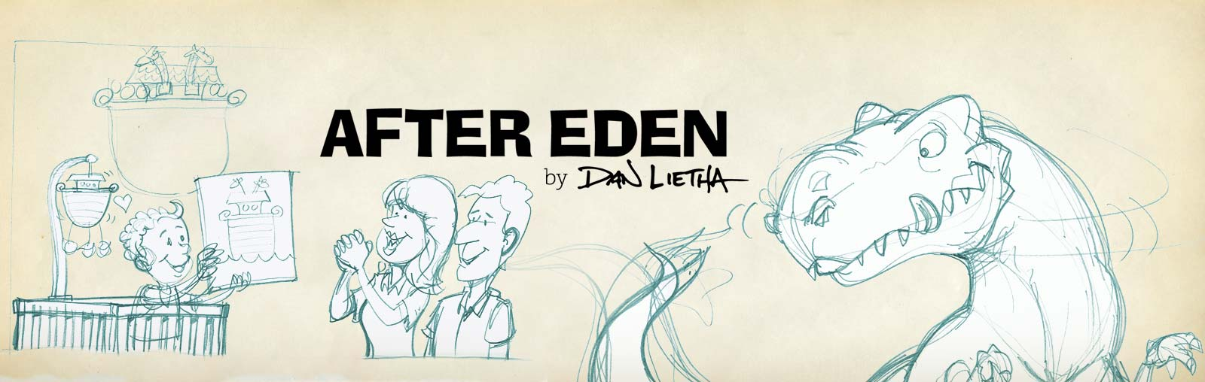

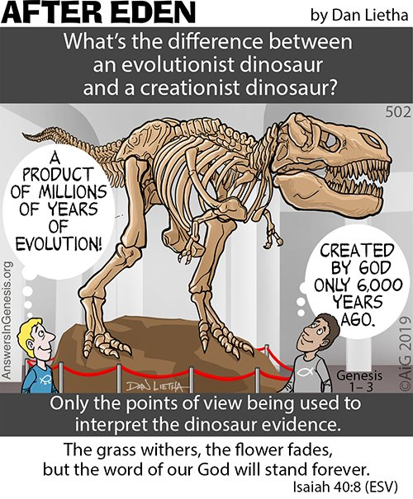
Dinosaur Thinking

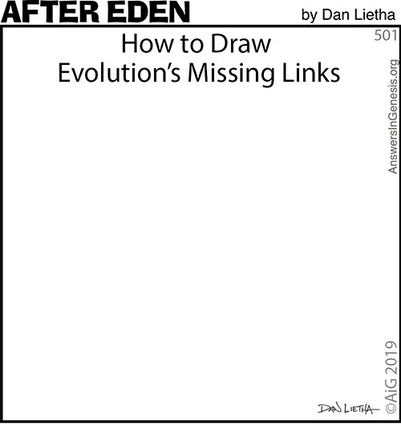
Missing

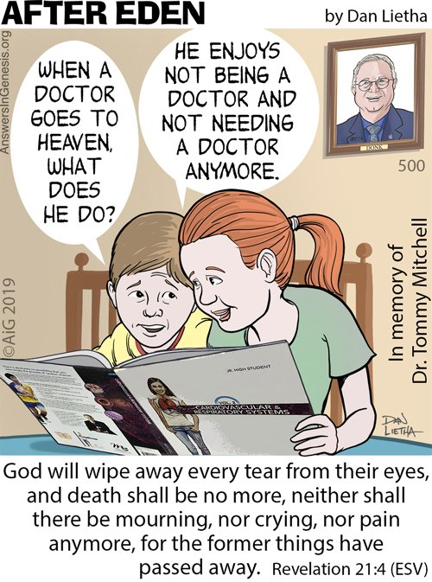
When a Doctor Goes to Heaven . . .

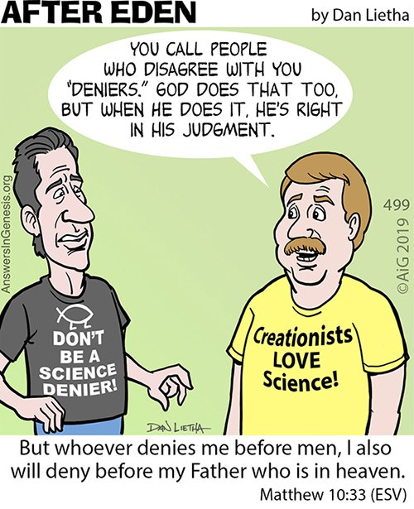
The Deniers

See more
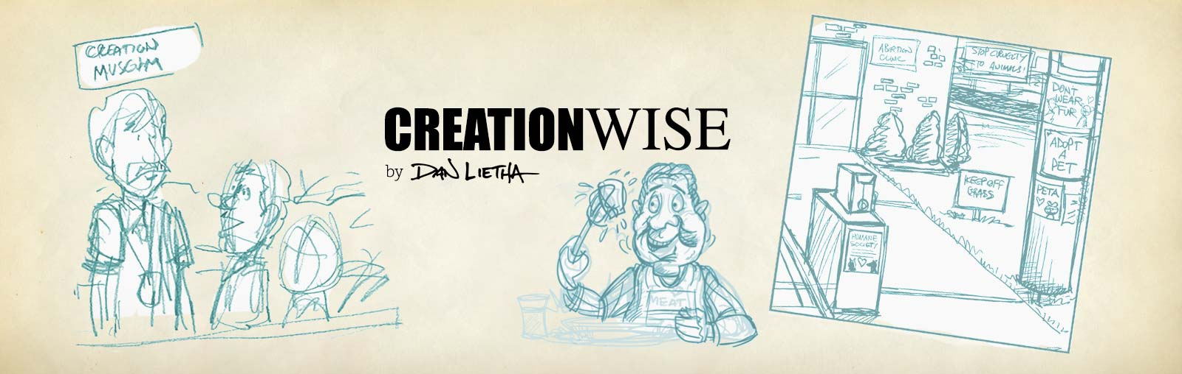

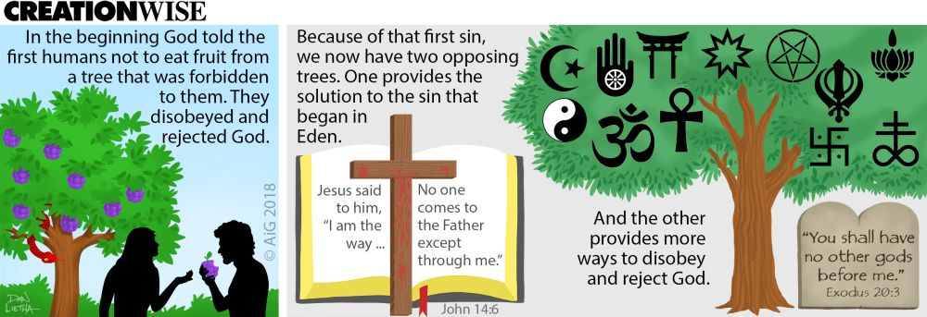
Two Opposing Trees

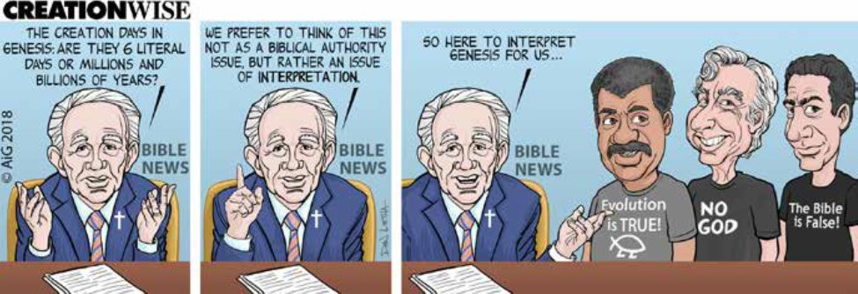
Interpreting Genesis

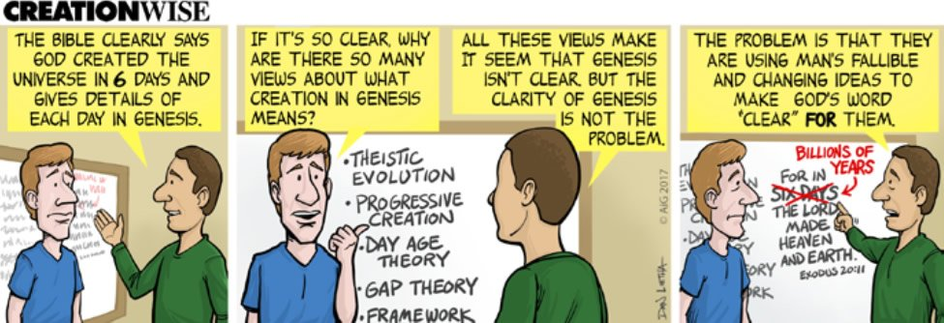
Clarity of Genesis

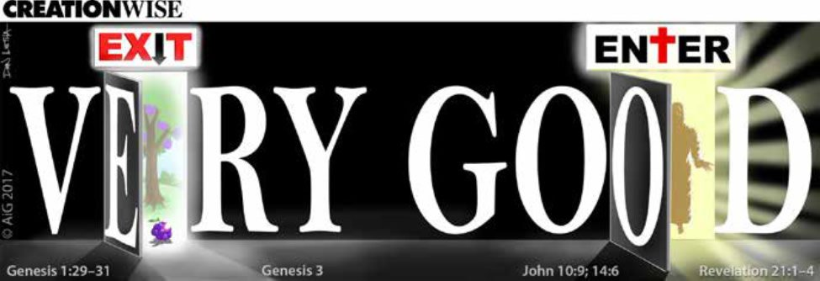
Very Good

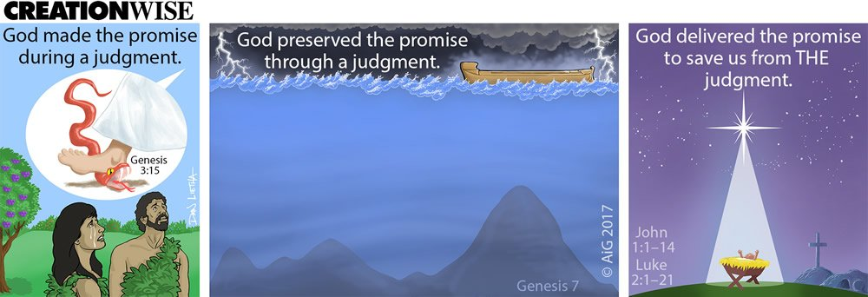
Promise Preserved

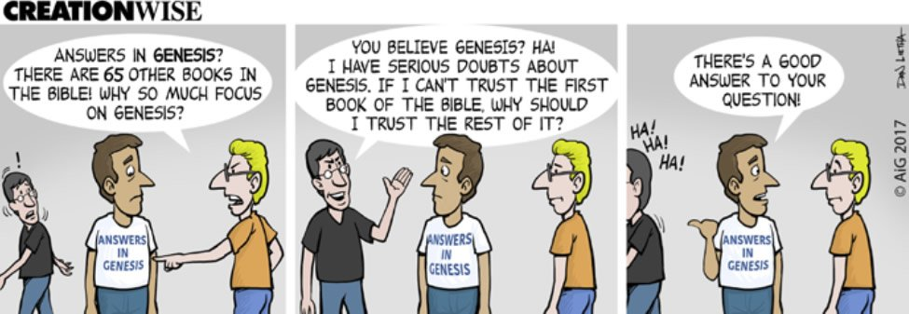
Why Focus on Genesis?

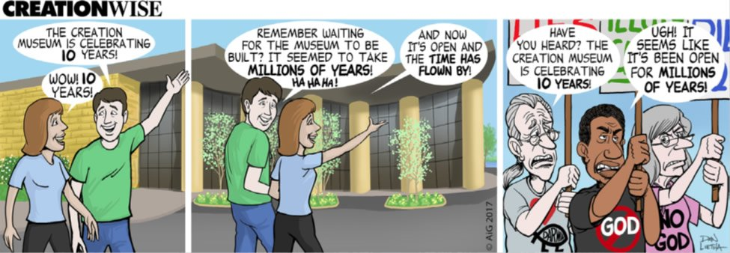
Creation Museum 10-Year Anniversary

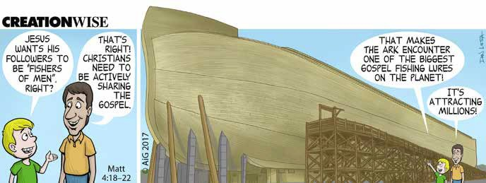
Ark Gospel Fishing Lure

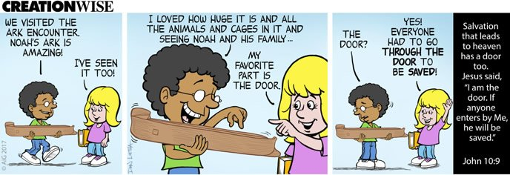
Through the Door

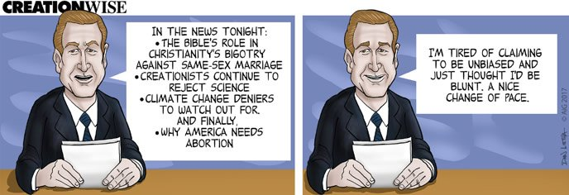
Unbiased Media

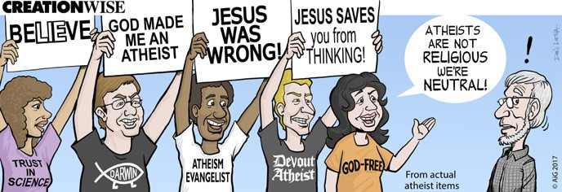
Neutral Atheists

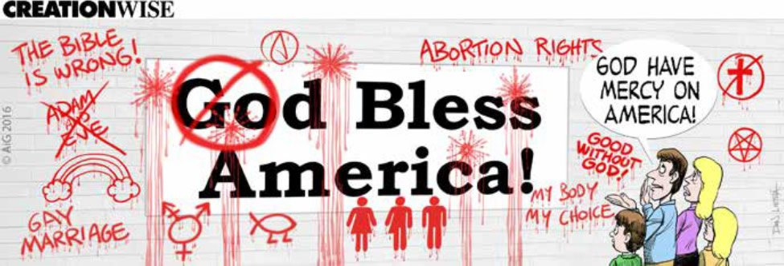
God Bless America!

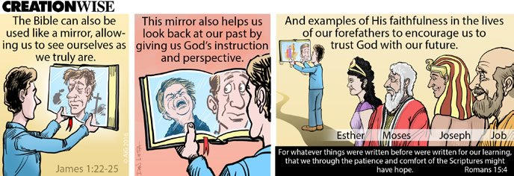
The Bible Is a Mirror

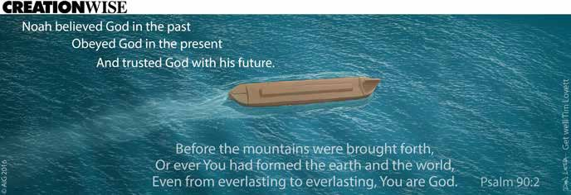
Noah Believed, Obeyed, and Trusted God

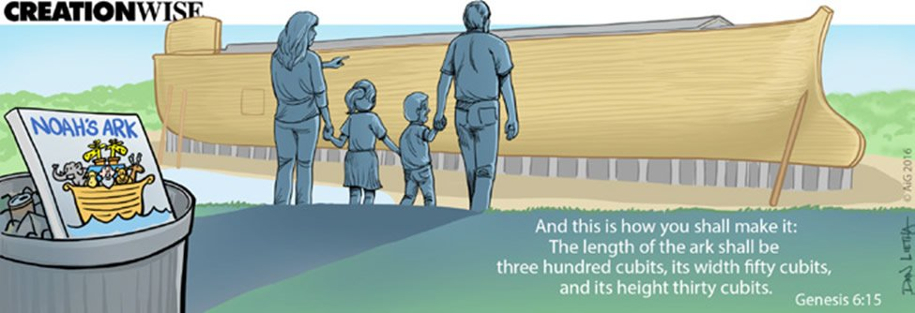
True Size of the Ark

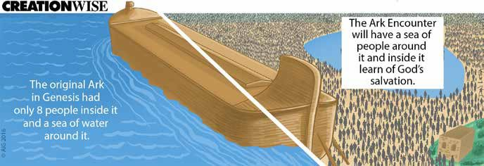
Ark Surrounded by Seas

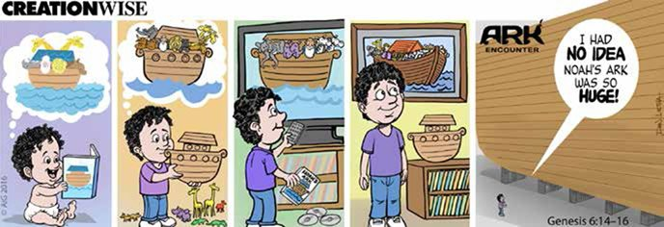
Huge Ark

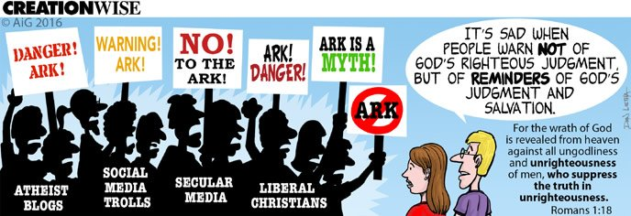
Ark Danger

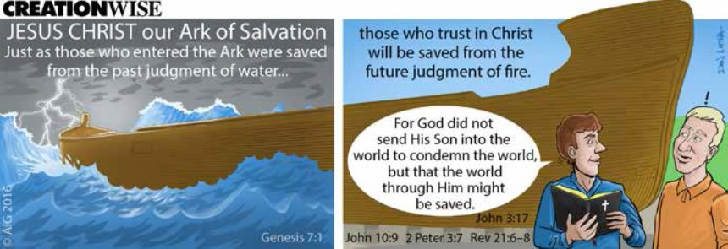
Ark of Salvation

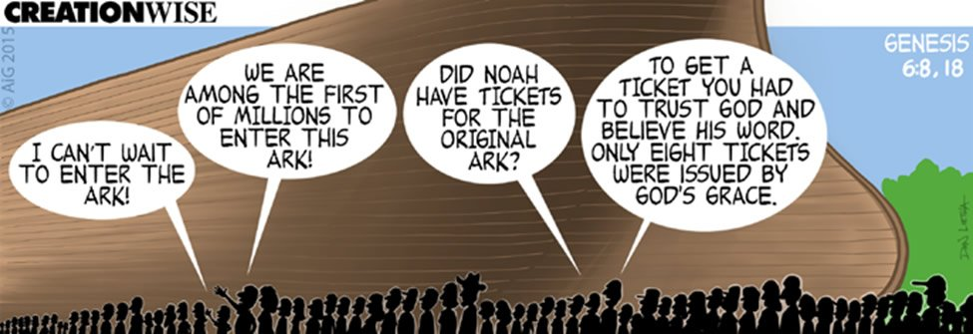
Enter the Ark

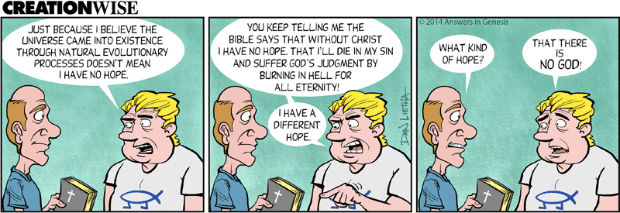
A Different Hope

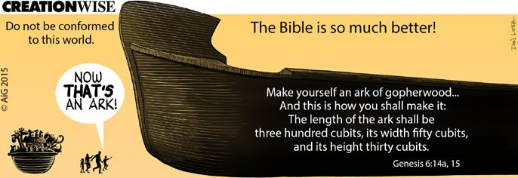
Now That’s an Ark!

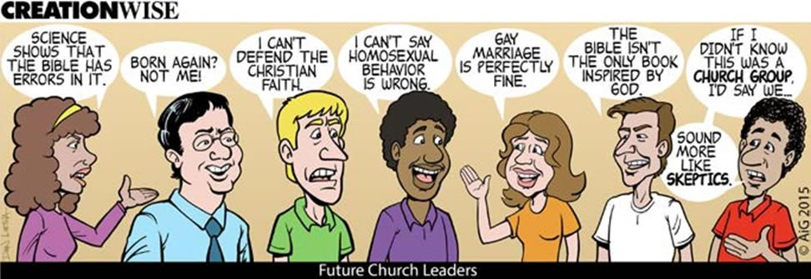
Future Church Leaders

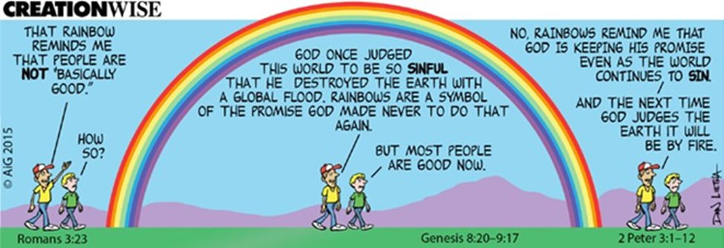
Rainbow Reminds Me

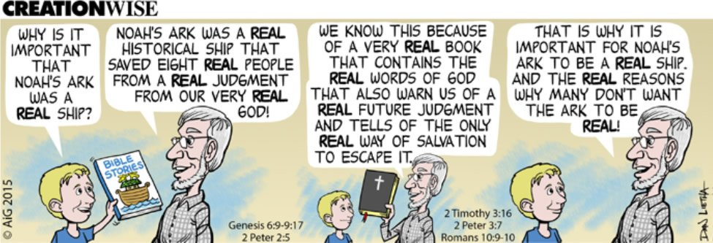
A Real Ship

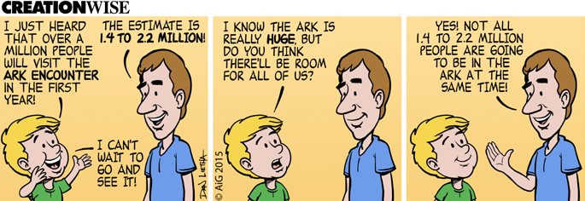
Millions to Visit Ark Encounter

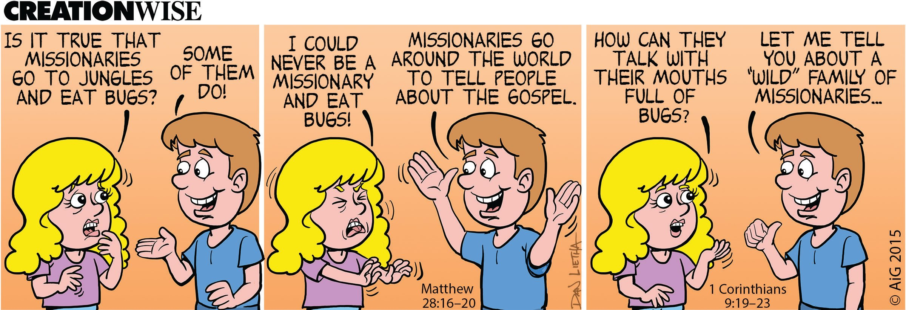
Wild Family of Missionaries

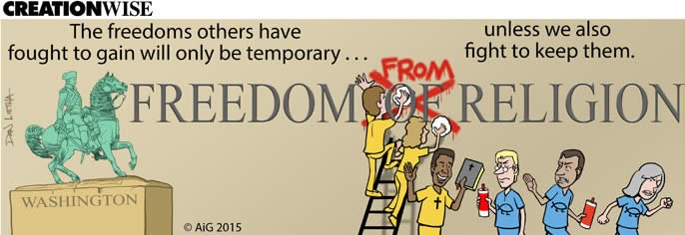
Freedom from Religion

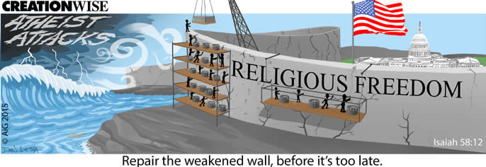
Atheist Attacks

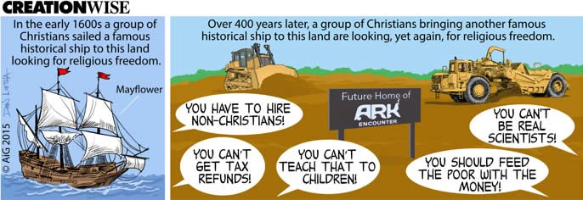
Looking for Religious Freedom

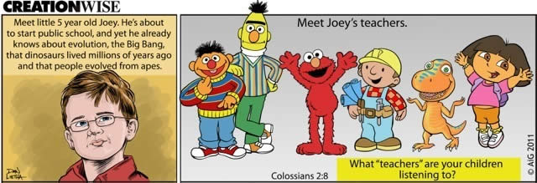
Joey's Teachers

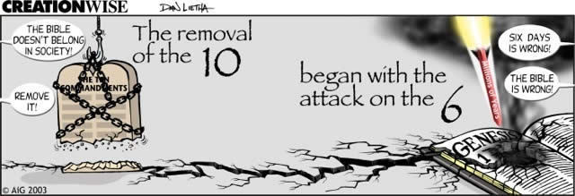
Removal of Ten, Attack on Six

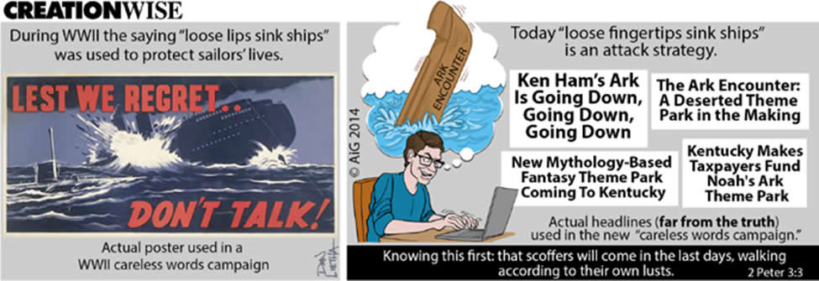
Careless Words


Earthmovers at the Ark

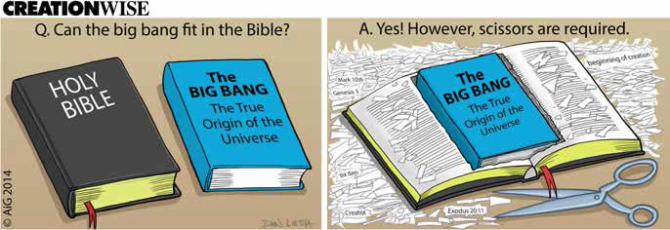
Big Bang in the Bible

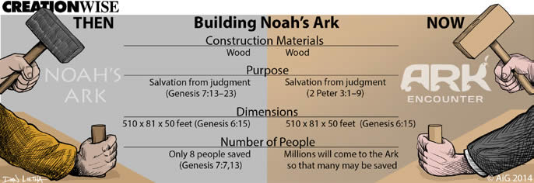
Building Noah's Ark, Then and Now

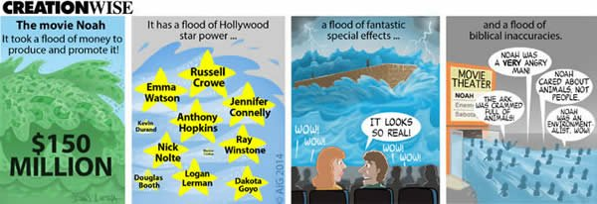
Noah Movie

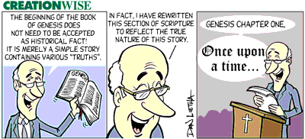
Once Upon a Time

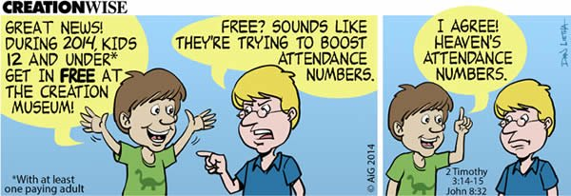
Boosting Heaven's Attendance Numbers

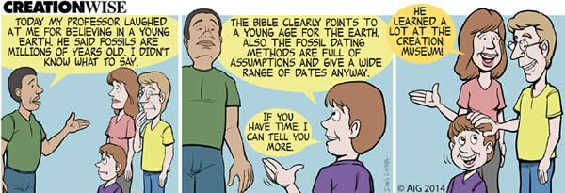
Learning at the Creation Museum

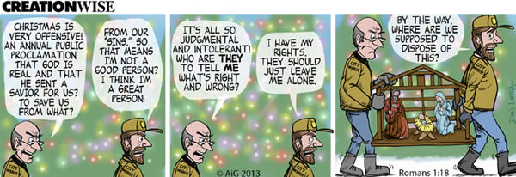
Offensive Christmas

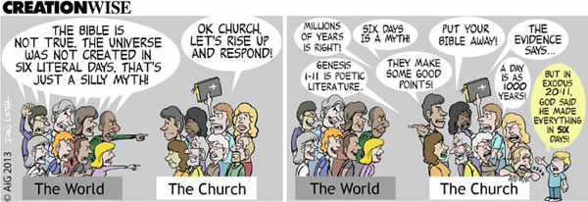
Six Days

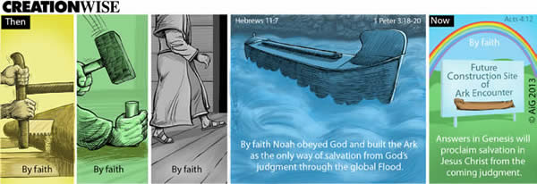
By Faith

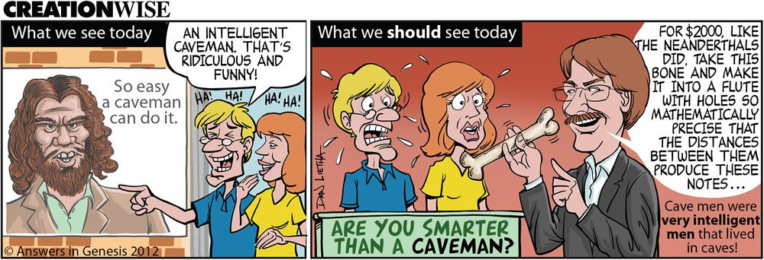
Caveman

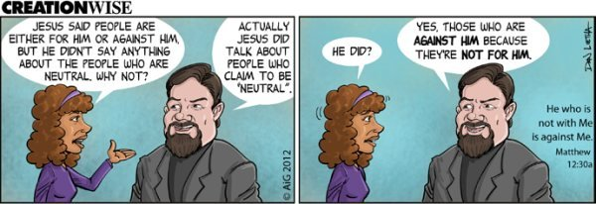
For or Against

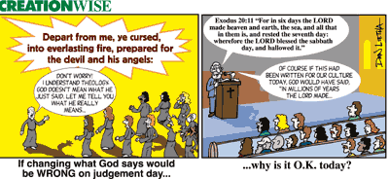
Changing the Word

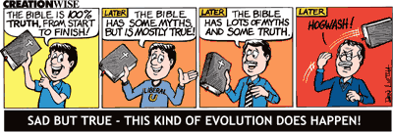
Evolution Happens

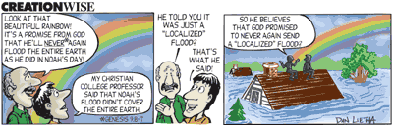
Flood

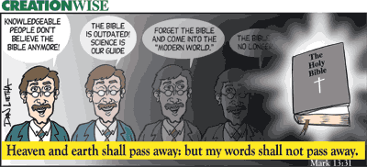
Outdated Bible

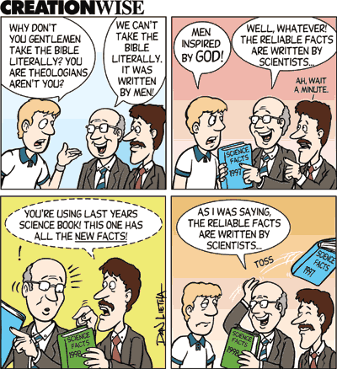
Reliable Facts

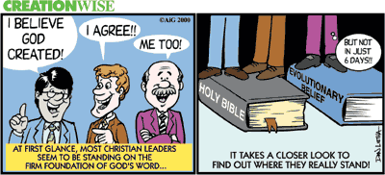
Stand

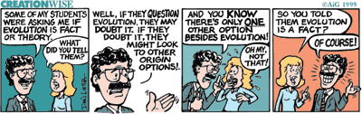
Teachers

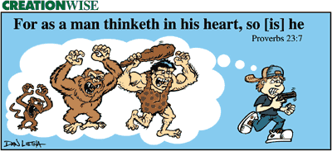
Thinketh

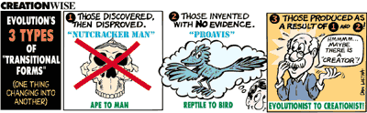
Transitional Forms

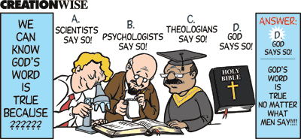
True Test

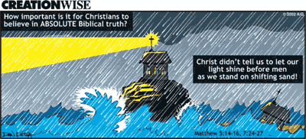
Absolute Truth

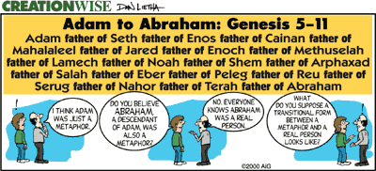
Adam Metaphor

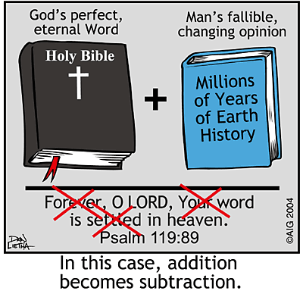
Addition and Subtraction

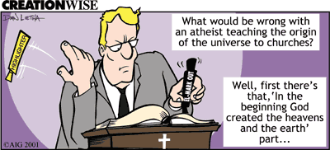
Atheist in Church

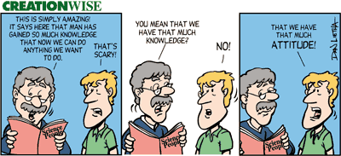
Attitude

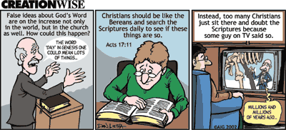
Bereans

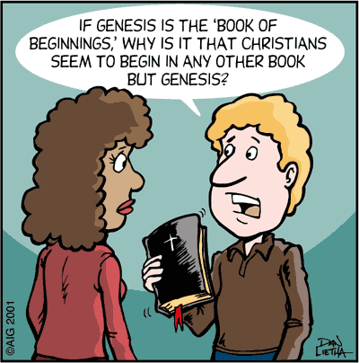
Book of Beginnings

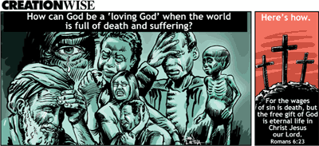
Death and Suffering

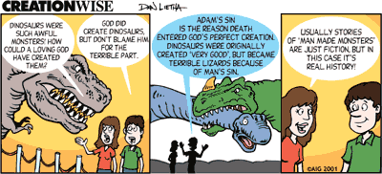
Dinosaur

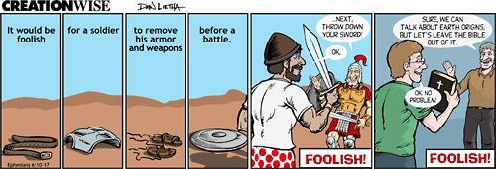
Disarmed


Don’t Open that Door

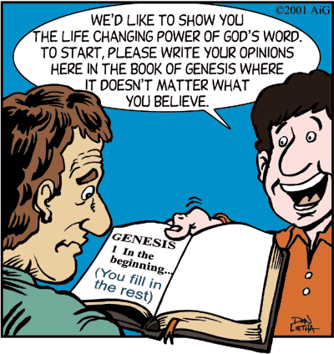
Fill in Genesis

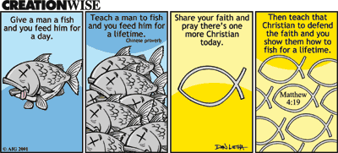
Fish

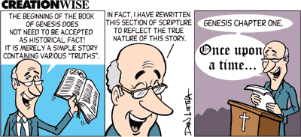
Genesis Tale

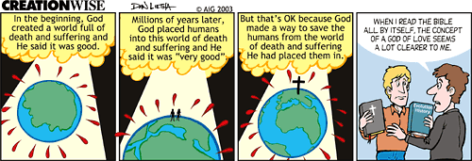
God of Love

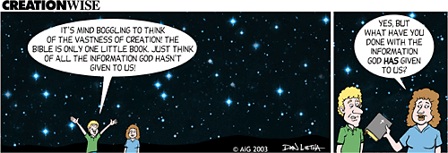
Infinite Information

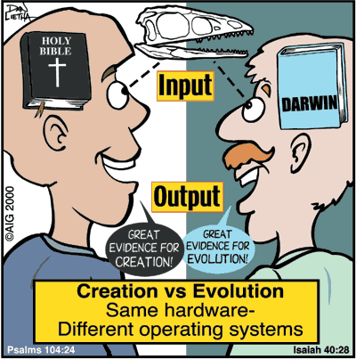
Input-Ouput

Dinosaur

Fill in Genesis

Fish

God of Love

Infinite Information

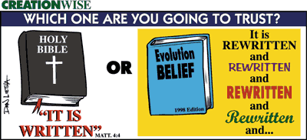
It Is Written

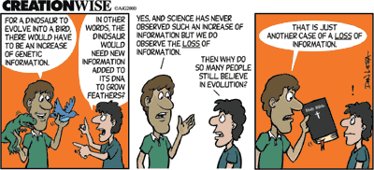
Loss of Information

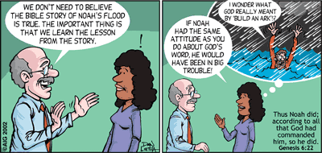
Noah’s Flood

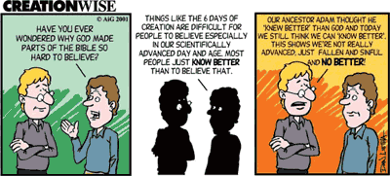
No Better

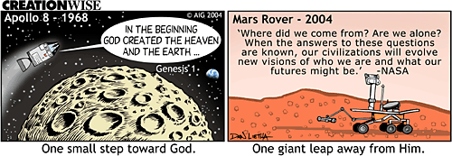
One Small Step . . .

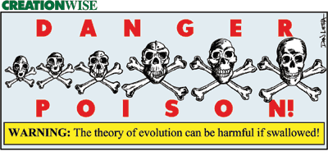
Poison

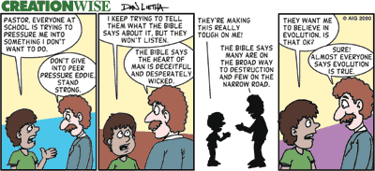
Pressure

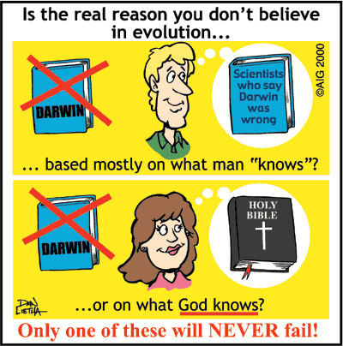
Real Reason

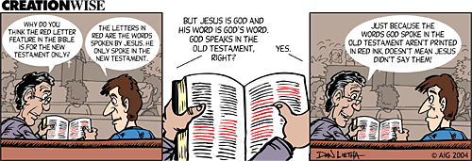
Red Letters

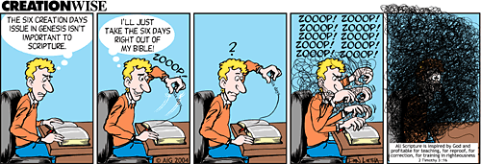
Removing the Six Days

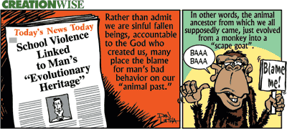
Scape Goat

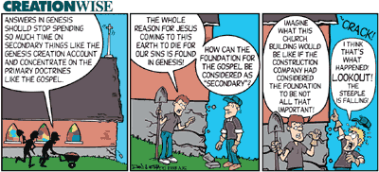
Secondary Things

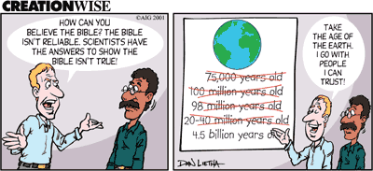
The Age of the Earth

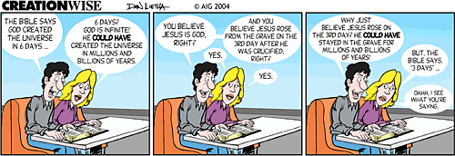
The Bible Says . . .

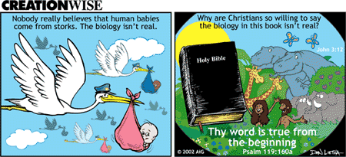
The Biology Isn't Real

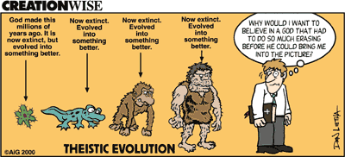
Theistic Evolution


Theological Jello

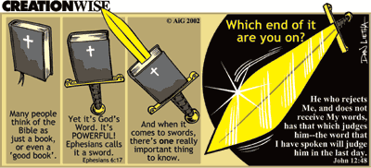
The Sword

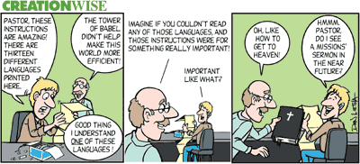
The Tower of Babel

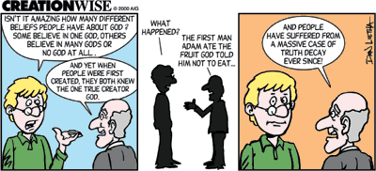
Truth Decay

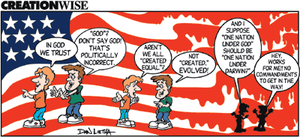
Under God

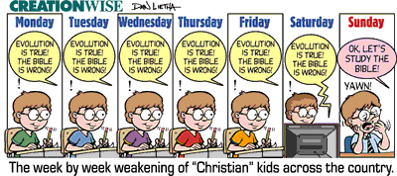
Week-ening

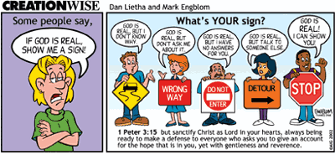
What’s Your Sign?

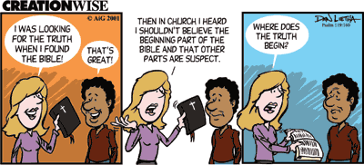
Where Does Truth Begin?

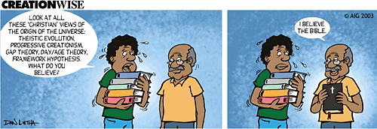
Which One?

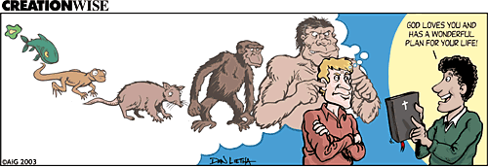
Wonderful Plan

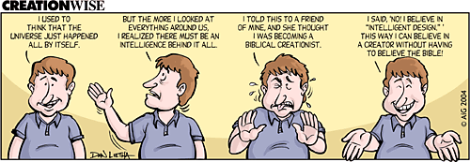
Intelligent Design

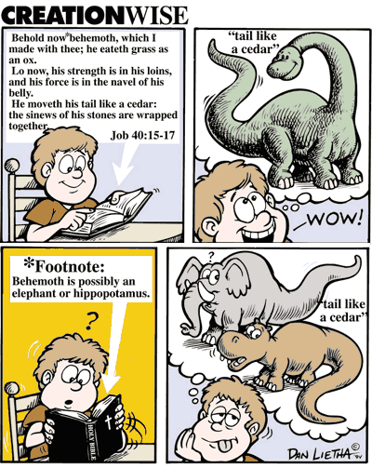
Behemoth

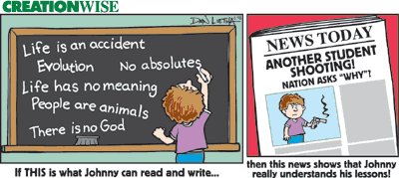
Life Lessons

- Cartoons
- After Eden
- Creation Wise
- Let There Be Truth

Newsletter
Get the latest answers emailed to you.
Support the creation/gospel message by donating or getting involved!

Week 6: The importance of computer knowledge during senior years. Learn from homeschools. 2-page summary report is due.
Computer usage must be learned as soon as a kid can type. It is used in all walks of life. Every person must be literate in computer applications. Schools also train students to use computers. There is a myriad of resources that students can use to do assignment and research.
Microsoft Office TrainingTutorials Include Word, Excel,PowerPoint, Access & More!
第六周：高年级计算机知识的重要性。向家庭学校学习。 2页摘要报告到期。
一旦孩子可以打字，就必须学会使用计算机。 它用于各行各业。 每个人都必须具备计算机应用知识。 学校还培训学生使用计算机。 学生可以使用大量资源进行作业和研究。
Microsoft Office TrainingTutorials包括Word，Excel，PowerPoint，Access等！

Homeschool Science Textbooks Too Much for Secularists?
on March 13, 2010

AP: “Top Home-School Texts Dismiss Darwin, Evolution” Many homeschool science textbooks are from Christian authors and are designed for Christian parents and students. Is that too much for secularists to handle?
An Associated Press story profiles homeschool mother Susan Mule, who regrets her adoption of a Christian science curriculum that didn’t toe the evolutionary line on origins. For some, the incident may be a reminder of caveat emptor. But for others, the very existence of the textbooks is a cause for concern.
“He probably knows [evolutionary material] better than the kids who have been taught evolution all through public school."
家庭学校科学教科书对世俗主义者来说太多了吗？
于2010年3月13日
•
美联社：“顶级家庭学校教科书驳斥了达尔文，进化论”许多家庭学校科学教科书来自基督教作家，专为基督教父母和学生设计。 对于世俗主义者来说，这太多了吗？
美联社的一个故事介绍了家庭学校的母亲苏珊·穆勒（Susan Mule），她为她采用基督教科学课程而感到遗憾，因为这门课程没有遵循起源的进化论路线。 对于某些人来说，这一事件可能会提醒人们注意。 但是对于其他人来说，教科书的存在确实令人担忧。
“他可能比那些在整个公立学校被教过进化论的孩子更了解[进化论]。”
One such individual is University of Chicago ecologist Jerry Coyne, who told the AP that the books “are promulgating lies to kids” and that students who use them are being “shortchanged, both rationally and in terms of biology.” Coyne and Virginia Tech biologist Duncan Porter recently reviewed science textbooks from Apologia Educational Ministries and Bob Jones University Press, with Porter concluding that he would give the books an F.
芝加哥大学的生态学家杰里·科恩（Jerry Coyne）就是这样的一个人，他告诉美联社，这些书“在向孩子撒谎”，而使用它们的学生“在理性和生物学方面都发生了变化”。 Coyne和弗吉尼亚理工大学的生物学家Duncan Porter最近审查了Apologia Educational Ministries和Bob Jones University Press的科学教科书，Porter总结说他会给这本书加F。
The article quotes several individuals who defend the books, including former chemistry professor Jay Wile who helped start the Apologia curriculum. Wile claims that Coyne “feels compelled to lie in order to prop up a failing hypothesis (evolution). . . . We tell [students] the facts that people like Dr. Coyne would prefer to cover up.”
And homeschooling mother Polly Brown notes that her son’s science education was not compromised by the use of creation-affirming materials: “He probably knows [evolutionary material] better than the kids who have been taught evolution all through public school. But that is in order for him to understand both sides of that argument.”
文章引用了为本书辩护的几个人，其中包括曾帮助开设Apologia课程的前化学教授Jay Wile。 Wile声称，Coyne不得不撒谎，以提出错误的假设（演变）。 。 。 。 我们告诉[学生]像科恩博士这样的人更愿意掩盖事实。”
在家上学的母亲波莉·布朗（Polly Brown）指出，使用创造力肯定的材料不会损害儿子的科学教育：“他可能比在公立学校教过进化论的孩子更了解[进化论材料]。 但这是为了让他理解该论点的两面。”
Obviously, we support Apologia and Bob Jones University’s right to publish textbooks that adopt an unashamed Bible-centric position in all areas of academic inquiry; after all, we have our own God’s Design for Science curriculum that adopts the same approach. It seems some atheists, evolutionists, and other secularists are not satisfied in having driven God and His Word from public schools. Over time, we will likely see increasing critical attention focused on private schools and homeschool families that teach God’s Word, as has been the case in other countries.

For more information:
- International Homeschooling on Shaky Ground
- Homeschooling—Growing Opportunity
- Inspection of Homeschooling
- What Is a Biblical Worldview?
- Get Answers: Education

显然，我们支持Apologia和Bob Jones University的出版教科书的权利，这些教科书在学术研究的所有领域中都应以不偏不倚的圣经为中心。 毕竟，我们有采用相同方法的自己的《上帝的科学设计》课程。 似乎有些无神论者，进化论者和其他世俗主义者对从公立学校驱逐上帝和圣言不满意。 随着时间的流逝，与其他国家的情况一样，我们可能会越来越多地将注意力集中在教授神道的私立学校和家庭学校家庭上。
想要查询更多的信息：
•摇摇欲坠的国际家庭学校
•家庭教育—不断增长的机会
•家庭学习检查
•什么是圣经世界观？
•获得答案：教育
Remember, if you see a news story that might merit some attention, let us know about it! (Note: if the story originates from the Associated Press, Fox News, MSNBC, the New York Times, or another major national media outlet, we will most likely have already heard about it.) And thanks to all of our readers who have submitted great news tips to us.
(Please note that links will take you directly to the source. Answers in Genesis is not responsible for content on the websites to which we refer. For more information, please see our Privacy Policy.)
请记住，如果您看到一个值得关注的新闻报道，请告诉我们！ （请注意：如果该故事来自美联社，福克斯新闻，MSNBC，《纽约时报》或其他主要的国家媒体，我们很可能已经听说过。）感谢所有提交了此书的读者 给我们的好消息提示。
（请注意，链接将直接带您到源。《创世纪》中的答案对我们所引用的网站上的内容概不负责。有关更多信息，请参阅我们的隐私政策。）

Five Tips for Beginning Homeschooling
by Avery Foley on July 21, 2020
What is school this year going to look like for your family? If you are like many Americans in 2020, your answer might be, “We have no idea!” As recommendations constantly shift and school boards are hesitant to release opening plans (or those plans change . . . again!), many families are frustrated when it comes for planning for the looming of “back to school.”
Others have realized they and their children have enjoyed some of the perks of homeschooling . . .
开始自学的五个技巧
由Avery Foley于2020年7月21日
您的家人今年打算去什么样的学校？ 如果您像2020年的许多美国人一样，您的答案可能是：“我们不知道！” 随着建议的不断变化以及学校董事会不愿发布开放计划（或那些计划再次发生变化……），许多家庭对于迫在眉睫的“返校”计划感到沮丧。
其他人意识到他们和他们的孩子享受了家庭教育的一些好处。 。
And for those parents who do know what their local school boards are doing, many are understandably apprehensive about the idea of sending their kids off to school with a mask and instructions to stay six feet away from their classmates. Others have realized they and their children have enjoyed some of the perks of homeschooling, such as shorter and more tailored schooldays. Because of these factors, many families are choosing, perhaps with a bit of trepidation, to homeschool their children (in fact, so many parents filed “intent to homeschool” forms in North Carolina that the government website crashed!). If you’re one of those parents, where should you start?
对于那些确实知道当地学校董事会正在做些事情的父母来说，许多人对于将他们的孩子戴上口罩并指示与同学保持六英尺远的想法感到担忧。 其他人已经意识到他们和他们的孩子享受了一些家庭学校的好处，例如更短，更适合自己的上课时间。 由于这些因素，许多家庭选择让孩子上学回家，也许有些担心（事实上，许多父母在北卡罗来纳州提交了“入学意图”表格，政府网站因此崩溃了！）。 如果您是这些父母之一，应该从哪里开始？
Lifetime Boarding Pass
Get lifetime admission to the Ark Encounter and Creation Museum plus exclusive benefits. Available for a limited time!
I’m from a homeschooler family (so is my husband), and we are just beginning the grand adventure of homeschooling as parents this fall with our preschool-aged guinea pig—oops, I meant son—Winston. Here’s how we’re going about beginning.
终生登机证
获得方舟En和创造博物馆的终生入场券，以及独家优惠。 在有限的时间内可用！
我来自一个家庭寄宿家庭（我的丈夫也是），今年秋天，我们正带着学龄前的豚鼠（哎呀，我的意思是儿子）温斯顿开始家庭教育的大冒险。 这就是我们要开始的方式。
- Define a philosophy of education. Homeschooling is simply schooling at home . . . right? Well, not so much anymore! The homeschooling movement is now old enough that there’s been time for clearly defined subgroups within the larger homeschool community to develop. Each is characterized by a philosophy of education, such as classical education, Charlotte Mason-style, unschooling, traditional, online, and more. Sound a bit overwhelming? Don’t worry—it doesn’t have to be. Find an article (like this one) that lays out the different styles to see which one gets you excited or would work best in your home.
Still not sure? Many parents chose the “traditional” style because that’s what they are comfortable with as it’s similar to a traditional classroom (think textbooks and distinct subjects, which is what I did growing up). With this style, you simply order grade-appropriate textbooks in the core subjects (math, science, history, literature, etc.) for each of your kids and follow what the textbook lays out. There are also online Christian homeschools that teach everything for you with teachers your kids can interact with if you want to go that route. As Dr. Georgia Purdom, a homeschooling mom, said in her recent article, “There’s no one right way to homeschool!”
Keep it simple as you begin.
1.定义教育理念。在家上学仅仅是在家里上学。 。 。对？好吧，不再是了！现在，家庭学校运动已经足够老了，以至于有足够的时间在较大的家庭学校社区中发展明确定义的子群体。每一种都具有教育哲学的特征，例如古典教育，夏洛特·梅森风格，未上学，传统，在线等。听起来有点压倒性吗？不用担心-不必如此。查找一篇介绍不同风格的文章（如本篇文章），看看哪一种会让您兴奋或最适合您的家庭。

还不确定吗？许多父母之所以选择“传统”风格，是因为他们喜欢这种方式，因为它类似于传统的课堂（想想教科书和不同的科目，这正是我成长的过程）。使用这种样式，您只需为每个孩子订购核心科目（数学，科学，历史，文学等）中适合年级的教科书，然后按照教科书的内容进行布置即可。也有在线基督教家庭学校，与您的孩子可以互动的老师一起教您一切，如果您想走这条路。正如在家上课的妈妈佐治亚·普多姆（Georgia Purdom）博士在她最近的文章中所说：“没有一种正确的家庭上学方法！”
开始时保持简单。
- Don’t overcomplicate it. It’s easy to get really excited about homeschooling, buy everything, and want to try everything (I’m guilty of this already!), but I’ve been warned by moms with experience to keep it simple as you begin. It might take a few “false starts” to figure out what works for you and your individual kids. Don’t get discouraged! Keep plucking away or trying something different that may work better.
2.不要过于复杂。 在家上学很容易感到兴奋，购买所有东西并想尝试所有东西（我已经对此感到内!！），但是有经验的妈妈警告我，在开始时要保持简单。 可能需要一些“错误的开始”才能弄清楚什么对您和您的孩子有用。 不要气our！ 继续采摘或尝试其他可能会更好的方法。
- Don’t force it. A veteran homeschool mom has advised me not to force schooling with my kids. One of the perks of homeschooling is, if you’re having one of “those days,” you can take a break! Go outside and go for a nature walk (or just play in the backyard). Stop and make a snack together. Call it a field trip day and go on an educational adventure. Or just stop for half an hour and try again when attitudes (perhaps including yours!) have had a reset. This is especially true as you just start out—it’s a big adjustment for you and your kids. It’ll be much more enjoyable and productive if you don’t force it on days where, for whatever reason, it’s just not working.
3.不要强迫它。 一位资深的在家上学的妈妈建议我不要强迫我的孩子上学。 家庭教育的好处之一是，如果您度过了“那些日子”之一，则可以休息一下！ 到外面去自然散步（或者只是在后院玩）。 停下来一起做点心。 将其称为实地考察日，然后进行一次教育冒险。 或者只是停止半个小时，然后在态度（可能包括您的态度）恢复原状后重试。 刚开始时尤其如此，这对您和您的孩子来说都是一个很大的调整。 如果您出于某些原因而不起作用的日子不使用它，它将变得更加有趣和高效。
- Watch out! Just because a curriculum is a “homeschool” curriculum doesn’t mean it’s Christian. And just because it’s “Christian” doesn’t mean it’s biblical! Dig a little before you invest money in a curriculum to make sure it’s really what you want shaping your children’s hearts and minds. And when concepts you don’t agree with do arise, either in your curriculum or outside it, be sure to have Bible-centered conversations that help teach your children discernment, critical thinking, and how to apply a biblical worldview to what they’re learning.
4.当心！ 仅仅因为课程是“家庭学校”课程并不意味着它是基督教的。 仅仅因为它是“基督徒”并不意味着它符合圣经！ 在您花钱购买课程之前，请先进行一点挖掘，以确保它确实是您想要塑造孩子的思想和观念的东西。 当您不同意的概念出现时，无论是在您的课程中还是在课程之外，请务必进行以圣经为中心的对话，以帮助您教导孩子们敏锐的洞察力，批判性思维以及如何将圣经的世界观应用于他们的所学内容。 学习。
- Pray. Bring your new venture before the Lord. Trust that he has given you what you need for the hard job of parenting, discipling, and, yes, schooling your child(ren). Homeschooling is hard. But it’s also very rewarding. (But don’t take my word for it—I haven’t started yet! Take my mom’s word for it—she’s successfully graduated eight homeschoolers, with seven more working towards the big graduation day!). If this is what the Lord has called you to do, and you’ve prayerfully decided that this is best for your family, be encouraged that God will give you the grace to do it and do it well. Keep coming before him with your worries, setbacks, victories, and questions, remembering “if any of you lacks wisdom, let him ask God, who gives generously to all without reproach, and it will be given him” (James 1:5).
5.祈祷。 将你的新事业带到耶和华面前。 相信他已经为您提供了完成育儿，门徒学习以及（是）对您的孩子进行学习的辛勤工作所需的一切。 在家上学很难。 但这也是非常有益的。 （但是，请不要相信我-我还没有开始！请相信我的母亲-她已经成功地毕业了八名家庭学生，另有七名学生正在努力完成毕业典礼！）。 如果这是主所呼召你做的，而你已虔诚地决定这对你的家庭最合适，那就受鼓励，上帝会赐你恩典去做并做好。 带着您的忧虑，挫折，胜利和问题不断出现在他面前，记住“你们中的任何人如果缺乏智慧，就请他问上帝，谁慷慨地向所有人慷慨奉献，将受到责备”（雅各书1：5） 。

Bonus Tip! Resources to Help You Get Started
If you’re looking for textbooks and curricula to help you get started with homeschooling, Answers in Genesis offers a variety of material, all of which teach a biblical worldview. You can be confident the worldview woven throughout these resources is one you want your children absorbing.
Here are some suggestions (please note they are divided into rough categories, but many of them overlap, e.g., science textbooks also contain apologetics material):
奖金提示！ 帮助您入门的资源
如果您正在寻找可以帮助您开始家庭学习的教科书和课程，《创世纪的答案》提供了多种材料，所有这些材料都教会了圣经的世界观。 您可以放心，您希望孩子吸收所有这些资源所编织的世界观。
以下是一些建议（请注意，它们被分为粗略的类别，但其中许多重叠，例如科学教科书中也包含辩护材料）：

Science:
- God’s Design for Science. Designed for grades 3–8, this science curriculum meets all your elementary and middle school science needs. Bonus: it’s designed to be multi-level so it’s easy to use with multiple children of different ages, saving you time, teaching, and money. A God's Design for Beginners is also available for kindergartners through second graders.
- Introduction to Anatomy & Physiology. Explore the marvel of the “fearfully and wonderfully made” human body with this intro to anatomy and physiology by the late Tommy Mitchell, M.D. This curriculum is designed for junior high.
- Biblical Archaeology Curriculum Pack. What’s the truth about dusty artifacts from past civilizations, including those mentioned in the Bible? Dig into archaeology with this high school curriculum pack.
- 科学：
- •上帝的科学设计。 该科学课程专为3-8年级设计，可满足您所有中小学科学的需求。 奖金：它设计为多层次的，因此可以轻松与多个不同年龄的孩子一起使用，从而节省了您的时间，教学和金钱。 幼儿园的二年级学生也可以使用上帝的初学者设计。
- •解剖与生理学简介。 已故医学博士Tommy Mitchell的解剖学和生理学简介介绍了“可怕而神奇的”人体的奇妙之处。此课程是为初中设计的。
- •圣经考古学课程包。 包括圣经中提到的过去文明在内的尘土文物的真实情况是什么？ 通过这个高中课程包，可以深入考古学。

Bible/Worldview/Apologetics:
- Answers for Kids Bible Curriculum. Discover the truth of God’s Word, biblical history, and more with this curriculum designed for kids aged 8 through 11.
- Elementary Apologetics Curriculum Pack. Our popular Answers Books for Kids series is now available as a curriculum. Kids will look at answers to 100 questions and find that God’s Word is true. Designed for grades 4–6.
- Apologetics in Action. How do we know the Bible is true? And what about those contradictions in the Bible? Equip high schoolers to defend the truth of God’s Word with this curriculum pack.
- Comparative Religions Curriculum Set. Discover the history of world religions, how they answer the ultimate questions, how they are similar and different from a biblical worldview, and how to share the gospel with others in this high school curriculum based on our three-volume World Religions and Cults book set.
- One Race, One Blood DVD Curriculum. In a world where racial tensions are extremely high, it is imperative that Christians address the racism issue from a biblical perspective. Equip your high schoolers with the biblical solution to racism with this curriculum.
- One Blood for Kids Pack. It’s not just high schoolers who need answers on the race issue—kids do too! Help kids understand biblical history, that we’re all one race, and the gospel message with this fun pack.
- Creation Apologetics Master Class. Limited time special offer! Enjoy all six of our in-depth creation apologetics classes for one low price of $19 (a nearly $300 value!). High school students and their parents will benefit from this deep-dive into apologetics. You will be equipped to think biblically and to have a foundational knowledge of biblical and creation apologetics that will be built on in in-depth classes on biology, geology, astronomy, and Bible.
- Answers Bible Curriculum. ABC, a four-year Sunday school curriculum, is easily adapted for homeschooling and has even won homeschooling awards. This curriculum goes from preschool through adult so the whole family can learn and grow in the knowledge of God’s Word together. ABC features biblical authority teaching, apologetics, theology, history, and more.
- 圣经/世界观/辩护法：
- •儿童圣经课程答案。专为8到11岁的孩子设计的课程，发现神的话语的真实性，圣经的历史以及更多内容。
- •基本的辩护课程包。我们现在很受欢迎的儿童答案书系列可以作为课程使用。孩子们将查看100个问题的答案，并发现上帝的话是真实的。专为4-6年级设计。
- •行动中的辩护法。我们怎么知道圣经是真实的？那么圣经中的那些矛盾呢？通过此课程包，使高中生能够捍卫上帝圣言的真理。
- •比较宗教课程集。探索世界宗教的历史，如何回答最终的问题，它们与圣经世界观的相似之处和不同之处，以及如何根据我们的三卷《世界宗教与邪教》书本在高中课程中与他人分享福音。
- •一种族一血DVD课程。在一个种族紧张局势极为紧张的世界中，基督徒必须从圣经的角度解决种族主义问题。通过本课程为高中生提供解决种族主义的圣经方法。
- •儿童专用一包血。不仅仅是高中生需要种族问题的答案，孩子们也需要答案！帮助孩子们了解圣经的历史，我们都是一个种族，并通过这个有趣的信息包传达福音信息。
- •创世辩护大师班。限时特价！只需19美元（约合300美元的低价），就可以享受我们所有六个深度创建的辩护医学课程。高中生及其父母将受益于这种深入的辩护论。您将具备进行圣经思考的能力，并拥有有关圣经和创造道歉论的基础知识，这些知识将在生物学，地质学，天文学和圣经的深入课程中建立。
- •回答圣经课程。美国广播公司（ABC）是一种为期四年的星期日学校课程，很容易适应家庭教育，甚至还获得了家庭教育奖。该课程从学前班到成人，因此全家可以一起学习和成长神的道。美国广播公司（ABC）具有圣经权威的教学，道歉，神学，历史等等。

Mathematics
- Principles of Mathematics. Transform how your students see math with this biblical worldview mathematics curriculum for grades 6–8.
- Math Lessons for a Living Education. This is math made fun in a Charlotte Mason-style curriculum for Levels 1–5.

History and Geography
- Elementary World History—You Report! This Charlotte Mason-style history teaches critical thinking, organizing ideas, and presenting information in oral and written form.
- Elementary Geography and Cultures Pack. Travel the world in the comfort of your own home as you learn about the 4,000 years of history and culture since Babel.

Supplemental
- Answers.tv. All of our video content is available on our streaming platform, Answers.tv. It’s a wealth of supplemental resources for the homeschooler. For example, studying geology? Go outside, look at some rocks, collect a few samples, then watch presentations on Answers.tv from real geologists who approach the rocks and layers with a biblical worldview. Answers.tv also has hands-on science teaching, art lessons, music, animal encounters for zoology, and more!
- 数学
- •数学原理。借助这本6-8年级的圣经世界观数学课程，可以改变学生对数学的看法。
- •生活教育的数学课。在夏洛特·梅森（Charlotte Mason）风格的1–5级课程中，这很有趣。
- 历史地理
- •基本世界历史-您报告！这本夏洛特·梅森（Charlotte Mason）风格的历史讲授批判性思维，组织思想并以口头和书面形式提供信息。
- •基础地理和文化包。了解自Babel以来的4,000年历史和文化，在自己舒适的家中环游世界。
- 补充性
- •Answers.tv。我们所有的视频内容都可以在我们的流媒体平台Answers.tv上获得。对于家庭学生来说，这是大量的补充资源。例如，学习地质学？走到外面，看一些岩石，收集一些样本，然后在Answers.tv上观看真正的地质学家的演讲，他们以圣经的世界观接近岩石和地层。 Answers.tv还提供动手科学教学，艺术课程，音乐，动物学动物学等等！
- Answers magazine. This biblical worldview magazine is for the whole family. It’s a great way to supplement your child’s school education with engaging and equipping articles on a plethora of relevant topics. And your print subscription includes the digital version and audio of each article as well!

Bonus Resource!
- Master Books. Our publisher, Master Books, offers a variety of homeschool curriculum and packs, and many of the packs feature our resources coupled with teacher guides, student guides, quizzes, and more. Explore their website to get tips on homeschooling and find all the curricula you need. Master Books homeschool curriculum is also available in discount packs from our store.
•答案杂志。 这本圣经的世界观杂志适用于整个家庭。 这是一种通过参与和撰写涉及大量相关主题的文章来补充孩子的学校教育的好方法。 您的印刷版订阅还包括每篇文章的数字版本和音频！
奖励资源！
•大师书籍。 我们的出版商Master Books提供各种家庭学校课程和资料包，其中许多资料包都包含我们的资源以及教师指南，学生指南，测验等。 浏览他们的网站以获取有关在家上学的提示，并找到您需要的所有课程。 我们商店也以折扣价提供Master Books家庭学校课程。

Homeschoolers Excelling at College
by Ken Ham on August 6, 2010
Given that I have seen and heard many comments from several secularists either criticizing or outright condemning homeschooling, I thought I should bring to your attention an article by the very respected HSLDA (Home School Legal Defense Association), which comments on real statistical research about homeschoolers and their success at college.
家庭学生在大学里表现出色
由Ken Ham于2010年8月6日
鉴于我已经看到并听到了许多世俗主义者的批评或完全谴责家庭学校教育的评论，我想我应该提请您注意备受尊敬的HSLDA（家庭学校法律辩护协会）的一篇文章，其中评论了有关家庭学生的真实统计研究 以及他们在大学中的成功。
Lifetime Boarding Pass
Get lifetime admission to the Ark Encounter and Creation Museum plus exclusive benefits. Available for a limited time!
From what I’ve read, most secularists make very negative comments about homeschooling because the majority of homeschoolers are Christians (it is primarily a Christian movement—even though there are secularists who also homeschool). Most secularists make such negative comments about homeschooling based on their emotional religious-secularist views that are intolerant of Christianity.
Most homeschoolers don’t homeschool just to isolate their children from the public education system (as is often claimed), but they want to ensure their children are taught critical thinking skills (which by and large are sadly lacking in public education—particular in science when it comes to origins), and to teach them a Christian worldview. After all, public education has all but eliminated Christianity and replaced it with naturalism—which is atheism (a religious worldview). Secularists want to impose their naturalistic/atheistic religion on generations of kids—and they often get so angry when there are Christians who won’t allow them to get away with that.
终生登机证
获得方舟En和创造博物馆的终生入场券，以及独家优惠。在有限的时间内可用！
根据我的阅读，大多数世俗主义者对家庭学校教育持非常负面的评论，因为大多数家庭学生是基督徒（这主要是基督教运动，尽管也有一些世俗主义者也在家中读书）。大多数世俗主义者基于他们对基督教的不容忍的情感宗教-世俗主义者观点，对家庭教育做出了如此消极的评论。
大多数家庭学生并非只是为了让孩子脱离公共教育系统而在家上学（通常这样说），但是他们想确保自己的孩子学会批判性思维能力（可悲的是，公共教育尤其是科学领域普遍缺乏这种能力）关于起源），并教会他们基督教世界观。毕竟，公共教育几乎消除了基督教，并用无神论（一种宗教世界观）取代了自然主义。世俗主义者想把他们的自然主义/无神论信仰强加于几代孩子。当有基督徒不允许他们摆脱这种情况时，他们常常会生气。
As it is, secularists are imposing their naturalistic/atheistic worldview on the culture (because most people don’t understand there is no neutral position—one is either for or against Christ, as there is no in-between). This naturalistic/atheistic worldview can be seen in the recent decision by the judge in California about the “Gay Marriage” issue, and I will comment more on this on my Sunday blog post.
What I expect is for many secularists to immediately dismiss this research commented on below and without logical reason—except for their intolerance that won’t allow them to accept it.
The HSLDA article is entitled, “New Study Shows Homeschoolers Succeeding in College.”
Here are some excerpts (with a link at the bottom so you can read the entire article):
实际上，世俗主义者正在将他们的自然主义/无神论世界观强加于文化上（因为大多数人不了解没有中立的立场-一个是支持还是反对基督，因为两者之间没有中间立场）。 这种自然主义/无神论的世界观可以从加利福尼亚法官最近关于“同性恋婚姻”问题的裁决中看出，我将在我的周日博客文章中对此发表更多评论。
我期望许多世俗主义者立即无缘无故地撤消下面评论的这项研究，没有逻辑上的理由，只是他们的不宽容不允许他们接受。
HSLDA文章的标题为“新研究表明家庭学生在大学中取得成功”。
以下是一些摘录（底部有链接，您可以阅读整篇文章）：
There is a growing body of research demonstrating the academic success of homeschoolers. The most recent major study is the Progress Report 2009, which surveyed over 11,000 homeschooled students, and showed homeschoolers K–12 scoring an average 37 percentile points above the national average on standardized achievement tests. However, as the homeschool movement has grown—by 7% per year for each of the past 10 years according to the National Center for Education Statistics—there has been little research on the academic performance of homeschoolers once they reach college. . . .
. . . Not only did colleges see that homeschoolers were self-motivated, but they also saw that homeschoolers were high academic achievers. Today, the overwhelming majority of colleges either have a homeschool admissions officer or a homeschooled admissions policy. . . .
Therefore, it was with great interest that we read the new study—Exploring Academic Outcomes of Homeschooled Students, by Michael F. Cogan—which shows homeschoolers succeeding in college. . . .
越来越多的研究表明家庭学生的学术成就。最近的一项主要研究是《 2009年进度报告》，该报告对11,000多名在家学习的学生进行了调查，结果显示，在标准化成绩测试中，K-12的家庭学生平均得分比全国平均水平高37个百分点。但是，随着家庭学校运动的发展（根据美国国家教育统计中心的数据，过去10年中每年以7％的速度增长），对家庭学生上大学后的学业表现的研究很少。 。 。 。
。 。 。大学不仅看到家庭学生是有上进心的，而且还看到家庭学生是高学业的人。今天，绝大多数大学都设有家庭学校招生官或家庭学校招生政策。 。 。 。
因此，我们非常感兴趣地阅读了迈克尔·科根（Michael F. Cogan）撰写的新研究《探索家庭学生的学术成果》，该书显示了家庭学生在大学中的成功。 。 。 。
Some of the major findings include:
- Homeschoolers scored higher on the ACT (26.5) compared with the overall student body (25).
- Homeschoolers earned more college credit (14.7) prior to their freshman year compared to the student body (6).
- Homeschooled students earned a higher fall semester GPA (3.37) when compared to other freshman students (3.08).
- Homeschooled students earned a higher first-year GPA (3.41) when compared to other freshman students (3.12).\
- Homeschooled students earned a higher fourth-year GPA (3.46) when compared to other freshman students who completed their fourth year (3.16). . . .
It is very encouraging to see both the academic results for homeschoolers as well as the ability to stay with a four-year college program.
You can read the entire article at: http://www.hslda.org/docs/news/201008030.asp
一些主要发现包括：
•与总体学生人数（25）相比，家庭学生在ACT上的得分更高（26.5）。
•与学生团体（6）相比，大一新生之前的家庭学生获得了更高的大学学分（14.7）。
•与其他新生（3.08）相比，自学学生的秋季学期GPA（3.37）高。
•与其他新生（3.12）相比，自学学生的第一年平均GPA（3.41）高。\
•与完成四年级的其他新生（3.16）相比，自学学生的四年级GPA（3.46）更高。 。 。 。
看到家庭学生的学业成绩以及保持四年制大学课程的能力，这是非常令人鼓舞的。
您可以在以下位置阅读整篇文章：http://www.hslda.org/docs/news/201008030.asp

Devotion
Strength is to sit still
(Isaiah 30:7,15) Their strength is to sit still . . . In returning and rest shall you be saved; in quietness and in confidence shall be your strength.
When trouble comes our first desire is to put the Lord on hold and fight, fight, fight, but our strength is to not be detracted from trusting the Lord Jesus Christ.
Thanks for stopping by and thanks for praying,
Ken
奉献精神
力量就是静坐
（以赛亚书30：7,15）他们的力量是静坐。 。 。 在归来和休息时，你将得救。 安静和自信将是你的力量。
当遇到麻烦时，我们的第一个愿望是将主搁置并与之搏斗，搏斗，搏斗，但我们的力量不可减损对主耶稣基督的信任。
感谢您的光临和祈祷，
肯
Week 7: The importance of understanding current culture during senior years. 2-page summary report is due.
Our current culture is the cumulation of years of indoctrination. Christian students must be aware of the influence of evil forces in our culture that torn down statues and despise our ancestors. President Trump has initiated patriotic courses in our schools. It will take time for young people to know our roots. Current culture includes socialism, free sex, blurring of sexual identity, abortion on demand, petty theft, animal rights, environmentalism, etc.
第7周：高中了解当代的文化的重要性。 2页摘要报告到期。
我们当前的文化是多年灌输的累积。 基督徒学生必须意识到邪恶力量在我们文化中的影响，这些力量摧毁了雕像并鄙视我们的祖先。 特朗普总统已在我们的学校开设了爱国课程。 年轻人需要时间了解我们的根源。 当前的文化包括社会主义，自由性，性身份模糊，按需堕胎，小偷小摸，动物权利，环境保护等。

Reaching a Different Culture

Impact
on July 1, 2015
A largely unreached culture is all around us. Approximately one million people in the United States are functionally deaf. Many consider themselves part of Deaf culture (the capital D emphasizes their cultural identity), with their own language, history, and customs. Their native language is not English; they communicate fluently using American Sign Language (ASL). Ministry to the Deaf is literally ministry in a different language and to a different culture.
传承不同的文化
影响力
于2015年7月1日
我们周围遍布着一种未曾普及的文化。 在美国，约有一百万人患有功能性聋。 许多人以自己的语言，历史和习俗将自己视为聋人文化的一部分（大写字母D强调其文化特性）。 他们的母语不是英语； 他们使用美国手语（ASL）进行流畅的交流。 聋人事工实际上是用不同的语言和不同的文化事奉。

Noah's Ark Guide - FREE
Get equipped with biblical answers to questions about Noah's ark and the global flood.

Calvin Farley believes that God prepared him for a special role in that kind of ministry. Since he was born deaf, he knows the challenges and rewards of being part of Deaf culture. He also had a brush with atheism, so he understands the value of creation apologetics.
In Deaf residential school, Calvin was greatly influenced by a science teacher who taught evolution and discounted Genesis. As a result, Calvin’s faith wavered for eight years, and he considered becoming an atheist or agnostic. When he finally found answers, he also found a new passion—to teach other Deaf Christians how to defend their faith.
卡尔文·法利（Calvin Farley）相信，上帝已为他在这种事工中的特殊角色做好了准备。 自从出生聋人以来，他就知道成为聋人文化的一部分所面临的挑战和收获。 他还迷恋无神论，因此他了解创造道歉论的价值。
在聋人寄宿学校，加尔文受到一位科学老师的影响，这位老师讲授进化论，并贬低了《创世纪》。 结果，加尔文的信仰动摇了八年，他考虑成为无神论者或不可知论者。 当他终于找到答案时，他还发现了一种新的热情-教导其他聋人基督徒如何捍卫自己的信仰。

When Calvin heard creation evangelist Ken Ham speak (through an ASL interpreter), he was thrilled to get answers to his many questions. That day he knelt down and said, “I’m so sorry for doubting you, God.” At that moment, he says, “God called me to be a teacher for the Deaf and to train Deaf people to learn how to defend their faith in Christ.”
While he works on a master’s degree in Deaf education, Calvin has been diligently studying apologetics and gaining practical experience as an adult Deaf Sunday school teacher at his church. He presented a four-hour workshop on Creation and the Flood to about 30 Deaf people at another church, and the Lord keeps opening doors to ministry. Recently he had the opportunity to share his “Relevance of Genesis” presentation at the Knoxville Center of the Deaf in Tennessee and to the Deaf congregation of First Baptist Church in Knoxville. In addition, Calvin created a Facebook page, Deaf Genesis Apologetics, where he posts news and brief teaching points related to the authority of Scripture.
当加尔文（Calvin）听到创始传道人肯·汉姆（Ken Ham）（通过ASL口译）讲话时，他很高兴为他的许多问题找到答案。那天他跪下来说：“我很抱歉怀疑你，上帝。”在那一刻，他说：“上帝呼召我成为聋人的老师，训练聋人学习如何捍卫对基督的信仰。”
卡尔文（Calvin）在聋人教育专业攻读硕士学位时，一直在他的教堂里勤奋地学习辩护法，并获得了成年聋人星期日学校老师的实践经验。他在另一个教堂为约30位聋人举办了一个为时四个小时的研讨会，内容涉及创造与洪水，而主一直为事工敞开大门。最近，他有机会在田纳西州聋人的诺克斯维尔中心和诺克斯维尔的第一浸信会聋人教会分享他的“创世纪的相关性”演讲。此外，加尔文还创建了一个Facebook页面，“聋人创世纪辩护法”，在其中发布与圣经权威有关的新闻和简要的教学要点。
Calvin is excited about the opportunity to give his “Relevance of Genesis” presentation on the next Deaf Day (October 10, 2015) at the Creation Museum near Cincinnati, Ohio. The annual Deaf Day event usually draws well over a hundred Deaf guests. Having a native ASL speaker who understands the relevance of creation will be a perfect fit.

卡尔文很高兴有机会在下一个聋人日（2015年10月10日）在俄亥俄州辛辛那提附近的创造博物馆发表“创世纪的相关性”演讲。 一年一度的聋人日活动通常吸引一百多位聋人来宾。 拥有一位懂得创作相关性的母语为ASL的演讲者将是一个完美的选择。

Biblical Beauty and the Culture Beast
by Lynn Armstrong on March 8, 2020
I was nine years old the first time I looked in the mirror and really evaluated my appearance. In a yellow sundress that my mother loved, I stood at the mirror, sides of my long, dull blonde hair pulled back by a beret. “What a chubby face,” I thought. My stomach seemed so round, my teeth looked so gapped and crooked. “I’m ugly,” I said to myself, and I’ve struggled with those words for over two decades, regardless of how many compliments I’ve received since.
圣经之美与文化野兽
由Lynn Armstrong于2020年3月8日发布
当我第一次照镜子并真正评估自己的外表时，我只有九岁。 穿着我母亲喜欢的黄色太阳裙，我站在镜子前，一头呆滞的金色长发被贝雷帽拉回。 我想：“真是个胖乎乎的脸。” 我的胃似乎太圆了，我的牙齿看上去又裂又歪。 我对自己说：“我很丑。无论过去有多少次赞美，我都用这些话奋斗了二十多年。
Noah's Ark Guide - FREE
Get equipped with biblical answers to questions about Noah's ark and the global flood.

Humans are fearfully and wonderfully made, Psalm 139:14 says. Yet, for many women, men, and even young girls and boys, physical attractiveness is a never-ending, sometimes unwinnable battle made even more difficult by cultural trends and philosophies. And is the fight even biblical?

诗篇139：14说，人类是可怕而奇妙的。 然而，对于许多妇女，男人，甚至年轻女孩和男孩来说，生理吸引力是永无止境的，有时是不可战胜的战斗，由于文化趋势和哲学而变得更加困难。 这场斗争甚至符合圣经吗？

The Culture Beast Emphasized the Fleeting
From magazine racks, department-store mannequins, TV commercials, and Hollywood, the message resounds: women should be thin, young, and beautiful.
From magazine racks, department-store mannequins, TV commercials, and Hollywood—including family-friendly films from Hallmark and even Christian studios—the message resounds: women should be thin, young, and beautiful.
Historians have traced beauty culture all the way to the Ancient Greeks, who believed that a beautiful face is one with perfect symmetry—including a unibrow! They searched for formulas that equaled beauty, devising what we know today as the “Golden Ratio.” In Medieval Japan, women dyed their teeth black and plucked off their eyebrows, then repainted them in high arches closer to the hairline. Renaissance women wanted receding hairlines. Elizabethan women preferred pale faces, and Victorian women strived for tiny, rosebud lips.1 If beauty culture is ever changing and redefined, why is it so heavily emphasized?
文化野兽强调流浪
从杂志架，百货公司的人体模特，电视广告和好莱坞，都传达出这样的信息：女人应该苗条，年轻和美丽。
从杂志架，百货公司的人体模特，电视广告和好莱坞，包括霍尔马克甚至基督教电影制片厂的家庭友善电影，都传达出这样的信息：女人应该是苗条，年轻和美丽。
历史学家一直将美容文化追溯到古希腊人，他们认为美丽的脸蛋是具有完美对称性的一张脸，包括一张眉毛！他们搜索了等于美的配方，并设计了我们今天所称的“黄金比例”。在中世纪的日本，妇女将牙齿染成黑色，然后拔掉眉毛，然后在靠近发际线的高拱形处重新粉刷。文艺复兴时期的女性希望减少发际线。伊丽莎白时代的女人偏爱脸色苍白的面孔，维多利亚时代的女人则为玫瑰花蕾的细小嘴唇而努力。1如果美容文化在不断变化和重新定义，为什么会如此强调呢?
Since nearly the beginning of time, it was essential in most cultures for a woman to marry because she often couldn’t work, own property, or hold a respectable role in society without a husband. Often, if a woman wanted a husband and didn’t have an appealing dowry or title, her appearance helped show that she was worthy of his matrimonial hand—that she was healthy, fertile, and desirable. The original beauty culture was simply putting one’s best . . . or prettiest . . . foot forward to attract a husband.
But women in much of the Western world today don’t need to marry to survive and function. Of course, women looking for a husband still try to look attractive, but the cultural obsession with beauty stems from something far different from natural attraction. Today, it stems from society’s adulterated expectations.
自从几乎开始以来，在大多数文化中，女人结婚是至关重要的，因为在没有丈夫的情况下，她通常无法工作，拥有财产或在社会中扮演重要角色。 通常，如果一个女人想要一个丈夫并且没有吸引人的嫁妆或头衔，那么她的外表有助于表明她配得上他的婚姻手-她健康，富饶且令人向往。 原始的美容文化只是尽力而为。 。 。 或最漂亮的。 。 。 向前走以吸引丈夫。
但是当今西方世界的许多女性并不需要结婚就可以生存和运转。 当然，寻找丈夫的女人仍然会看起来很有吸引力，但是对美丽的文化迷恋源于与自然吸引力截然不同的东西。 今天，它源于社会掺假的期望。
Now, a person’s sensuality is a cultural measure of beauty, with an emphasis on youth and vitality. Women of childbearing years (18–35 years old) have always been more employed by Hollywood and advertising industries. Many women are resisting such a ridiculous standard of beauty—while simultaneously adding to the problem. Rather than deny that beauty is merely outward appearance or peak childbearing potential, they miss the point and argue that women over the age of 35 can still be attractive and therefore worthy of admiration. This deception has been furthered just recently in the media—by the overwhelming praise of the provocative 2020 Superbowl halftime show featuring two women over the age of 40, and by the increasing demand for women over 50 in the Sports Illustrated swimsuit issue.

现在，一个人的性感是对美的一种文化衡量，重点是青春和活力。 育龄妇女（18-35岁）一直受好莱坞和广告业的雇用。 许多妇女正在抵制如此荒谬的美丽标准，同时又加剧了问题。 他们没有否认美只是外表或生育能力的最高峰，而是没有指出这一点，而是认为35岁以上的女性仍然具有吸引力，因此值得钦佩。 最近，在媒体上进一步加剧了这种骗局，包括对具有争议性的2020年超级碗半场表演的热烈欢迎，该表演以两名40岁以上的女性为代表，并且对《体育画报》泳装问题的需求超过50岁的女性。

Biblical Beauty Is Ageless
But biblical beauty is more than outward appearance—and even culture knows this truth deep down.
But biblical beauty is more than outward appearance—and even culture knows this truth deep down.
In the beginning of Walt Disney’s 1991 Beauty and the Beast, the enchantress warns the prince “not to be deceived by appearances, for beauty is found within.” These words ring hypocritical in a movie that then stars a young woman so beautiful that even her name, Belle, means beauty and whose proclaimed appearance has “no parallel.” But the sentiments echo 1 Samuel 16:7: “But the Lord said to Samuel, ‘Do not look on his appearance or on the height of his stature, because I have rejected him. For the Lord sees not as man sees: man looks on the outward appearance, but the Lord looks on the heart.”
Humans should know that their worth is so much more than what they look like and how old they are, but it’s difficult not to cave to outward pressures, especially considering that humans are not God and therefore have no visual access to each other’s heart. So, what does God expect of women—and men—who have a desire to be beautiful in a world full of eyes that can’t see the soul? Is it a sin to desire beauty? How does God define beauty? What should Christian parents tell their sons and daughters about physical attractiveness?
圣经之美永恒
但是圣经的美不仅仅是外表的美，甚至文化也深深地知道这个真理。
但是圣经的美不仅仅是外表的外表，甚至文化都深深地知道这个真理。
在沃尔特·迪斯尼（Walt Disney）1991年的《美女与野兽》（Beauty and the Beast）诞生之初，女巫警告王子“不要被外表所欺骗，因为里面有美。这些话在一部电影中虚伪，然后饰演一个如此美丽的年轻女子，以至于她的名字“百丽”也代表着美丽，而且其宣称的外表“无与伦比”。但是情感却回荡了撒母耳记16：7：“主却对撒母耳说：‘不要看他的容貌或身高，因为我已经拒绝了他。因为主所看的不如人所见：人看在外表上，但主看在心上。”
人们应该知道自己的价值远远超过他们的外表和年龄，但是要克服外在的压力是很难的，尤其是考虑到人不是上帝，因此看不到彼此的内心。那么，上帝希望女人和男人在一个看不见灵魂的充满双眼的世界里变得美丽的期望是什么？渴望美丽是一种罪过吗？上帝如何定义美？基督徒父母应该向他们的儿子和女儿说什么关于身体的吸引力？
We must understand that many times beautiful character is not a consolation prize for a less-than-Hollywood face.
First, we must understand that beautiful character is never a consolation prize for a less-than-Hollywood face. Too often, we hear perhaps well-intentioned lines such as, “She’s not much to look at, but she’s got a great personality!” These reversed values are unbiblical, for Proverbs 31:30–31 tells us, “Charm is deceitful, and beauty is vain, but a woman who fears the Lord is to be praised. Give her of the fruit of her hands, and let her works praise her in the gates.”
我们必须了解，很多时候，美丽的性格并不是好莱坞的脸庞的安慰。
首先，我们必须了解，对于不如好莱坞的面孔，美丽的性格绝不是安慰奖。 我们经常听到一些好听的话，例如：“她没什么好看的，但她很有个性！” 这些颠倒的价值观是不符合圣经的，因为箴言31：30–31告诉我们：“魅力是骗人的，美丽是徒劳的，但是一个敬畏耶和华的妇女应当受到赞美。 给她双手的果实，让她的作品在城门中赞美她。”
Second, beauty is not a sin. Humans crave it, and we mimic our Creator by creating beautiful things, including hairstyles, modest clothing, and tasteful adornments that accompany a God-fearing heart. While there is a Hollywood standard of appearance, beauty overall is very subjective—even among celebrities. Everyone prefers certain leading ladies and men to others. And who’s to say who’s the most attractive? It’s noteworthy that God didn’t provide detailed descriptions of Eve, who was created perfectly and untouched by sin; Bathsheba, whose noted beauty was enough to attract King David’s attention; Mary, who was chosen to mother God’s only Son; or any other person, comely or not, in the Bible. Apart from relevant details for some characters—Samson’s hair and strength, Zacchaeus’s wee stature, Moses as a pretty baby, metaphors of King Solomon’s lover, and so on—the Bible rarely dwells on or even mentions physical appearance or beauty except to make a point. One point it specifically does make is that Jesus himself was not comely (Isaiah 53:2)
其次，美丽不是罪。人类渴望它，我们通过创造美丽的事物来模仿我们的造物主，包括发型，朴素的衣服和敬畏上帝的心的雅致装饰。尽管好莱坞的外观标准是标准的，但总体而言，美女是非常主观的，即使是名人也是如此。每个人都比其他人更喜欢某些领导女士。谁说谁最有吸引力？值得注意的是，上帝没有提供对夏娃的详细描述，夏娃是完美的创造者，不受罪恶感动。拔示巴（Bathsheba）的美貌足以吸引大卫王（King David）的注意；被选为母亲上帝唯一儿子的玛丽；或圣经中其他任何人，无论有没有成见。除了某些人物的相关细节（萨姆森的头发和力量，扎克修斯的矮胖身材，摩西的漂亮婴儿，所罗门王的情人的隐喻等等）之外，圣经很少着眼于甚至甚至没有提到外表或美貌，只是为了指出要点。 。它明确指出的一点是，耶稣本人并不谦卑（以赛亚书53：2）
Third, we must remind ourselves that all of us, men and women alike, are image-bearers of God and that we were created to bring him glory and fulfill his purposes for our lives:
“So God created man in his own image, in the image of God he created him; male and female he created them” (Genesis 1:27).
“For we are his workmanship, created in Christ Jesus for good works, which God prepared beforehand, that we should walk in them” (Ephesians 2:10).
“Do not let your adorning be external—the braiding of hair and the putting on of gold jewelry, or the clothing you wear—but let your adorning be the hidden person of the heart with the imperishable beauty of a gentle and quiet spirit, which in God’s sight is very precious” (1 Peter 3:3–4).
These verses don’t indicate that we shouldn’t care at all about how we look. We should appear clean, orderly, and respectable as a testimony to our Creator (1 Thessalonians 4:12). But our emphasis should not be on fleeting cultural beauty standards meant only to satisfy ourselves and the lusty appetites of others. Our focus should be on pleasing God alone (Galatians 1:10).
第三，我们必须提醒自己，我们所有人，不论男女，都是上帝的偶像，我们的建立是为了带给他荣耀，并实现他的人生目标：
“所以上帝按照自己的形像创造了人，按照上帝的形像创造了人；他创造了雄性和雌性”（创世记1：27）。
“因为我们是他的做工，是在基督耶稣里创造的，是上帝事先准备好的事，我们要在其中行进”（以弗所书2:10）。
“不要让您的装饰在外部—编织头发，穿上金饰或穿上的衣服—但要让您的装饰成为内心的隐藏人，并拥有柔和而宁静的精神，这是永恒的美，在上帝看来，这是非常宝贵的”（彼得一书3：3-4）。
这些经文并不表示我们根本不关心外观。我们应当表现出整洁，有序和受人尊敬，这是对我们创造主的见证（帖撒罗尼迦前书4:12）。但是，我们的重点不应只在于短暂的文化美丽标准，这些标准仅是为了满足自己和他人的欲望。我们的重点应该放在独自取悦上帝（加拉太书1：10）。
Finally, we must recognize that a woman’s and man’s outward appearance is not the measure of their beauty or worth. Being made in the image of God is that measure, and it makes all of us equally valuable, from fertilization to death, regardless of age, ability, or appearance. As Paul told the church, “Though our outer self is wasting away, our inner self is being renewed day by day” (2 Corinthians 4:16). Women and men don’t lose their beauty as they grow older when they look for it in the right places. Yes, skin will wrinkle and sag, hair will gray, and bodies will lose their shapeliness. But a woman who fears God, who has a gentle and quiet spirit—her beauty is “imperishable,” and her worth is more than precious jewels (Proverbs 31).
最后，我们必须认识到，男人和女人的外表并不能衡量男人的美貌或价值。 照上帝的形像被造就是这样的措施，它使我们所有人从受精到死亡，无论年龄，能力或外表，都具有同等的价值。 正如保罗告诉教会的那样，“尽管我们的内在自我正在浪费，但我们的内在自我却每天都在更新”（哥林多前书2：4）。 女人和男人在适当的地方寻找美丽时，他们不会随着年龄的增长而失去美丽。 是的，皮肤会起皱和下垂，头发会变灰，身体会失去其整形。 但是，一个敬畏上帝的女人，有着柔和而安静的精神，她的美貌是“永恒的”，她的价值超过了珍贵的珠宝（箴言31）。

Countering the Culture
“Countering the Culture” is AiG’s ongoing examination of how, from the book of Genesis, the Bible’s authority speaks with relevance to many of the hot button news and events of our day. For Christians, Countering the Culture seeks to help them become better informed believers and to embolden them to be more effective in engaging our culture with biblical truth. For non-Christians, we seek to proclaim the authority of the Bible and the gospel message with boldness.

News to Know
Get a biblical perspective on recent news, from cultural issues to global sociological events to discoveries that “confirm” evolution. As Christians, we must have answers to the questions of modern society, and looking at the news—if done in balance and with the right attitude—is an important way to understand the questions people have and will have.
反文化
AiG一直在研究“反文化”，即从创世记来看，圣经的权威如何与当今的许多热门新闻和事件相关地讲话。 对于基督徒而言，“反文化”旨在帮助他们成为知识渊博的信徒，并鼓舞他们更有效地使我们的文化与圣经真理相结合。 对于非基督徒，我们力求大胆宣扬圣经的权威和福音信息。
要知道的新闻
从文化问题到全球社会事件再到“证实”进化的发现，从圣经的角度对最近的新闻有所了解。 作为基督徒，我们必须对现代社会的问题有答案，并且以平衡和正确的态度看新闻是理解人们所拥有和将要拥有的问题的重要方式。

Get Educated
Educational choices matter. In an increasingly anti-God culture, children and adults alike need to be equipped with solid, biblical answers to defend their faith. Visit our Education section for a wealth of resources for Sunday school and VBS, parenting, public school, homeschool, college, and more.

TV Reviews
Television programs influence the thinking of millions every day. Some popular shows actively seek to undermine the clear teaching and authority of God’s Word, so Christians need to be equipped to respond with biblical answers.

Movie Reviews
Like television, movies can impact how people think and what they believe. That’s why Answers in Genesis provides reviews to help moviegoers consider the worldview of popular films in the light of God’s Word.
受教育
教育选择至关重要。 在日益反神的文化中，儿童和成人都需要配备扎实的圣经答案来捍卫自己的信仰。 请访问我们的“教育”部分，以获取有关周日学校和VBS，育儿，公立学校，家庭学校，大学等的大量资源。
电视评论
电视节目每天影响着数百万的思想。 一些受欢迎的节目积极地寻求破坏上帝话语的明确教导和权威，因此基督徒需要具备应对圣经答案的能力。
电影评论
像电视一样，电影会影响人们的思维方式和信念。 这就是为什么《创世纪的答案》提供评论以帮助观影者根据上帝的话语考虑流行电影的世界观的原因。

New Answers DVD Videos

Articles About Countering the Culture
Show:
新答案DVD视频
关于反文化的文章
节目：

- All

Alien Abductions: Freaky or Fiction?

Aug. 11, 2020
Some report communication with aliens and some even claim to have been taken aboard spaceships. What are we to make of claims of alien abductions?
一些报告称与外星人交流，有些甚至声称已被带入宇宙飞船。 我们要如何对待外星人绑架的主张？

Is Euthanasia a Biblical Solution to Terminal Illness or Suffering?

Feb. 19, 2018
Should people have a right to death-on-demand by euthanasia or physician-assisted suicide to escape suffering or a life some consider “not worth living”? When we realize that this is tantamount to asking for murder-on-demand, the sanitized sounding word euthanasia takes on its true colors.
人们是否应享有因安乐死或医生协助的自杀而按需死亡的权利，以逃避痛苦或某些人认为“不值得生活”的生活？ 当我们意识到这无异于要求按需谋杀时，安乐死这个听起来听起来很清醒的词听起来很真实。

Do Dinosaur Footprint Fossils Indicate Sauropods Splashed in Water?

March 21, 2016
Secular geologists attribute cluster of dinosaur tracks to a “dinosaur disco” and that sauropods spent time in the water. But what does the evidence say?
恐龙足迹化石是否表明蜥脚类动物溅入水中？

2016年3月21日
世俗的地质学家将恐龙足迹簇归因于“恐龙迪斯科”，而蜥脚类恐龙在水中度过了一段时间。 但是证据怎么说呢？
•

Why Does God Let Bad Things Happen?

March 8, 2016
We know death and suffering aren’t God’s fault—they are the result of living in a sin-cursed world. And Bible believing Christians have hope in midst of pain.
我们知道死亡和痛苦不是上帝的错，而是生活在一个被诅咒的世界中的结果。 相信圣经的基督徒在痛苦中充满希望。

What Are the Most Important Questions?

Feb. 19, 2016
The most important questions really come down to who is God and what does He want from you?
最重要的问题实际上归结为谁是上帝，他从您那里想要什么？

If God Made Woman for Man, Then What Is God’s Plan for Singleness?

Feb. 12, 2016
This Valentine’s Day, in your singleness, I encourage you to look for love, for belonging, and for acceptance in what Jesus offers.
在您的独身情人节中，我鼓励您在耶稣的奉献中寻找爱，归属和接受。

Bill Nye Debates Ken Ham
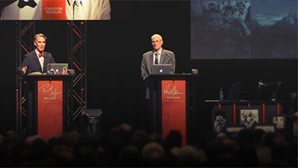
Feb. 4, 2016
Watch Bill Nye debate Ken Ham on whether creation is a viable model of origins in today’s modern scientific era.
观看比尔·奈（Bill Nye）辩论肯·汉姆（Ken Ham）关于创造是否是当今现代科学时代的可行的起源模型。

When to Introduce Your Kids to Evolution

Jan. 29, 2016
Our children should acquire an understanding of evolutionary ideas, particularly as it contrasts with a biblical creation viewpoint.
我们的孩子应该对进化观念有所了解，尤其是与圣经的创造观点形成鲜明对比的时候。

The Evolution of the Permian Extinction?
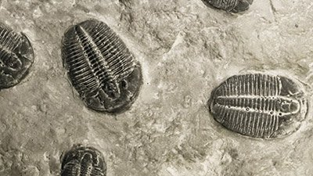
Dec. 23, 2015
Geologists claim their work with the fossil Dicynodon shows that the supposed terrestrial mass extinction happened before the marine extinction.
地质学家声称他们与化石龙的化石工作表明，所谓的陆地大规模灭绝是在海洋灭绝之前发生的。

How “Evolution” Might Save Coral Reefs

Dec. 21, 2015
What can we do to help corals survive and why should we want to?
我们该怎么做才能帮助珊瑚生存，我们为什么要这样做？

Evolutionary Conjecture Cannot Cure Cancer

Nov. 27, 2015
Evolutionary scientists assume the patterns they see result from evolution and therefore erroneously believe evolutionary thinking can help the war on cancer.
进化猜想不能治愈癌症

2015年11月27日
进化科学家假设他们看到的模式是进化的结果，因此错误地认为进化思维可以帮助抗击癌症。

Is The Good Dinosaur Good?
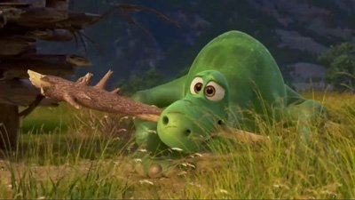
Nov. 25, 2015
Disney/Pixar’s Good Dinosaur did leave us wondering what exactly good means. But the Christian has a perfect standard on this.

迪斯尼/皮克斯的《好恐龙》确实让我们想知道到底什么意味着好。 但是基督徒对此有一个完美的标准。

Did We Really Land on the Moon?
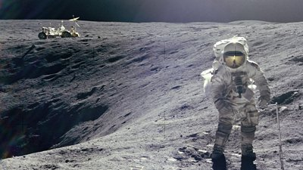
Nov. 21, 2015
Many people remember watching on TV the remarkable events of July 20, 1969, when Neil Armstrong and Buzz Aldrin walked on the moon. Or did they?
许多人记得在电视上观看1969年7月20日的重大事件，当时尼尔·阿姆斯特朗和巴兹·奥尔德林在月球上行走。 还是他们？

How the Gospel, Not Evolution, Can Solve Society’s Problems

Nov. 14, 2015
Evolutionists are correct in one thing: understanding where people came from is essential to understanding morality and answering the problems in our society.
进化论者在一方面是正确的：了解人们来自何处对于理解道德和回答我们社会中的问题至关重要。

Evolutionists Must Know Something That Algae Don’t

Nov. 13, 2015
A recent study on algae supposedly sheds light on how aquatic life became terrestrial.
进化论者必须知道藻类不知道的东西

2015年11月13日
据推测，最近对藻类的研究揭示了水生生物如何成为陆地生物。

Were Duck-Billed Dinosaurs Found in Alaska Warm Blooded?
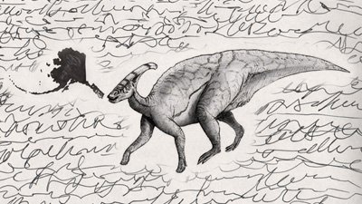
Nov. 7, 2015
The observational evidence of this Alaskan dinosaur graveyard fits much better with the Biblical account of the Global Flood.
这个阿拉斯加恐龙墓地的观测证据更符合圣经对全球洪水的描述。

Misconceptions About Creation

Oct. 24, 2015
Instead of fairly presenting what creationists teach, the senior editor of BioLogos chose to ignore actual creationist arguments.
对创造的误解
2015年10月24日
BioLogos的高级编辑没有公平地表达创世论者的教导，而是选择忽略实际的创世论者的论点。

Finding Noah: An Adventure of Faith

Oct. 7, 2015
Finding Noah will at least give AiG a platform to put the biblical Ark in front of many more people, who may turn to the Bible itself for further study.
寻找诺亚：信仰冒险
2015年10月7日
寻找诺亚至少将为AiG提供一个平台，将圣经的方舟摆在更多的人面前，他们可能会求助于圣经本身做进一步的研究。

Dead Chickens Tell No Tales, Though Journalists Might

Oct. 5, 2015
Scientists were hoping for insight into why so many fossilized dinosaurs are buried in rock appearing to be in what’s been called the “throes of death” posture.
死鸡没有故事，尽管记者可能
2015年10月5日
科学家希望能洞悉为什么这么多化石恐龙被埋在岩石中，看上去像是所谓的“死亡之喉”。

What If Dinosaurs Really Had Feathers?
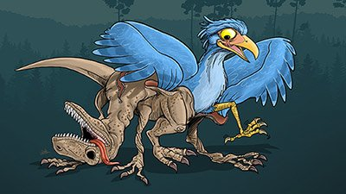
Sept. 24, 2015
Zhenyuanlong is not a blow to biblical belief or proof that dinosaurs evolved into birds, but a testimony to avian diversity of the pre-Flood world.
震源龙不是对圣经信仰的打击，也不是恐龙进化为鸟类的证据，而是对洪水前鸟类多样性的见证。

A Matter of Faith

Feb. 15, 2015
This new film by Rich Christiano explores the conflict of worldviews and the importance of faith.
信仰问题
2015年2月15日
Rich Christiano执导的这部新电影探讨了世界观的冲突和信仰的重要性。

One-Year Anniversary of the Nye-Ham Debate
Feb. 2, 2015
This interview, on the one-year anniversary of the debate between Bill Nye and Ken Ham, captures the impact of the debate and AiG's heart for ministry.
这次采访是在比尔·奈（Bill Nye）和肯·汉姆（Ken Ham）辩论一周年之际，捕捉到了这场辩论的影响以及AiG事工的心。

Feedback: Did Ken Ham Lose the Debate?
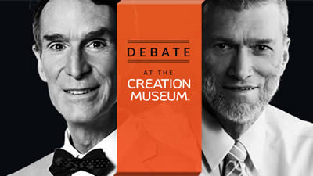
Jan. 30, 2015
A skeptic argues that Ken Ham lost the debate because AiG continues to publish debate answers, but Bill Nye never addressed the topic.
怀疑论者认为，肯·汉姆（Ken Ham）败诉是因为AiG继续发布辩论的答案，但比尔·奈（Bill Nye）从未谈到这个话题。

Responding to Atheist Propaganda

Jan. 16, 2015
Many secularists have put together a very effective propaganda machine as part of their effort to impose their atheistic religion on the Western culture.
回应无神论者的宣传
2015年1月16日
许多世俗主义者聚集了一个非常有效的宣传机器，作为他们将无神论宗教强加于西方文化的努力的一部分。
•

Week 8: The importance of Christian friendship during senior years. Learn from David and Jonathan. Summary report is due.
Childhood friendships are precious. They could last a lifetime. That’s why schools are important. Chinese culture is essential for the growth of boys and girls.
第八周：高年级基督徒友谊的重要性。 向大卫和乔纳森学习。 摘要报告到期。
童年的友谊是宝贵的。 他们可以持续一生。 这就是为什么学校很重要。 中国文化对于男孩和女孩的成长至关重要。

The Story of David

David, a young shepherd from the fields of Bethlehem, rose to become king of Israel.
David was described as “glowing with health and had a fine appearance and handsome features” and he was “well spoken.”
1 SAMUEL 16:12, 18
大卫的故事
大卫是伯利恒地里的一位年轻牧羊人，起身成为以色列的国王。
大卫被描述为“健康健康，外表美观，特征英俊”，并且“口语很好”。
1 SAMUEL 16:12，18

One Story You Know
Most people have heard of the famous fight between David and Goliath—an inexperienced boy against a battle-hardened giant, who stood between 9 and 11 feet tall. His armor alone weighed over 125 pounds and his spear’s tip was about 15 pounds. Goliath cursed God and the men of Israel.
At 14 to 16 years of age, David volunteered to fight the giant using only a sling. Modern testing has proven that a skilled adult could fling a 2- to 3-inch stone at speeds up to 150 miles per hour. With great accuracy, the teenager killed Goliath with a single rock.
David and Goliath is more than the tale of an underdog defeating an unbeatable adversary. It was about God using David in the battle.
你知道的一个故事
大多数人都听说过大卫与巨人之间的著名战斗，这是一个缺乏经验的男孩，与一个身高9至11英尺的顽强巨人作战。 仅他的装甲重125磅，矛尖约15磅。 歌利亚诅咒上帝和以色列人。
在14至16岁时，戴维（David）自愿只用吊索与巨人作战。 现代测试证明，熟练的成年人可以以每小时150英里的最高速度跳出2至3英寸的石头。 这位少年非常准确地用一块石头杀死了巨人。
大卫和歌利亚不仅仅是失败者击败无敌对手的故事。 关于上帝在战斗中使用大卫。
One Story You Don’t Know
Fully understanding David’s story sometimes requires following a story that skips along with connections appearing in several books of the Old and New Testaments. One of these stories starts long before David’s birth. It’s a footnote to the famous Battle of Jericho, and involves a prostitute named Rahab.
As told in Joshua Chapter 2, Rahab hid two Israelite spies sent into Jericho prior to its destruction. Soldiers hunting for the spies could not find them because Rahab hid them. For this, she was blessed by God.
Rahab is mentioned again later in the Old Testament. Though she was not born a Jew, Rahab converted and, according to a genealogy in Ruth 4, Rahab married Salmon, a prince of Judah, and later became David’s great, great grandmother. This is important because this David connection puts Rahab in the family tree of Jesus. She is included, along with David, in the genealogy of Jesus (Matthew 1:4-6). It’s one of the most amazing details about His blood relations and the meaning of grace: A prostitute is included in Jesus’s earthly family.
一个你不知道的故事
全面了解大卫的故事有时需要跟随一个故事，而这个故事会与旧约和新约的几本书中出现的联系相伴而生。这些故事之一是在大卫出生之前很久开始的。这是著名的耶利哥战役的脚注，其中包括一个名叫拉哈卜的妓女。
如约书亚记第2章所述，拉哈卜藏匿了两名进入耶利哥的以色列间谍，然后将其摧毁。搜寻间谍的士兵找不到他们，因为Rahab隐藏了他们。为此，她得到了上帝的祝福。
拉哈卜在旧约中再次提到。拉哈卜虽然未出生为犹太人，但还是converted依了他，根据路得记4章的家谱，拉哈卜嫁给了犹大王子萨蒙，后来成为大卫的曾祖母。这很重要，因为大卫的这种联系使拉哈卜进入了耶稣的家谱。她与大卫一起被列入耶稣的家谱中（马太福音1：4-6）。这是有关他的血缘关系和恩典含义的最令人惊讶的细节之一：耶稣的世俗家庭中有一个妓女。

BECOMING KING DAVID
David was young when Samuel anointed him, promising God one day would make David king. David tended sheep for years, waiting on God. Then things happened. David played harp for Saul. He killed Goliath. Saul made David an army commander. David excelled in Saul’s army. (1 Samuel 18:5)
But jealousy and fear crept into Saul. “Saul was afraid of David, because the LORD was with David but had departed from Saul.” (1 Samuel 18:12 ESV) Saul banished David. Men gathered around David over time.
Years later, the Philistines killed Saul and Jonathan. David mourned the loss of Saul and Jonathan. (2 Samuel 1:11,12) David was crowned king.
成为大卫王
撒母耳膏膏大卫时，他还年轻，就曾许诺上帝会成为大卫王。 大卫抚养绵羊多年，一直在等待上帝。 然后事情发生了。 大卫为扫罗演奏竖琴。 他杀死了歌利亚。 扫罗任命大卫为陆军司令。 大卫在扫罗的军队中表现出色。 （撒母耳记18：5）
但是嫉妒和恐惧蔓延到扫罗。 “扫罗惧怕大卫，因为耶和华与大卫同在，却离开扫罗。” （撒母耳记18:12 ESV）扫罗放逐了大卫。 随着时间的流逝，人们聚集在大卫身边。
多年以后，非利士人杀死了扫罗和约拿单。 大卫哀悼扫罗和约拿单的丧生。 （2撒母耳记1：11,12）大卫被加冕为王。

DAVID'S RULE
Consolidation: David became king of Judah at age 30. Seven years later, Israel and Judah united under David’s rule.
City of David: The Jebusites, a foreign tribe, controlled Jerusalem. David captured Jerusalem and made it his kingdom’s capital.
Fulfilled Promise: Early, David defended the kingdom against the Philistines. Later, he extended the kingdom by defeating the Moabites and Hadadezer, King of Zobah. David’s kingdom included the land promised to Abraham.
A New Home: David brought the Ark to Jerusalem, celebrating all the way.
Rule: David organized the kingdom. He established officials, prepared for the temple’s construction and organized the Levites and priests.
Loyalty: David showed his loyalty by providing for Jonathan’s disabled son, Mephibosheth.
Justice: Joshua established a truce between Israel and the Gibeonites. Saul had tried to decimate them. David made reparations.
Intrigue: Amnon, David’s first born son raped his beautiful half sister, Tamar. David did not punish Amnon. Absalom, Tamar’s brother, plotted revenge. Two years later, Absalom had Amnon murdered when he was drunk.
Power Struggle: Absalom tried to wrestle power from David. When David was old, Adonijah, another son, tried to usurp the throne from Solomon. David had Solomon anointed king while Adonijah’s coronation party was in progress.
大卫的规则
巩固：大卫在30岁时成为犹大王。七年后，以色列和犹大在大卫的统治下联合。
大卫市：耶布斯人（一个外国部落）控制着耶路撒冷。大卫占领了耶路撒冷，并将其作为他王国的首都。
兑现承诺：早期，大卫为非利士人捍卫了王国。后来，他击败了扎巴赫国王摩押人和哈达德泽，扩大了王国。大卫的王国包括应许给亚伯拉罕的土地。
新家：大卫将方舟带到耶路撒冷，一路庆祝。
法则：大卫组织了王国。他建立了官员，为圣殿的建造做准备，并组织了利未人和祭司。
忠诚度：David通过提供乔纳森（Jonathan）的残疾儿子Mephibosheth来表达自己的忠诚度。
正义：约书亚在以色列和基遍人之间建立了休战。扫罗曾试图使他们丧命。大卫作出赔偿。
阴谋：戴维（David）的长子安农（Amnon）强奸了他漂亮的同父异母妹妹塔玛（Tamar）。大卫没有惩罚阿嫩。添马舰的兄弟押沙龙策划了复仇行动。两年后，押沙龙在醉酒时杀害了暗嫩。
权力斗争：押沙龙试图从大卫手中夺取权力。大卫年老时，另一个儿子亚多尼雅（Adonijah）试图从所罗门手中夺取王位。在亚多尼雅的加冕聚会进行期间，大卫将所罗门膏为王。

MORAL FAILURE
David, “a man after God’s own heart,” displayed outstanding public leadership. But David sinned and repented in his private life. David was not perfect, just forgiven.
David’s affair with Bathsheba, Uriah’s wife, was his greatest moral failure. A pregnancy and a failed cover-up resulted. To hide his sin, David murdered Uriah, an army officer, by having him abandoned on the battlefield. God’s prophet, Nathan confronted David. Though David confessed and repented, Nathan prophesied the Lord would bring judgment to David (2 Samuel 11, 12). These punishments included:
• The death of David and Bathsheba’s baby
• Violence for David’s household, including Tamar’s rape and Amnon’s murder.
• More trouble for David’s household. Absalom launched a conspiracy to overthrow his father. Over time, Absalom won over the men of Israel, and launched his coup. A battle ensued and 20,000 Israelites died. Absalom was captured and killed by those who remained loyal to David. This led to David’s heartbreaking lament, “O my son Absalom, my son, my son Absalom! Would I had died instead of you, O Absalom, my son, my son!” 2 Samuel 18:33
道德失误
戴维（David）是“追求上帝自己内心的人”，表现出杰出的公众领导能力。但是大卫在自己的私生活中犯了罪并悔改了。大卫不是完美的，只是被宽恕了。
大卫与乌里亚（Uriah）的妻子拔示巴（Bathsheba）的恋情是他最大的道德失败。怀孕和掩饰失败。为了掩饰自己的罪过，戴维通过将他遗弃在战场上而谋杀了一名军官乌里亚。上帝的先知内森与大卫对峙。尽管大卫认罪悔改，但内森预言主会审判大卫（撒母耳记下11，12）。这些惩罚包括：
•大卫和拔示巴的婴儿去世
•对大卫家的暴力，包括塔玛（Tamar）的强奸和阿农（Amnon）的谋杀。
•给大卫的家庭带来更多麻烦。押沙龙发起阴谋推翻父亲。随着时间的流逝，押沙龙战胜了以色列人，发动了政变。随后发生战斗，20,000名以色列人丧生。押沙龙被仍然忠于大卫的人俘虏杀害。这引起了大卫令人心碎的哀叹：“我的儿子押沙龙，我的儿子，我的押沙龙！我的儿子，我的儿子阿押沙龙，我愿意代替你而死！” 2撒母耳记18:33

A Faithful Friend
by Charles H. Spurgeon on May 24, 2009

Friendship seems as necessary an element of a comfortable existence in this world as fire or water, or even air itself.
A Sermon Delivered On Sunday Morning, March 8, 1857, By Pastor C. H. Spurgeon, At The Music Hall, Royal Surrey Gardens.
There is a friend who sticks closer than a brother. (Pr 18:24)
忠实的朋友
由Charles H. Spurgeon在2009年5月24日

友谊似乎是这个世界上舒适存在的必要元素，例如火或水，甚至空气本身。
1857年3月8日（星期日）早晨，布赫牧师在皇家萨里花园音乐厅举行的布道。
有一个比兄弟更贴近朋友的朋友。 （箴18:24）
  - Cicero has well said, “Friendship is the only thing in the world concerning the usefulness of which all mankind are agreed.” Friendship seems as necessary an element of a comfortable existence in this world as fire or water, or even air itself. A man may drag along a miserable existence in proud solitary dignity, but his life is scarcely life, it is nothing but an existence, the tree of being stripped of the leaves of hope and the fruits of joy. He who wishes to be happy here must have friends; and he who wishes to be happy hereafter, must, above all things, find a friend in the world to come, in the person of God, the Father of his people.
1.西塞罗很好地说：“友谊是世界上唯一关于全人类都被接受的有用性的事情。” 友谊似乎是这个世界上舒适存在的必要元素，例如火或水，甚至空气本身。 一个人可能以自豪的孤独尊严在悲惨的生活中挣扎，但他的生活简直就是生活，它不过是一种生存，被剥夺了希望的叶子和喜悦的果实。 希望在这里幸福的人必须有朋友。 希望以后幸福的人必须首先在神的人，他子民的父那里找到世界上一位朋友。
2. Friendship, however, though very pleasing and exceedingly blessed, has been the cause of the greatest misery to men when it has been unworthy and unfaithful; for just in proportion as a good friend is sweet, a false friend is full of bitterness. “A faithless friend is sharper than an adder’s tooth.” It is sweet to repose in someone; but oh! how bitter to have that support snapped, and to receive a grievous fall as the result of your confidence. Fidelity is an absolute necessity in a true friend; we cannot rejoice in men unless they will stand faithful to us. Solomon declares that “there is a friend who sticks closer than a brother.” That friend, I suppose, he never found in the pomps and vanities of the world. He had tried them all, but he found them empty; he passed through all their joys, but he found them “vanity of vanities.” Poor Savage spoke from sad experience when he said—
You’ll find the friendship of the world a show!
Mere outward show! ‘Tis like the harlot’s tears,
The statesman’s promise, or false patriot’s zeal,
Full of fair seeming, but delusion all.
2.然而，友谊虽然令人愉悦并受到极大的祝福，但在不值得和不忠的情况下，却是造成人类最大痛苦的原因；因为好朋友是甜蜜的，所以假朋友充满了痛苦。 “一个不忠实的朋友比加法器的牙齿更敏锐。”和某人在一起很甜蜜。但是哦！失去这种支持是多么痛苦，并由于您的信心而遭受严重挫败。在一个真正的朋友中，忠诚是绝对必要的。除非他们忠于我们，否则我们无法为人高兴。所罗门宣称“有一个朋友比一个兄弟更靠近”。我想，那个朋友，他在世界的盛况和虚荣心中从未发现过。他试过了所有的东西，但发现它们是空的。他经历了他们的所有欢乐，但发现他们“虚荣心”。可怜的野蛮人从悲伤的经历中说道​​：
您会发现一场世界友谊！
只是外向表演！就像妓女的眼泪，
政治家的诺言，或爱国者的热心，
看起来很公平，但全是幻想。
And so for the most part they are. The world’s friendship is always brittle. Trust in it, and you have trusted a robber; rely upon it, and you have leaned upon a thorn; aye, worse than that, upon a spear which shall pierce you to the soul with agony. Yet Solomon says he had found “a friend who sticks closer than a brother.” Not in the haunts of his unbridled pleasures, nor in the wanderings of his unlimited researches, but in the pavilion of the Most High, the secret dwelling place of God, in the person of Jesus, the Son of God, the Friend of sinners
因此，在大多数情况下都是如此。 世界的友谊总是脆弱的。 相信它，您就相信了强盗。 依靠它，您就倚在荆棘上。 是的，比这还糟糕的是，长矛将痛苦地刺入你的灵魂。 然而所罗门说，他已经找到了“一个比兄弟更亲密的朋友”。 不是在他无拘无束的欢乐的，绕中，也不是在他无限的研究的徘徊中，而是在至高的殿堂中，上帝的秘密住所，上帝的儿子耶稣，罪人的朋友，
  - It is saying a great thing, to affirm that “there is a friend who sticks closer than a brother;” for the love of brotherhood has produced most valiant deeds. We have read stories of what brotherhood could do, which, we think, could hardly be excelled in all the annals of friendship. Timoleon, with his shield, stood over the body of his slain brother, to defend him from the insults of the foe. It was reckoned a brave deed of brotherhood that he should dare the spears of an army in defence of his brother’s corpse. And many such instances there have been, in ancient and modern warfare, of the attachment of brothers. There is a story told of two brothers in a Highland regiment, who, while marching through the Highlands, lost their way; they were overtaken by one of the terrible storms, which will sometimes come upon travellers unawares, and blinded by the snow, they lost their way upon the mountains. Almost frozen to death, it was with difficulty they could continue their march. One man after another dropped into the snow and disappeared. There were two brothers, however, by the name of Forsythe; one of them fell prostrate on the earth, and would have lain there to die, but his brother, though barely able to drag his own limbs across the white desert, took him on his back, and carried him along, and as others fell one by one, this brave true hearted brother carried his loved one on his back, until at last he himself fell down overcome with fatigue, and died. His brother, however, had received such warmth from his body that he was enabled to reach the end of his journey in safety, and so lived. Here we have an instance of one brother sacrificing his life for another. I hope there are some brothers here who would be prepared to do the same if they would ever be brought into the same difficulty. It is saying a great thing, to declare that “there is a friend who sticks closer than a brother.” It is putting that friend first of all in the list of loving ones; for surely, next to a mother’s love, there is, and there ought to be, no higher affection in the world than the love of a brother to one begotten by the same father, and dandled on the same knee. Those who have, “Grown in beauty side by side, and filled one house with glee,” ought to love one another. And we think there have been many glorious instances and mighty proofs of the love of brothers. Yet, says Solomon, “there is a friend who sticks closer than a brother.”
3.肯定是一件好事，肯定是“有一个朋友比一个兄弟更亲密；”因为热爱兄弟会产生了最英勇的事迹。我们已经读过关于兄弟会可以做什么的故事，我们认为，在所有友谊史上，这很难超越。蒂莫龙带着他的盾牌，站在他被杀死的兄弟的身上，以保护他免受敌人的侮辱。人们认为他是一个勇敢的兄弟会，他应该敢为捍卫哥哥的尸体而动一支军队的长矛。在古代和现代战争中，有许多这样的情况是兄弟的依恋。有一个故事讲述了一个高地团中的两个兄弟，他们在高地行军时迷路了。他们被一场可怕的风暴所超越，有时会无意识地出现在旅行者身上，被雪蒙蔽，他们迷路了。他们几乎无法继续前进，几乎被冻死了。一个男人一个接一个地跌入雪地，消失了。然而，有两个兄弟，名叫福赛斯（Forsythe）。他们中的一个跌倒在地上，本该躺在那里死去的，但是他的兄弟虽然勉强能将自己的四肢拖到白色的沙漠上，却把他背在背上，并把他带走，其他人跌倒了。这位勇敢，真心实意的兄弟背负着自己所爱的人，直到最后他自己疲惫地摔倒了，死了。然而，他的兄弟从身体得到了如此温暖，以至于他得以安全度过旅程的最后阶段，因此得以生存。在这里，我们有一个例子，一个兄弟为了另一个而牺牲自己的生命。我希望这里有一些兄弟，如果他们遇到同样的困难，他们愿意做同样的事情。宣布“有一个朋友比一个兄弟更亲密”是一件很棒的事情。它把那个朋友放在了最爱的人的名单中。当然，在母亲的爱旁边，世界上应该而且应该存在的爱情，不应该比兄弟对同一个父亲所生的爱的爱更高。那些拥有“并排成长的美，并在一间房子里充满欢乐”的人应该彼此相爱。我们认为，有许多光荣的实例和强有力的证据证明了兄弟的爱。所罗门说：“然而，有一个朋友比一个兄弟更加亲密。”
4. To repeat our assertion, we believe that this friend is the blessed Redeemer Jesus Christ. It shall be ours first, to prove, this morning the fact that he sticks closer than a brother; then as briefly as we can, to show you why he sticks closer than a brother; and then to finish up by giving you some lessons which may be drawn from the doctrine, that Jesus Christ is a faithful friend.
4.为了重申我们的主张，我们相信这个朋友是有福的救赎主耶稣基督。 今天早晨，这是我们的第一个事实，证明他比兄弟更贴近事实。 然后尽可能简短地向您展示为什么他比兄弟更靠近 最后，向您提供一些可以从该教义中吸取的教训，那就是耶稣基督是一位忠实的朋友。
5. I. First, then, beloved, we assert that CHRIST IS “A FRIEND WHO STICKS CLOSER THAN A BROTHER.” And in order to prove this from facts, we appeal to such of you as have had him for a friend. Will you not, each of you, at once give your verdict, that this is neither more nor less than an unexaggerated truth? He loved you before all worlds, long before the daystar flung its ray across the darkness, before the wings of angels had flapped the unnavigated ether, before anything in creation had struggled from the womb of nothingness, God, even our God, had set his heart upon all his children. Since that time, has he once swerved, has he once turned aside, once changed? No; you who have tasted of his love and know his grace will bear me witness, that he has been a certain friend in uncertain circumstances.
He, near your side has always stood,
His loving kindness, oh! how good!
You fell in Adam; did he cease to love you? No; he became the second Adam to redeem you. You sinned in practice and brought upon your head the condemnation of God; you deserved his wrath and his utter anger; did he then forsake you? No!
He saw you ruined in the fall,
Yet lov’d you notwithstanding all.
5. I.首先，然后，亲爱的，我们断言基督是“比兄弟更亲密的朋友”。为了从事实中证明这一点，我们呼吁您邀请他为朋友。你们每个人都不会立刻做出判决，认为这既不等于也不小于一个夸大的事实吗？他在万物之前就爱过你，在白日之星在黑暗中掠过它的光芒之前，在天使的翅膀扑过那条无法通行的以太之前，在创造的任何事物摆脱虚无的子宫挣扎之前，上帝，甚至我们的上帝都已经定了他的爱。怀念他所有的孩子。从那时起，他是否曾经弯下腰，是否曾经转过身，变过身？没有;那些尝过了他的爱，知道他的恩典的人，将使我见证他在不确定的情况下已经是某个朋友。
他，在你身边一直站着，
他的慈爱哦！有多好！
你爱上亚当；他停止爱你了吗？没有;他成为第二位赎回您的亚当。你在实践中犯了罪，把对上帝的谴责带到了你的头上。你应得他的愤怒和愤怒。然后他离弃了你吗？没有！
他看到你在秋天被毁了，
然而，尽管如此，您还是会爱上您的。
He sent his minister after you—you despised him; he preached the gospel in your ears—you laughed at him; you broke God’s Sabbath, you despised his Word. Did he then forsake you? No!
Determined to save, he watched o’er your path,
While Satan’s blind slave, you sported with death.
And at last he arrested you by his grace, he humbled you, he made you penitent, he brought you to his feet and he forgave all your sins. Since then, has he left you? You have often left him; has he ever left you? You have had many trials and troubles; has he ever deserted you? Has he ever turned away his affections, and shut up his heart of compassion? No, children of God, it is your solemn duty to say “No,” and bear witness to his faithfulness. You have been in severe afflictions and in dangerous circumstances; did your friend desert you then? Others have been faithless to you; he who eats bread with you has lifted up his heel against you; but has Christ ever forsaken you? Has there ever been a moment when you could go to him, and say, “Master, you have betrayed me.” Could you once, in the blackest hour of your grief, dare to impugn his fidelity? Could you dare to say of him, “Lord, you have promised what you did not perform?” Will you not bear witness now: “Not one good thing has failed of all that the Lord God has promised; all has come to pass?” And do you fear he will yet forsake you? Ask, then, the bright ones before the throne—“You glorified spirits! Did Christ forsake you? You have passed through Jordan’s stream; did he leave you there? You have been baptized in the black flood of death, did he there forsake you? You have stood before the throne of God; did he then deny you?” And they answer “No; through all the troubles of our life, in all the bitterness of death, in all the agonies of our expiring moments, and in all the terrors of God’s judgment, he has been with us, "a friend who sticks closer than a brother."” Out of all the millions of God’s redeemed, there is not one he has forsaken. Poor they have been, lowly and distressed, but he has never abhorred their prayer, never turned aside from doing them good. He has been always with them.
For his mercy shall endure,
Ever faithful, ever sure.
他派大臣追随你-你鄙视他；他在你耳边传福音，你在嘲笑他。你打破了上帝的安息日，鄙视了他的话。然后他离弃了你吗？没有！
决心要保存，他看着你的路，
当撒旦是盲目的奴隶时，你却死得像体育。
最后他以恩典逮捕了你，他谦卑了你，使你悔改了，他使你站起来，他宽恕了你的所有罪过。从那以后，他离开了你吗？你经常离开他；他有没有离开过你？您经历了许多考验和麻烦。他有没有抛弃你？他有没有放弃过自己的感情，闭上了同情心？不，上帝的儿女，您的庄严义务是说“不”，并为他的忠诚做见证。您遭受了严重的苦难和处于危险的境地；那你的朋友离开了你吗？别人对你不忠；与你一起吃面包的人将他的脚跟抬起。但是基督有没有抛弃你？曾经有片刻你可以去找他，说：“师父，你背叛了我。”在悲伤的最黑暗的时刻，你能一次敢责备他的忠诚吗？您能不敢对他说：“主，您已答应了您未履行的义务？”您现在不愿作见证吗：“主上帝应许的一切都没有一件好事失败了；一切都过去了？”并且您担心他会放弃您吗？然后问问宝座前那些聪明的人-“你们荣耀了灵魂！基督离弃了你吗？您已经穿越了约旦的溪流；他有没有把你留在那里？您在死亡的黑色洪水中受洗了，他在那里抛弃了您吗？你站在上帝的宝座前；然后他否认了你吗？”他们回答“不，在我们生活中的所有麻烦，死亡的痛苦，死亡时刻的所有痛苦中，以及在上帝审判的所有恐怖中，他一直与我们在一起，“一个比兄弟更亲密的朋友”。 “在赎回的数以百万计的上帝中，没有一个他被抛弃过。他们一直贫穷，卑鄙和痛苦，但他从未憎恶他们的祈祷，从未放弃过为他们做好事。他一直和他们在一起。
因为他的怜悯将忍受，
永远忠实，永远确定。
- But I shall spend no more time on this point, since I cannot prove this to the ungodly, and to the godly it is already proven, for they know it by experience; therefore it is very little necessity that I should do more than just certify the fact that Christ is a faithful friend—a friend in every hour of need and every time of distress.
6.但是我在这一点上不会再花时间了，因为我无法向不敬虔的人证明这一点，也已经向敬虔的人证明了这一点，因为他们从经验中知道这一点。 因此，除了证明基督是一个忠实的朋友-每一个需要和痛苦的时候都是朋友这一事实，我几乎不需要做更多的事情。
7. II. And now I have to tell you THE REASONS WHY IT IS WE MAY DEPEND UPON CHRIST AS BEING A FAITHFUL FRIEND.
8. There are some things in himself which render it certain that he will stick close to his people.
9. 1. True friendship can only be made between true men, whose hearts are the soul of honour. There can be no lasting friendship between bad men. Bad men may pretend to love each other, but their friendship is a rope of sand, which shall be broken at any convenient season; but if a man has a sincere heart within him, and is true and noble, then we may confide in him. Spenser sings in fine old English verse—
Ne, (never) certes (of a certainty) can that friendship long endure,
However gay and goodly be the style,
That doth ill cause or evil end enure, (commit)
For Vertue (virtue) is the band that bindeth Harts (hearts) most sure.
But who can find a stain in the character of Jesus, or who can tarnish his honour? Has there ever been a spot on his escutcheon? (shield with a coat of arms on it) Has his flag ever been trampled in the dust? Does he not stand the true witness in heaven, the faithful and just? Is it not declared concerning him that he is God who cannot lie? Have we not found him so up to this moment; and may we not, knowing that he is “Holy, holy, holy Lord,” confide in him, that he will stick closer to us than a brother? His goodness is the guarantee of his fidelity; he cannot fail us.
7.二。现在，我不得不告诉您，为什么我们可能会成为基督徒而依赖基督教。
8.他内在的某些事情使他确信他会紧贴自己的人民。
9. 1.真正的友谊只能建立在真正的人之间，他们的心是荣誉的灵魂。坏人之间不可能有持久的友谊。坏人可能会假装彼此相爱，但他们的友谊是一条沙绳，在任何方便的季节都将被打断。但是，如果一个人内心深处真诚，高尚，那么我们可以向他倾诉。斯彭塞（Spencer）在古老的英语经典诗歌中唱歌—
Ne（肯定）永不能够长期维持这种友谊，
不管是同性恋还是好人，
造成病因或邪恶的事情必定会发生，（犯）
对于Vertue（美德）来说，最能约束Harts（心灵）的乐队。
但是谁能在耶稣的品格上找到污点，或者谁能损害他的荣誉呢？他的锁眼盖上有过吗？ （戴上盾牌的盾牌）他的旗帜曾经被践踏过吗？他难道不是站在天堂里的忠实和正义的真正见证者吗？难道没有宣布他是不能撒谎的上帝吗？到目前为止，我们还没有找到他吗？难道我们不知道他是“圣洁，圣洁，圣洁的主”，向他倾诉，他会比兄弟更亲近我们吗？他的善良是他忠诚的保证。他不能让我们失败。
10. 2. Faithfulness to us in our faults is a certain sign of fidelity in a friend. You may depend upon that man who will tell you of your faults in a kind and considerate manner. Fawning hypocrites, insidious flatterers, are the sweepings and offal of friendship. They are the parasites upon that noble tree. But true friends put enough trust in you to tell you openly about your faults. Give me for a friend the man who will speak honestly about me to my face; who will not tell first one neighbour, and then another, but who will come straight to my house, and say, “Sir, I feel there is such-and-such a thing in you, which, as my brother, I must tell you about”—that man is a true friend; he has proven himself to be so; for we never get any praise for telling people about their faults, we rather risk their dislike; a man will sometimes thank you for it, but he does not often like you any the better. Praise is a thing we all love. I met with a man the other day who said he was impervious to flattery; I was walking with him at the time, and turning around rather sharply, I said, “At any rate sir, you seem to have a high gift in flattering yourself, for you are really doing so, in saying you are impervious to flattery.” “You cannot flatter me,” he said. I replied, “I can, if I wish to try;” and perhaps may do so before the day is out. I found I could not flatter him directly, so I began by saying what a fine child that was of his; and he drank it in as a precious draught; and when I praised this thing and that belonging to him, I could see that he was very easily flattered; not directly, but indirectly. We are all pervious to flattery; we like the soothing cordial, only it must not be labelled flattery; for we have a religious abhorrence of flattery if it is so called; call it by any other name, and we drink it in, even as the ox drinks in water. Now, child of God, has Christ ever flattered you? Has he not told you of your faults very truly? Has he not pricked your conscience even upon what you thought to gloss over—your little secret sins? Has he not provoked conscience to thunder in your ears notes of terror, because of your misdeeds? Well, then, you may trust him, for he shows that faithfulness which renders a man very trustworthy. Thus I have pointed out to you that there are reasons in himself for which we may trust him.
10. 2.忠于我们，是对我们朋友的忠诚。您可能依赖那个会以善良和体贴的方式告诉您您的错误的人。讨人喜欢的伪君子，阴险的奉承者，是友谊的大杂烩。它们是那棵高树上的寄生虫。但是，真正的朋友对您有足够的信任，可以公开告诉您您的过错。给我一个朋友，这个男人会诚实地对我说我的话。他们不会先告诉一个邻居，然后再告诉另一个邻居，但是谁会直接来到我家，并说：“先生，我觉得你里面有那么多东西，作为我的兄弟，我必须告诉你约”-那个男人是一个真正的朋友；他证明自己是这样；因为我们永远不会因为告诉人们他们的过错而得到任何赞美，我们宁愿冒他们不喜欢的风险；一个人有时会为此而感谢您，但他并不经常喜欢您。赞美是我们所有人都喜欢的事情。前几天我遇到一个男人，他说他不敢恭维。当时我正和他一起走路，转过身时非常锐利，我说：“先生，无论如何，你似乎在奉承自己方面有很高的天分，因为你确实这样做了，说你不能奉承。 ”他说：“你不能奉承我。”我回答说：“如果可以，我可以；”也许可以在一天结束之前这样做。我发现我不能直接恭维他，所以我首先说他是个好孩子。他把它当作珍贵的吃喝喝了。当我称赞这东西和他的东西时，我可以看出他很容易受宠若惊。不是直接的，而是间接的。我们所有人都乐于奉承。我们喜欢舒缓的亲切，但绝不能标榜奉承；因为所谓的奉承是我们的宗教憎恶；用其他任何名字称呼它，我们就喝它，就像牛在水中喝一样。现在，上帝的儿女，基督曾经恭维你吗？他不是真的把你的错告诉了你吗？即使您以为您掩饰了您的小秘密罪孽，他是否也没有刺您的良心？他是否因为您的不当行为而引起良知在您耳中惊恐地打雷？那么，您可能会信任他，因为他表现出的忠诚使一个人非常值得信赖。因此，我已经向您指出，我们自己可以相信他的某些理由。
11. 3. In the next place, there are some things in his friendship which render us sure of not being deceived, when we put our confidence in him. True friendship must not be of hasty growth. As quaint old Master Fuller says, “Let friendship creep gently to a height; if it rush to it, it may soon run itself out of breath.” It is even so. I think it was Joanna Baillie who said,—
Friendship is no plant of hasty growth.
Though planted in esteem’s deep fixed soil,
The gradual culture of kind intercourse
Must bring it to perfection.
In vain you trust the gourd over your head, oh Jonah; it will not be of much use to you; it came up in a night, it may wither in a night. It is the strong stiff oak, of ages growth, which shall abide the tempest; which shall alike put out its wings to shield you from the sun, and shall afterwards find you a hovel in its heart, if necessary, in its grey old age, when its branches tremble in the blast. Friendship is true when it begins; but we must have a man’s friendship long before we can say of him, that he will stick closer than a brother. And how long has Christ loved you? That you cannot tell. When the ages were not born he loved you; when this world was an infant, wrapped in the swaddling clothes of mist, he loved you; when the old pyramids had not begun to be built, his heart was set upon you; and ever since you have been born he has had a strong affection for you. He looked on you in your cradle, and he loved you then; he was affianced to you when you were an infant of a span long, and he has loved you ever since. Some of you I see with grey hairs, some with heads all bald with age; he has loved you up until now, and will he now forsake you? Oh! no, his friendship is so old that it must last; it has been matured by so many tempests, it has been rooted by so many winds of trouble, that it can only endure, it must stand. Even as the granite peak of the mountain shall not be melted, because, unlike the young snow, it has braved the blast, and borne the heat of the burning sun; it has stood out always, catching in its face every blow from the fist of nature, and yet been unmoved and uninjured. It shall last, for it has lasted. But when the elements shall melt, and in a stream of dissolving fire shall run away, then shall Christ’s friendship still exist, for it is of older growth than they. He must be “a friend who sticks closer than a brother;” for his friendship is a hoary friendship—hoary as his own head of which it is said, “His head and his hair are white like snow, as white as wool.”
11. 3.其次，当我们对他充满信心时，他的友谊中有几件事使我们确信自己不会被欺骗。真正的友谊决不能草率增长。就像古朴的富勒大师所说：“让友谊慢慢地攀升到最高点；如果它赶时间，它可能很快就会气喘吁吁。”即使如此。我认为是乔安娜·贝利（Joanna Baillie）说，
友谊不是仓促增长的植物。
虽然种植在受人尊敬的深层固定土壤中，
渐进式交际文化
必须使其完美。
约拿，你白白相信葫芦是徒劳的。它对您没有多大用处；它是在一个夜晚出现的，它可能会在一个夜晚凋谢。这是经久耐用的坚硬的橡木，将经受狂风。它会像翅膀一样伸出来保护您免受日晒，然后在您的心脏灰暗的高龄中，必要时在树枝发抖的颤抖中找到您的小屋。友谊从一开始就属实；但是我们必须要有一个男人的友谊，然后我们才能说出他会比一个兄弟更靠近他。基督爱你多久了？你无法分辨。几岁以前，他就爱你。当这个世界是婴儿时，被雾气笼罩的衣服包裹着，他爱你。当旧的金字塔还没有开始建造时，他的心就落在了你身上；自从您出生以来，他就对您产生了深厚的感情。他在你的摇篮里注视着你，那时他爱你。当您还是一个跨度很长的婴儿时，他就与您联系，从那时起，他就一直爱着您。我看到的有些人是白发，有些人的头随着年龄的增长而秃顶。到目前为止，他一直爱着你，现在他会抛弃你吗？哦!不，他的友谊太老了，必须持续下去；它已经经历了许多暴风雨的考验，它已经被如此多的麻烦之风所根深蒂固，它只能经得住，它必须经得起考验。即使山上的花岗岩山峰不融化，因为与年轻的雪不同，它冒着爆炸的气势，承受着烈日的灼热。它总是脱颖而出，从大自然的拳头扑向它的每一个打击，却丝毫没有动摇和受伤。它应该持续下去，因为它已经持续了。但是，当这些元素融化，并在一连串的溶解之火中消散时，基督的友谊将仍然存在，因为它的发展比他们早。他必须是“一个比兄弟更亲密的朋友；”因为他的友谊是一种神圣的友谊-像他自己的头这样说：“他的头和头发像雪一样白，像羊毛一样白。”
12. 4. But note, further, the friendship which will last does not make its rise in the chambers of mirth, nor is it fed and fattened there. Young lady, you speak of a dear friend whom you acquired last night in a ballroom. Do not, I beseech you, misuse the word; he is not a friend if he was acquired merely there; friends are better things than those which grow in the hot house of pleasure. Friendship is a more lasting plant than those. You have a friend, have you? Yes; and he keeps a pair of horses, and has a good establishment. Ah! but your best way to prove your friend is to know that he will be your friend when you have not so much as a humble cottage; and when homeless and without clothing, you are driven to beg your bread. Thus you would make true proof of a friend. Give me a friend who was born in the winter time, whose cradle was rocked in the storm; he will last. Our fair weather friends shall flee away from us. I would rather have a robin for a friend than a swallow; for a swallow abides with us only in the summer time, but a robin comes to us in the winter. Those are close friends that will come the nearest to us when we are in the most distress; but those are not friends who speed themselves away when bad times come. Believer, have you reason to fear that Christ will leave you now? Has he not been with you in the house of mourning? You found your friend where men find pearls, “In caverns deep, where darkness dwells;” you found Jesus in your hour of trouble. It was on the bed of sickness that you first learned the value of his name; it was in the hour of mental anguish that you first laid hold of the hem of his garment; and since then, your nearest and sweetest intercourse has been held with him in hours of darkness. Well then, such a friend, proven in the house of sorrow—a friend who gave his heart’s blood for you, and let his soul run out in one great river of gore—such a friend never can and never will forsake you; he sticks closer than a brother.
12. 4.但是，还要注意，持久的友谊不会在欢乐的殿堂中兴起，也不会在欢乐的殿堂中滋养和增肥。小姐，您说的是您昨晚在舞厅结识的一位亲爱的朋友。我恳求你，不要滥用这个词。如果只是在那儿被收购，他就不是朋友；朋友比在欢乐的屋子里成长的朋友更好。友谊比那些友谊更持久。你有一个朋友，对吗？是;他养着一匹马，并拥有良好的地位。啊!但是证明你的朋友的最好方法是知道当你没有那么简陋的小屋时，他会成为你的朋友；当无家可归，没有衣服的时候，你会被迫乞讨面包。因此，您将成为朋友的真实证明。给我一个冬天出生的朋友，摇篮在暴风雨中摇摇欲坠。他将持续。我们的晴天朋友将逃离我们。我宁愿给朋友一个知更鸟，也不愿吞下燕子。燕子只在夏天与我们同住，而知更鸟在冬天来。那些最亲密的朋友，在我们最痛苦的时候会离我们最近。但是那些不是朋友，他们会在困难时期来临时让自己走开。相信者，您是否有理由担心基督现在会离开您？他不是在哀悼屋中与您同在吗？您在朋友发现珍珠的地方找到了您的朋友，“在深深的洞穴中，那里住着黑暗；”你在麻烦的时候找到了耶稣。您首先是在病床上得知他的名字的价值。在精神痛苦的时刻，您第一次抓住了他衣服的下摆；从那时起，您与他之间最近最甜蜜的交往就在黑暗中进行。好吧，这样的朋友，在悲伤的房子里得到了证明–一个为您献血的朋友，让他的灵魂在血腥的大河中枯竭–这样的朋友永远也不会抛弃您。他比一个兄弟更靠近。
13. 5. Again, a friend who is acquired by folly is never a lasting friend. Do a foolish thing, and make a man your friend; it is only a confederacy in vice, and you will soon discover that his friendship is worthless; the friendships you acquire by doing wrong, you would be better without. Oh! how many silly friendships there are springing up, the mere fruit of a sentimentalism, having no root whatever, but like the plant of which our Saviour tells us, “It sprang up because it had no depth of earth.” Jesus Christ’s friendship is not like that; there is no ingredient of folly in it; he loves us discreetly, not winking or conniving at our follies, but instilling into us his wisdom. His love is wise; he has chosen us according to the counsel of his wisdom; not blindly and rashly, but with all judgment and prudence.
13. 5.再一次，被愚蠢的朋友永远不会是持久的朋友。 做一件愚蠢的事，使一个人成为你的朋友； 这只是邦联中的罪恶，你很快就会发现他的友谊毫无价值。 通过做错事获得的友谊，没有它会更好。 哦! 多少愚蠢的友谊如雨后春笋般涌现，只是一种情感主义的果实，毫无根源，却像我们的救主告诉我们的植物：“它蔓延是因为它没有土深。” 耶稣基督的友谊不是那样。 里面没有愚蠢的成分； 他谨慎地爱我们，不眨眼或纵容我们的愚蠢，而是向我们灌输他的智慧。 他的爱是明智的。 他是根据他智慧的计谋选择我们的； 并非盲目而轻率，而是具有所有判断力和审慎性。
14. Under this point I may likewise observe, that the friendship of ignorance is not a very desirable one. I desire no man to call himself my friend, if he does not know me. Let him love me in proportion to his knowledge of me. If he loves me for the little he knows, when he knows more he may cast me aside. “That man,” says one, “seems to be a very amiable man.” “I am sure I can love him,” says another, as he scans his features. Aye, but do not write “friend” yet; wait a wee bit, until you know more of him; just see him, examine him, try him, test him, and not until then enter him on the sacred list of friends. Be friendly to all, but make no one your friend until they know you, and you know them. Many a friendship born in the darkness of ignorance has died suddenly in the light of a better acquaintance with each other. You supposed men to be different from what they were, and when you discovered their real character you disregarded them. I remember one saying to me, “I have great affection for you, sir;” and he mentioned a certain reason. I replied, “My dear fellow, your reason is absolutely false; the very thing you love me for, I am not, and hope I never shall be.” And so I said, “I really cannot accept your friendship, if it is founded upon a misunderstanding of what I may have said.” But our Lord Jesus never can forsake those whom once he loves, because he can discover nothing in us worse than he knew, for he knew all about us beforehand. He saw our leprosy, and yet he loved us; he knew our deceitfulness and unbelief, and yet he pressed us to his heart; he knew what poor fools we were, and yet he said he would never leave us nor forsake us. He knew that we would rebel against him and despise his counsel often; he knew that even when we loved him our love would be cold and languid; but he loved for his own sake. Surely, then, he will stick closer than a brother.
14.在这一点上，我同样可以观察到，无知的友谊不是非常可取的。如果他不认识我，我不希望任何人称自己为我的朋友。让他按我对我的了解程度来爱我。如果他只知道一点点就爱我，那么当他知道更多时，他可能会将我抛在一边。一个人说：“那个人似乎是一个非常和可亲的人。”另一位在扫描自己的特征时说：“我确定我会爱上他。”是的，但不要写“朋友”；等一会儿，直到你对他有了更多的了解；只是看到他，检查他，尝试他，测试他，然后直到在神圣的朋友名单上输入他。对所有人都友好，但是在他们认识您并且认识他们之前，不要让任何人成为您的朋友。由于彼此之间的熟识，许多在无知的黑暗中诞生的友谊突然消失了。您以为男人与他们不同，当您发现他们的真实性格时，便无视了他们。我记得有一句话对我说：“先生，我对你很感激；”他提到了某些原因。我回答：“亲爱的同胞，您的理由绝对是错误的；你爱我的目的，我不是，希望我永远不会。”所以我说：“如果建立在对我可能说的话的误解上，我真的不能接受你的友谊。”但是我们的主耶稣永远也不会抛弃那些曾经爱过的人，因为他无法在我们里面发现比他所知道的更糟的东西，因为他已经事先了解了我们的全部。他看到了我们的麻风病，但他仍然爱我们。他知道我们的欺骗和不信，但他却把我们压在心上。他知道我们是什么可怜的傻瓜，但是他说他永远不会离开我们也不会抛弃我们。他知道我们会反抗他，经常鄙视他的律师。他知道即使我们爱他，我们的爱也会变得冷淡无聊。但他为自己而爱。可以肯定的是，他会比兄弟更靠近。
15. 6. Yet again, friendship and love, to be real, must not lie in words, but in deeds. The friendship of bare compliment is the fashion of this age, because this age is the age of deceit. The world is the great house of sham. Go where you may in London, sham is staring you in the face, there are very few real things to be discovered. I allude not merely to tricks in business, adulterations in food, and such like. Deception is not confined to the tradesman’s shop. It prevails throughout society; the sanctuary is not exempt. The preacher adopts a sham voice. You hardly ever hear a man speak in the pulpit in the same way he would speak in the parlour. Why, I hear my brethren, sometimes, when they are at tea or dinner, speak in a very comfortable decent sort of English voice, but when they get into their pulpits they adopt a sanctimonious tone, and fill their mouths with inflated utterance, or else whine most pitifully. They degrade the pulpit by pretending to honour it: speaking in a voice which God never intended any mortal to have. This is the great house of sham; and such little things show which way the wind blows. You leave your card at a friend’s house; that is an act of friendship—the card! I wonder whether, if he would be hard up for cash, you would leave your cheque book! You write, “My dear sir,” “Yours very truly;” it is a sham; you do not mean it. “Dear!” that is a sacred word; it ought to be used for no one except those whom you regard with affection; but we tolerate falsehoods now, as if they were truths; and we call them courtesies. Courtesies they may be; but untruths they are in many cases. Now, Christ’s love lies not in words, but in deeds. He does not say, “My dear people;” but he let his heart out, and we could see what that was. He does not come to us, and say, “Dearly beloved” simply; but he hangs upon the cross, and there we read “Dearly beloved” in red letters. He does not come to us with the kisses of his lips first—he gives us blessings with both his hands; he gives himself for us, and then he gives himself to us. Trust no complimentary friend; rely upon the man who gives you real tokens worth your having, who does for you deeds to show the truthfulness of his heart. Such a friend—and such is Jesus—“sticks closer than a brother.”
15. 6.再次重申，要实现真实的友谊和爱，绝不能在于言传，而在于行为。夸奖的友谊是这个时代的时尚，因为这个时代就是欺骗的时代。世界是假的伟大之屋。到伦敦的任何地方去，假面都盯着你，几乎没有什么真正的东西可以发现。我不仅指商业上的花招，食品中的掺假等。欺骗不仅限于商人的商店。它遍及整个社会。该庇护所不被​​豁免。传教士采用虚假的声音。您几乎听不到一个人在讲台上讲话的方式与在讲堂中讲话的方式相同。为什么我听到我的弟兄们有时在喝茶或晚餐时用一种非常像样的英语声音说话，但是当他们进入讲台时，他们采取了一种卑鄙的语气，夸大了嘴巴，或者否则最可怜的抱怨。他们假装称颂讲坛，以降低讲坛的地位：以上帝从未想过任何凡人拥有的声音说话。这是假的大房子。这些小东西显示出风向。您将卡留在朋友家中；那是友谊的行为-卡片！我想知道，如果他不愿意花钱，你会留下支票簿！您写道：“亲爱的先生，”“您的确很真实；”这是假的；你不是这个意思。 “亲！”那是一个神圣的词；除了您深爱的人之外，任何人都不应使用它；但是我们现在容忍虚假，就好像它们是真理一样。我们称其为礼貌。可能是礼貌的；但在许多情况下它们都是不真实的。现在，基督的爱不在于言语，而在于行为。他没有说：“我亲爱的人；”但是他让自己的心敞开心,，我们可以看到那是什么。他没有来找我们，只是说：“亲爱的”。但他挂在十字架上，在那里我们用红色字母读着“亲爱的”。他没有先用嘴唇的吻来找我们，而是用双手给了我们祝福。他为我们奉献自己，然后他为我们奉献自己。不要信任任何免费朋友；依靠给您值得拥有的真实令牌的人，为您做事的人才能显示出他内心的真实性。这样的朋友-耶稣也是如此-“比兄弟更靠近”。
16. 7. Once more, and I shall not weary you, I trust. A purchased friend will never last long. Give to a man nineteen times, and deny him the twentieth, and he shall hate you; for his love sprang only from your gifts. The love which I could buy for gold I would sell for dross; the friendship that I could buy for pearls I would dispense with for pebbles; it would be of no value, and therefore the sooner lost the better. But oh! believer, Christ’s love was unpurchased love. You brought him no present. Jacob said, when his sons went to Egypt, “Take the man a present, a little oil, a little balm, a few nuts and almonds;” but you took Christ no presents. When you came to him you said—
Nothing in my hands I bring,
Simply to your cross I cling.
You did not even promise that you would love him; for you had such a faithless heart, you dared not say so. You asked him to make you love him; that was the most you could do. He loved you for nothing at all—simply because he wished to love you. Well, that love which so lived on nothing but its own resources, will not starve through the scantiness of your returns; the love which grew in such a rocky heart as this, will not die for lack of soil. That love which sprang up in the barren desert, in your unirrigated soul, will never, never die for lack of moisture; it must live, it cannot expire. Jesus must be “a friend who sticks closer than a brother.”
16. 7.我相信，我不会再让您感到疲倦了。购买的朋友永远不会长久。给一个人十九次，否认他二十倍，他必恨你。因为他的爱只源于您的礼物。我可以用黄金买到的爱，我会用渣卖掉。我可以为珍珠而买的友谊，而卵石则可以免去；它没有任何价值，因此，越早失去越好。但是哦！信徒，基督的爱是未购买的爱。您没有给他带来礼物。雅各布说，他的儿子们去埃及时，说：“给那人一个礼物，一点油，一点香脂，一点坚果和杏仁；”但是你不带礼物给基督。当你来到他身边时，你说-
我没有带任何东西，
我只是紧紧抓住你的十字架。
您甚至没有保证会爱他。因为你有一颗不忠实的心，所以你不敢这么说。你要他让你爱他；那是你最大的能力。他一点也不爱你-因为他想爱你。好吧，那种只靠自己的资源生活的爱，不会因你回报的匮乏而饿死；在如此坚如磐石的心中成长的爱不会因缺乏土壤而死。在那荒芜的沙漠中，在你未灌溉的灵魂中散发出的爱，将永远也不会因缺乏水分而死。它必须存在，它不能过期。耶稣必须是“一个比兄弟更亲密的朋友”。
17. 8. Shall I continue to give more reasons? I may only mention one more, namely, this—that there cannot, by any possibility, arise any cause which could make Christ love us less. You say, how is this? One man loves his friend, but he suddenly grows rich, and now he says, I am a greater man than I used to be, I forget my old acquaintances. But Christ can grow no richer; he is as rich as he can be, infinitely so. He loves you now; then it cannot be possible that he will by reason of an increase in his own personal glory forsake you, for everlasting glories now crown his head; he can never be more glorious and great, and therefore he will love you still. Sometimes, on the other hand, one friend grows poorer, and then the other forsakes him; but you never can grow poorer than you are, for you are “a poor sinner and nothing at all” now; you have nothing of your own, all you have is borrowed, all given to you by him. He cannot love you, then, less, because you grow poorer; for poverty that has nothing is at least as poor as it can be, and can never sink lower in the scale. Christ, therefore, must love you for all your nakedness and all your poverty.
17. 8.我可以继续说明更多原因吗？我只能再提一个，那就是这一点，即不可能出现任何可能使基督减少爱我们的原因。你说，这怎么样？一个人爱他的朋友，但是他突然变得富有，现在他说，我比以前更伟大，忘记了我的老相识。但是基督不能富足。他无限地富有。他现在爱你；然后他不可能因自己的个人荣耀增加而抛弃你，因为永恒的荣耀现在抬头了。他再也不会比以前更光荣和伟大了，因此他仍然会爱你。另一方面，有时一个朋友变得更贫穷，然后另一个人抛弃了他。但是你永远都不可能变得比现在更穷，因为你现在是“一个可怜的罪人，一点都没有”。你自己一无所有，你所有的一切都是借来的，都是他给你的。那么，他不能爱你更少，因为你变得更贫穷。因为一无所有的贫困至少是它所能拥有的，并且永远不会在规模上降低。因此，基督必须因你的赤身裸体和所有的贫穷而爱你。
18. “But I may prove sinful,” you say. Yes, but you cannot be more so than he foreknew you would be; and yet he loved you with the foreknowledge of all your sins. Surely then, when it happens it will be no surprise to him; he knew it all beforehand, and he cannot swerve from his love; no circumstance can possibly arise that ever will divide the Saviour from his love to his people, and the saint from his love to his Saviour. He is “a friend who sticks closer than a brother.”
18.“但是我可能证明是有罪的，”您说。 是的，但是你不能比他预想的要多。 然而他却以你所有罪过的预见爱着你。 当然，一旦发生，这对他来说就不足为奇了。 他事先知道这一切，他不能转身离开他的爱。 不可能出现将救主从他的爱分给他的子民，将圣人从他的爱分到他的救主的情况。 他是“一个比兄弟更亲密的朋友”。
19. III. Now then, AN INFERENCE TO BE DERIVED FROM THIS. Lavater says, “The qualities of your friends will be those of your enemies: cold friends, cold enemies; half-friends, half-enemies; fervid enemies, warm friends.” Knowing this be a truth, I have often congratulated myself, when my enemies have spoken fiercely against me. Well, I have thought, “My friends love me intensely; let the enemies be as hot as they please; it only indicates that the friends are proportionately firm in affection.” Then we draw this inference, that if Christ sticks close, and he is our friend, then our enemies will stick close, and never leave us until we die. Oh, Christian, because Christ sticks close, the devil will stick close too: he will be at you and with you; the dog of hell will never cease his howlings, until you reach the other side of Jordan; no place in this world is out of bowshot of that great enemy; until you have crossed the stream his arrows can reach you, and they will. If Christ gave himself for you, the devil will do all he can to destroy you; if Christ has been longsuffering to you, Satan will be persevering, in hopes that Christ may forget you; he will strive after you, and strive until he shall see you safely landed in heaven. But do not be disappointed, the louder Satan roars, the more proof you shall have of Christ’s love. “Give me,” said old Rutherford, “give me a roaring devil rather than a sleeping one; for sleeping devils make me slumber, but roaring ones provoke me to run to my Master.” Oh! be glad then, if the world rants at you, if your foes attack you fiercely. Christ is just as full of love to you as they are of hatred. Therefore,
Be firm and strong;
Be grace your shield, and Christ your song.
19.三。现在，从这个推论得出。 Lavater说：“朋友的特质将是敌人的特质：冷酷的朋友，冷酷的敌人；半友半仇热情的敌人，热情的朋友。”知道这是一个事实，当敌人仇恨我时，我常常向自己表示祝贺。好吧，我想：“我的朋友们非常爱我；让敌人随心所欲；它只表明朋友在感情上相称坚定。”然后我们得出这样的推论，即如果基督紧贴，而他是我们的朋友，那么我们的敌人就会紧贴，直到我们死去才离开我们。哦，基督教徒，因为基督紧贴，魔鬼也会紧贴：他将与你同在，与你同在。地狱的狗永远不会停止他的how叫，直到你到达约旦的另一边。在这个世界上，没有哪个地方是那个大敌人的绝招；直到您越过溪流，他的箭头才能到达您，他们会到达。如果基督为你舍己，那么魔鬼将竭尽所能摧毁你。如果基督一直在忍受你，撒但会坚持不懈，希望基督可以忘记你。他会为你而奋斗，并努力直到他看到你安全地降落在天堂。但不要失望，撒但的吼声越大，您就越能证明基督的爱。老卢瑟福说：“给我，给我一个咆哮的魔鬼，而不是一个沉睡的魔鬼。因为沉睡的魔鬼使我沉睡，但是咆哮的魔鬼激怒了我，让我跑向主人。哦!那么，如果世界对你怒吼，如果你的敌人猛烈地攻击你，那就感到高兴。基督对你的爱和对他们的仇恨一样充满。因此，
要坚定而坚强；
增添你的盾牌，基督增添你的歌声。
20. And now I have a question to ask: that question I ask of every man and every woman in this place, and of every child too—Is Jesus Christ your friend? Have you a friend at court—at heaven’s court? Is the Judge of the quick and dead your friend? Can you say that you love him, and has he ever revealed himself in the way of love to you? Dear hearer, do not answer that question for your neighbour; answer it for yourself. Peer (an English noble) or peasant, rich or poor, learned or illiterate, this question is for each of you; therefore, ask it. Is Christ my friend? Did you ever consider that question? Have you ever asked it? Oh! to be able to say “Christ is my friend,” is one of the sweetest things in the world. A man who had lived much in sin one day casually entered a place of worship. Before the sermon, this hymn was sung—
“Jesus, lover of my soul.”
20.现在我有一个问题要问：这个问题我要问这个地方的每个男人和每个女人，以及每个孩子-耶稣基督是你的朋友吗？ 您在天堂的法庭上有朋友吗？ 快死者法官是您的朋友吗？ 你能说你爱他，他有没有以对你的爱的方式展现自己？ 亲爱的听众，请勿为您的邻居回答该问题； 自己回答。 同辈（英国贵族）或农民，富人或穷人，博学或文盲，这个问题适合每个人； 因此，请询问。 基督是我的朋友吗？ 你有没有考虑过这个问题？ 你有问过吗？ 哦! 能够说“基督是我的朋友”是世界上最甜蜜的事情之一。 一天有一个生活在罪恶中的人，随随便便进入了礼拜场所。 在布道前，这首赞美诗就唱了
“耶稣，我灵魂的爱人。”
The next day the man was met by an acquaintance who asked him how he liked the sermon. He said, “I do not know, but there were two or three words that took such a hold of me that I did not know what to do with myself. The minister read that hymn, ‘Jesus, lover of my soul.’ Ah!” he said, though he was by no means a religious man—“to be able to say that, I would give up all I have! But do you think,” he asked, “that Jesus would ever be the lover of such a man as I am? ‘Jesus, lover of my soul!’ Oh! could I say it.” And then he buried his head in his hands and wept. I have every reason to fear that he went back to his sin, and was the same afterwards as before. But you see, he had conscience enough to let him know how valuable it was to have Christ for his lover and his friend. Ah! rich man, you have many friends. There are some here who have learned the faithlessness of friends, there are some here who have toiled for their country’s good, and deserve a reward of honour at their country’s hands, who, for one mistake—or what perhaps was a mistake—have been neglected by too many who once appeared to be their most trusty adherents. Oh! put no confidence, you great men and you rich, in the adherence of your friends. David said in his haste, “All men are liars;” you may one day have to say it at your leisure. And oh! you kind and affectionate hearts, who are not rich in wealth, but who are rich in love—and that is the world’s best wealth—put this golden coin among your silver ones, and it will sanctify them all—Get Christ’s love shed abroad in your hearts, and your mother’s love, your daughter’s love, your husband’s love, your wife’s love, will become more sweet than ever. The love of Christ does not expel the love of relatives, but it sanctifies our loves, and makes them far sweeter. Remember, dear hearer, the love of men and women is very sweet; but all must pass away; and what will you do, if you have no wealth but the wealth that fades, and no love but the love which dies, when death shall come? Oh! to have the love of Christ! You can take that across the river of death with you; you can wear it as your bracelet in heaven, and set it up as a seal upon your hand; for his love is “strong as death and mightier than the grave.” Good old Bishop Beveridge, I think it was, when dying, did not know his best friends. One said, “Bishop Beveridge, do you know me?” He said, “Who are you?” and when the name was mentioned, he said, “No.” “But do you not know your wife, Bishop?” “What is her name?” he said. She said, “I am your wife.” “I did not know I had one,” he said. Poor old man! his faculties had all failed him. At last one stooped down and whispered, “Do you know the Lord Jesus Christ?” “Yes,” said he, making an effort to speak “I have known him these forty years, and I never can forget him.” It is marvellous how memory will hold a place for Jesus, when it will with no one else; and it is equally marvellous, that
When all created streams are dry,
Christ’s fulness is the same.
第二天，一个熟人遇到了那个人，问他对讲道的看法。他说：“我不知道，但是有两三个词使我如此牵连，以至于我不知道该如何对待自己。牧师读到这首赞美诗，‘耶稣，我的灵魂的爱人。’啊！他说，尽管他绝不是一个虔诚的人-“可以这么说，我会放弃我所拥有的一切！但是您是否认为，”他问道，“耶稣会成为我这样一个男人的情人吗？ ‘耶稣，我灵魂的爱人！’哦！我能说吗。”然后他把头埋在手里哭了。我完全有理由担心他会重蹈覆辙，事后与以前一样。但是你知道，他有足够的良心让他知道拥有基督为他的爱人和他的朋友是多么有价值。啊!有钱人，你有很多朋友。这里有些人已经学会了朋友的不信任，有些人为国家的利益而辛勤劳作，并应得到国家的荣誉奖赏，他们曾经犯了一个错误，或者也许是一个错误。被曾经似乎是他们最可信赖的信徒的太多人所忽视。哦!贵族和富翁对朋友的坚持不放任何信心。大卫急忙说：“所有人都是骗子；”您可能有一天必须在闲暇时说出来。哦！你们仁慈而深情的心，他们虽然不富裕，却富有爱心-那是世界上最好的财富-将此金币放在您的银币之中，并将其全部圣化–将基督的爱流洒在国外您的心，母亲的爱，女儿的爱，丈夫的爱，妻子的爱将比以往任何时候都更加甜蜜。基督的爱不能驱逐亲戚的爱，但可以使我们的爱成圣，并使他们的爱更加甜蜜。亲爱的听众，请记住，男人和女人的爱是非常甜蜜的。但是所有人都必须去世；当死亡来临的时候，如果你没有财富，但财富却消失了，没有爱，只有爱灭了，你会怎么办？哦!拥有基督的爱！你可以带着它穿越死亡之河。您可以将它作为天上的手镯戴上，并设置为手印。因为他的爱“比死亡更坚强，比坟墓还强大”。好的老主教贝弗里奇，我想那是垂死之际，不认识他最好的朋友。有人说：“贝弗里奇主教，你认识我吗？”他说：“你是谁？”当提到名字时，他说：“不。” “但是你不认识你的妻子，主教吗？” “她叫什么名字？”他说。她说：“我是你的妻子。”他说：“我不知道自己有一个。”可怜的老头！他的所有能力使他失败了。最后一个人弯腰低声说：“你认识主耶稣基督吗？” “是的，”他努力地说，“我已经认识他四十年了，我永远都不会忘记他。”当没有其他人时，记忆将如何为耶稣占据一席之地真是奇妙。同样奇妙的是
当所有创建的流都干燥后，
基督的丰盛是一样的。
21. My dear hearers, do think of this matter. Oh that you might have Christ for your friend; he will never be your friend while you are self-righteous; he will never be your friend while you live in sin. But do you believe yourselves guilty? Do you desire to stop sinning? Do you want to be saved? Do you desire to be renewed? Then let me tell you, my Master loves you! Poor, weak, and helpless worms, my Master’s heart is full of love for you; his eyes at this moment are looking down with pity on you. “Oh! Jerusalem, Jerusalem, Jerusalem!” He now bids me tell you that he died for all of you who confess yourselves to be sinners, and feel it. He bids me say to you, “Believe on the Lord Jesus Christ, and you shall be saved.” He tells me to proclaim salvation full and free—full, needing nothing of yours to help it; free, needing nothing of yours to buy it.
Come, you thirsty, come and welcome;
God’s free bounty glorify:
True belief and true repentance,
Every grace that brings us near—
Without money,
Come to Jesus Christ, and buy.
There is nothing I feel that I fail so much in as addressing sinners. Oh! I wish I could cry my heart out, and preach my heart out, to you and at you.
Dear Saviour, draw reluctant hearts;
To thee let sinners fly,
And take the bliss your love imparts;
And drink, and never die.
21.我亲爱的听众，一定要考虑这个问题。哦，愿你有基督为你的朋友。当你自以为是时，他永远不会成为你的朋友；当你生活在罪中时，他永远不会成为你的朋友。但是你相信自己有罪吗？您想停止犯罪吗？你想被保存吗？您想被更新吗？然后让我告诉你，我的主人爱你！贫穷，脆弱和无助的蠕虫，主人的心对你充满爱；此刻他的眼睛低头看着你。 “哦！耶路撒冷，耶路撒冷，耶路撒冷！”他现在恳求我告诉你，他为所有承认自己是罪人并感到自己的人而死。他要我对你说：“相信主耶稣基督，你就会得救。”他告诉我宣告救恩是完全自由的，完全不需要你们的帮助。免费，不需要任何东西即可购买。
来吧，您渴了，来了，欢迎您；
上帝的免费赏金荣耀：
真正的信念和真正的悔改，
使我们靠近的每一个恩典
没有钱，
到耶稣基督那里去买。
我没有什么能比对罪人大得多的失败了。哦!我希望我可以向您和您自己哭泣，向您宣讲我的心。
亲爱的救主，请您留下一颗勉强的心。
要让罪人飞翔，
接受你的爱所带来的幸福；
喝酒，永不死。
22. Farewell, with this one thought—we shall never all of us meet together here again. It is a very solemn thought, but according to the course of nature and the number of deaths, if all of you were willing to come here next Sunday morning, it is not at all likely that all of you will be alive; one out of this congregation will be sure to have gone the way of all flesh. Farewell, you who are appointed to death, I do not know where you are—that strong man, or that tender maiden, with the hectic flush of consumption on her cheek. I do not know who is appointed to death; but I do now most solemnly take my farewell of such a one. Farewell poor soul; and is it farewell for ever? Shall we meet in the land of the hereafter, in the home of the blessed; or do I bid you farewell now for ever? I do solemnly bid farewell to you for ever, if you live and die without Christ. But I cannot bear that dreary thought; and I therefore say, poor sinner! stop and consider—consider your ways, and now “turn, turn, why will you die?” “Why will you die?” “Why will you die?” “Why will you die?” Ah! you cannot answer that question. May God help you to answer it in a better fashion: by saying—“Here Lord!
Just as I am, without one plea,
But that your blood was shed for me,
Oh Son of God, I come to thee.
I trust my soul in your kind hands.” The Lord bless you all; for Christ’s sake. Amen.
22.告别，有了这个想法，我们再也不会在这里再次见面了。这是一个非常严肃的思想，但是根据自然过程和死亡人数，如果你们所有人都愿意在下周日早上来到这里，那么你们所有人都还活着是不可能的。这个会众中的一个肯定会走遍所有的肉体。再见了，被任命为死刑的你，我不知道你在哪里-那个强壮的男人，或者那个温柔的少女，脸上洋溢着大量的消费。我不知道谁被任命死刑；但我现在最郑重地向我告别。告别可怜的灵魂；永别了吗？我们要在以后的土地上，在有福者的家中相遇吗？还是我现在永远告别你？如果您在没有基督的情况下生活和死亡，我将向您郑重告别。但是我不能忍受那种沉闷的想法。因此，我说，可怜的罪人！停下来思考-考虑一下自己的方式，现在“转身，转身，你为什么会死？” “你为什么会死？” “你为什么会死？” “你为什么会死？”啊!你不能回答这个问题。愿上帝帮助您以更好的方式回答：说：“主啊！
就像我一样，没有任何恳求，
但是你的血为我流血，
哦，上帝的儿子，我来找你。
我相信我的灵魂在你善良的手中。”上帝保佑你们。为了基督的缘故阿们

Spurgeon Sermons
These sermons from Charles Spurgeon are a series that is for reference and not necessarily a position of Answers in Genesis. Spurgeon did not entirely agree with six days of creation and dives into subjects that are beyond the AiG focus (e.g., Calvinism vs. Arminianism, modes of baptism, and so on).

Terms of Use
Modernized Edition of Spurgeon’s Sermons. Copyright © 2010, Larry and Marion Pierce, Winterbourne, Ontario, Canada. Used by Answers in Genesis by permission of the copyright owner. The modernized edition of the material published in these sermons may not be reproduced or distributed by any electronic means without express written permission of the copyright owner. A limited license is hereby granted for the non-commercial printing and distribution of the material in hard copy form, provided this is done without charge to the recipient and the copyright information remains intact. Any charge or cost for distribution of the material is expressly forbidden under the terms of this limited license and automatically voids such permission. You may not prepare, manufacture, copy, use, promote, distribute, or sell a derivative work of the copyrighted work without the express written permission of the copyright owner.

Week 9: The importance of understanding counter-culture during senior years. 2-page summary report is due.
A counterculture is a culture whose values and norms of behavior differ substantially from those of mainstream society, sometimes diametrically opposed to mainstream cultural mores.^{[1][2]} A countercultural movement expresses the ethos and aspirations of a specific population during a well-defined era. When oppositional forces reach critical mass, countercultures can trigger dramatic cultural changes. Prominent examples of late modern countercultures in the Western world include the Levellers (1645–1650),^{[3]} Romanticism (1790–1840),^{[citation needed]} Bohemianism (1850–1910), the Non-conformists of the 1930s, the more fragmentary counterculture of the Beat Generation (1944–1964), followed by the globalized counterculture of the 1960s (1964–1974), usually associated with the hippie subculture^{[4]} as well as the diversified punk subculture of the 1970s and 1980s.
第9周：高年级了解反文化的重要性。 2页摘要报告到期。
反对文化是一种文化，其行为价值观和行为规范与主流社会的价值观和行为规范有很大不同，有时与主流文化习俗截然相反。[1] [2] 在明确的时代，反文化运动表达了特定人群的精神和志向。 当反对力量达到临界点时，反文化会引发戏剧性的文化变革。 西方世界近代反主流文化的杰出例子包括：矫平器（1645–1650），[3]浪漫主义（1790–1840），[需要引用]波西米亚主义（1850–1910），1930年代的非循规蹈矩者，等等。 节拍一代（1944-1964年）的零碎反文化，随后是1960年代（1964-1974年）的全球化反文化，通常与嬉皮亚文化[4]以及1970年代和1980年代的朋克多元亚文化有关。


Contents
- 1Definition and characteristics
- 2Literature
- 3Media
  - 3.1Music
  - 3.2Assimilation
- 4LGBT
- 5History
  - 5.1United States
  - 5.2Australia
  - 5.3Great Britain
  - 5.4Russia/Soviet Union
  - 5.5Asia
- 6See also
- 7Bibliography
- 8References
- 9External links

Definition and characteristics[edit]
John Milton Yinger originated the term "contraculture" in his 1960 article in American Sociological Review. Yinger suggested the use of the term contraculture "wherever the normative system of a group contains, as a primary element, a theme of conflict with the values of the total society, where personality variables are directly involved in the development and maintenance of the group's values, and wherever its norms can be understood only by reference to the relationships of the group to a surrounding dominant culture."^{[5]}
Some scholars have attributed the counterculture to Theodore Roszak,^{[4][6][7]} author of The Making of a Counter Culture.^{[8]} It became prominent in the news media amid the social revolution that swept the Americas, Western Europe, Japan, Australia, and New Zealand during the 1960s.^{[1][4][7]}
定义和特征[编辑]
约翰·弥尔顿·英格（John Milton Yinger）在1960年的《美国社会学评论》上发表了“逆向文化”一词。 Yinger建议使用“反文化”一词，“只要一个群体的规范体系包含与整个社会的价值观冲突的主题作为主要要素，那么个性变量就直接参与了该群体价值观的发展和维护。 ，并且只要参考该群体与周围主导文化的关系就可以理解其规范。” [5]
一些学者将反文化归因于西奥多·罗斯扎克[4] [6] [7]《反文化的形成》 [8]的作者。 在1960年代席卷美洲，西欧，日本，澳大利亚和新西兰的社会革命中，它在新闻媒体中变得十分显眼。[1] [4] [7]

Scholars differ in the characteristics and specificity they attribute to "counterculture". "Mainstream" culture is of course also difficult to define, and in some ways becomes identified and understood through contrast with counterculture. Counterculture might oppose mass culture (or "media culture"),^{[9]} or middle-class culture and values.^{[10]} Counterculture is sometimes conceptualized in terms of generational conflict and rejection of older or adult values.^{[11]}
Counterculture may or may not be explicitly political. It typically involves criticism or rejection of currently powerful institutions, with accompanying hope for a better life or a new society.^{[12]} It does not look favorably on party politics or authoritarianism.^{[13]}
学者们将其归因于“反文化”的特征和特异性不同。 当然，“主流”文化也很难定义，并且通过与反文化的对比在某些方面变得可以识别和理解。 反对文化可能反对大众文化（或“媒体文化”），[9]或中产阶级文化和价值观。[10] 有时将反文化概念化，以代际冲突和拒绝老年人或成年人的价值观为概念。[11]
反文化可能是政治性的，也可能不是。 它通常涉及对当前强大机构的批评或拒绝，并伴随着对更好生活或新社会的希望。[12] 它在党派政治或独裁主义看来并不有利。[13]
Cultural development can also be affected by way of counterculture. Scholars such as Joanne Martin and Caren Siehl, deem counterculture and cultural development as "a balancing act, [that] some core values of a counterculture should present a direct challenge to the core values of a dominant culture". Therefore, a prevalent culture and a counterculture should coexist in an uneasy symbiosis, holding opposite positions on valuable issues that are essentially important to each of them. According to this theory, a counterculture can contribute a plethora of useful functions for the prevalent culture, such as "articulating the foundations between appropriate and inappropriate behavior and providing a safe haven for the development of innovative ideas".^{[14]}
文化发展也可能受到反文化的影响。 乔安妮·马丁（Joanne Martin）和卡伦·西尔（Caren Siehl）等学者认为反文化和文化发展是“一种平衡行为，[反文化的某些核心价值应该对主流文化的核心价值提出直接挑战”。 因此，一种普遍的文化和一种反文化应该共存于不安共生之中，在对他们每个人都至关重要的重要问题上持相反的立场。 根据这一理论，反文化可以为流行文化贡献大量有用的功能，例如“阐明适当行为与不适当行为之间的基础，并为创新思想的发展提供避风港”。[14]

Typically, a "fringe culture" expands and grows into a counterculture by defining its own values in opposition to mainstream norms.^{[citation needed]} Countercultures tend to peak, then go into decline, leaving a lasting impact on mainstream cultural values. Their life cycles include phases of rejection, growth, partial acceptance and absorption into the mainstream.^{[citation needed]} During the late 1960s, hippies became the largest and most visible countercultural group in the United States.^{[15]} The "cultural shadows" left by the Romantics, Bohemians, Beats and Hippies remain visible in contemporary Western culture.^{[citation needed]}
通常，“边缘文化”通过定义自己的与主流规范相对的价值观而扩展并发展成为反文化。 它们的生命周期包括排斥，成长，部分接受和吸收进入主流的阶段。[需要引用]在1960年代后期，嬉皮士成为美国最大和最明显的反文化群体。[15] 浪漫主义者，波西米亚人，节拍和嬉皮士留下的“文化阴影”在当代西方文化中仍然可见。[需要引用]

According to Sheila Whiteley, "recent developments in sociological theory complicate and problematize theories developed in the 1960s, with digital technology, for example, providing an impetus for new understandings of counterculture".^{[16]} Andy Bennett writes that "despite the theoretical arguments that can be raised against the sociological value of counterculture as a meaningful term for categorising social action, like subculture, the term lives on as a concept in social and cultural theory… [to] become part of a received, mediated memory". However, "this involved not simply the utopian but also the dystopian and that while festivals such as those held at Monterey and Woodstock might appear to embrace the former, the deaths of such iconic figures as Brian Jones, Jimi Hendrix, Jim Morrison and Janis Joplin, the nihilistic mayhem at Altamont, and the shadowy figure of Charles Manson cast a darker light on its underlying agenda, one that reminds us that ‘pathological issues [are] still very much at large in today's world".^{[17]}
根据Sheila Whiteley的说法，“社会学理论的最新发展使1960年代发展的理论变得复杂和成问题，例如，数字技术为对反文化的新理解提供了动力。” [16]安迪·贝内特（Andy Bennett）写道：“尽管可以提出反对反文化的社会学价值的理论论点，因为反社会文化是对社会行为进行分类的有意义的术语，例如亚文化，但该术语作为社会文化理论中的一个概念而存在…………成为其中的一部分。接收的，介导的记忆”。但是，“这不仅涉及乌托邦，还涉及反乌托邦，尽管在蒙特雷和伍德斯托克举行的节日似乎似乎涵盖了前者，但布莱恩·琼斯，吉米·亨德里克斯，吉姆·莫里森和贾尼斯·乔普林等标志性人物的死亡，阿尔塔蒙特（Altamont）的虚无主义混乱以及可疑人物查尔斯·曼森（Charles Manson）在其基本议程上投下了更黑暗的阴影，这提醒我们“当今世界，病理问题仍然很大”。[17]

Literature[edit]
The counterculture of the 1960s and early 1970s generated its own unique brand of notable literature, including comics and cartoons, and sometimes referred to as the underground press. In the United States, this includes the work of Robert Crumb and Gilbert Shelton, and includes Mr. Natural; Keep on Truckin'; Fritz the Cat; Fat Freddy's Cat; Fabulous Furry Freak Brothers; the album cover art for Cheap Thrills; and in several countries contributions to International Times, The Village Voice, and Oz magazine. During the late 1960s and early 1970s, these comics and magazines were available for purchase in head shops along with items like beads, incense, cigarette papers, tie-dye clothing, Day-Glo posters, books, etc.
During the late 1960s and early 1970s, some of these shops selling hippie items also became cafés where hippies could hang out, chat, smoke marijuana, read books, etc., e.g. Gandalf's Garden in the King's Road, London, which also published a magazine of the same name.^{[18]} Another such hippie/anarchist bookshop was Mushroom Books, tucked away in the Lace Market area of Nottingham.^{[19][20]}
文学[编辑]
1960年代和1970年代初期的反文化产生了自己独特的著名文学品牌，包括漫画和卡通作品，有时也被称为地下新闻。在美国，这包括Robert Crumb和Gilbert Shelton的工作，包括Natural先生。继续卡车运输';猫猫弗里茨；胖弗雷迪的猫；神话般的毛茸茸的怪胎兄弟； Cheap Thrills的专辑封面；并在多个国家/地区为《国际时报》，《乡村之声》和《绿野仙踪》撰稿。在1960年代末和1970年代初，这些漫画和杂志以及珠子，熏香，卷烟纸，扎染服装，Day-Glo海报，书籍等物品可在总店购买。
在1960年代末和1970年代初，一些出售嬉皮用品的商店也变成了咖啡馆，嬉皮士可以在那里闲逛，聊天，抽大麻，读书等，例如伦敦国王路的甘道夫花园，也出版了同名杂志。[18]另一个类似嬉皮/无政府主义者的书店是藏在诺丁汉花边市场地区的蘑菇书。[19] [20]

Media[edit]
Some genres tend to challenge societies with their content that is meant to outright question the norms within cultures and even create change usually towards a more modern way of thought. More often than not, sources of these controversies can be found in art such as Marcel Duchamp whose piece Fountain was meant to be "a calculated attack on the most basic conventions of art"^{[21]} in 1917. Contentious artists like Banksy base most of their works off of mainstream media and culture to bring pieces that usually shock viewers into thinking about their piece in more detail and the themes behind them. A great example can be found in Dismaland, the biggest project of "anarchism" to be organised and exhibited which showcases multiple works such as an "iconic Disney princess's horse-drawn pumpkin carriage, [appearing] to re-enact the death of Princess Diana".^{[22]}
媒体[编辑]
有些类型倾向于以其内容挑战社会，这是为了彻底质疑文化中的规范，甚至通常朝着更现代的思维方式创造变化。 这些争议的根源经常出现在诸如马塞尔·杜尚（Marcel Duchamp）之类的艺术作品中，该作品的创作目的是“对1917年最基本的艺术惯例进行有计划的攻击” [21]。像班克斯（Banksy）这样有争议的艺术家大多基于 他们的作品从主流媒体和文化中脱颖而出，带来的作品通常会震撼观众，使他们对作品的细节和背后的主题进行思考。 迪斯玛兰（Dismaland）是一个很好的例子，这是组织和展出的最大的“无政府主义”项目，展示了多部作品，例如“标志性的迪斯尼公主的马拉南瓜车，[再现]重现戴安娜王妃的死。 “。[22]

Music[edit]
Counterculture is very much evident in music particularly on the basis of the separation of genres into those considered acceptable and within the status quo and those not. Since many minorities groups are already considered counterculture, the music they create and produce may reflect their sociopolitical realities and their musical culture may be adopted as a social expression of their counterculture. This is reflected in dancehall with the concept of base frequencies and base culture in Henriques's "Sonic diaspora", where he expounds that "base denotes crude, debased, unrefined, vulgar, and even animal" for the Jamaican middle class and is associated with the "bottom-end, low frequencies…basic lower frequencies and embodied resonances distinctly inferior to the higher notes" that appear in dancehall.^{[23]} According to Henriques, "base culture is bottom-up popular, street culture, generated by an urban underclass surviving almost entirely outside the formal economy".^{[24]} That the music is low frequency sonically and regarded as reflective of a lower culture shows the influential connection between counterculture and the music produced. Although music may be considered base and counter culture, it may actually enjoy a lot of popularity which can be seen by the labelling of hip hop as a counter culture genre, despite it being one of the most commercially successful and high charting genres.
音乐[编辑]
反对文化在音乐中非常明显，特别是根据将流派划分为被认为可以接受，在现状之内和在不被接受的情况下的流派。由于许多少数民族已经被视为反文化，他们创造和生产的音乐可能反映出他们的社会政治现实，并且他们的音乐文化可以被当作其反文化的社会表达。这在Henriques的“声波散居者”中用基本频率和基本文化的概念反映在舞厅中，他在其中解释说“基本代表牙买加中产阶级的原始，堕落，未精制，粗俗甚至是动物”，并且与舞厅中出现的“低端，低频……基本低频和所体现的共鸣明显不及高音。” [23]根据亨里克斯（Henriques）的说法，“基础文化是自下而上流行的街头文化，由几乎完全在正规经济之外幸存下来的城市下层阶级产生。” [24]音乐在声音上是低频的，并被认为反映了较低的文化，这表明了反文化与所产生的音乐之间的影响力联系。尽管音乐可能被视为基础文化和反文化，但实际上它可能会受到很多欢迎，这可以通过将嘻哈音乐标记为反文化流派，尽管它是最成功的商业和最高制图流派之一。

Assimilation[edit]
Many of these artists though once being taboo, have been assimilated into culture and are no longer a source of moral panic since they don't cross overtly controversial topics or challenge staples of current culture.^{[25][26]} Instead of being a topic to fear, they have initiated subtle trends that other artists and sources of media may follow.^{[25]}
同化[编辑]
这些艺术家中的许多人虽然曾经是禁忌者，但已被融入文化之中，并且不再因道德问题或挑战当前文化的主流而不再成为道德恐慌的根源。[25] [26] 他们没有成为一个令人恐惧的话题，而是引发了其他艺术家和媒体来源可能效仿的微妙趋势。[25]

LGBT[edit]
Gay liberation (considered a precursor of various modern LGBT social movements) was known for its links to the counterculture of the time (e.g. groups like the Radical Faeries), and for the gay liberationists' intent to transform or abolish fundamental institutions of society such as gender and the nuclear family;^{[27]} in general, the politics were radical, anti-racist, and anti-capitalist in nature.^{[28]} In order to achieve such liberation, consciousness raising and direct action were employed.^{[27]}
LGBT [编辑]
同性恋解放（被认为是各种现代LGBT社会运动的先驱）以其与当时的反文化（例如Radical Faeries之类的群体）的联系以及同性恋解放主义者改变或废除诸如 性别与核心家庭； [27]总的来说，政治本质上是激进，反种族主义和反资本主义的。[28] 为了实现这种解放，人们采取了提高意识和直接行动的措施。[27]

At the outset of the 20th century, homosexual acts were punishable offenses in these countries.^{[29]} The prevailing public attitude was that homosexuality was a moral failing that should be punished, as exemplified by Oscar Wilde's 1895 trial and imprisonment for "gross indecency". But even then, there were dissenting views. Sigmund Freud publicly expressed his opinion that homosexuality was "assuredly no advantage, but it is nothing to be ashamed of, no vice, no degradation; it cannot be classified as an illness; we consider it to be a variation of the sexual function, produced by a certain arrest of sexual development".^{[30]} According to Charles Kaiser's The Gay Metropolis, there were already semi-public gay-themed gatherings by the mid-1930s in the United States (such as the annual drag balls held during the Harlem Renaissance). There were also bars and bathhouses that catered to gay clientele and adopted warning procedures (similar to those used by Prohibition-era speakeasies) to warn customers of police raids. But homosexuality was typically subsumed into bohemian culture, and was not a significant movement in itself.^{[31]}
在20世纪初，同性恋行为在这些国家是应受惩罚的罪行。[29]普遍的公众态度是，同性恋是道德上的失败，应该受到惩罚，例如奥斯卡·王尔德（Oscar Wilde）1895年的审判和“严重dec亵”的监禁就是例证。但是即使那样，也有不同意见。西格蒙德·弗洛伊德（Sigmund Freud）公开表达了他的观点，即同性恋“绝对没有优势，但是没有什么可耻的，没有邪恶，没有退化；它不能被归类为疾病；我们认为它是性功能的变异，通过性发展的某种逮捕”。[30]根据查尔斯·凯泽（Charles Kaiser）的《同性恋大都市》，到1930年代中期，已经有半公开的以同性恋为主题的聚会（例如在哈林复兴时期举行的年度拖球）。也有酒吧和澡堂迎合同性恋客户，并采取警告程序（类似于禁酒时代的演讲所使用的程序）来警告顾客警方突袭。但是同性恋通常被包含在波西米亚文化中，本身并不是一个重要的运动。[31]

Eventually, a genuine gay culture began to take root, albeit very discreetly, with its own styles, attitudes and behaviors and industries began catering to this growing demographic group. For example, publishing houses cranked out pulp novels like The Velvet Underground that were targeted directly at gay people. By the early 1960s, openly gay political organizations such as the Mattachine Society were formally protesting abusive treatment toward gay people, challenging the entrenched idea that homosexuality was an aberrant condition, and calling for the decriminalization of homosexuality. Despite very limited sympathy, American society began at least to acknowledge the existence of a sizable population of gays. The film The Boys in the Band, for example, featured negative portrayals of gay men, but at least recognized that they did in fact fraternize with each other (as opposed to being isolated, solitary predators who "victimized" straight men).^{[citation needed]}
最终，一种真正的同性恋文化开始生根，尽管它非常谨慎，以其自己的风格，态度和行为，各行各业开始适应这个不断增长的人口群体。 例如，出版社出版了直接针对同性恋者的纸浆小说，例如《天鹅绒地下》。 到1960年代初，诸如Mattachine Society之类的公开同性恋政治组织正式抗议对同性恋者的虐待，挑战根深蒂固的观念，即同性恋是一种异常状况，并呼吁将同性恋定为非刑事化。 尽管同情心非常有限，但美国社会至少开始承认存在大量同性恋者。 例如，电影《乐队中的男孩》（The Boys in the Band）以对同性恋者的负面描写为特征，但至少认识到他们实际上彼此为敌（相对于孤立的，孤立的掠食者，他们“杀害”了异性恋者）。 需要]

Disco music in large part rose out of the New York gay club scene of the early 1970s as a reaction to the stigmatization of gays and other outside groups such as blacks by the counterculture of that era.[32][33][34][35][36][37][38][39] By later in the decade Disco was dominating the pop charts.^{[40]} The popular Village People and the critically acclaimed Sylvester had gay-themed lyrics and presentation.^{[41][42]}
Another element of LGBT counter-culture that began in the 1970s—and continues today—is the lesbian land, landdyke movement, or womyn's land movement.^{[43]} Radical feminists inspired by the back-to-the-land initiative and migrated to rural areas to create communities that were often female-only and/or lesbian communes.^{[44]} "Free Spaces" are defined by Sociologist Francesca Polletta as "small-scale settings within a community or movement that are removed from the direct control of dominant groups, are voluntarily participated in, and generate the cultural challenge that precedes or accompanies political mobilization.^{[45]} Women came together in Free Spaces like music festivals, activist groups and collectives to share ideas with like-minded people and to explore the idea of the lesbian land movement. The movement is closely tied to eco-feminism.^{[46]}
十年后，迪斯科主导了流行音乐排行榜。[40]受欢迎的乡村人和备受赞誉的西尔维斯特（Sylvester）都有以同性恋为主题的歌词和演讲。[41] [42]
LGBT反文化的另一要素始于1970年代，并一直持续到今天，是女同性恋土地，陆堤运动或womyn的土地运动。[43]激进的女权主义者受到“返乡”倡议的鼓舞，并迁移到农村地区，以创建通常是女性和/或女同性恋社区的社区。[44]社会学家弗朗西斯卡·波列塔（Francesca Polletta）将“自由空间”定义为“社区或运动中的小规模环境，这些环境被移出了主要群体的直接控制，自愿参与，并在政治动员之前或伴随着文化挑战。[ [45]妇女在音乐节，激进主义者团体和集体等自由空间聚会，与志趣相投的人分享想法，探讨女同性恋土地运动的思想，该运动与生态女性主义紧密相关。[46]
The four tenets of the Landdyke Movement are relationship with the land, liberation and transformation, living the politics, and bodily Freedoms.^{[47]} Most importantly, members of these communities seek to live outside of a patriarchal society that puts emphasis on "beauty ideals that discipline the female body, compulsive heterosexuality, competitiveness with other women, and dependence".^{[48]} Instead of adhering typical female gender roles, the women of Landdyke communities value "self-sufficiency, bodily strength, autonomy from men and patriarchal systems, and the development of lesbian-centered community".^{[48]} Members of the Landdyke movement enjoy bodily freedoms that have been deemed unacceptable in the modern Western world—such as the freedom to expose their breasts, or to go without any clothing at all.^{[49]} An awareness of their impact on the Earth, and connection to nature is essential members of the Landdyke Movement's way of life.^{[50]}
Landdyke运动的四个宗旨是与土地的关系，解放和变革，生活政治和身体自由。[47] 最重要的是，这些社区的成员寻求生活在重男轻女的社会之外，重男轻女的社会强调“规范女性身体的美丽理想，强迫性异性恋，与其他女性的竞争能力以及依赖性”。[48] 兰迪克社区的妇女没有遵循典型的女性性别角色，而是重视“自给自足，身体力量，男人和父权制的自治权以及以女同性恋为中心的社区的发展”。[48] Landdyke运动的成员享有在现代西方世界中被认为是不可接受的身体自由，例如裸露乳房或完全不穿衣服的自由。[49] 认识到地球对地球的影响以及与自然的联系是兰迪克运动生活方式的重要组成部分。[50]

The watershed event in the American gay rights movement was the 1969 Stonewall riots in New York City. Following this event, gays and lesbians began to adopt the militant protest tactics used by anti-war and black power radicals to confront anti-gay ideology. Another major turning point was the 1973 decision by the American Psychiatric Association to remove homosexuality from the official list of mental disorders.^{[51]} Although gay radicals used pressure to force the decision, Kaiser notes that this had been an issue of some debate for many years in the psychiatric community, and that one of the chief obstacles to normalizing homosexuality was that therapists were profiting from offering dubious, unproven "cures".^{[31]}
美国同性恋权利运动的分水岭是1969年纽约市的斯通沃尔暴动。 在此事件之后，男女同性恋者开始采取反战和黑人势力激进分子用来对抗反同性恋意识形态的好战抗议策略。 另一个重大转折点是1973年，美国精神病学协会决定将同性恋从正式的精神疾病清单中删除。[51] 尽管同性恋激进分子使用压力来迫使这一决定，但Kaiser指出，这一直是精神病学界多年辩论的一个问题，而使同性恋正常化的主要障碍之一是治疗师从提供可疑，未经证实的“ 治愈”。[31]

The AIDS epidemic was initially an unexpected blow to the movement, especially in North America. There was speculation that the disease would permanently drive gay life underground. Ironically, the tables were turned. Many of the early victims of the disease had been openly gay only within the confines of insular "gay ghettos" such as New York City's Greenwich Village and San Francisco's Castro; they remained closeted in their professional lives and to their families. Many heterosexuals who thought they didn't know any gay people were confronted by friends and loved ones dying of "the gay plague" (which soon began to infect heterosexual people also). LGBT communities were increasingly seen not only as victims of a disease, but as victims of ostracism and hatred. Most importantly, the disease became a rallying point for a previously complacent gay community. AIDS invigorated the community politically to fight not only for a medical response to the disease, but also for wider acceptance of homosexuality in mainstream America. Ultimately, coming out became an important step for many LGBT people.^{[citation needed]}
During the early 1980s what was dubbed "New Music", New wave, "New pop" popularized by MTV and associated with gender bending Second British Music Invasion stars such as Boy George and Annie Lennox became what was described by Newsweek at the time as an alternate mainstream to the traditional masculine/heterosexual rock music in the United States.^{[52][53][54]}
In 2003, the United States Supreme Court officially declared all sodomy laws unconstitutional in Lawrence v. Texas.^{[55]}
艾滋病的流行最初是对该运动的意外打击，尤其是在北美。人们猜测，这种疾病将永久性地将同性恋者的生活推向地下。具有讽刺意味的是，桌子已经翻了。该病的许多早期受害者只有在诸如纽约市格林威治村和旧金山的卡斯特罗这样的孤立的“同性恋贫民窟”范围内才公开成为同性恋。他们的职业生涯和家人都保持封闭状态。许多以为自己不认识任何同性恋者的异性恋者遭到死于“同性恋瘟疫”（不久也开始感染异性恋者）的亲朋好友的袭击。 LGBT社区不仅被视为疾病的受害者，而且被视为排斥和仇恨的受害者。最重要的是，这种疾病成为以前自满的同性恋社区的聚集点。艾滋病在政治上鼓舞了社区，不仅为对这种疾病的医学反应而战，而且为在美国主流国家更广泛地接受同性恋而战。最终，出来成为许多LGBT人的重要一步。[需要引用]
在1980年代初期，由MTV推广并与性别偏见相关联的被称为“新音乐”，“新浪潮”，“新流行”的音乐是第二英国音乐入侵明星（如Boy George和Annie Lennox）在当时被《新闻周刊》称为[52] [53] [54]是美国传统男性/异性摇滚音乐的替代主流。
2003年，美国最高法院在劳伦斯诉德克萨斯州一案中正式宣布所有鸡奸法违宪。[55]

History[edit]
Bill Osgerby argues that:
the counterculture's various strands developed from earlier artistic and political movements. On both sides of the Atlantic the 1950s "Beat Generation" had fused existentialist philosophy with jazz, poetry, literature, Eastern mysticism and drugs – themes that were all sustained in the 1960s counterculture.^{[56]}
历史[编辑]
Bill Osgerby认为：
反文化的各个方面是从早期的艺术和政治运动发展而来的。 在大西洋两岸，1950年代的“节拍一代”将存在主义哲学与爵士乐，诗歌，文学，东方神秘主义和毒品融合在一起，这些主题在1960年代的反文化中一直得到维持。[56]

United States[edit]
Main articles: Counterculture of the 1960s and Timeline of 1960s counterculture
In the United States, the counterculture of the 1960s became identified with the rejection of conventional social norms of the 1950s. Counterculture youth rejected the cultural standards of their parents, especially with respect to racial segregation and initial widespread support for the Vietnam War,^{[2][57]} and, less directly, the Cold War—with many young people fearing that America's nuclear arms race with the Soviet Union, coupled with its involvement in Vietnam, would lead to a nuclear holocaust.
美国[编辑]
主要文章：1960年代的反文化和1960年代的反文化时间表
在美国，由于拒绝了1950年代的传统社会规范，因此确定了1960年代的反文化。 反对文化的年轻人拒绝父母的文化标准，特别是在种族隔离和最初对越南战争[2] [57]以及冷战（不那么直接）的广泛支持方面，许多年轻人担心美国的核军备竞赛 与苏联，再加上其在越南的介入，将导致核大屠杀。

In the United States, widespread tensions developed in the 1960s in American society that tended to flow along generational lines regarding the war in Vietnam, race relations, sexual mores, women's rights, traditional modes of authority, and a materialist interpretation of the American Dream. White, middle class youth—who made up the bulk of the counterculture in western countries—had sufficient leisure time, thanks to widespread economic prosperity, to turn their attention to social issues.^{[58]} These social issues included support for civil rights, women's rights, and gay rights movements, and a rejection of the Vietnam War. The counterculture also had access to a media which was eager to present their concerns to a wider public. Demonstrations for social justice created far-reaching changes affecting many aspects of society. Hippies became the largest countercultural group in the United States.^{[15]}
"The 60s were a leap in human consciousness. Mahatma Gandhi, Malcolm X, Martin Luther King, Che Guevara, Mother Teresa, they led a revolution of conscience. The Beatles, The Doors, Jimi Hendrix created revolution and evolution themes. The music was like Dalí, with many colors and revolutionary ways. The youth of today must go there to find themselves."
— Carlos Santana^{[59]}
在美国，1960年代在美国社会中出现了广泛的紧张关系，这种趋势趋向于世代相传，涉及越南战争，种族关系，性行为，妇女权利，传统的权威模式以及对美国梦的唯物主义解释。白人，中产阶级青年，在西方国家构成了反主流文化的主体，由于广泛的经济繁荣，有足够的闲暇时间将注意力转向社会问题。[58]这些社会问题包括对民权，妇女权利和同性恋权利运动的支持，以及对越南战争的拒绝。反对文化还可以接触到渴望向广大公众表达其关切的媒体。社会正义的示威产生了影响社会许多方面的深远变化。嬉皮士成为美国最大的反文化团体。[15]
“ 60年代是人类意识的飞跃。圣雄甘地，马尔科姆X，马丁·路德·金，切·格瓦拉，特蕾莎修女，引发了一场良心革命。甲壳虫，门，吉米·亨德里克斯创造了革命和进化的主题。音乐是像达利（Dalí）一样，有着多种色彩和革命性的方式。今天的年轻人必须去那里找到自己。”
—卡洛斯·桑塔纳[59]

Rejection of mainstream culture was best embodied in the new genres of psychedelic rock music, pop-art and new explorations in spirituality. Musicians who exemplified this era in the United Kingdom and United States included The Beatles, John Lennon, Neil Young, Bob Dylan, The Grateful Dead, Jefferson Airplane, Jimi Hendrix, The Doors, Frank Zappa, The Rolling Stones, Velvet Underground, Janis Joplin, The Who, Joni Mitchell, The Kinks, Sly and the Family Stone^{[60]} and, in their early years, Chicago. New forms of musical presentation also played a key role in spreading the counterculture, with large outdoor rock festivals being the most noteworthy. The climactic live statement on this occurred from August 15–18, 1969, with the Woodstock Music Festival held in Bethel, New York—with 32 of rock's and psychedelic rock's most popular acts performing live outdoors during the sometimes rainy weekend to an audience of half a million people. (Michael Lang stated 400,000 attended, half of which did not have a ticket.)^{[61]} It is widely regarded as a pivotal moment in popular music history—with Rolling Stone calling it one of the 50 Moments That Changed the History of Rock and Roll.^{[62]} According to Bill Mankin, "It seems fitting… that one of the most enduring labels for the entire generation of that era was derived from a rock festival: the ‘Woodstock Generation’."^{[63]}
在迷幻摇滚音乐的新流派，波普艺术和对灵性的新探索中，最好地体现了对主流文化的排斥。在英国和美国代表这个时代的音乐家包括甲壳虫乐队，约翰·列侬，尼尔·扬，鲍勃·迪伦，感恩之死，杰斐逊飞机，吉米·亨德里克斯，门，弗兰克·扎帕，滚石乐队，地下丝绒，贾尼斯·乔普林，The Who，Joni Mitchell，The Kinks，Sly和Family Stone [60]，以及在成立初期的芝加哥。音乐表演的新形式在反文化的传播中也起着关键作用，其中最值得注意的是大型户外摇滚音乐节。 1969年8月15日至18日，在纽约伯特利举行的伍德斯托克音乐节上，进行了高潮的现场直播，其中32支摇滚乐和迷幻摇滚音乐最受欢迎的表演在有时是下雨的周末的户外演出中，半数观众一百万人（迈克尔·朗（Michael Lang）表示有40万人参加，其中有一半没有门票。）[61]人们普遍认为，这是流行音乐历史上的关键时刻，滚石乐队将其称为“改变摇滚乐历史的50时刻”之一。卷[62]根据比尔·曼金（Bill Mankin）的说法，“似乎很合适……那个时代整个一代人中最持久的标签之一来自摇滚音乐节：'伍德斯托克时代'。” [63]
Sentiments were expressed in song lyrics and popular sayings of the period, such as "do your own thing", "turn on, tune in, drop out", "whatever turns you on", "Eight miles high", "sex, drugs, and rock 'n' roll", and "light my fire". Spiritually, the counterculture included interest in astrology, the term "Age of Aquarius" and knowing people's astrological signs of the Zodiac. This led Theodore Roszak to state "A [sic] eclectic taste for mystic, occult, and magical phenomena has been a marked characteristic of our postwar youth culture since the days of the beatniks."^{[7]} In the United States, even actor Charlton Heston contributed to the movement, with the statement "Don't trust anyone over thirty" (a saying coined in 1965 by activist Jack Weinberg) in the 1968 film Planet of the Apes; the same year, actress and social activist Jane Fonda starred in the sexually-themed Barbarella. Both actors opposed the Vietnam War during its duration, and Fonda would eventually become controversially active in the peace movement.
在这段时期的歌曲歌词和流行语中表达了情感，例如“做自己的事”，“打开，调入，退出”，“无论打开什么”，“八英里高”，“性，毒品” ，“ n'roll”和“ light my fire”。在精神上，反文化包括对占星术的兴趣，“水瓶座年龄”一词以及了解人们的十二生肖的占星术迹象。这导致西奥多·罗斯扎克（Theodore Roszak）指出：“自Beatniks时代以来，一种神秘，神秘和魔术现象的折衷品味一直是我们战后青年文化的显着特征。” [7]在美国，甚至是演员查尔顿。赫斯顿在1968年的电影《猿人星球》中发表了“不要相信三十岁以上的人”（激进主义者杰克·温伯格在1965年提出的说法），为这场运动做出了贡献。同年，女演员和社会活动家简·芳达（Jane Fonda）出演了性主题的芭芭拉拉（Barbarella）。在越战期间，两位演员都反对越南战争，而芳达最终将在和平运动中引起争议。
The counterculture in the United States has been interpreted as lasting roughly from 1964 to 1972^{[64]}—coincident with America's involvement in Vietnam—and reached its peak in August 1969 at the Woodstock Festival, New York, characterized in part by the film Easy Rider (1969). Unconventional or psychedelic dress; political activism; public protests; campus uprisings; pacifist then loud, defiant music; drugs; communitarian experiments, and sexual liberation were hallmarks of the sixties counterculture—most of whose members were young, white and middle-class.^{[65]}
美国的反文化被解释为大约在1964年至1972年持续[64]，这与美国在越南的介入相吻合，并在1969年8月纽约纽约伍德斯托克艺术节上达到顶峰，部分原因是电影《逍遥骑士》 （1969）。 非常规或迷幻的着装； 政治行动主义 公众抗议； 校园起义； 和平主义者然后发出响亮而挑衅的音乐； 毒品; 社区实验和性解放是六十年代反文化的标志-大多数成员是年轻，白人和中产阶级。[65]
In the United States, the movement divided the population. To some Americans, these attributes reflected American ideals of free speech, equality, world peace, and the pursuit of happiness; to others, they reflected a self-indulgent, pointlessly rebellious, unpatriotic, and destructive assault on the country's traditional moral order. Authorities banned the psychedelic drug LSD, restricted political gatherings, and tried to enforce bans on what they considered obscenity in books, music, theater, and other media.
美国的反文化被解释为大约在1964年至1972年持续[64]，这与美国在越南的介入相吻合，并在1969年8月纽约纽约伍德斯托克艺术节上达到顶峰，部分原因是电影《逍遥骑士》 （1969）。 非常规或迷幻的着装； 政治行动主义 公众抗议； 校园起义； 和平主义者然后发出响亮而挑衅的音乐； 毒品; 社区实验和性解放是六十年代反文化的标志-大多数成员是年轻，白人和中产阶级。[65]
The counterculture has been argued to have diminished in the early 1970s, and some have attributed two reasons for this. First, it has been suggested that the most popular of its political goals—civil rights, civil liberties, gender equality, environmentalism, and the end of the Vietnam War—were "accomplished" (to at least some degree); and also that its most popular social attributes—particularly a "live and let live" mentality in personal lifestyles (including, but not limited to the "sexual revolution")—were co-opted by mainstream society.^{[58][66]} Second, a decline of idealism and hedonism occurred as many notable counterculture figures died, the rest settled into mainstream society and started their own families, and the "magic economy" of the 1960s gave way to the stagflation of the 1970s^{[58]}—the latter costing many in the middle-classes the luxury of being able to live outside conventional social institutions. The counterculture, however, continues to influence social movements, art, music, and society in general, and the post-1973 mainstream society has been in many ways a hybrid of the 1960s establishment and counterculture.^{[66]}
有人认为反文化在1970年代初已减少，有人认为这是两个原因。首先，有人建议说（至少在某种程度上）“完成了”它最流行的政治目标，即公民权利，公民自由，性别平等，环境保护和越南战争的结束。 [58] [66]以及其最流行的社会属性，尤其是个人生活方式中的“活着而活着”的心态（包括但不限于“性革命”）。[58] [66]第二，理想主义和享乐主义的下降是由于许多著名的反文化人物去世，其余的人进入主流社会并建立了自己的家庭，而1960年代的“魔术经济”被1970年代的滞胀所取代[58]。后者使许多中产阶级丧失了能够在传统社会制度之外生活的奢侈。然而，反文化继续对社会运动，艺术，音乐和整个社会产生影响，1973年后的主流社会在许多方面一直是1960年代建立和反文化的混合体。[66]
The counterculture movement has been said to be rejuvenated in a way that maintains some similarities from the Counterculture of the 1960s, but it is different as well. Photographer Steve Schapiro investigated and documented these contemporary hippie communities from 2012 to 2014. He traveled the country with his son, attending festival after festival. These findings were compiled in Schapiro’s book Bliss: Transformational Festivals & the Neo Hippie. One of his most valued findings was that these “Neo Hippies” experience and encourage such a spiritual commitment to the community.
据说反文化运动以一种与1960年代的反文化保持某些相似之处的方式复兴，但它也有所不同。 摄影师史蒂夫·沙皮罗（Steve Schapiro）从2012年至2014年调查并记录了这些当代嬉皮社区。他与儿子一起旅行到该国，一次又一次地参加节日活动。 这些发现被编入了沙皮罗的书《极乐：转型节日与新嬉皮》中。 他最有价值的发现之一是，这些“新嬉皮”经历并鼓励了这种对社区的精神承诺。

Australia[edit]
Australia's countercultural trend followed the one burgeoning in the US, and to a lesser extent than the one in Great Britain. Political scandals in the country, such as the disappearance of Harold Holt, and the 1975 constitutional crisis, as well as Australia's involvement in Vietnam War, led to a disillusionment or disengagement with political figures and the government. Large protests were held in the countries most populated cities such as Sydney and Melbourne, one prominent march was held in Sydney in 1971 on George Street. The photographer Roger Scott, who captured the protest in front of the Queen Victoria Building, remarked: "I knew I could make a point with my camera. It was exciting. The old conservative world was ending and a new Australia was beginning. The demonstration was almost silent. The atmosphere was electric. The protesters were committed to making their presence felt … It was clear they wanted to show the government that they were mighty unhappy".^{[67]}
Political upheaval made its way into art in the country: film, music and literature were shaped by the ongoing changes both within the country, the Southern Hemisphere and the rest of the world. Bands such as The Master’s Apprentices, The Pink Finks and Normie Rowe & The Playboys, along with Sydney’s The Easybeats, Billy Thorpe & The Aztecs and The Missing Links began to emerge in the 1960s.
One of Australia's most noted literary voices of the counter-culture movement was Frank Moorhouse, whose collection of short stories, Futility and Other Animals, was first published in Sydney 1969.^{[68]} Its "discontinuous narrative" was said to reflect the "ambience of the counter-culture".^{[68]} Helen Garner's Monkey Grip (1977), released eight years later, is considered a classic example of the contemporary Australian novel, and captured the thriving countercultural movement in Melbourne's inner-city in the mid 1970s, specifically open relationships and recreational drug use.^{[69][70]} Years later, Garner revealed it was strongly autobiographical and based on her own diaries.^{[70]} Additionally, from the 1960s, surf culture took rise in Australia given the abundance of beaches in the country, and this was reflected in art, from bands such as The Atlantics and novels like Puberty Blues as well as the film of the same name.
As delineations of gender and sexuality have been dismantled, counter-culture in contemporary Melbourne is heavily influenced by the LGBT club scene.

Great Britain[edit]
Starting in the late 1960s the counterculture movement spread quickly and pervasively from the US.^{[71]} Britain did not experience the intense social turmoil produced in America by the Vietnam War and racial tensions. Nevertheless, British youth readily identified with their American counterparts' desire to cast off the older generation's social mores. The new music was a powerful weapon. In this case, it took the form of a wholesale revolt against the class system, which was now being questioned for the first time in the nation's history. Rock music, which had first been introduced from the US in the 1950s, became a key instrument in the social uprisings of the young generation and Britain soon became a groundswell of musical talent thanks to groups like the Beatles, Rolling Stones, the Who, Pink Floyd, and more in coming years.^{[72][73][74]}
The antiwar movement in Britain closely collaborated with their American counterparts, supporting peasant insurgents in the Asian jungles.^{[75]} The "Ban the Bomb" protests centered around opposition to nuclear weaponry; the campaign gave birth to what was to become the peace symbol of the 1960s.

Russia/Soviet Union[edit]
Although not exactly equivalent to the English definition, the term Контркультура (Kontrkul'tura) became common in Russian to define a 1990s cultural movement that promoted acting outside of cultural conventions: the use of explicit language; graphical descriptions of sex, violence and illicit activities; and uncopyrighted use of "safe" characters involved in such activities.
During the early 1970s, the Soviet government rigidly promoted optimism in Russian culture. Divorce and alcohol abuse were viewed as taboo by the media. However, Russian society grew weary of the gap between real life and the creative world,^{[citation needed]} and underground culture became "forbidden fruit". General satisfaction with the quality of existing works led to parody, such as how the Russian anecdotal joke tradition turned the setting of War and Peace by Leo Tolstoy into a grotesque world of sexual excess. Another well-known example is black humor (mostly in the form of short poems) that dealt exclusively with funny deaths and/or other mishaps of small, innocent children.
In the mid-1980s, the Glasnost policy permitted the production of less optimistic works. As a consequence, Russian cinema during the late 1980s and the early 1990s manifested in action movies with explicit (but not necessarily graphic) scenes of ruthless violence and social dramas about drug abuse, prostitution and failing relationships. Although Russian movies of the time would be rated "R" in the United States due to violence, the use of explicit language was much milder than in American cinema.
In the late 1990s, Russian counterculture became increasingly popular on the Internet. Several websites appeared that posted user-created short stories dealing with sex, drugs and violence. The following features are considered the most popular topics in such works:
- Wide use of explicit language;
- Deliberate misspelling;
- Descriptions of drug use and consequences of abuse;
- Negative portrayals of alcohol use;
- Sex and violence: nothing is a taboo – in general, violence is rarely advocated, while all types of sex are considered good;
- Parody: media advertising, classic movies, pop culture and children's books are considered fair game;
- Non-conformance; and
- Politically incorrect topics, mostly racism, xenophobia and homophobia.
A notable aspect of counterculture at the time was the influence of contra-cultural developments on Russian pop culture. In addition to traditional Russian styles of music, such as songs with jail-related lyrics, new music styles with explicit language were developed.

Asia[edit]
In the recent past, Dr. Sebastian Kappen, an Indian theologian, has tried to redefine counterculture in the Asian context. In March 1990, at a seminar in Bangalore, he presented his countercultural perspectives (Chapter 4 in S. Kappen, Tradition, modernity, counterculture: an Asian perspective, Visthar, Bangalore, 1994). Dr. Kappen envisages counterculture as a new culture that has to negate the two opposing cultural phenomena in Asian countries:
- invasion by Western capitalist culture, and
- the emergence of revivalist movements.
Kappen writes, "Were we to succumb to the first, we should be losing our identity; if to the second, ours would be a false, obsolete identity in a mental universe of dead symbols and delayed myths".
The most important countercultural movement in India had taken place in the state of West Bengal during the 1960s by a group of poets and artists who called themselves Hungryalists.
亚洲[编辑]
最近，印度神学家塞巴斯蒂安·卡彭（Sebastian Kappen）博士试图在亚洲背景下重新定义反文化。 1990年3月，在班加罗尔的一次研讨会上，他提出了他的反文化观点（S. Kappen的第4章，传统，现代性，反文化：亚洲观点，班加罗尔Visthar，1994年）。 卡彭博士将反文化设想为一种新文化，它必须否定亚洲国家的两种对立的文化现象：
1.西方资本主义文化的入侵，以及
2.复兴运动的出现。
卡彭写道：“如果我们屈服于第一个，我们就应该失去我们的身份；如果到第二个，我们将成为一个虚假的，过时的象征，在死灵符号和神话的误解中”。
印度最重要的反文化运动发生在1960年代的西孟加拉邦，是一群自称为匈牙利主义者的诗人和艺术家。

The Answer for a Culture in Chaos
by Dr. Owen Strachan on December 17, 2017
Our culture is tearing itself apart because it rejects all authority. How can Christians demonstrate that God’s authority is just what everyone needs?
What strange days these are in American political and cultural life. Few American groups vie for the top spot in our crazy, overheated age more than the “anti-fascist” group Antifa, which gained notoriety last summer when it clashed with white supremacists at a rally in Charlottesville, Virginia.
混沌文化的答案
由Owen Strachan博士on 2017年12月17日
我们的文化正在瓦解，因为它拒绝所有权威。 基督徒如何证明每个人都需要上帝的权柄？
在美国的政治和文化生活中，这是多么奇怪的日子。 在“疯狂的，过热的时代”，没有哪个美国团体比“反法西斯”团体安提法（Antifa）更渴望争夺头筹。安提法去年夏天在弗吉尼亚州夏洛茨维尔的一次集会上与白人至上主义者发生冲突，因此声名狼藉。
Noah's Ark Guide - FREE
Get equipped with biblical answers to questions about Noah's ark and the global flood.

Though Antifa avoids formal organization and top-down leadership, it nonetheless organizes and articulates passionately held philosophical views. According to one affiliate: “We are in direct conflict with racism, homophobia, sexism, anti-Semitism, Islamophobia, transphobia . . . [We] are anti-authoritarians and anti-nationalist.” According to a group website, one of the goals of Antifa’s violence is to shut down its opponents’ “attempts to speak in public, hold political demonstrations, or recruit openly.”
For those keeping score at home: to stop violence, it’s okay to commit violence. To prevent discrimination, it’s right to discriminate with force. To oppose authoritarianism, it’s necessary to enact a version of it. This logic is no logic at all.
It’s a schoolboy revolution, a lunchroom fight in a ski-mask that’s oh-so chic. Do Christians, who reputedly follow an outdated authority, have any chance to be heard?
尽管Antifa避免了正式的组织和自上而下的领导，但它仍然组织和表达了热情持有的哲学观点。 一位会员说：“我们与种族主义，同性恋恐惧症，性别歧视，反犹太主义，伊斯兰恐惧症，跨性别恐惧症直接冲突。 。 。 （我们）是反威权主义者和反民族主义者。” 据一个团体网站称，安提法暴力的目的之一是制止其对手的“试图在公开场合讲话，举行政治示威或公开招募”。
对于那些在家得分的人：停止暴力，可以实施暴力。 为防止歧视，以武力歧视是正确的。 为了反对专制主义，有必要制定一个版本。 这种逻辑完全没有逻辑。
这是一场小学生革命，一场戴着滑雪面具的午餐室之战非常时尚。 据说遵循过时权威的基督徒有没有机会被听到？

How Did We Get Here?
The rise of Antifa reminds us about the crisis in modern American public life: we have no shared authority. The seeds of the Enlightenment, long spreading its tendrils throughout our society and culture, have born bitter fruit before. The anti-authority, pro-“reason” program of European thinkers of the 1700s, such as Voltaire and Rousseau, sparked the bloody French Revolution (1789) and Reign of Terror (1793–1794), leading to the death of thousands of religious leaders and innocent citizens.
The Enlightenment achieved some real gains for humanity. Its general doctrine, however, struck hard against traditional norms and a shared vision of authority, leading to power vacuums throughout Europe that totalitarian regimes eventually filled. In a bid to bring order from the chaos, Napoleon crowned himself Emperor of a secular France and plunged the continent into endless war. A century later, Germany, once the seedbed of the Protestant Reformation, became home to history’s deadliest fascist government. Italy, the heart of global Catholicism, transformed into a totalitarian police state. Anti-religious Communism seized Russia in the early twentieth century and heedlessly killed tens of millions of ordinary people to enact its programs of social justice, while similar waves of slaughter broke out in Communist China under Chairman Mao.
我们是怎么来到这里的？
Antifa的兴起使我们想起了现代美国公共生活中的危机：我们没有共同的权威。启蒙运动的种子在整个社会和文化中长期蔓延开来，早已结出苦果。 1700年代欧洲思想家（例如伏尔泰和卢梭）的反权威，亲“理由”计划引发了血腥的法国大革命（1789年）和恐怖统治（1793年至1794年），导致成千上万名宗教信仰者丧生。领导人和无辜的公民。
启蒙运动为人类带来了一些实际收获。但是，它的一般学说强烈反对传统规范和共同的权威观，导致整个欧洲的权力真空，极权主义政权最终得以填补。为了从混乱中获得秩序，拿破仑将自己定为世俗法国皇帝，并使非洲陷入无休止的战争。一个世纪后，曾经是新教改革的温床的德国成为了历史上最致命的法西斯政府的所在地。意大利是全球天主教的心脏，已转变为极权主义的警察国家。反宗教共产主义在20世纪初占领了俄罗斯，无情地杀死了数以千万计的普通民众，以制定其社会正义计划，与此同时，在毛主席领导下的共产主义中国也爆发了类似的屠杀浪潮。
Many factors contributed to these awful outcomes, to be sure. But we cannot miss that secularism spread over the world at the same time totalitarian governments came to power. The twentieth century was supposed to be the age of peace, when the “superstitions” of religious belief were finally eclipsed by reason, and humanity finally agreed to a common vision of human goodness, authoritative reason, and ennobling scientific progress. Not so: the twentieth century proved to be the bloodiest in human history.
Replacing God with man did not lead to a harvest of universal happiness. As Whittaker Chambers, a former Communist, wrote in his autobiography Witness, “The crisis of the Western world exists to the degree in which it is indifferent to God.” Today, in the age of familial breakdown and political unrest, many people have little sense of what to make of authority. For the younger generation, “resistance” and “protest” are code words for coolness and authenticity. Yet most Millennials have no defined sense of what they are rebelling against; instead, they merely follow the cultural script, affecting a posture of airbrushed skepticism, artsy apartness. Cultural influences like ESPN, young women’s magazines, “elite” universities and colleges, and social-media campaigns all play a role in tricking conformist mobs into thinking they belong to a free-thinking movement.
可以肯定的是，许多因素促成了这些可怕的结果。但是我们不能错过世俗主义在极权政府上台的同时蔓延到世界的情况。二十世纪被认为是和平时代，当时宗教信仰的“迷信”最终因理性而黯然失色，人类最终同意了人类善良，权威性理性和科学进步的共同愿景。事实并非如此：二十世纪被证明是人类历史上最血腥的。
用人代替上帝并没有带来普遍幸福的收获。正如前共产党人惠特克·钱伯斯（Whittaker Chambers）在自传《见证》中写道：“西方世界的危机在某种程度上对上帝漠不关心。”如今，在家庭破裂和政治动荡的时代，许多人几乎不知道该如何授权。对于年轻的一代，“抵抗”和“抗议”是冷静和真实的代名词。然而，大多数千禧一代对他们所反对的东西并没有明确的认识。取而代之的是，他们只是遵循文化习俗，影响了喷枪式的怀疑态度，附庸风雅的距离。 ESPN，年轻女性杂志，“精英”大学和学院以及社交媒体运动等文化影响力都在诱使顺从性暴民以为自己属于自由思想运动中发挥了作用。

A Biblical Response
In a culture like this, what are Christians to do, exactly? I suggest two main responses.
First, we should show that authority is good, and everyone trusts someone. Being “anti-authority” is really just mouthing an empty slogan, philosophical marketing. In truth, everyone trusts someone—or something. We all have a natural need to know what “true truth” is, as Francis Schaeffer termed it, and thus to know how to live. We are beings made by God, so we all have an innate thirst for ultimate reality, for relationship, for leadership (see Genesis 1:26–27, 2:7–24).
圣经的回应
在这样的文化中，基督徒到底要做什么？ 我建议两个主要回应。
首先，我们应该证明权威是好的，每个人都信任一个人。 成为“反权威”实际上只是一个空口号，哲学营销。 实际上，每个人都信任某人或某物。 我们所有人都自然需要了解弗朗西斯·舍弗（Francis Schaeffer）所说的“真实真理”，从而知道如何生活。 我们是上帝创造的生命，因此我们都对终极现实，人际关系和领导力有着天生的渴望（见创世记1：26-27，2：7-24）。
The question before us is not whether we trust authority, but rather who or what we follow.
Because of the Fall, we do not follow God, the true authority (see Genesis 3:1–19; Romans 3:10–18). But we did not lose our yearning for trustworthy authority that will show us the right way to live. Perhaps we look to ourselves as the voice of reason. Perhaps we follow a celebrity, a big-hearted activist, or a philosopher. Or is it a sports team, a master chef, a radio personality, a religious figure, a sibling, a politician, a comic-book designer, a movie director, a scientist? Options abound and loyalties vary. But everyone follows someone. Even the nihilists look to Nietzsche to firm up their views and justify their decisions. The question before us is not whether we trust authority, but rather who or what we follow. To pretend otherwise leads to chaos in the name of freedom.
我们面前的问题不是我们是否信任权威，而是我们关注谁或跟随什么。
由于堕落，我们没有跟随上帝，即真正的权威（见创世记3：1-19；罗马书3：10-18）。 但是，我们并没有失去对可信赖权威的渴望，这将向我们展示正确的生活方式。 也许我们认为自己是理性的声音。 也许我们追随一位名人，一个积极的活动家或一个哲学家。 还是运动队，大厨，无线电人物，宗教人物，兄弟姐妹，政客，漫画书设计师，电影导演，科学家？ 期权众多，忠诚度各不相同。 但是每个人都跟随一个人。 甚至虚无主义者也希望尼采坚定自己的观点并为自己的决定辩护。 我们面前的问题不是我们是否信任权威，而是我们关注谁或跟随什么。 假装否则会以自由的名义造成混乱。
Second, we should preach and share that the Bible is our authority. Christians are fundamentally a submissive people (James 4:7). We place ourselves under the rule of God, and thus the rule of his holy Word. We receive, and in no way edit, the Bible. The Bible is not an open-source document. Composed by human authors through the Spirit’s agency, the Word is the very speech and breath of God (2 Timothy 3:16). This is the perspective—the true perspective—we offer to the outside world without apology.
Christians know that the order of biblical teaching matters greatly. We do not pick and choose which doctrines and Bible chapters we like best, and which ones we wish to revise. The Bible begins by presenting reality, and it ends by presenting reality. The doctrines of Scripture hang together or fall together. The cosmos did not emerge from a gaseous exchange; the Lord spoke it directly into existence (Genesis 1). We human beings are not cosmic accidents; we are the very image of God, made by his own hand (Genesis 1:26–27, 2:4–24). Gender is not a social invention; it owes to the Lord’s design (Matthew 19:3–6). Mankind is not basically good; our nature is corrupt as the result of an actual historical Fall in the Garden of Eden (Genesis 3:1–19; Romans 3:10–18). We cannot make ourselves right with God; we need an alien righteousness, the spotless righteousness of Christ (Romans 4–5).
第二，我们应该宣讲和分享圣经是我们的权威。基督徒从根本上是一个顺从的人（雅各书4：7）。我们将自己置于上帝的统治之下，并因此置于他圣言的统治之下。我们收到但绝不编辑圣经。圣经不是开源文件。道是由人类的作者通过圣灵的机构组成的，是神的说话和呼吸（提摩太前书3：16）。这是我们提供给外界的道歉，即真实的道歉，而无需道歉。
基督徒知道圣经教学的次序非常重要。我们不会选择我们最喜欢的教义和圣经章节，以及希望修改的教义和圣经章节。圣经以呈现现实开始，而以呈现现实结束。圣经的教义相互依存或相交。宇宙并不是从气体交换中产生的。耶和华直接说了它的存在（创世记1）。我们人类不是宇宙事故；我们是神的形象，是由他亲手创造的（创世记1：26-27，2：4-24）。性别不是社会发明；这归功于耶和华的旨意（马太福音19：3–6）。人类基本上不是一个好人。我们的天性由于伊甸园中历史性的实际沦陷而败坏了（创世记3：1-19；罗马书3：10-18）。我们不能使自己与上帝对立；我们需要外在的公义，基督一尘不染的公义（罗马书4-5）。

But our modern culture, which has tried to dethrone God, rejects all this. Refusing to believe the biblical witness, it now pursues a “secular” public order. In doing so, it endorses and spreads evolutionary beliefs, champions transgender and homosexual identity, and declares the “right” to abortion. The lesson is clear: devaluing God’s Word and removing it from its rightful place as our absolute authority leads to the awful downward trajectory of horrific evil and untold human suffering.
We could summarize our culture’s deepest need in this way: If the Bible—and the creation account that all Scripture builds on—is a mere myth, so is human dignity.
但是，我们试图推翻上帝的现代文化拒绝了所有这些。 现在，它拒绝相信圣经的见证人，而是追求一种“世俗的”公共秩序。 通过这样做，它认可并传播了进化论的信念，拥护变性者和同性恋身份，并宣布了堕胎的“权利”。 这个教训很明确：贬低上帝的圣言，将其从应有的地位上除掉，因为我们的绝对权威导致可怕的邪恶和无法形容的人类苦难的可怕轨迹。
我们可以这样总结我们文化的最深层次的需求：如果圣经以及所有圣经所赖以建立的创造故事只是一个神话，人类尊严也是如此。

No Time to Fear
What a strange time this is. “Fairness” begets unfairness; “progress” often means regression; “anti-authoritarian” signals weaponized (and coordinated) rebellion. Ironies abound in such an age. What is stranger than being “anti-violence” while beating people up, as Antifa does?
As Christians, we know of a greater irony. Twenty centuries ago, a group of political and religious leaders moved against Jesus, and “protected” the people by crucifying Christ. Yet his death, an event that seemed to signal hopelessness, ensured the salvation of countless sinners like us. His death became our life; his defeat became our hope; his humiliation became our cry of freedom.
In our fractured age, let’s remember the power of the Cross. This central truth of history, understood in light of the whole teaching of God’s Word, is exactly what sinners like us—hostile and angry—need. We’re made for more than turmoil and street protests. We’re made for God. We’re shaped and fashioned for eternity.
没时间害怕
这是多么奇怪的时刻。 “公平”导致不公平； “进步”通常意味着回归； “反威权主义”表示武器化（和协调）的叛乱。在这样一个时代，反讽比比皆是。像安提法一样，在殴打别人时“反暴力”还有什么奇怪的呢？
作为基督徒，我们知道更大的讽刺意味。二十个世纪前，一群政治和宗教领袖反对耶稣，并通过将基督钉在十字架上来“保护”人民。然而，他的去世似乎标志着绝望，这确保了像我们这样无数罪人的得救。他的死成为我们的生命；他的失败成为我们的希望；他的屈辱成为我们对自由的呐喊。
在我们破碎的时代，让我们记住十字架的力量。从上帝圣言的全部教导中可以理解这一历史的中心真理，正是我们这样的罪人（敌对和愤怒）所需要的。我们的目标不只是动荡和街头抗议。我们是为上帝而造的。我们为永恒而塑造和塑造。

Substitute Authorities
Through the fall of Adam and Eve, we not only became sinful, we sought to displace God as our rightful ruler. Now, we naturally seek different leaders than the divine. Here are common authorities that sinful humanity idolizes today:
- Science seems to many intellectuals to explain life and the universe. Christians are pro-science, to be sure, but we know that science at best is a method, not a worldview. It’s only as good as its starting assumptions. Despite the contradiction of basic scientific laws, many otherwise intelligent people believe a “big bang” produced our universe. That makes no sense, but many people still trust this as their creation myth.
- Government is the secular savior that many folks turn to. Those who hate injustice—following their God-given conscience—seek to achieve lofty civic ideals through charismatic politicians and popular causes. They fail to see that no person, apart from the God-man Jesus, can set the world right (see Revelation 21).
替代当局
在亚当夏娃的陷落中，我们不仅变得有罪，而且还试图取代上帝作为我们的正当统治者。现在，我们自然会寻求与神灵不同的领袖。以下是当今有罪人类崇拜的普通权威：
在许多知识分子看来，科学似乎可以解释生命和宇宙。毫无疑问，基督徒是支持科学的人，但是我们知道科学充其量只是一种方法，而不是世界观。它只是起初的假设而已。尽管基本科学定律相互矛盾，但许多本来聪明的人却认为“大爆炸”产生了我们的宇宙。那没有道理，但是许多人仍然相信这是他们的创造神话。
2.政府是许多人求助的世俗救世主。那些不公正的人（遵循上帝赋予的良心）寻求通过有魅力的政治家和大众原因实现崇高的公民理想。他们没有看到，除了神人耶稣以外，没有人能使世界正确（见启示录21）。
- Hollywood celebrities, who sell us whitewashed images and perfectly sculpted bodies, are our modern prophets—when they speak, people listen. For a populace that idolizes self and taps into mishmash spirituality, enlightened entertainers offer an alternate path to wholeness (until the smoking wreckage of their personal lives reveals the emptiness of their words).
- Individualism fits elegantly with America’s pragmatic spirit. As is repeated ad nauseum, to your own self be true. Though individualism serves our innate egoism, it fails to account for our God-given compulsion for love, for community, for serving others, and ultimately, our emptiness without God (Romans 1).
Dr. Owen Strachan is associate professor of Christian theology and director of the Center for Public Theology at Midwestern Baptist Theological Seminary. He is the author of Risky Gospel, and coeditor of Designed for Joy (Crossway).
3.向我们出售涂有粉饰图像和完美造型的好莱坞名人，是我们的现代先知-当他们说话时，人们会听。 对于一个将自我崇拜并融入杂技的灵性的民众来说，开明的演艺人员提供了一条通向整体性的替代途径（直到其个人生活中的吸烟残骸暴露出他们言辞的空虚）。
4.个人主义非常符合美国的务实精神。 正如重复出现的恶心一样，对您自己的看法是真实的。 尽管个人主义服务于我们与生俱来的利己主义，但它并不能解释我们上帝为爱，社区，为他人服务以及最终导致我们在没有上帝的情况下的空虚的强迫（罗马书1）。
Owen Strachan博士是基督教神学副教授，也是中西部浸信会神学院的公共神学中心主任。 他是《风险福音》的作者，也是《为欢乐而设计》（Crossway）的共同编辑。

A Tale of Two Legacies + Match Big
by Ken Ham on November 18, 2020
My wife has said to me on more than one occasion, “I’m so concerned about the culture our 18 grandchildren are growing up in. They have to face challenges that we never had.”
Yes, our families are having to face giants in the culture we didn’t have to deal with as kids. Even when I was a teenager growing up in Australia, I didn’t hear about abortion, gay “marriage,” transgenderism, euthanasia, pedophilia, and so on. Now, that’s not to say there weren’t such issues within the culture, but they weren’t out in the public in all their naked ferocity as they are today. The past generations were more Christianized (even if many people weren’t true Christians) than today’s generations (such as Generation X, Millennials, and Generation Z), who are much more secularized and supportive of moral relativism.
两个遗产的故事+大比拼
由Ken Ham在2020年11月18日发布
我的妻子不止一次地对我说：“我非常担心我们18个孙子的成长文化。他们必须面对我们从未有过的挑战。”
是的，我们的家人不得不面对我们小时候不需要面对的文化巨人。 即使在我十几岁的时候在澳大利亚长大，我也没有听说过堕胎，同性恋“婚姻”，变性，安乐死，恋童癖等等。 现在，这并不是说文化中没有这样的问题，但是他们并没有像今天这样赤裸裸地公开露面。 与当今世代（例如X世代，千禧一代和Z世代）相比，前几代人更加基督教化（即使很多人不是真正的基督徒），他们世俗化并支持道德相对论。
Lifetime Boarding Pass
Get lifetime admission to the Ark Encounter and Creation Museum plus exclusive benefits. Available for a limited time!
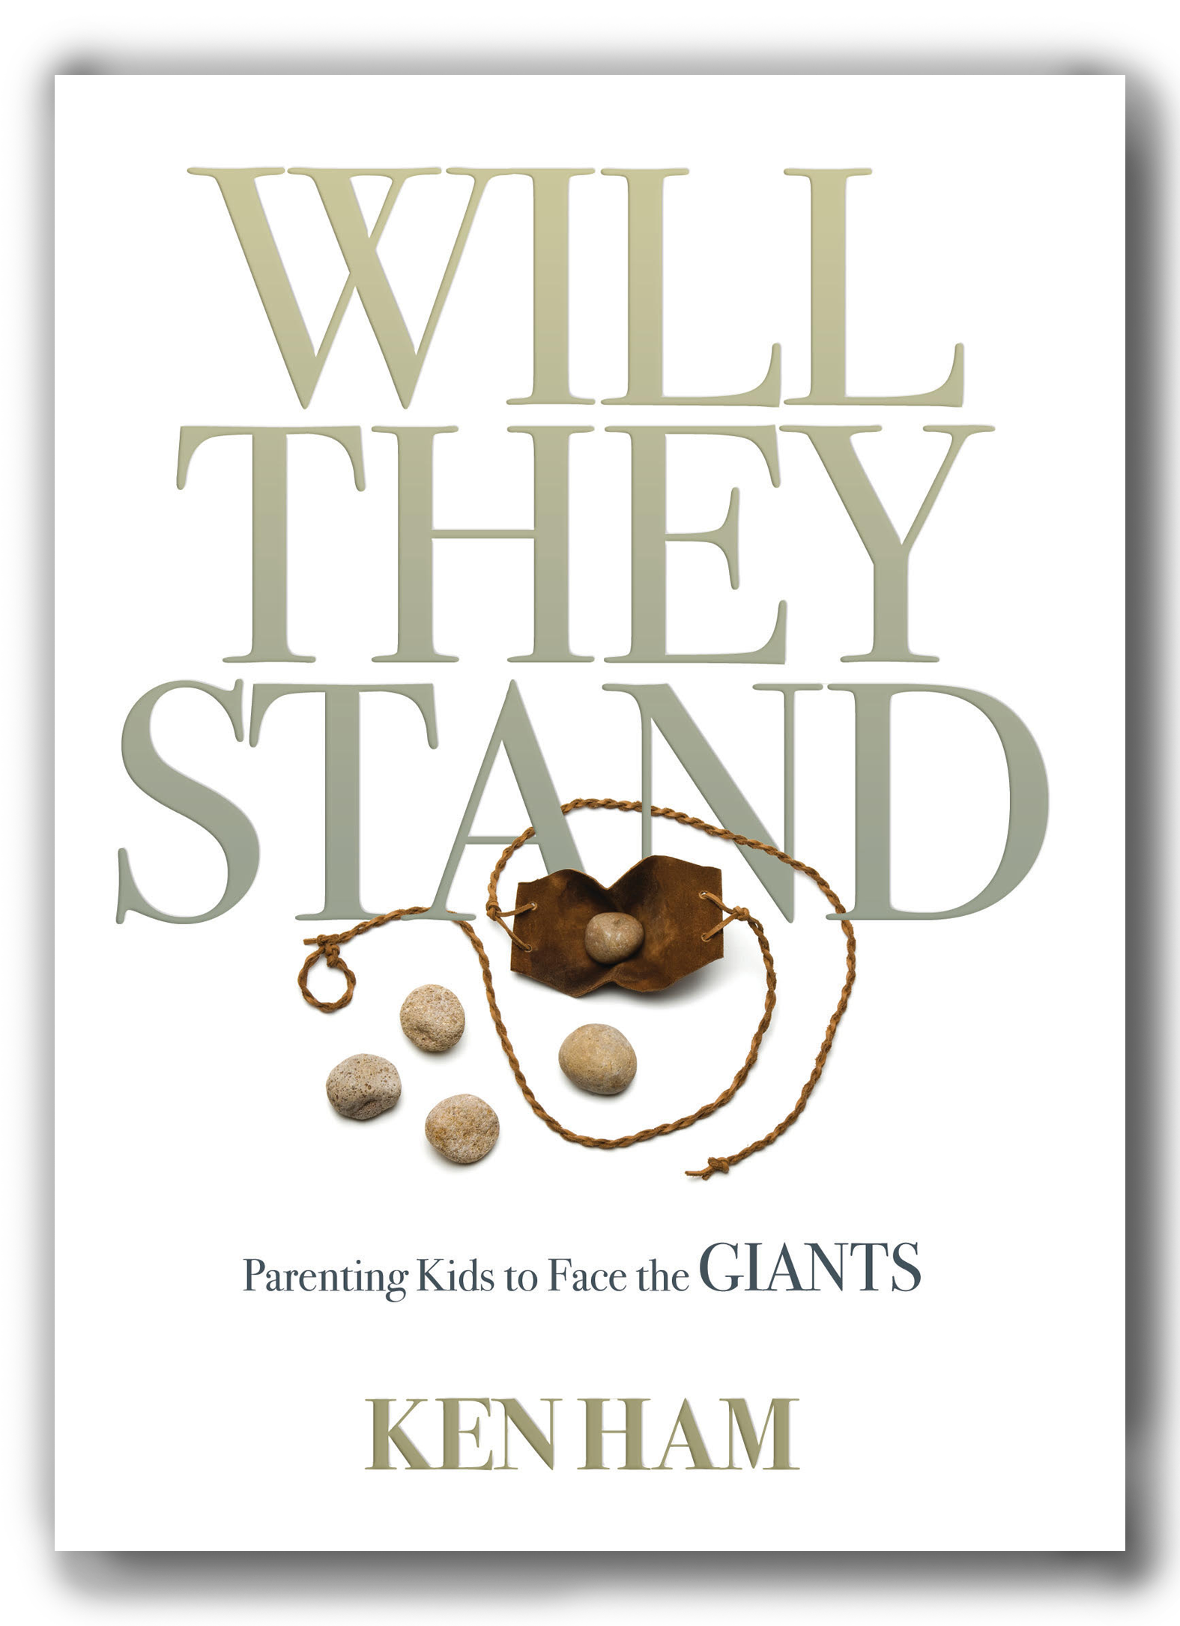
I’ve been so burdened about this, that during the shutdown I decided to write a new book called Will They Stand? Parenting Kids to Face the Giants. I took sections of an older book (Raising Godly Children in an Ungodly World) and added a lot more biblical teaching; personal testimony and history; a chapter written by our eldest daughter who founded and heads up our Christian school, Twelve Stones Christian Academy; and a chapter written by one of our authors (Avery Foley) who interviewed my wife, Mally, for her perspective on our lives and those of our children. Parts of it do open up our personal lives, but we believe this can be a help to parents as we all struggle with the tornado of moral relativism trying to sweep our children away.
Really, this book is all about legacy. What legacy are you leaving in this world? What legacy are you leaving your children, and their children?
我对此感到非常负担，以至于在关闭期间，我决定写一本新书《他们会站立吗？ 为人父母的孩子面对巨人。 我读了一本较旧的书（在一个超凡的世界里养育敬虔的孩子）的部分内容，并增加了更多的圣经教义。 个人证词和历史； 由我们的长女所写的一章，她创办并领导了我们的基督教学校，十二石基督教学院。 还有一个由我们的作者之一（Avery Foley）撰写的一章，作者采访了我的妻子玛丽（Mally），以她对我们以及我们孩子的生活的看法。 它的某些部分确实打开了我们的个人生活，但是我们相信这可以为父母提供帮助，因为我们所有人都在为将孩子们扫除的道德相对论的龙卷风而挣扎。
确实，这本书是关于遗产的。 您将在这个世界留下什么遗产？ 您将给您的孩子及其孩子留下什么遗产？
Really, this book is all about legacy. What legacy are you leaving in this world? What legacy are you leaving your children, and their children? What is the most important legacy any of us can leave in this world?
This really “hit” me when I heard of the death of Supreme Court Justice Ruth Ginsburg. She championed many evil things in our culture. She aggressively supported the LGBTQ movement, officiated at a gay “marriage” ceremony, and sanctioned the murder of millions of children in their mother’s wombs (abortion). Many said she was the most liberal left-leaning justice on that court. Her legacy is an evil, destructive one that undermined the true family and Christian morality. Yet she was applauded by liberals and many conservatives and was elevated as a great woman leaving an impressive legacy by the secular media. Even a number of Christians wrote glowing reports about her life as a female judge. Now, don’t get me wrong, we as Christians have no pleasure in the death of the wicked. As God’s Word states:
Say to them, As I live, declares the Lord GOD, I have no pleasure in the death of the wicked, but that the wicked turn from his way and live; turn back, turn back from your evil ways, for why will you die, O house of Israel? (Ezekiel 33:11)
确实，这本书是关于遗产的。您将在这个世界留下什么遗产？您将给您的孩子及其孩子留下什么遗产？我们每个人在这个世界上可以留下的最重要的遗产是什么？
当我听到最高法院大法官露丝·金斯堡（Ruth Ginsburg）的去世时，这真的使我“受打击”。她拥护我们文化中的许多邪恶事物。她积极支持LGBTQ运动，主持一场同性恋“结婚”仪式，并批准在其母亲的子宫内谋杀数百万儿童（堕胎）。许多人说她是该法院最宽松的左倾大法官。她的遗产是一种邪恶的破坏性遗产，破坏了真正的家庭和基督教道德。然而，她受到自由主义者和许多保守派的称赞，并被提升为一位伟大的女人，被世俗媒体留下了深刻的遗产。甚至有许多基督徒撰写了有关她作为女法官的生活的精彩报道。现在，请不要误解我，作为基督徒的我们对邪恶的死并不高兴。正如神的话所说：
对他们说，当我活着的时候，主耶和华宣布，我对恶人的死感到不高兴，但恶人转离了他的生活。回头，从邪恶的道路回头，以色列家啊，为什么要死？ （以西结书33:11）
We don’t know what was in Ruth Ginsburg’s heart as she faced death—only God knows. We understand about the thief on the cross and the change in his heart. But as far as we know, there’s no evidence she changed from what she was in her life with her anti-God worldview. From the world’s perspective, Justice Ginsburg was a heroine. But from God’s perspective, what would the only truly righteous judge say about her legacy?

Righteous Anger
I was angry about all this. It’s the same type of anger I saw in my father, a righteous anger like that of Nehemiah, when he saw injustices. So, I decided the day after the death of Ruth Ginsburg to write a Facebook post about my mother. Here is what I posted:
After watching the news and reading news reports last night and this morning, I thought I would post this today. My mother went to her heavenly home this past November. By the world’s standards, she was not newsworthy. She didn’t get talked about for hours on news programs or have large numbers of news articles praising her.
我们不知道露丝·金斯堡（Ruth Ginsburg）面对死亡时的内心到底是什么，只有上帝知道。我们了解十字架上的小偷和他内心的变化。但据我们所知，没有证据表明她从反神的世界观中改变了自己的一生。从世界范围来看，金斯堡大法官是女主角。但是从上帝的角度来看，唯一真正正义的法官会对她的遗产怎么说？
义愤
我为所有这一切感到生气。我在父亲中看到的是同一种愤怒，就像尼希米（Nehemiah）看到不公正时一样，是一种正义的愤怒。因此，我决定在露丝·金斯堡（Ruth Ginsburg）去世后的第二天写一篇有关我母亲的Facebook帖子。这是我发布的内容：
在昨晚和今天早上看完新闻并阅读了新闻报道之后，我想我今天就发布。去年十一月，我母亲去了她的天堂家。按照世界的标准，她没有新闻价值。她没有在新闻节目上谈论数小时，也没有收到许多赞美她的新闻文章。
But when she passed away, she received a great reward—the most valuable reward ever: a priceless reward, a “crown of righteousness.” Over the years, even though it wasn’t reported on by the media, there was great rejoicing by angels in heaven as my mother impacted so many people for the Lord Jesus Christ. She started a Sunday school as a teenager to reach children with the truth of God’s Word and the gospel. She looked after missionaries who stayed with us so they could preach God’s Word. She was loved by so many people. Only God knows how many she impacted for the Lord.
但是，当她去世时，她获得了巨大的奖励-有史以来最有价值的奖励：无价的奖励，“正义的冠冕”。 多年来，即使媒体没有对此进行报道，但天上的天使还是非常高兴的，因为我母亲为主耶稣基督影响了许多人。 她在少年时期就开办了周日学校，以神的话语和福音的真相接触儿童。 她照顾与我们同在的传教士，以便他们宣讲上帝的圣言。 她受到了很多人的爱。 只有上帝知道她为主而受了多少影响。
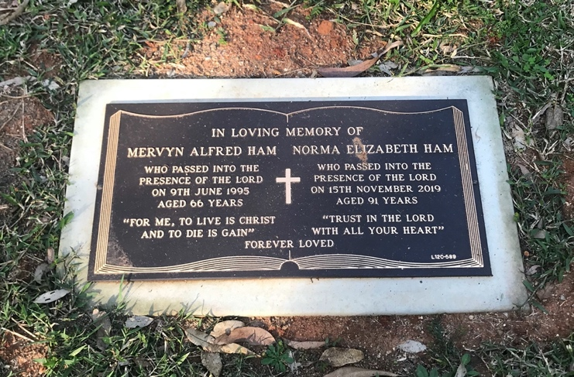+
I’ll never forget her teaching us over and over, “It’s only what is done for Jesus that lasts.” And she also taught us to always put “God first, others second, yourself last”—and that’s what I saw her do throughout her life. She taught us marriage was one man for one woman. She was saddened by the evil of abortion and called it murder. She was a godly, devoted wife, mother, grandmother, and great-grandmother. She and my dad were so burdened to reach as many as possible with the message of salvation.
And her legacy includes the ministry of Answers in Genesis, Ark Encounter, and Creation Museum that impact tens of millions of people a year with the most important message of all—God’s Word and the saving gospel.
Oh, there’s so much more I could say. My mum didn’t leave a legacy like Supreme Court Justice Ginsburg and receive national news headlines. My mum left a different legacy and received “headlines” in heaven, “Well done, good and faithful servant.”
我永远不会忘记她一遍又一遍地教我们，“只有耶稣所做的一切才能持久。” 她还教我们永远把“上帝放在首位，别人放在第二位，自己放在最后” —这就是我一生所看到的。 她教我们结婚是一对一的女人。 她为堕胎的罪恶感到悲伤，称其为谋杀。 她是一位虔诚，虔诚的妻子，母亲，祖母和曾祖母。 她和我的父亲很重，无法传达救恩的信息。
她的遗产包括创世纪答案部，方舟遭遇博物馆和创造博物馆，这些博物馆每年影响成千上万人，其中最重要的信息是上帝的话语和拯救福音。
哦，我还有很多话要说。 我妈妈没有留下像最高法院大法官金斯堡（Ginsburg）这样的遗产，并获得了全国新闻头条。 我妈妈留下了不同的遗产，并在天堂收到了“头条新闻”，“干得好，善良而忠诚的仆人。”
This post received many thousands of likes and hundreds of comments. What an encouragement to know that so many others shared the same righteous “anger” I did. I thought it would be good to share just a small sample of the wonderful comments with you:
这篇文章收到了成千上万的喜欢和数百条评论。 知道这么多其他人也和我一样有义无反顾的“愤怒”真是令人鼓舞。 我认为最好只与您分享一小部分精彩的评论：
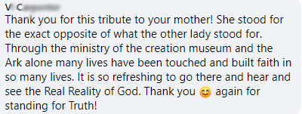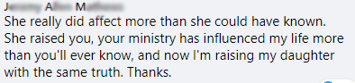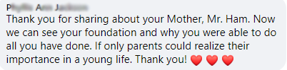

Impacting Millions
Actually, comparing the legacies of my mother and Ruth Ginsburg really represents the spiritual war that began in a garden six thousand years ago and rages today—the ongoing battle on this earth between God’s Word and man’s word.
Ruth Ginsburg’s legacy is associated with the murder of the unborn, the destruction of the family, an anti-God worldview of moral relativism, and a negative impact on the younger generations in leading them away from the truth of God’s Word and the gospel.
My mother’s legacy is associated with offspring who pass on a godly spiritual legacy from one generation to the next; people who were led to saving faith in Christ; the ministry of Answers in Genesis, the Ark Encounter, and Creation Museum, which is impacting tens of millions of people a year for the Lord; and untold thousands of families equipped to raise up godly generations.
This new book is really part of my father and mother’s legacy, and I do my part to pass on the spiritual legacy they imparted to me.
影响百万
实际上，比较我母亲和露丝·金斯堡（Ruth Ginsburg）的遗产确实代表了六千年前在花园中开始并在今天肆虐的精神战争-地球上上帝的道与人的道之间的持续斗争。
露丝·金斯堡（Ruth Ginsburg）的遗产与谋杀未出生者，破坏家庭，对道德相对主义的反上帝世界观以及导致年轻一代远离上帝圣言和福音的负面影响有关。
我母亲的遗产与后代相关，后代将敬虔的精神遗产代代相传。被引导拯救基督的人；创世记回答部，方舟En和创世博物馆，每年为耶和华影响数千万人；和成千上万的家庭装备起来养育世代。
这本新书确实是我父母的遗产的一部分，我将尽我所能，将他们赋予我的精神遗产继续下去。
This new book is really part of my father and mother’s legacy, and I do my part to pass on the spiritual legacy they imparted to me to others.
I do want to thank our supporters who have been so generous in supporting AiG financially this year to preserve this ministry—this legacy—as we’ve all gone through a very stressful time of lockdowns and unemployment. Many of you have watched our recent virtual dedication of what I believe is the most powerful pro-life exhibit in the world, Fearfully and Wonderfully Made, now installed at the Creation Museum.
这本新书确实是我父亲和母亲的遗产的一部分，我尽我所能将他们赋予我的精神遗产传授给他人。
我确实要感谢我们的支持者，他们在今年非常慷慨地向AiG提供财政支持，以保留这一部委（这一遗产），因为我们所有人都经历了非常紧张的封锁和失业时期。 你们中的许多人都观看了我们最近对我认为是世界上最强大的生命展览的虚拟献身作品《恐惧与奇妙的制作》，该作品现已安装在创作博物馆中。
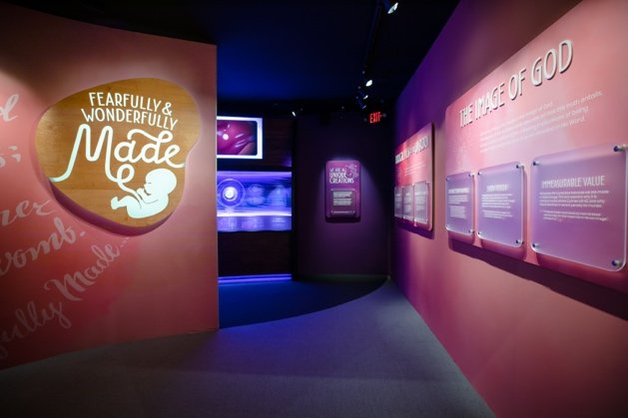
At the end of the dedication, I asked for prayer. I explained that squirrels must store up fuel to survive through the winter. Normally, to get us through the winter, we put away funds from the summer months when most of the visitors come to the Ark Encounter and Creation Museum. But this year, because of the shutdowns, we were unable to do that—and we do need “fuel” for the winter.
We praise the Lord for the $3.5 million matching gift challenge through Dec. 31 to help “fuel” all these ministries.
Will you help us fully reach the $3.5 million matching gift goal by the end of the year with a gift today?
在奉献结束时，我要求祈祷。 我解释说，松鼠必须储存燃料才能在冬季生存。 通常，为了使我们度过冬天，我们从夏季的大部分时间都来参观方舟博物馆和造物博物馆的时候就撤出资金。 但是今年，由于停工，我们无法做到这一点，而且我们确实需要冬季的“燃料”。
我们赞扬上帝在12月31日之前提供了350万美元的匹配礼物挑战，以帮助“加油”所有这些部门。
您是否会通过今天的礼物帮助我们在今年年底之前完全实现350万美元的匹配礼物目标？

Still Working
Also, we don’t want to stop our talented design team from moving ahead with another powerful exhibit we had planned for the Creation Museum that will be about Israel, called Borderland. Israel is a borderland, constantly caught between great kingdoms and empires, creating immense cultural tension that God used as the perfect condition to send forth the gospel. This exhibit, loaded with illustrations and sculptures, will allow guests an intimate look at the culture of first-century Israel at the time of Jesus, helping them understand the context of the New Testament.
We believe guests will leave energized and excited to read their Bibles with fresh understanding after seeing the ancient world brought to life.
We also need funds to prepare for the 2021 readiness of not only the Ark Encounter and Creation Museum, but also to help develop and launch our next Answers VBS, an expanded Answers Bible Curriculum for Sunday school—with an exciting homeschool edition—and an expansion of Answers TV content.
还在工作
另外，我们也不想阻止我们的才华横溢的设计团队继续前进，而我们计划为以色列创造博物馆举办的另一场强大展览将称为“无主之地”。以色列是一个边境地区，经常陷入大国与帝国之间，造成巨大的文化张力，上帝曾以此为发福音的理想条件。该展览配有插图和雕塑，可让客人亲眼目睹耶稣时代的第一世纪以色列文化，从而帮助他们了解新约的背景。
我们相信，在看到了古代世界之后，客人们将充满活力和兴奋，以全新的理解方式阅读圣经。
我们还需要资金来为Ark Encounter and Creation Museum做好2021年准备的准备，还需要帮助开发和启动我们的下一个Answers VBS，针对星期日学校的扩展的Answers圣经课程（具有令人兴奋的家庭学校版本）和扩展功能的Answers电视内容。
We praise the Lord that a family foundation has stepped up to help AiG through the winter months, get this exhibit built, and help us launch all the above projects. It’s quite a list, but our staff are ready to get it all done. The family foundation has offered a $3.5 million matching gift challenge through December 31 to raise the funds needed to “fuel” all these ministries. Will you help us meet the $3.5 million match challenge to raise $7 million by the end of the year?
As millions of people a year are being impacted through Answers in Genesis, I urge you to help us continue and expand the enormous reach of this ministry—and pray God raises up young and old alike to face the giants in our secularized culture.
Thanks for stopping by and thanks for praying,
Ken
This item was written with the assistance of AiG’s research team.
我们赞美上帝，一个家庭基金会已经加强了对AiG的帮助，度过了整个冬季，建造了这个展览，并帮助我们启动了上述所有项目。 这是一份完整的清单，但我们的员工已准备就绪，可以完成所有工作。 截至12月31日，家庭基金会提出了350万美元的匹配礼物挑战，以筹集“加油”所有这些部门所需的资金。 您是否会帮助我们应对350万美元的比赛挑战，从而在年底之前筹集700万美元？
每年都有成千上万的人受到创世纪答案的影响，我敦促您帮助我们继续扩大这一事工的广泛影响范围，并祈求上帝使年轻人和老年人长大，以面对我们世俗文化中的巨人。
感谢您的光临和祈祷，
肯
此项目是在AiG研究团队的协助下撰写的。

Week 10: The importance of understand Genesis as the foundation of Christianity. 2-page summary report is due.
10,000 results found
第十周：了解创世记作为基督教基础的重要性。 2页摘要报告到期。
找到10,000个结果

Genesis—the Foundation of Christianity
https://answersingenesis.org/blogs/ken-ham/2016/12/29/genesis-foundation-of-christianity/
Dec. 29, 2016 … Understanding the importance of the book of Genesis is similar to knowing how you would build a house … : Genesis is the foundation for the rest of the Bible.
- 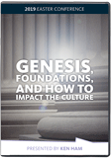

Answering Atheists: Genesis, Foundations, and How to Impact the Culture
•创世纪-基督教的根基
https://answersingenesis.org/blogs/ken-ham/2016/12/29/genesis-foundation-of-christianity/
2016年12月29日…了解创世记的重要性类似于了解如何建造房屋……：创世记是圣经其余部分的基础。
•
无神论者的回答：起源，基础以及如何影响文化
•https://answersingenesis.org/store/product/answering-atheists-genesis-foundations-culture/
Discover the foundation for all our Christian doctrine, how and why we should stand boldly on our foundation …

A Foundation of Scripture
https://answersingenesis.org/morality/a-foundation-of-scripture/
July 4, 2008 … That it laid the cornerstone of human government upon the first precepts of Christianity?” … Used by permission from WallBuilders Foundation, P.O.

Borrowing From a Christian Foundation
https://answersingenesis.org/media/audio/answers-with-ken-ham/volume-136/borrowing-from-a-christian-foundation/
Jan. 27, 2020 … Atheists often accuse Christians of being irrational for believing in miracles.

Genesis—Foundational for Marriage
https://answersingenesis.org/media/audio/answers-with-ken-ham/volume-137/genesis-foundational-for-marriage/
May 12, 2020 … The foundation for marriage is in Genesis.

A Firm Foundation
https://answersingenesis.org/media/audio/answers-with-ken-ham/volume-135/a-firm-foundation/
Nov. 26, 2019 … As Christians, we’re not tossed back and forth by changing ideas. … We’ve a firm foundation for our thinking—God’s Word.

Genesis—It’s Foundational
https://answersingenesis.org/media/audio/answers-with-ken-ham/volume-129/genesis-foundational/
June 1, 2018 … Some Christians argue that what we believe about Genesis is just a side issue. … But did you know all our major Christian doctrines are grounded in Genesis?

2094. Foundation Work
https://answersingenesis.org/education/spurgeon-sermons/2094-foundation-work/
Nov. 23, 2016 … Solomon began to build the temple at the foundation.

Genesis—A Foundational Issue!
https://answersingenesis.org/media/audio/answers-with-ken-ham/volume-137/genesis-a-foundational-issue/
May 11, 2020 … All this week we’re going to look at just some of these doctrines that’re grounded in Genesis. … Well, to understand why, you’ve got to look at Genesis.

1420. Faith’s Sure Foundation
https://answersingenesis.org/education/spurgeon-sermons/1420-faiths-sure-foundation/
April 22, 2014 … Charles Spurgeon discusses Christ Jesus, the foundation of the believer’s faith.
•圣经的基础
https://answersingenesis.org/morality/a-foundation-of-scripture/
2008年7月4日……这是否为基督教的第一条戒律奠定了人类政府的基石？” …经WallBuilders Foundation，P.O.的许可使用。
•从基督教基金会借款
https://answersingenesis.org/media/audio/answers-with-ken-ham/volume-136/borrowing-from-a-christian-foundation/
2020年1月27日…无神论者经常指责基督徒因相信奇迹而变得不理性。
•创世纪-婚姻基础
https://answersingenesis.org/media/audio/answers-with-ken-ham/volume-137/genesis-foundational-for-marriage/
2020年5月12日…婚姻的基础是创世纪。
•坚实的基础
https://answersingenesis.org/media/audio/answers-with-ken-ham/volume-135/a-firm-foundation/
2019年11月26日…作为基督徒，我们不会因观念的改变而来回奔波。 ……我们为我们的思想奠定了坚实的基础-神的话语。
•创世纪-基础
https://answersingenesis.org/media/audio/answers-with-ken-ham/volume-129/genesis-foundational/
2018年6月1日…一些基督徒争辩说，我们对创世纪的看法只是附带问题。 …但是您知道我们所有主要的基督教教义都建立在创世纪的基础上吗？
•2094.基础工作
https://answersingenesis.org/education/spurgeon-sermons/2094-foundation-work/
2016年11月23日……所罗门开始在地基上建造圣殿。
•创世纪-基本问题！
https://answersingenesis.org/media/audio/answers-with-ken-ham/volume-137/genesis-a-foundational-issue/
2020年5月11日…这整个星期，我们将只讨论一些基于《创世纪》的教义。 …好吧，要了解原因，您必须研究《创世纪》。
•1420年。Faith的Sure基础
https://answersingenesis.org/education/spurgeon-sermons/1420-faiths-sure-foundation/
2014年4月22日…Charles Spurgeon讨论了基督耶稣，信徒信仰的基础。

Genesis—A Foundational Issue!
on May 11, 2020
This is Ken Ham, head of the ministry that built a full-size Noah’s Ark south of Cincinnati.

Transcript
Shop Now
Many people see creation versus evolution as just a side issue. But what you believe about Genesis matters. You see, all of our major Christian doctrines are either directly or indirectly founded in Genesis.
All this week we’re going to look at just some of these doctrines that’re grounded in Genesis. Here’s one—why are we sinners? Well, to understand why, you’ve got to look at Genesis. It teaches that God created everything perfect. But the first people, Adam and Eve, rebelled against God. We sinned in Adam, and we continue to sin. That’s why we’re sinners and need a Savior!
创世记–基础问题！
2020年5月11日
该部负责人是肯·汉姆（Ken Ham），他在辛辛那提以南建造了一个全尺寸的诺亚方舟。

许多人认为创造与进化只是附带问题。 但是您对创世纪的看法很重要。 您会发现，我们所有主要的基督教学说都直接或间接地建立在创世纪中。
这整个星期，我们将只讨论一些基于创世纪的教义。 这是一个-我们为什么是罪人？ 好吧，要了解原因，您必须了解创世记。 它教导说上帝创造了一切完美的东西。 但是，第一批亚当夏娃叛逆了上帝。 我们在亚当犯罪了，我们继续犯罪。 这就是为什么我们是罪人，需要救世主！
What you believe about Genesis matters. It’s not a side issue—it’s a foundational one!

Dig Deeper
- Raising Up Generations with the Right Foundation
- A Foundation of Scripture
- 您对创世纪的看法至关重要。 这不是附带问题，而是根本问题！
- 深入挖掘
- •通过正确的基础培养下一代
- •圣经的基础

About Ken Ham
Ken Ham is the CEO and founder of Answers in Genesis-US, the highly acclaimed Creation Museum, and the world-renowned Ark Encounter. Ken Ham is one of the most in-demand Christian speakers in North America.
关于肯汉姆
肯·汉姆（Ken Ham）是美国《创世纪》（Genesis-US），广受赞誉的创造博物馆和世界知名的方舟En（Ark Encounter）的首席执行官和创始人。 肯·汉姆（Ken Ham）是北美最受欢迎的基督徒演讲者之一。

Raising Up Generations with the Right Foundation
by Ken Ham on July 17, 2018

Yes, it’s alarming! And when I show it in graph form at my public presentations, people see it so clearly. As they say, “A picture is worth a thousand words,” and these graphs emphasize how we need to raise up generations with the right foundation for their worldview.
用正确的基础养育世代
由Ken Ham在2018年7月17日
是的，这令人震惊！ 当我在公开演讲中以图表形式展示它时，人们会如此清晰地看到它。 正如他们所说：“一张图片值得一千个单词。”这些图表强调了我们需要如何为他们的世界观建立正确的基础来抚养后代。
Lifetime Boarding Pass
Get lifetime admission to the Ark Encounter and Creation Museum plus exclusive benefits. Available for a limited time!
Let me share with you what I’ve been saying to people in my recent presentations. In a slide, I show how researchers have divided generations into the following groups:
- Greatest—Born before 1928
- Silent—Born 1928–1945
- Boomers—Born 1946–1964
- Generation X—Born 1965–1980
- Generation Y (millennials)—Born 1980s & 1990s
- Generation Z—Born 1996–2010
Now I want to show you two graphs, adapted from those found in a paper published in 2010 by the Pew Research Center. The first one is titled “Attendance at Religious Services, by Generation—Percent Saying They Attend Several Times a Week, Every Week or Nearly Every Week”:
The next graph I show is titled “Views of Homosexuality, by Generation—Percent Saying Same-Sex Sexual Relations Are Always Wrong”:
让我与您分享我在最近的演讲中对其他人所说的话。 在幻灯片中，我展示了研究人员如何将几代人分为以下几类：
•最伟大的-生于1928年
•沉默-生于1928-1945年
•婴儿潮时期出生于1946年至1964年
•X代-1965年至1980年出生
•Y世代（千禧一代）-1980年代和1990年代出生
•Z代-1996年至2010年出生
现在，我想向您展示两个图表，这些图表是根据皮尤研究中心（Pew Research Center）在2010年发表的一篇论文中找到的图表改编而成的。 第一个标题为“按年龄分列的宗教服务出席率—说他们每周，每周或几乎每周参加几次的百分比”：
我显示的下一张图表标题为“同性恋观点，按世代相传—说同性性关系的比例总是错误的”：
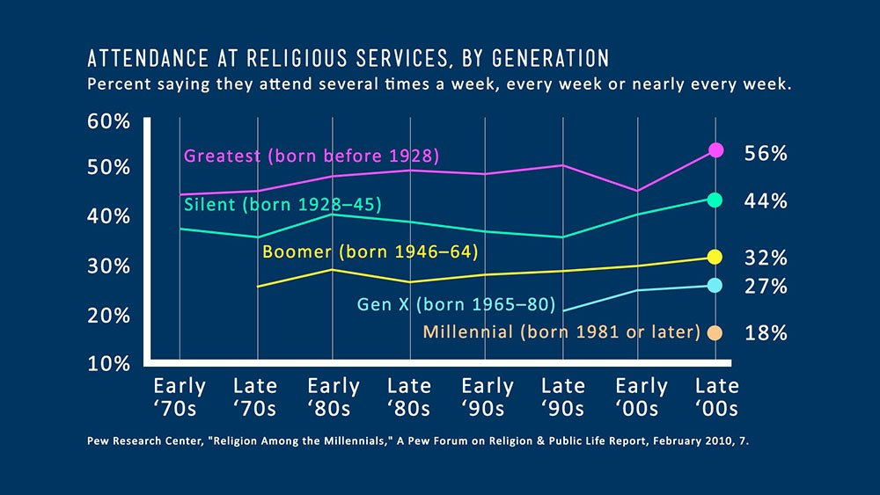
Now consider the latest research (2018) conducted on Generation Z (born 1996–2010). By the way, not a lot has been studied concerning this group because they are harder to research due to their young ages. Here is what pollster George Barna found in the general US population:
现在考虑对Z代（1996年至2010年出生）进行的最新研究（2018年）。 顺便说一下，关于这个群体的研究还不是很多，因为他们由于年龄小而难以研究。 以下是民意调查员乔治·巴纳（George Barna）在美国总人口中发现的东西：
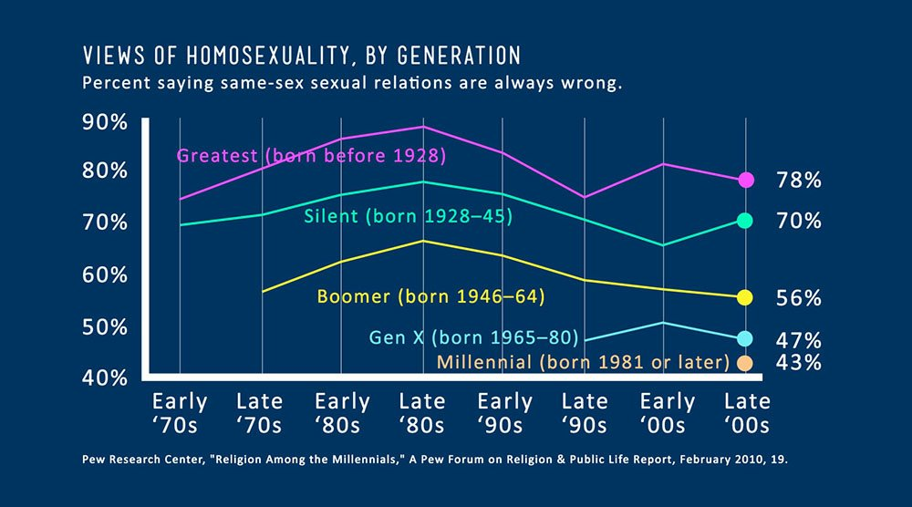
“Teens 13–18 years old are twice as likely as adults to say they are atheist ”.1
When we conducted a general population study in 2015 to estimate the expected number of Ark Encounter visitors (using America’s Research Group), we also found similar alarming trends regarding church attendance in respondents ages 20–29 and 60–69. Twenty-two percent of those now in their 60s who once attended church regularly have stopped going, but 53% of those now in their 20s who once attended church regularly stopped going.2
“ 13至18岁的青少年说他们是无神论者的可能性是成年人的两倍。” 1
当我们在2015年进行了一项总体人口研究以估计Ark Encounter访客的预期人数（使用美国研究小组）时，我们还发现20-29岁和60-69岁年龄段的受访者在教堂出席方面也有类似的令人震惊的趋势。 现在20岁的曾经去教堂的人中有22％的人停止了活动，但是现在20岁的曾经去教堂的人中53％的人停止了去教堂。2
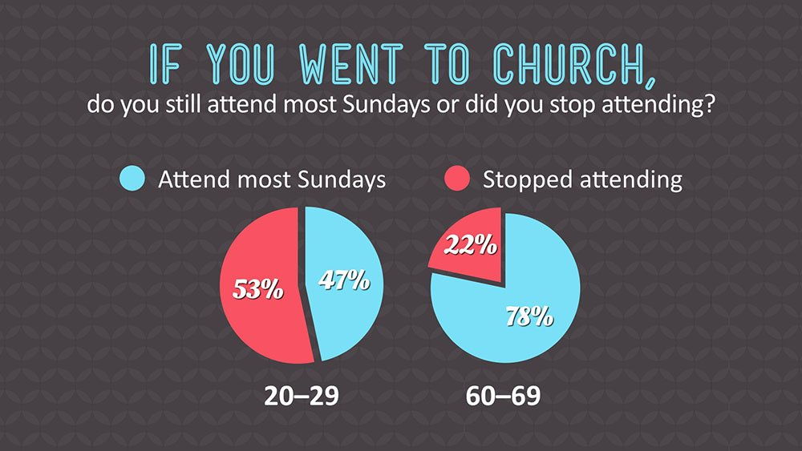
Yes, there’s no doubt that, from a Christian perspective, America is on the brink of catastrophic change! That change has already happened in other Western nations.
But is there any hope? What can we do?
Well, when Christians express hopelessness at what’s happening in the culture, I always challenge them by highlighting what God’s Word teaches us. In the parable of the 10 minas in Luke 19:13, Jesus taught that after entrusting resources to his servants, the nobleman (representing Jesus) said,
“‘Engage in business until I come” (Luke 19:13).
This verse is a reminder that God has entrusted resources and talents to each of us. God expects us to do the best we can with what he has entrusted us with to engage in the business of the King (the King of Kings) until he returns. It’s the business of proclaiming the truth of God’s Word and the gospel.
是的，毫无疑问，从基督徒的角度来看，美国正处于灾难性变革的边缘！ 这种变化已经在其他西方国家发生过。
但是有希望吗？ 我们能做些什么？
好吧，当基督徒对文化中发生的事情表示绝望时，我总是通过强调神的话语教导我们来挑战他们。 耶稣在路加福音19:13中的十个小寓言比喻中，教导说，贵族（代表耶稣）将资源托付给仆人后说：
“‘从事生意直到我来”（路加福音19:13）。
这节经文提醒我们，上帝已将资源和才智委托给我们每个人。 上帝希望我们尽他所托付我们从事国王（万王之王）的生意，直到他回来为止。 宣讲上帝圣言和福音的真理。
At Answers in Genesis, we’ve always used a considerable number of resources, such as books, curricula, DVDs, and so on, to disseminate information to all ages, including children and teens. Our Vacation Bible School (VBS) program is now in the top three sold in the world and reaches tens of thousands of children each year. Our four-year ABC Bible curriculum teaches all age groups and is used in about 10,000 churches.
It’s also thrilling for me to see so many kids and young people attending AiG conferences and then telling me afterward about their excitement of learning apologetics truths. Their faith is bolstered as they are equipped to be bold in getting out the Christian message to their peers and others.
And that brings me to an exciting part of what we’re doing for children and young people, especially at the Creation Museum—and, soon even more so, at the Ark Encounter, when our large auditorium and workshop rooms are completed.
We have a group of very talented staff members who conduct workshops for children and teens on a variety of topics. These workshops are often fully booked. We have also introduced special day camps for the summer, and these are already very popular.
在《创世纪的答案》中，我们一直使用大量的资源（如书籍，课程，DVD等）将信息传播给各个年龄段，包括儿童和青少年。我们的假期圣经学校（VBS）计划目前在世界销量排名前三位，每年有成千上万的儿童参加。我们为期四年的ABC圣经课程教授所有年龄段的人，并在10,000座教堂中使用。
看到如此众多的孩子和年轻人参加AiG会议，然后向我讲述他们对学习道歉真相的兴奋之情，也让我感到非常激动。他们的信心得到了增强，因为他们有能力大胆向同龄人和其他人传达基督教的信息。
这使我进入了我们为儿童和年轻人所做的令人兴奋的部分，尤其是在创造博物馆。不久之后，当我们的大型礼堂和工作室完工时，在方舟count台，我们的工作也更加精彩。
我们拥有一群非常有才华的员工，他们为儿童和青少年举办各种主题的研讨会。这些讲习班经常被预订满。我们还为夏季引入了特殊的日间营地，这些营地已经很受欢迎。
We’re finding a hunger like we haven’t seen before in the younger generations! So many more young people want to learn how to defend the Christian faith and have a truly Christian worldview. They are hungry to be trained in creation apologetics so they can be effective witnesses for the Lord Jesus.
AiG continues to expand our offerings in this area. Right now, we have an immediate need to buy special equipment due to the high demand for our science workshops. We do charge a nominal fee for most workshops to cover the items children deplete. However, the permanent lab equipment we can use year after year is still unfunded.
This lab equipment will enable us to add even more youth programs and teach more of the coming generations from a creationist/Christian worldview perspective.
我们正在发现饥饿，这是年轻一代以前从未见过的！ 越来越多的年轻人希望学习如何捍卫基督教信仰并拥有真正的基督教世界观。 他们渴望接受创造道歉的训练，因此他们可以成为主耶稣的有效见证。
AiG继续在这一领域扩展我们的产品。 目前，由于对科学车间的需求很高，我们现在迫切需要购买专用设备。 对于大多数讲习班，我们确实收取象征性费用，以涵盖儿童所消耗的物品。 但是，我们可以年复一年使用的永久性实验室设备仍然没有资金。
这种实验室设备将使我们能够添加更多的青年计划，并从神创论者/基督徒的世界观角度教授更多的下一代。
Your support and prayer will allow us to offer these important programs for children and teens at the Creation Museum—and eventually at the Ark Encounter when the new Answers Center and its lower-level workshop rooms are fully funded and finished.
Let’s raise up generations who will be the light and salt needed in our increasingly secularized culture! That’s such an important legacy for us to build for future ministry impact, as our younger generations continue the effort to engage in “business until he comes.”
您的支持和祈祷将使我们能够在创作博物馆中为儿童和青少年提供这些重要的节目，最终在新的答疑中心及其下层工作室得到充分资助并完成后，在方舟聚会中提供这些重要节目。
让我们复活几代人，他们将是我们日益世俗化的文化中所需要的光和盐！ 对于我们来说，建立如此重要的遗产对未来的事工有很大的影响，因为我们的年轻一代继续努力从事“业务直到他来”。

A Foundation of Scripture
by David Barton on May 30, 2006; last featured July 4, 2008

To most of America’s founding fathers, the Bible was true from beginning to end, and it was the only source upon which to establish the new, independent nation.
However, with the advent of conjectures and hypotheses that undermined how people viewed the Bible’s history, its moral authority began to erode. Without the Bible’s absolute moral truths guiding the American people, the institution undergirded by this authority and designed to govern them will falter.
圣经的基础
由David Barton在2006年5月30日发表； 上次发布时间：2008年7月4日

对于美国大多数开国元勋而言，圣经自始至终都是正确的，并且是建立新的独立国家的唯一依据。
然而，随着猜想和假设的出现破坏了人们如何看待圣经的历史，其道德权威开始受到侵蚀。 如果没有圣经的绝对道德真理指导美国人民，那么被这一权威所支配并旨在统治美国的机构将步履蹒跚。

Lifetime Boarding Pass
Get lifetime admission to the Ark Encounter and Creation Museum plus exclusive benefits. Available for a limited time!

If the absolute authority of God’s Word is removed and moral relativity becomes the order of the day, on what will government and freedom stand? John Adams—one of America’s founding fathers and its second president—emphasized this truth when he said, “We have no government armed with power capable of contending with human passions unbridled by morality and religion. Our constitution was made only for a moral and religious people. It is wholly inadequate to the government of any other.”1
America’s founding fathers saw the importance of establishing their new country on the absolute, unchanging laws of the Creator God, instead of the wavering whims of the times.
In the United States the Fourth of July is a national holiday to reflect not only on the sacrifices of America’s founding fathers and the nation’s spiritual foundation, but also on where its people are today and what lies ahead if they do not return to trusting God’s Word as their foundation of truth in every area. It was this type of nation for which the founding fathers so willingly sacrificed their fortunes, homes, families, comforts, personal freedoms and lives.
如果神的话语的绝对权威被取消，道德相对性成为日常事务，那么政府和自由将站在什么位置？美国的开国元勋和第二任总统约翰·亚当斯（John Adams）强调了这一道理，他说：“我们没有一个政府拥有能够抵御道德和宗教所束缚的人类激情的力量。我们的宪法仅是为有道德和宗教信仰的人民制定的。它完全不适合任何其他政府。” 1
美国的开国元勋们看到了根据造物主上帝的绝对不变的法律建立新国家的重要性，而不是时代的一时兴起。
在美国，七月四日是国定假日，不仅要反映美国开国元勋的牺牲和国家的精神基础，而且要反映出其今天的人民以及如果他们不恢复对上帝圣言的信奉，前景如何。作为他们在每个领域的真理基础。正是这种民族，开国元勋们为此自愿牺牲了自己的财富，住所，家庭，舒适，个人自由和生活。
This year marks 230 years since America’s founding fathers gave to its citizenry its national “birth certificate.” The United States continues to be the longest on-going constitutional republic in the history of the world. Blessings such as those bestowed on this nation do not happen by chance or accident. They are blessings of God.
On July 2, 1776, after much discussion and prayer, Congress voted to approve a complete separation from Great Britain. Two days afterward, July 4, the early draft of the Declaration of Independence was signed, albeit by only two individuals at that time: John Hancock, president of Congress, and Charles Thompson, secretary of Congress. Four days later, members of Congress took that document and read it aloud from the steps of Independence Hall in Philadelphia, after which the Liberty Bell was rung.
今年是美国开国元勋将其国民“出生证明”授予其公民的230年。 美国仍然是世界历史上持续时间最长的宪法共和国。 诸如此类的祝福不会偶然或偶然发生。 他们是上帝的祝福。
1776年7月2日，经过大量的讨论和祈祷，国会投票批准完全脱离英国。 之后的两天，即7月4日，签署了《独立宣言》的初稿，尽管当时只有两个人：国会主席约翰·汉考克和国会秘书查尔斯·汤普森。 四天后，国会议员拿走了这份文件，并从费城独立厅的台阶上大声朗读了文件，然后自由钟响了起来。

Declaration and Deliverance

Photo courtesy of www.istockphoto.com
Comparing the turmoil, struggles and revolutions in other nations, in contrast to the relative stability and obvious blessings in the U.S., prompts American citizens to ask how this has been achieved. What was the basis of American independence? John Adams said, “The general principles on which the Fathers achieved independence were the general principles of Christianity.”2 Perhaps the clearest identification of the spirit of the American Revolution was given by John Adams in a letter to his wife Abigail. Adams cautiously wrote, “This day will be the most memorable epic in the history of America. I am apt to believe that it will be celebrated by succeeding generations as the great anniversary festival.”3 John Adams believed that the Fourth of July should become a religious holiday—a day when Americans remember God’s hand of deliverance and a day of religious activities when its citizens commit themselves to Him in “solemn acts of devotion to God Almighty.” 4 Such was the spirit of the American Revolution as seen through the eyes of those who led it, evidenced even further in the words of John Quincy Adams, one who was deeply involved in the activities of the Revolution.
John Adams said, “The general principles on which the Fathers achieved independence were the general principles of Christianity.”
声明和交付

照片由www.istockphoto.com提供
与其他国家的动荡，斗争和革命相比，与美国的相对稳定和明显的福祉形成鲜明对比，这促使美国公民问起这是如何实现的。美国独立的基础是什么？约翰·亚当斯说：“父亲获得独立的一般原则是基督教的一般原则。” 2也许约翰·亚当斯在给妻子阿比盖尔的信中对美国革命的精神有最清晰的认识。亚当斯谨慎地写道：“今天将是美国历史上最令人难忘的史诗。我很容易相信它将被后代庆祝为伟大的周年纪念日。” 3约翰·亚当斯（John Adams）认为，七月四日应该成为一个宗教节日，这一天美国人纪念上帝的拯救之手和宗教活动当它的公民以“对全能的上帝的庄严奉献的行为”向他承诺时。 4从领导革命的人的眼中可以看出美国革命的精神，而约翰·昆西·亚当斯（John Quincy Adams）则深深地参与了革命的活动。
约翰·亚当斯（John Adams）说：“父亲获得独立的一般原则是基督教的一般原则。”
In 1837 when Adams was 69 years old, he delivered a Fourth of July speech at Newburyport, Massachusetts. In that address, he posed the question: “Why is it that, next to the birthday of the Savior of the world, your most joyous and most venerated festival returns on this day [the Fourth of July]?” Note his answer: “Is it not that, in the chain of human events, the birthday of the nation is indissolubly linked with the birthday of the Savior? That it forms a leading event in the progress of the Gospel dispensation? Is it not that the Declaration of Independence first organized the social compact on the foundation of the Redeemer’s mission upon earth? That it laid the cornerstone of human government upon the first precepts of Christianity?”5
1837年，亚当斯（Adams）享年69岁，他在马萨诸塞州的纽伯里波特（Newburyport）发表了美国独立纪念日演讲。 他在讲话中提出了一个问题：“为什么在世界救世主诞辰日临近的那天（七月四日）您最欢乐，最受尊敬的节日回来了？” 请注意他的回答：“难道不是在人类事件的链条中，国家的生日与救主的生日紧密地联系在一起吗？ 它是否在福音派发的进程中成为重要事件？ 难道不是《独立宣言》首先在救赎者的地球使命基础上组织了社会契约吗？ 它是否为基督教的第一条戒律奠定了人类政府的基石？” 5

If the absolute authority of God’s Word is removed and moral relativity becomes the order of the day, on what will government and freedom stand?
According to John Quincy Adams, for Americans Christmas and the Fourth of July were intrinsically connected. On the Fourth of July, America’s founders simply took the precepts of Christ which came into the world through His birth (Christmas) and incorporated those principles into civil government.
如果神的话语的绝对权威被取消，道德相对性成为日常事务，那么政府和自由将站在什么位置？
根据约翰·昆西·亚当斯（John Quincy Adams）的观点，美国人对圣诞节和七月四日有着内在的联系。 七月四日，美国的创始人简单地接受了基督的戒律，基督的戒律是通过基督的诞生（圣诞节）而诞生的，并将这些原则纳入了民间政府。

Integrity and Impact
Have you ever considered what it meant for those 56 men—an eclectic group of ministers, businessmen, teachers, university professors, sailors, captains, farmers—to sign the Declaration of Independence? This was a contract that began with the reasons for the institutional separation from Great Britain and closed in the final paragraph stating: “And for the support of this Declaration, with a firm reliance on the protection of Divine Providence, we mutually pledge to each other our lives, our fortunes, and our sacred honor.” Dr. Benjamin Rush, the father of American medicine and a signer of the Declaration of Independence, recorded the events of that day in his diary. In 1781 he wrote to John Adams, “Do you recollect the pensive and awful silence which pervaded the House when we were called up, one after another, to the table of the President of Congress to subscribe to what was believed by many at that time to be our death warrants?” 6
Preserving American liberty depends first upon our understanding the foundations on which this great country was built and then preserving those principles.
诚信与影响
您是否考虑过这56名男人（包括一群部长，商人，教师，大学教授，水手，船长，农民）的折衷主义，这意味着什么？这份合同最初是从英国与英国体制分离的原因开始的，并在最后一段中说：“并且为了坚定支持《神圣天意》，为了支持该《宣言》，我们相互保证我们的生活，我们的命运和我们的神圣荣誉。”美国医学之父，《独立宣言》的签署人本杰明·拉什（Benjamin Rush）博士在日记中记录了当天的事件。 1781年，他写信给约翰·亚当斯（John Adams），“当我们一次又一次地被召集到国会主席席上接受当时许多人的信奉时，您是否能回忆起笼罩着众议院的沉思和可怕的沉默？成为我们的死刑令？” 6
维护美国自由首先取决于我们对这个伟大国家建立的基础的理解，然后维护这些原则。
These men took this pledge seriously. Robert Morris of Pennsylvania is an example of the highest level of integrity. He was chosen as the financier of the American Revolution. An honor … except that there was no bank willing to give any loans to help fund the Revolution during its first three years. So where did the money come from? Robert Morris effected loans of tens of thousands of dollars upon his own credit. In 1781 George Washington conceived the expedition against Cornwallis at Yorktown. He asked Judge Peters of Pennsylvania, “What can you do for me?” “With money, everything, without it, nothing,” Peters replied. Mr. Morris spoke up, “Let me know the sum you desire,” and before noon Washington’s estimates were complete. Robert Morris promised him the amount, and Morris raised it upon his own responsibility. America couldn’t repay him because there was no money, and yet Robert Morris never complained, because he had given his word. 7
Many other such stories exist in the records of the American Revolution.
Preserving American liberty depends first upon its citizenry understanding the foundations on which this greatly blessed country was built and then preserving those principles. Americans must not let the purpose for which the nation was established be forgotten. The founding fathers passed a torch; modern Americans would do well not to let it go out.
这些人认真对待了这一承诺。宾夕法尼亚州的罗伯特·莫里斯（Robert Morris）是最高诚信水平的典范。他被选为美国独立战争的资助人。一种荣誉……只是没有一家银行愿意在革命的头三年里提供任何贷款来为革命提供资金。那么钱从哪里来？罗伯特·莫里斯（Robert Morris）凭着自己的信誉提供了数万美元的贷款。 1781年，乔治·华盛顿（George Washington）在约克镇（Yorktown）设想了对康沃尔利斯（Cornwallis）的探险。他问宾夕法尼亚州的彼得斯法官，“您能为我做什么？”彼得斯回答：“有了钱，一切，没有它，什么都没有。”莫里斯先生大声说：“让我知道你想要的钱。”在中午之前，华盛顿的估计还没有完成。罗伯特·莫里斯（Robert Morris）向他答应了这笔款项，莫里斯（Morris）自行承担了责任。美国无法偿还他，因为没有钱，而罗伯特·莫里斯（Robert Morris）却从未抱怨过，因为他说了算。 7
美国革命的记录中还存在许多其他这样的故事。
维护美国自由首先取决于其公民对这个受到极大祝福的国家的基础，然后再维护这些原则。美国人决不能忘记建立民族的宗旨。开国元勋们传递了火炬。现代美国人最好不要让它出去。
Abridged version, with added introduction, adapted from 4th of July article by David Barton. Used by permission from WallBuilders Foundation, P.O. Box 397, Aledo, Texas 76008, www.wallbuilders.com

Authority: War’s Motto

The spiritual emphasis manifested so often by the Americans during the Revolution caused one crown-appointed British governor to write to Great Britain complaining. “If you ask an American who is his master, He’ll tell you he has none. And he has no governor but Jesus Christ.” Letters like those from our founding fathers and sermons like the one preached by the Reverend Peter powers, titled Jesus Christ the King, gave rise to a sentiment that has been described as a motto of the American Revolution. Most Americans are unaware that the Revolution might have had mottoes, but many wars do (e.g., in Texas’ war for independence, it was “Remember the Alamo”; in the Union side in the Civil War, it was “In God We Trust”; in World War I, it was “Remember the Lusitania”; in World War II, it was “Remember Pearl Harbor”). A motto of the American Revolution, directed against the tyrant King George III and the theologically discredited doctrine of the divine right of kings (which asserted that when the king spoke, it was the voice of God speaking directly to the people), was simple and direct: “No King but King Jesus!” Photo courtesy of www.istockphoto.com
美国人在革命期间如此频繁地表现出精神上的强调，导致一位被任命为王冠的英国州长写信给大不列颠抱怨。 “如果您问一位美国人是他的主人，他会告诉您他没有。除耶稣基督外，他没有州长。”像我们的开国元勋和布道一样的信，例如彼得牧师牧师所宣扬的，名为“耶稣基督国王”的信，引起了人们的情绪，这种情绪被描述为美国独立战争的座右铭。大多数美国人不知道革命可能有座右铭，但是许多战争确实如此（例如，在德克萨斯州争取独立的战争中，它是“记住阿拉莫”；在南北战争中，联盟方面是“在我们信任的上帝中” ”；在第一次世界大战中是“记住卢西塔尼亚”；在第二次世界大战中是“记住珍珠港”）。美国革命的座右铭是针对暴君乔治三世国王和神学上不承认国王的权利的学说（该断言说，当国王讲话时，这是上帝直接向人民讲话的声音）直接：“没有国王，只有耶稣国王！”照片由www.istockphoto.com提供

